Lab 2 - Implementing Decision Instructions in RISC V Assembly Language

Name: Aayan Rizvi | Student ID: 11089

Task 1:

Code:

# listing 03
li x22, 2
li x23, 4
li x24, 6
li x25, 5
main:
bne x22, x23, Else
add x19, x20, x21
beq x0, x0, Exit
Else: sub x19, x20, x21
Exit:
# Listing 04
main:
li x22, 2
li x23, 4
li x24, 2
li x25, 0x100

li x9, 2
sw x9, 0(x25)
li x9, 2
sw x9, 4(x25)
li x9, 2
sw x9, 8(x25)
li x9, 2
sw x9, 12(x25)
Loop: slli x10, x22, 2
add x10, x10, x25
lw x9, 0(x10)
bne x9, x24, Exit
addi x22, x22, 1
beq x0, x0, Loop
Exit:

Results:
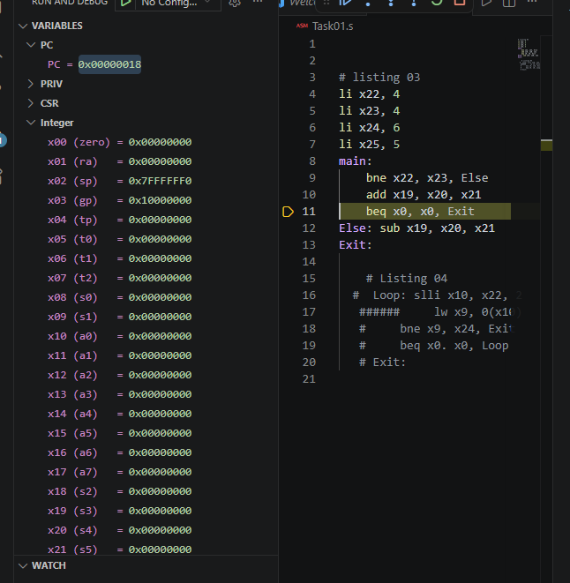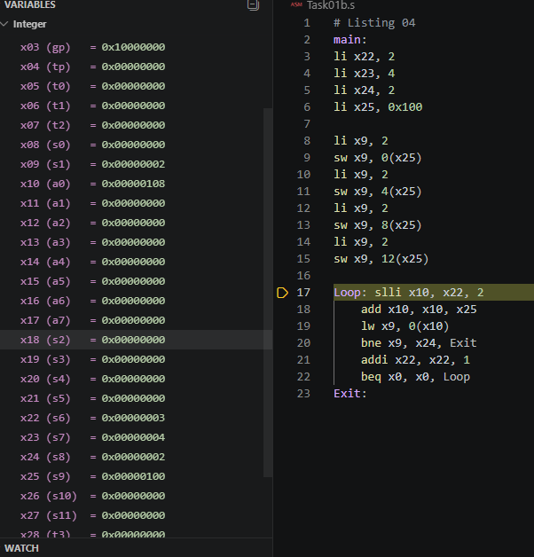

Part 1: This program demonstrates conditional branching using bne and beq. Since x22 and x23 contain different values, the program jumps to the Else block and performs subtraction instead of addition.
Part 2: This program uses a loop to access array elements stored in memory and compares each value with a target value. The loop continues while the values match and exits as soon as a different value is encountered.

Task 2:

Code:
main:
# x x20
# a x21
# b x22
# c x23
li x22, 3
li x23, 2

li t0, 1
beq x24,t0, Case1
li t0, 2
beq x24, t0, Case2
li t0, 3
beq x24, t0, Case3
li t0, 4
beq x24, t0, Case4
j default

slli x21, x22, 1
Case1:
add x21, x22, x23
j Exit
Case2:
sub x21, x22, x23
j Exit
Case3:
slli x21, x22, 1
j Exit
Case4:
srai x21, x22, 1
j Exit
default:
li x21, 0
j Exit
Exit:

Results:
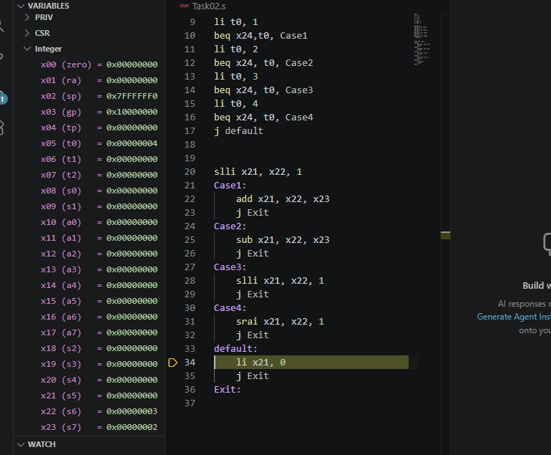

This task implements a switch-case structure in RISC-V using branch instructions. Depending on the value in x24, it performs addition, subtraction, left shift, right shift, or assigns a default value of zero.

Task 3:

Code:
main:
# i in x22
# sum in x22
li x5, 0x200
li x6, 10

li x22, 0
loop1:
bge x22, x6, Exit
slli x7, x22, 2
add x7, x5, x7
sw x22, 0(x7)
addi x22, x22, 1
j loop1
Exit:

loop2:
bge x22, x6, Exit
slli x7, x22, 2
add x7, x5, x7
lw x28, 0(x7)
add x23, x23, x28
addi x22, x22, 1
j loop2
Exit:

This task demonstrates the use of loops and memory operations. The first loop stores numbers sequentially into memory, while the second loop reads them back and accumulates their sum in a register.

Results:
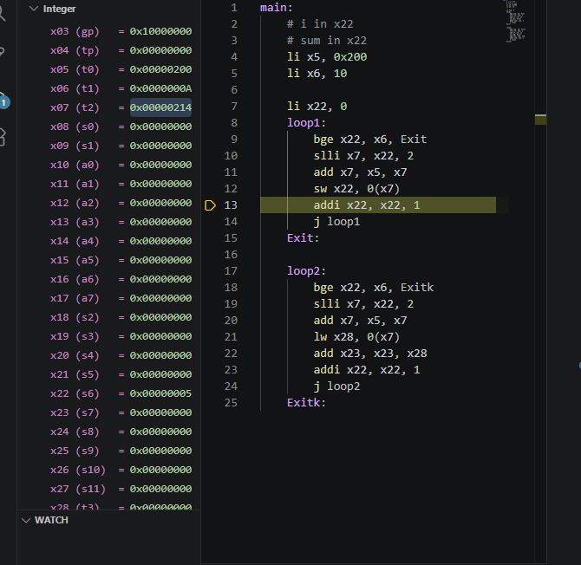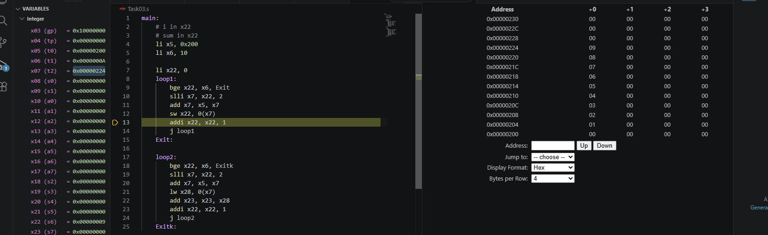

Task 4:

Code:
main:
# x5 =a
# x6 =b
# x7 =i
#x29 =j
li x7, 0
li x29, 0
Loop1:
bge x7, x5, Loop1end
Loop2:
bge x29, x6, Loop2end
slli x30, x29, 4
add x30, x10, x30

add x31, x7, x29
sw x31, 0(x30)

addi x29, x29, 1
j Loop2
Loop2end:
addi x7,x7, 1
j loop1
Loop1end:

This program uses nested loops to generate and store values in memory based on the indices i and j. For each iteration, it calculates i + j and saves the result in an array-like memory structure.

Results:
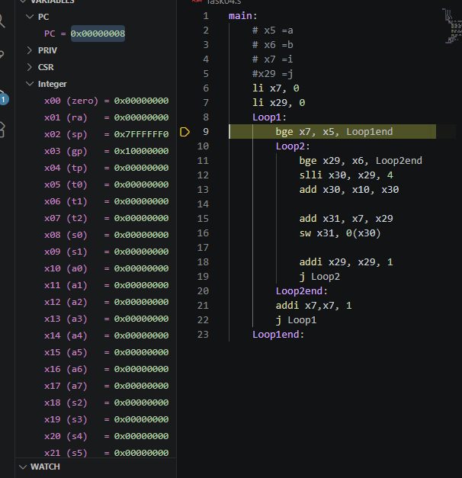

Assessment Rubric
Lab 2 - Implementing Decision Instructions in RISC V Assembly Language

Name: Aayan Rizvi | Student ID: 11089 | Section: T-4

Points Distribution:

 | Task No. | LR 2 (Code) | LR 5 (Results)
In-Lab | Task 1 | - | /5
 | Task 2 | /10 | /10
 | Task 3 | /15 | /10
 | Task 4 | /20 | /10
Total Points: 100 |  | /45 | /35
CLO Mapped |  | CLO 2

Affective Domain Rubric |  | Points | CLO Mapped
AR7 | Report Submission & Git Upload | /10 & /10 | CLO 2

CLO | Total Points | Points Obtained
2 | 100
Total | 100

