TEST PROCEDURE
Title: Test
Reference: Test
Operator: Alexis
Category: Assembly
Date: 24/06/2026
I. Preparation of Tools
1. Place the following tools on the workbench: | 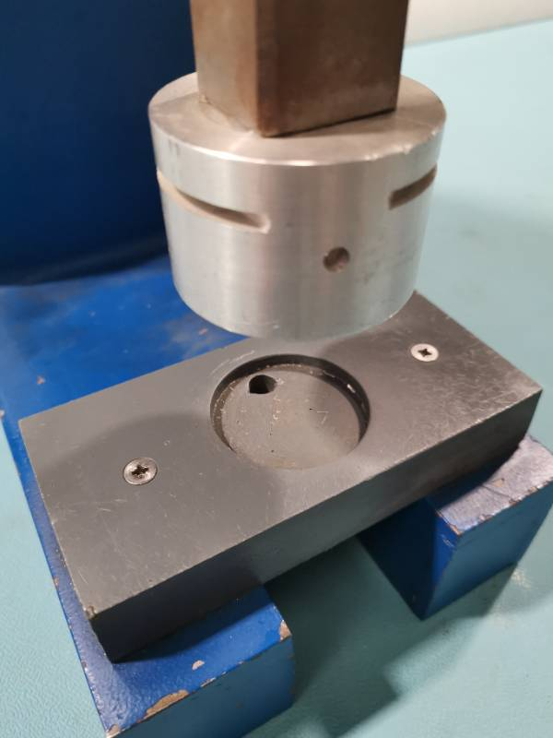  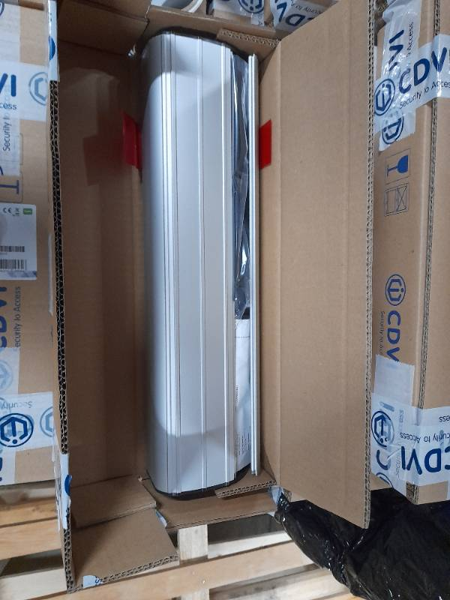

• Tool 1
• Tool 2
• Tool 3
(see photo)
II. Testing Process
1. Verify that all tools are calibrated and in good working condition.
2. Conduct a preliminary inspection of the assembly components for any visible damage or defects.
3. Begin the testing procedure by following the specific test parameters outlined in the product specifications.
III. Documentation and Reporting
1. Record all test results in the designated logbook.
2. If any defects are discovered, document the issue and report it to the quality assurance department.
3. Ensure all documentation is completed accurately and submitted by the end of the shift.
IV. Clean-Up
1. After testing is complete, return all tools to their designated storage locations.
2. Clean the workbench and surrounding area to ensure it is ready for the next operator.
3. Dispose of any waste materials according to the company's safety regulations.
End of Procedure
Photos
preparation des outils — Step 1
Mettre ces outils sur la table de travail



Etablit par : | Contrôlé par :
Alexis

