Project Identification

Project: | T04 – Dragon Boat
Prepared By: | Andrew Cobb
Document Version: | 0.1
Published Date: | <Insert Date: month, day, year>

Contributors

Name | Title
Andrew Cobb | Head Programmer

Distribution
This document is distributed to all the following people.
Name | Title
Andrew Cobb | Head Programmer
Arsalan Farooqi
Giuseppe Ragusa | Scrum Master

Referenced Documents
This document refers to the following materials
Version number | Title | Author | Date | Source / Location

Revision History

Version Number | Revision Date | Summary of Changes | Modified by
0.1 | 26/09/2019 | Started Document | Andrew Cobb
0.2 | 29/09/2019 |  | Andrew Cobb
[Note: It is recommended that drafts be numbered 0.1 to 0.9, and that the first approved version be numbered 1.0. Thereafter, new version numbers will depend upon changes: 1.01, 1.1, etc for minor updates, 2.0, 3.0 etc for major changes.]

TABLE OF CONTENTS
1. Business Context Diagram 3
2. REquirements Scope Statements 4
3. High Level Business Requirements (HLR) Traceability 4
4. High Level Business Requirements Sign-Off 5

- Business Context Diagram

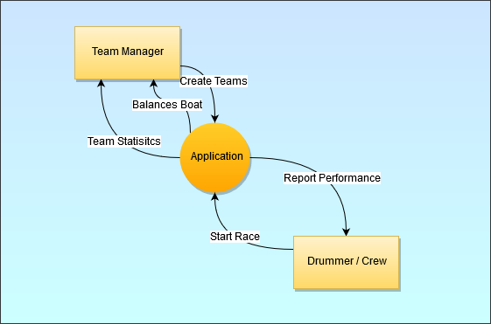

Requirement Scope Area | Description
Application | Mobile App

External Entity | Description
Team Manger | Manager in charge of selecting team members for boat
Drummer / crew | Crew member who will be using app during race

Information Flows | Description
Create teams | Manger selects who will be on the team
Balances boat | App reports the position of team members to the boat is balanced
Team Statistics | App reports speed vs time graph and show route of boat after race
Report performance | Live report of current speed and position
Start Race | Crew signifies start of race
- Requirements Scope Statements
HLR# | Description | Priority  (H, M, L)
 | Application allows user to select a team and see if boat is balanced | H
 | Application automatically balances boat | H
 | Application allows for tracking of speed of boat | H
HLR04 | Application can save graphs of speed correlated to team | M

- High Level Business Requirements Sign-Off
The undersigned acknowledge their agreement with the contents of Version <x.x> of the High-Level Requirements document for <Project Name>.

Following approval of this document, requirements changes will be governed by the project’s change management process, including impact analysis and appropriate reviews and approvals, under the general control of the Project Plan and according to company policy. Approved Change Request Documents, if present, will be attached to this Requirements Document as updates.

Name | Project Role and  Functional Area | Date Signed
Andrew Cobb | Head Programmer | 29/09/2019
Giuseppe Ragusa | Scrum Master | 29/09/2019

* Note: physical signatures are not required. Email approvals are acceptable and should be appended to project documents.

