Andrew Cobb | Giuseppe Ragusa | Arsalan Farooqui

Group 9

My Movement

Comp 3074 Project

Contents

Description 2

Project Objectives 2

Scope 2

Design 3

Overview 3

Story Board 3

Wireframes 3

Title Screen 4

About Screen 5

Manage routes screen 6

Route details 7

Share route screen 8

Map Screen 9

Full map screen 10

# Description

My Movement is an app to record walks and hikes. Its goal is to provide users with a method of reviewing their activity, sharing their activity through social media and to encourage physical activity and exploration. The user will be able to start recording their position at the start of a new route and stop at the end, after completing route the user will be able save the route, rate it and add tags. Saved routes can be shared through social media and email. Saved routes may be search by tags, name or rating and viewed to allow user to revisit routes.

## Project Objectives

Our objective is to encourage users to be active and explore their surroundings, we will be providing our customers detailed information on previous activity, as well as allowing them to share and see activities of their friends. The goal of the application is to get users thinking about how they travel as part of an effort to encourage fitness and sustainable living.

## Scope

The scope of the project is to create an app to share routes traveled by foot. We will not be focused on navigation or waypoint finding. Travel by other methods such as cycling, or boating may be considered in future versions of the application but are not part of this release. As such our scope is defined as the following:

In scope

* Compatibility Android SDK version 15 or higher
* Record and save routes
* Create sharable route data
* Provide instructions to users
* Integration with social media: Facebook, Twitter
* Creation of tags
* Editing route meta data

Not in scope

* Cross platform compatibility (e.g. iOS, Windows)
* Back end server
* Waypoint searching
* Changing saved routes GPS data
* Creating route through user interface (creating route without traveling it)
* Tracking vehicle routes
* Saving speed data or other performance metrics

# Design

## Overview

## Story Board

## Wireframes

### Title Screen

Landing screen for the application, allows user to navigate to other app functionalities.

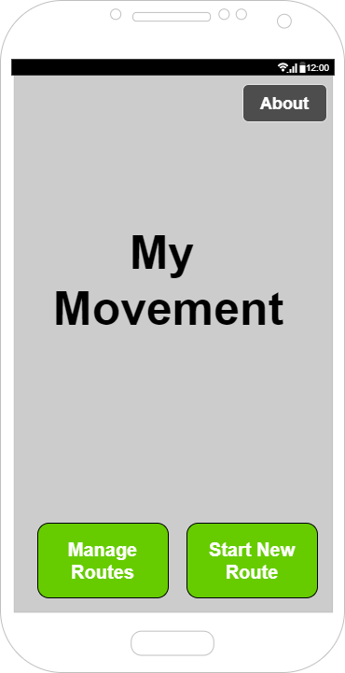

### About Screen

Gives user a description of us as a company, no farther navigation from this screen.

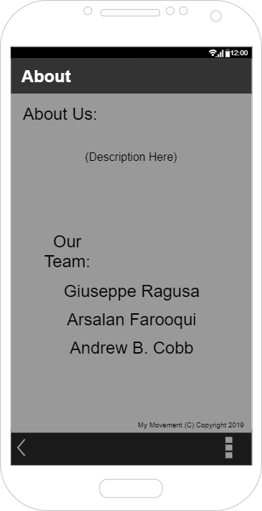

### Manage routes screen

Allows the users to view previously saved routes and search for routes. Selecting route navigates to route details screen.

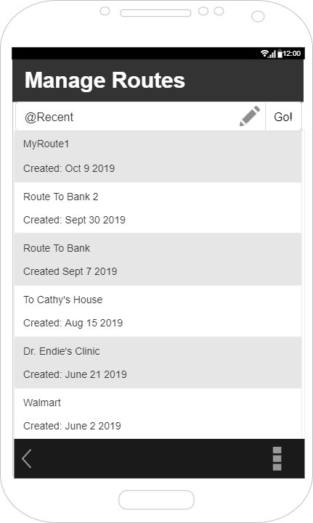

### Route details

Allows user to preform CRUD operations on selected route such as editing name, rating route, adding tags or deleting route.

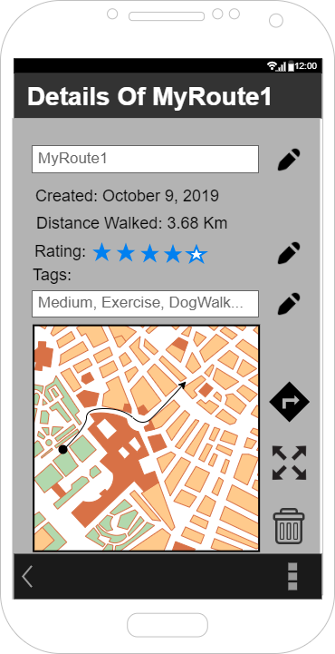

### Share route screen

Allows user to email route details

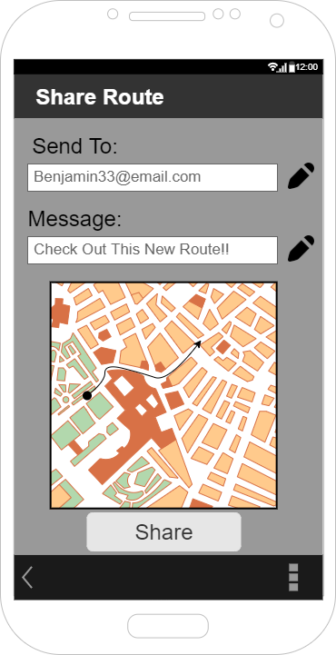

### Map Screen

Screen displayed while walking on route. Allows user to save route.

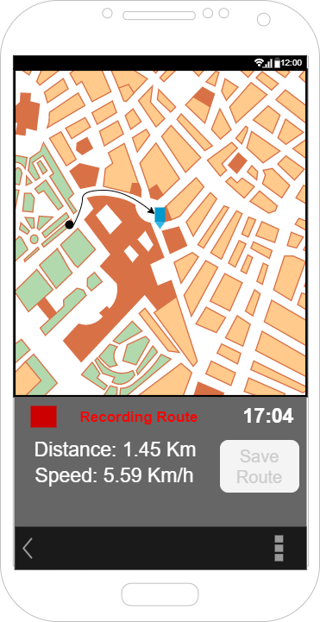

### Full map screen

Allows user to view map without GUI

