实验报告

实验名称 | 实验二 类的创建与封装实验
实验教室 | 丹青905 | 实验日期 | 2021 年 4月 2日
学 号 | 2019210173 | 姓 名 | 刘思远
专业班级 | 计算机科学与技术 2019-04
指导教师 | 王波

东北林业大学
奥林学院

- 实验目的
1．掌握类的声明和创建，掌握构造方法的定义和使用。
2．掌握成员变量和方法的定义和调用。
3．掌握对象的创建、实例或类成员变量和方法的引用。
4．掌握包的使用和导入，掌握Import语句的使用。
5．掌握访问权限的作用范围。
二、实验环境
windows10，开发工具idea，JDK11
- 实验内容、代码及结果截图
1038
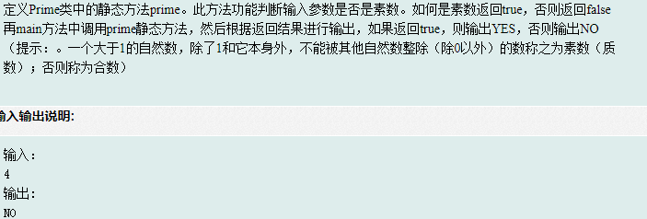
import java.util.Scanner;
class Prime{
// Write your own code
public static boolean prime(int num){
if(num <= 1) return false;
for(int i = 2; i < num; i ++){
if(num % i == 0) return false;
}
return true;
}
}
public class Main {
public static void main(String[] args) {
Scanner cin = new Scanner(System.in);
int n = cin.nextInt();
// Write your own code
if (Prime.prime(n) == true) {
System.out.println("YES");
} else {
System.out.println("NO");
}
}
}
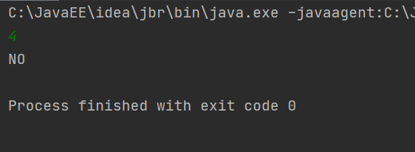
1039
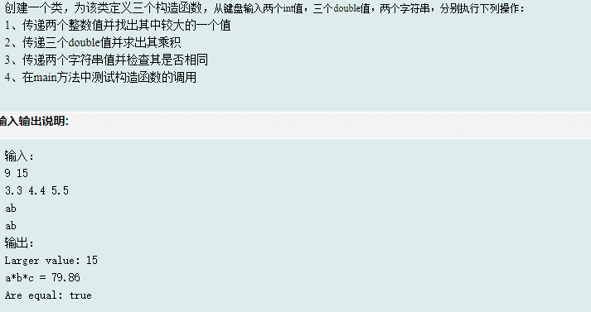
import java.util.Scanner;
class Check {
//write your code here
public static int ans1;
public static double ans2;
public static boolean ans3;
public Check(int x, int y){
Check.ans1 = Math.max(x ,y);
}
public Check(double x, double y, double z){
Check.ans2 = x * y * z;
}
public Check(String a, String b){
Check.ans3 = a.equals(b);
}
}
public class Main {
public static void main(String[] args) {
Scanner cin = new Scanner(System.in);
int x = cin.nextInt(), y = cin.nextInt();
Check obj1 = new Check(x, y);
System.out.println("Larger value: " + Check.ans1);
double a = cin.nextDouble(), b = cin.nextDouble(), c = cin.nextDouble();
Check obj2 = new Check(a, b, c);
System.out.println("a*b*c = " + Check.ans2);
cin.nextLine();
String p = cin.nextLine();
String q = cin.nextLine();
Check obj3 = new Check(p, q);
System.out.println("Are equal: " + Check.ans3);
}
/**
9 15
3.3 4.4 5.5
ab
ab*/
}
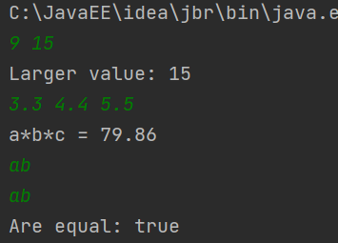
1044
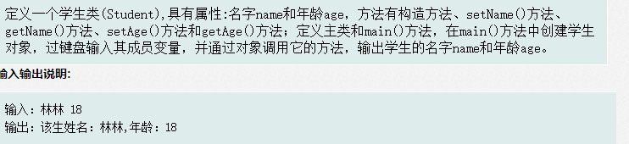
import java.util.Scanner;
class Student{
private String name;
private int age;
public Student(String name, int age){
this.name = name;
this.age = age;
}
public void setAge(int age) {
this.age = age;
}
public void setName(String name) {
this.name = name;
}
public int getAge() {
return age;
}
public String getName() {
return name;
}
}
public class Main {
public static void main(String[] args) {
Scanner cin = new Scanner(System.in);
String name = cin.next();
int age = cin.nextInt();
Student student = new Student(name, age);
System.out.println("该生姓名：" + student.getName() + ",年龄：" + student.getAge());
}
}
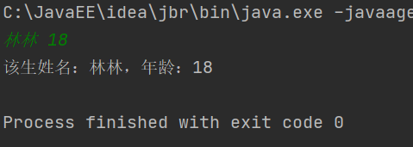
1051
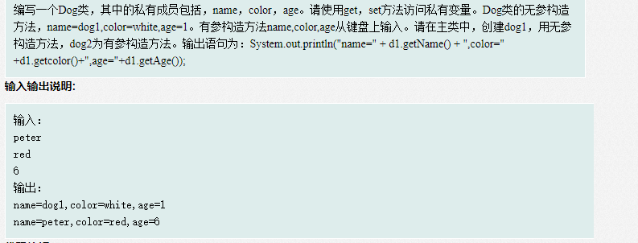
import java.util.Scanner;
class Dog{
private String name;
private String color;
private int age;
public Dog(){
this.name = "dog1";
this.color = "white";
this.age = 1;
}
public Dog(String name, String color, int age){
this.name = name;
this.color = color;
this.age = age;
}
public void setName(String name) {
this.name = name;
}
public void setAge(int age) {
this.age = age;
}
public void setColor(String color) {
this.color = color;
}
public int getAge() {
return age;
}
public String getColor() {
return color;
}
public String getName(){
return name;
}
}
public class Main {
public static void main(String[] args) {
//write code here
Scanner cin = new Scanner(System.in);
String name = cin.nextLine();
String color = cin.nextLine();
int age = cin.nextInt();
Dog d1 = new Dog();
Dog d2 = new Dog(name, color, age);
System.out.println("name=" + d1.getName() + ",color=" +d1.getColor()+",age="+d1.getAge());
System.out.println("name=" + d2.getName() + ",color=" +d2.getColor()+",age="+d2.getAge());
}
}
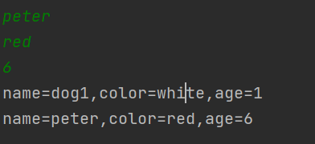
7201
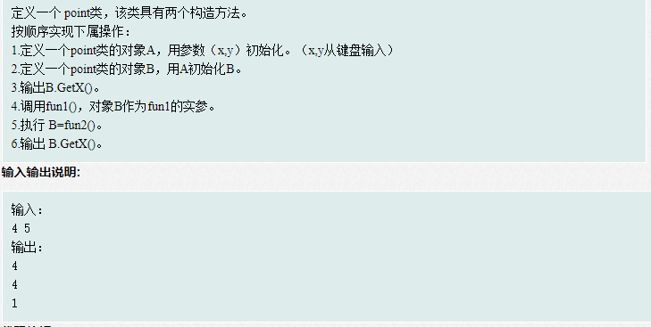
import java.util.Scanner;
class Point {
private int x;
private int y;
public Point(int xx,int yy) //构造方法
{
this.x=xx;
this.y=yy;
}
public int getX() {
return x;
}
public int getY() {
return y;
}
//write your code
public static void fun1(Point p)
{
System.out.println(p.getX());
}
public static Point fun2()
{
Point A =new Point(1,2);
return A;
}
}
public class Main{
public static void main(String[] args) {
//write your code
Scanner cin = new Scanner(System.in);
int x = cin.nextInt(), y = cin.nextInt();
Point a = new Point(x, y);
Point b = new Point(a.getX(), a.getY());
System.out.println(b.getX());
Point.fun1(b);
b = Point.fun2();
System.out.println(b.getX());
}
}
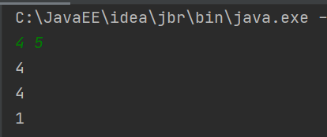
7202
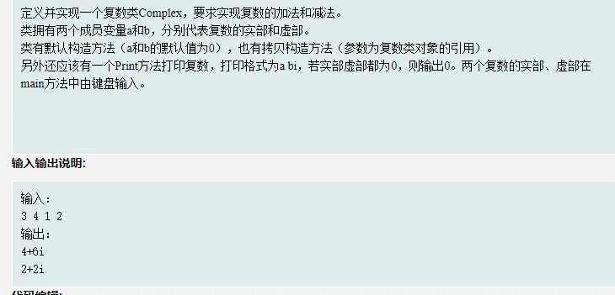
import java.util.*;
class Complex{
private int a;
private int b;
public Complex(){
this.a = 0;
this.b = 0;
}
public Complex(int a, int b){
this.a = a;
this.b = b;
}
public Complex(Complex a){
this.a = a.getA();
this.b = a.getB();
}
public Complex Add(Complex a){
Complex complex = new Complex(a.getA() + this.a, a.getB() + this.b);
return complex;
}
public Complex Sub(Complex a){
Complex complex = new Complex(this.a - a.getA(), this.b - a.getB());
return complex;
}
public int getA() {
return a;
}
public int getB() {
return b;
}
public void setA(int a) {
this.a = a;
}
public void setB(int b) {
this.b = b;
}
public void Print(){
if(a == 0 && b == 0){
System.out.println(0);
}
else{
System.out.println(a + " " + b + "i");
}
}
}
public class Main{
public static void main(String[] args) {
int m,n; //第一个数的实部和虚部
int p,q; //第二个数的实部和虚部
Scanner scanner =new Scanner(System.in);
m=scanner.nextInt();
n=scanner.nextInt();
p=scanner.nextInt();
q=scanner.nextInt();
Complex t =new Complex(m,n);
Complex s =new Complex(t);
Complex r=new Complex(p,q);
(s.Add(r)).Print();
(t.Sub(r)).Print();
}
}
// Write your own code
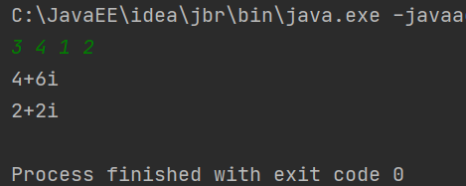
1342
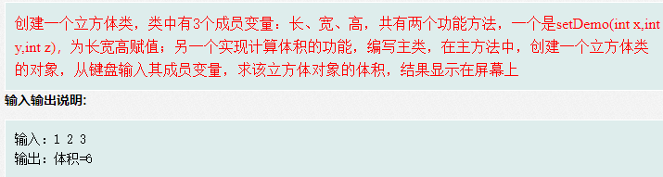
import java.util.*;
class Cuboid{
private int c;
private int k;
private int h;
public Cuboid(int c, int k, int h){
this.h = h;
this.c = c;
this.k = k;
}
public int getC() {
return c;
}
public int getH() {
return h;
}
public int getK() {
return k;
}
public void setC(int c) {
this.c = c;
}
public void setH(int h) {
this.h = h;
}
public void setK(int k) {
this.k = k;
}
public static int caculateT(Cuboid cuboid){
return cuboid.c * cuboid.k * cuboid.h;
}
public static int caculateM(Cuboid cuboid){
return 4 * (cuboid.c + cuboid.k + cuboid.h);
}
}
public class Main{
public static void main(String[] args) {
Scanner cin =new Scanner(System.in);
int a = cin.nextInt(), b = cin.nextInt(), c = cin.nextInt();
Cuboid cuboid = new Cuboid(a, b, c);
System.out.println("体积=" + Cuboid.caculateT(cuboid));
}
}
// Write your own code
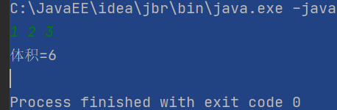
7203
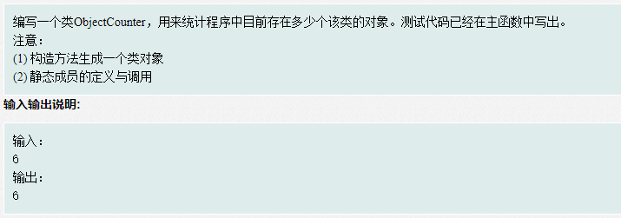
import java.util.Scanner;
class ObjectCounter {
private static int count = 0;
public ObjectCounter(){
count += 1;
}
public static int getCount(){
return ObjectCounter.count;
}
//write your code here
}
public class Main {
public static void main(String[] args) {
Scanner scan = new Scanner(System.in);
int n = scan.nextInt();
for(int i=0;i<n;i++){
ObjectCounter str1 = new ObjectCounter();
}
System.out.println(ObjectCounter.getCount());
}
}
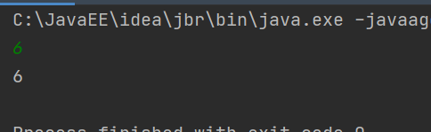

四、实验过程分析与讨论
查询了有关拷贝构造法的资料，学到了很多新知识和概念。
- 指导教师意见

指导教师签字：
年 月 日

