实验报告

实验名称 | 实验三 类的继承与多态实验
实验教室 | 丹青 905 | 实验日期 | 2021 年4 月9日
学 号 | 2019210173 | 姓 名 | 刘思远
专业班级 | 计算机科学与技术2019-04
指导教师 | 王波

东北林业大学
奥林学院

- 实验目的
1. 掌握类的继承方法及上转型对象的方法调用。
2．掌握this和super的区别及使用。
3．理解抽象类的概念及作用，掌握接口的声明，实现及接口回调。
- 实验环境
windows10，开发工具idea，JDK11
实验内容、代码及结果截图
7173

import java.util.*;
import java.math.*;

public class Main {
public static class Dog{
private String name;
private int weight;
private String color;

public Dog(String name, int weight, String color) {
this.name = name;
this.weight = weight;
this.color = color;
}

public String getName() {
return name;
}

public void setName(String name) {
this.name = name;
}

public int getWeight() {
return weight;
}

public void setWeight(int weight) {
this.weight = weight;
}

public String getColor() {
return color;
}

public void setColor(String color) {
this.color = color;
}
public void show(){
System.out.println("这是一只" + name + "体重为" + weight + ",颜色为" + color);
}
}

public static class UnspottedDog extends Dog{
public UnspottedDog(String name, int weight, String color) {
super(name, weight, color);
}
@Override
public void show(){
System.out.println("这是一只" + getName() + "犬");
}
}
public static class SpottedDog extends Dog{
private String spotColor;
public SpottedDog(String name, int weight, String color, String spotColor) {
super(name, weight, color);
this.spotColor = spotColor;
}

public String getSpotColor() {
return spotColor;
}

public void setSpotColor(String spotColor) {
this.spotColor = spotColor;
}
@Override
public void show(){
System.out.println("这是一只" + getName() + "体重为" + getWeight() + ",颜色为" + getColor());
System.out.println("这是一只" + getName() + ",颜色为" + getColor() + ",斑点颜色为" + getSpotColor());
}
}
public static void main(String[] args) {
Scanner cin = new Scanner(System.in);
String name = cin.next();
int weight = cin.nextInt();
String color = cin.next();
String spotColor = cin.next();

SpottedDog spottedDog = new SpottedDog(name, weight, color, spotColor);
spottedDog.show();

name = cin.next();
weight = cin.nextInt();
color = cin.next();
UnspottedDog unspottedDog = new UnspottedDog(name, weight, color);
unspottedDog.show();
}
}
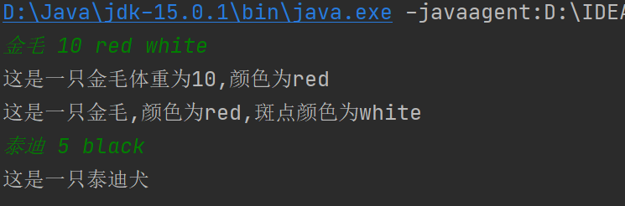
7174
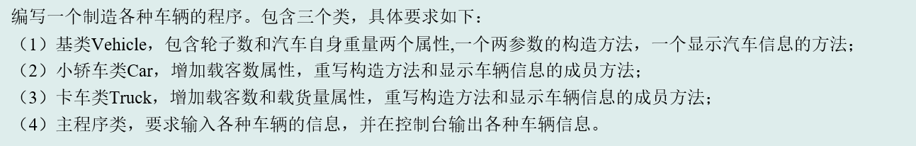
import java.util.*;
import java.math.*;

public class Main {
public static class Vehicle{
private int circles;
private float weight;

public Vehicle(int circles, float weight) {
this.circles = circles;
this.weight = weight;
}

public int getCircles() {
return circles;
}

public void setCircles(int circles) {
this.circles = circles;
}

public float getWeight() {
return weight;
}

public void setWeight(float weight) {
this.weight = weight;
}
public void show(){
System.out.println("汽车:\n" + "轮子数:" + circles + "个\n" + "自身重量:" + weight + "吨");
}
}
public static class Car extends Vehicle{
private int number;

public Car(int circles, float weight, int number) {
super(circles, weight);
this.number = number;
}

public int getNumber() {
return number;
}

public void setNumber(int number) {
this.number = number;
}

@Override
public void show(){
System.out.println("小轿车:\n" + "轮子数:" + getCircles() + "个\n" + "自身重量:" + getWeight() + "吨\n" + "额定乘客数:" + getNumber() + "人");
}
}
public static class Truck extends Vehicle{
private int number;
private float numWeight;

public Truck(int circles, float weight, int number, float numWeight) {
super(circles, weight);
this.number = number;
this.numWeight = numWeight;
}

public int getNumber() {
return number;
}

public void setNumber(int number) {
this.number = number;
}

public float getNumWeight() {
return numWeight;
}

public void setNumWeight(float numWeight) {
this.numWeight = numWeight;
}
@Override
public void show(){
System.out.println("卡车:\n" + "轮子数:" + getCircles() + "个\n" + "自身重量:" + getWeight() + "吨\n" + "额定乘客数" + getNumber() + "人\n" + "载重量" + getNumWeight() + "吨");
}
}
public static void main(String[] args) {
Scanner cin = new Scanner(System.in);
int circle = cin.nextInt();
float weight = cin.nextFloat();
Vehicle vehicle = new Vehicle(circle, weight);
vehicle.show();

circle = cin.nextInt();
weight = cin.nextFloat();
int num = cin.nextInt();
Car car = new Car(circle, weight, num);
car.show();;

circle = cin.nextInt();
weight = cin.nextFloat();
num = cin.nextInt();
float numWeight = cin.nextFloat();
Truck truck = new Truck(circle, weight, num, numWeight);
truck.show();
}
}

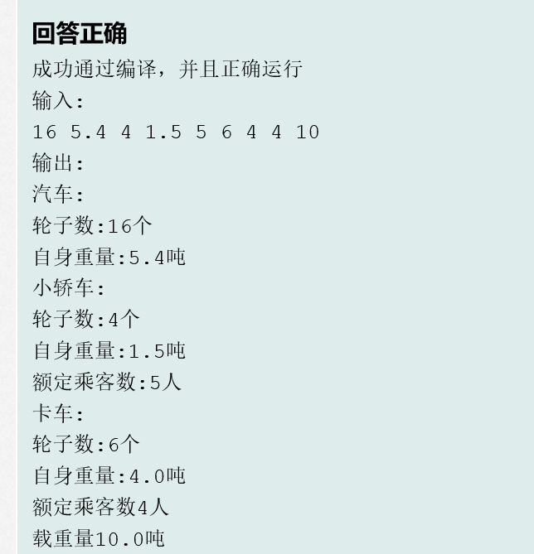
7175
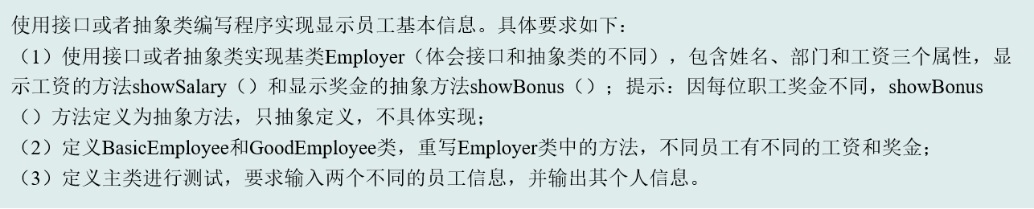
import java.util.*;
import java.math.*;

public class Main {
public static abstract class Employer{
private String name;
private String department;
private float salary;
public Employer(String name, String department, float salary) {
this.name = name;
this.department = department;
this.salary = salary;
}

public String getName() {
return name;
}

public void setName(String name) {
this.name = name;
}

public String getDepartment() {
return department;
}

public void setDepartment(String department) {
this.department = department;
}

public float getSalary() {
return salary;
}

public void setSalary(float salary) {
this.salary = salary;
}

void showSalary(){}
void showBonus(){}
}
public static class BasicEmployee extends Employer{
public BasicEmployee(String name, String department, float salary) {
super(name, department, salary);
}
@Override
public void showSalary(){
System.out.println(String.format("我叫%s,在%s部门，我的工资是%.1f", getName(), getDepartment(), getSalary()));
}
@Override
public void showBonus(){
System.out.println("我是普通员工，没有奖金，加油升级！");
}
}
public static class GoodEmployee extends Employer{
private float bonus;

public GoodEmployee(String name, String department, float salary, float bonus) {
super(name, department, salary);
this.bonus = bonus;
}

public float getBonus() {
return bonus;
}

public void setBonus(float bonus) {
this.bonus = bonus;
}
@Override
public void showSalary(){
System.out.println(String.format("我叫%s,在%s部门，我的工资是%.1f", getName(), getDepartment(), getSalary()));
}
@Override
public void showBonus(){
System.out.println(String.format("我是优秀员工，我的奖金是%.1f", getBonus()));
}
}
public static void main(String[] args) {
Scanner cin = new Scanner(System.in);
String name = cin.next();
String department = cin.next();
float salary = cin.nextFloat();

BasicEmployee basicEmployee = new BasicEmployee(name, department, salary);
basicEmployee.showSalary();
basicEmployee.showBonus();

name = cin.next();
department = cin.next();
salary = cin.nextFloat();
float bonus = cin.nextFloat();

GoodEmployee goodEmployee = new GoodEmployee(name, department, salary, bonus);
goodEmployee.showSalary();
goodEmployee.showBonus();
}
}
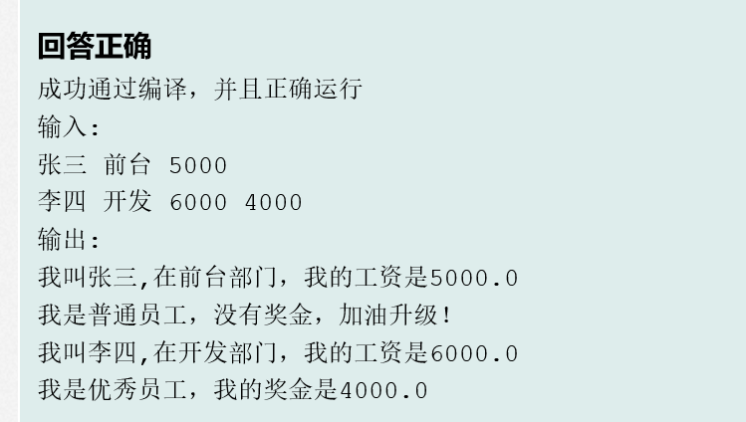
7176
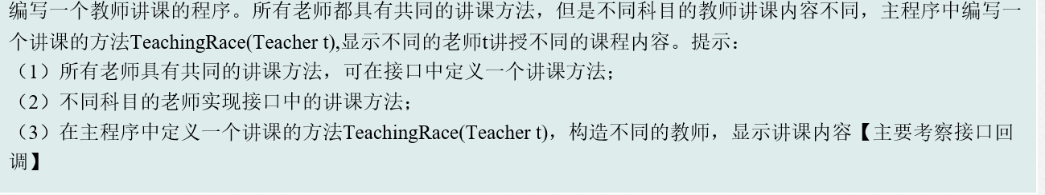
import java.util.*;
import java.math.*;

interface Teacher{
void teachering();
}

class Englishclass implements Teacher{
private String knowledge;

public Englishclass(String knowledge) {
this.knowledge = knowledge;
}

public String getKnowledge() {
return knowledge;
}

public void setKnowledge(String knowledge) {
this.knowledge = knowledge;
}

@Override
public void teachering() {
System.out.println(String.format("我是英语老师，I say %s", knowledge));
}
}
class Mathclass implements Teacher{
private String knowledge;

public Mathclass(String knowledge) {
this.knowledge = knowledge;
}

public String getKnowledge() {
return knowledge;
}

public void setKnowledge(String knowledge) {
this.knowledge = knowledge;
}

@Override
public void teachering() {
System.out.println(String.format("我是数学老师，I say %s", knowledge));
}
}

public class Main {
public static void main(String[] args) {
Scanner cin = new Scanner(System.in);
String knowledge = cin.next();
Teacher teacher = new Englishclass(knowledge);
TeachingRace(teacher);

knowledge = cin.next();
teacher = new Mathclass(knowledge);
TeachingRace(teacher);
}
public static void TeachingRace(Teacher t){
t.teachering();
}
}
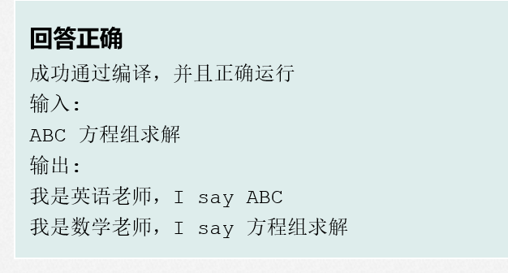
7177
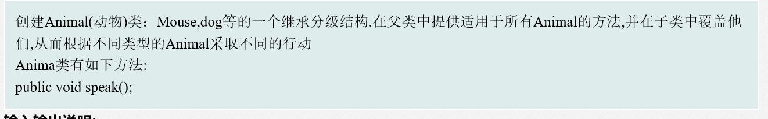
import java.util.*;
import java.math.*;

abstract class Animai{
private String name;

public String getName() {
return name;
}

public void setName(String name) {
this.name = name;
}

public Animai(String name) {
this.name = name;
}

public abstract void speak();
}

class Mouse extends Animai{
public Mouse(String name) {
super(name);
}
@Override
public void speak() {
System.out.println(String.format("%s的叫声为喵喵",getName()));
}
}
class Dog extends Animai{
public Dog(String name) {
super(name);
}
@Override
public void speak() {
System.out.println(String.format("%s的叫声为吱吱",getName()));
}
}
public class Main {
public static void main(String[] args) {
Scanner cin = new Scanner(System.in);
Animai mouse = new Mouse(cin.next());
mouse.speak();
Animai dog = new Dog(cin.next());
dog.speak();
}
}
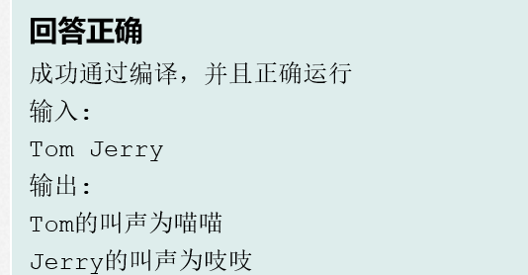
7178
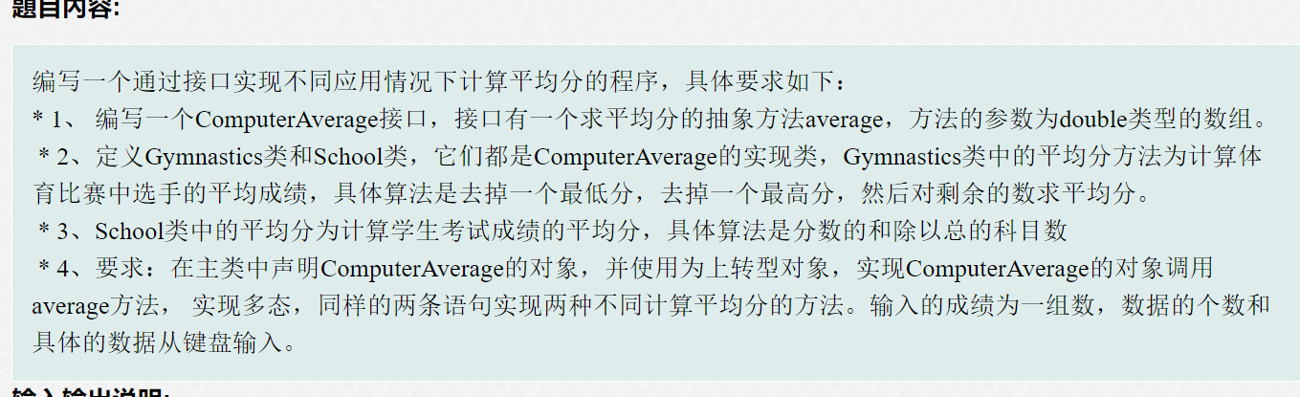
import java.util.Scanner;
interface ComputerAverage {
//start
double average(double[] data);
//write your code between start and end,do not delete any code
//end
}
class Gymnastics implements ComputerAverage {
public double average(double []data) {
double sum=0;
double temp;
double mx = -1, mn = 0x3f3f3f;
for (int i = 0; i < data.length; i++){
mx = Math.max(mx, data[i]);
mn = Math.min(mn, data[i]);
sum += data[i];
}
return (sum - mn - mx) / (data.length - 2);
//start
//write your code between start and end,do not delete any code
//end
}
}
class School implements ComputerAverage{
//start
public double average(double []data) {
double sum=0;
for (int i = 0; i < data.length; i++){
sum += data[i];
}
return sum / data.length;
//start
//write your code between start and end,do not delete any code
//end
}
//write your code between start and end,do not delete any code
//end
}

public class Main {
public static void main(String[] args) {
Scanner scan=new Scanner(System.in);
int n=scan.nextInt();
double []data=new double[n];
for(int i=0;i<n;i++){
data[i]=scan.nextDouble();
}
//start
ComputerAverage g = new Gymnastics();
//write your code between start and end,do not delete any code
//end
System.out.print("Gymnastics average is:");
System.out.printf("%.2f\n",g.average(data));
//start
g = new School();
//write your code between start and end,do not delete any code
//end
System.out.print("School average is:");
System.out.printf("%.2f",g.average(data));
}
}
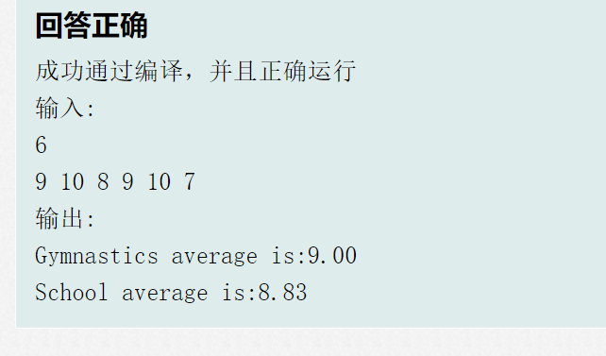

四、实验过程分析与讨论
结果均正确，在试验时对多态的了解还不够深刻，在不断地做题中对多态有了更深一步的理解。
- 指导教师意见

指导教师签字：
年 月 日

