Supporting Information
8 February 2022
Forsyth, D. M., S. Comte, N. E. Davis, A. J. Bengsen, S. D. Côté, D. G. Hewitt, N. Morellet, and A. Mysterud. Methodology matters when estimating deer abundance: a global systematic review and recommendations for improvements. Journal of Wildlife Management
S4. Spatio-Temporal Analysis of First-order Field Methods

Materials and Methods
Six first-order methods of estimating deer abundance or density emerged from the data: pedestrian sign counts, pedestrian direct counts, vehicular direct counts, aerial direct counts, motion-sensitive cameras, and harvest data. Additional estimates were from secondary sources such as expert knowledge (no published reference) and gray literature (no peer-reviewed published reference).
We first analyzed the spatio-temporal trends for the 6 first-order methods. Since these methods were independent and mutually exclusive, we used multinomial log-linear regression to examine the effects of year of data collection (1980–2017), region (Europe, North America, South America and Asia–Australasia), and the 6 biophysical and anthropogenic variables defined in Supporting Information S1 (i.e., study area, deer density, elevation, tree cover, net primary productivity [NPP] and Global Human Influence Index [GHII]). The small number of estimates from Australasia were pooled with the estimates from Asia. We first fitted the full model with and without the interaction term between year and region and used Akaike’s Information Criterion corrected for small sample sizes (AIC_{c}) to identify the best of these 2 models (Burnham and Anderson 2002). We then fitted a first set of candidate models by removing one explanatory variable at a time (8 models). We used a stepwise model selection procedure (Murtaugh 2009) to select the best model based on the lowest AIC_{c}. This process was repeated until the removal of any additional explanatory variable resulted in a higher AIC_{c} value.
Five of the 6 first-order methods were further divided based on field or analysis methods, with the proviso that sub-classes needed to have ≥30 estimates (Table S4.1): further division was not possible for motion-sensitive cameras due to small sample sizes. As for the first-order methods, we used a multinomial log-linear regression to test the effect of the year of data collection (1980–2017) and the 6 biophysical and anthropogenic variables previously described. We again used stepwise model selection to identify the model with the smallest AIC_{c}.
All analyses were performed using R version 4.0.2 (R Core Team 2020) and the function multinom from the package nnet version 7.3-14 (Venables and Ripley 2002). The data and code that support the findings of this study are openly available in figshare at https://doi.org/10.6084/m9.figshare.18846647.v1 (Forsyth et al. 2022).

Results
The 3,870 estimates used in this review were made using 6 first-order methods (Table S4.1): 15.9% used pedestrian sign counts, 29.7% used pedestrian direct counts, 12.3% used vehicular direct counts, 16.6% used aerial direct counts, 6.6% used motion-sensitive cameras, and 18.9% used harvest data.
The best model of the relative use of the 6 first-order methods included the interaction term between year and region (Tables S4.2, S4.3). The relative use of the different methods varied strongly in space and time (Fig. S4.1). In Europe, pedestrian direct counts were the main method used before 2000, but this method was replaced by pedestrian sign counts and vehicular direct counts. The use of harvest data steadily declined after 1980. Motion-sensitive cameras were first used in 2010, and aerial direct counts were little used throughout 1980–2018. In North America, prior to 2000, deer abundance estimates were made using harvest data, pedestrian direct counts, and aerial direct counts. After 2000, these 3 methods were rapidly replaced by motion-sensitive cameras, pedestrian sign counts, and vehicular direct counts. In South America, pedestrian sign counts dominated in the 1980s, but thereafter vehicular direct counts and aerial direct counts dominated. Since 2010, the use of motion-sensitive cameras and pedestrian direct counts has increased. Harvest data were not used to estimate deer abundance in South America. In Asia and Australasia, the use of harvest data and aerial direct counts, which were both dominant in the 1980s, declined substantially after 1990 and have been replaced by pedestrian sign counts and pedestrian direct counts. In all 4 regions, the use of vehicular direct counts and motion-sensitive cameras has increased since 2000.

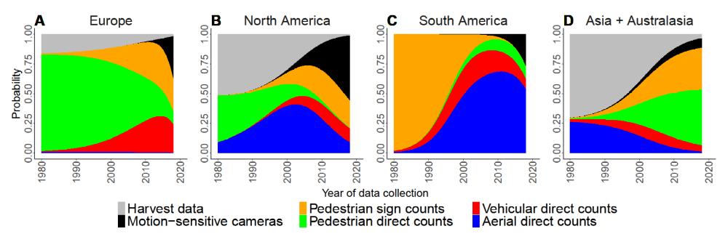
Figure S4.1. Regional–temporal variation in the probability of each of six methods being used to estimate deer abundance or density in articles published during 2004–2018.

Table S4.1. Sub-categories and sample size for the 6 first-order methods and 2 secondary sources used to estimate deer abundance or density in articles published during 2004–2018.
Method |  | Number of estimates
Pedestrian sign counts
 | Snow track count | 38
 | Fecal pellet count | 458
 | Fecal pellet distance sampling | 75
 | Fecal pellet DNA | 38
 | Browsing intensity | 14
Pedestrian direct counts
 | Walked visual count | 670
 | Vantage point | 242
 | Drive count | 239
Vehicular direct counts
 | Diurnal | 181
 | Nocturnal spotlight | 184
 | Nocturnal thermal | 112
Aerial direct counts
 | Helicopters visual | 318
 | Fixed-wing visual | 180
 | Thermal imagery | 38
Motion-sensitive cameras |  | 256
Harvest data
 | Hunting bag | 144
 | Integrated models | 280
 | Population reconstruction | 306

Table S4.2. Summary of the stepwise selection process identifying the best model (shown in bold) explaining the relative use of the 6 first-order methods to estimate deer abundance or density in articles published during 2004–2018. AIC_{c}: Akaike Information Criterion corrected for small sample size. w_{i}: model weight.
Modelª | df | logLik | AIC_{c} | ΔAIC_{c} | w_{i} | Pseudo R²
Year*region + area + density + elev + GHII + tree + NPP | 70 | –4,166 | 8,474 | 0 | 1 | 0.37
Year + region + area + density + elev + GHII + tree + NPP | 55 | –4,279 | 8,669 | 195 | 0 | 0.35
Year*region + area + density + elev + GHII + tree | 65 | –4,256 | 8,644 | 170 | 0 | 0.35
Year*region + area + density + elev + GHII + NPP | 65 | –4,348 | 8,828 | 354 | 0 | 0.34
Year*region + area + density + elev + tree + NPP | 65 | –4,375 | 8,883 | 409 | 0 | 0.34
Year*region + area + density + GHII + tree + NPP | 65 | –4,289 | 8,710 | 236 | 0 | 0.35
Year*region + area + elev + GHII + tree + NPP | 65 | –4,253 | 8,638 | 164 | 0 | 0.35
Year*region + density + elev + GHII + tree + NPP | 65 | –4,354 | 8,840 | 366 | 0 | 0.34
Year + area + density + elev + GHII + tree + NPP | 40 | –4,920 | 9,921 | 1,447 | 0 | 0.25
region + area + density + elev + GHII + tree + NPP | 50 | –4,629 | 9,359 | 885 | 0 | 0.30
ªElev: elevation. GHII: Global Human Influence Index. NPP: net primary productivity.
Table S4.3. Coefficients from the best model (see Table S4.2) explaining the relative use of the 6 first-order methods to estimate deer abundance or density in articles published during 2004–2018.
 | Motion-sensitive cameras |  |  | Vehicular direct counts |  |  |  | Pedestrian direct counts |  |  | Pedestrian sign counts |  |  | Harvest data
Variableª | Estimate | SE | Z-value |  | Estimate | SE | Z-value | Estimate | SE | Z-value | Estimate | SE | Z-value | Estimate | SE | Z-value
Intercept = aerial direct counts | –397.6151 | 1.27E–05 | –31,201,671 |  | –218.1682 | 3.35E–06 | –65,114,670 | –394.4485 | 5.34E–06 | –73,861,745 | –371.997 | 6.01E–06 | –61,934,866 | –6.811653 | 7.27E–06 | –937,583.3
Year | 0.1995 | 0.0003 | 586.1033 |  | 0.1080 | 0.0003 | 357.3111 | 0.1958 | 0.0003 | 718.1207 | 0.1863 | 0.0003 | 689.2213 | 0.0021 | 0.0003 | 7.8465
Region Europe | –925.3823 | 2.45E–07 | –3.77E+09 |  | –34.4725 | 3.12E–06 | –11,044,832 | 426.2404 | 3.93E–06 | 108,526,790 | 114.0100 | 1.90E–06 | 60,152,060 | 47.1178 | 3.34E–06 | 14,116,785
Region North America | –113.6096 | 1.16E–05 | –9,792,835 |  | –58.3734 | 2.38E–06 | –24,501,959 | 644.9542 | 2.36E–06 | 273,506,697 | 106.5699 | 6.21E–06 | 17,148,183 | 206.9502 | 7.89E–06 | 26,237,951
Region South America | –285.6334 | 4.38E–07 | –6.52E+08 |  | 331.6697 | 1.65E–06 | 201,240,020 | 312.1168 | 2.54E–07 | 1.23E+09 | 939.0512 | 5.06E–07 | 1.855E+09 | –0.0058 | 7.07E–16 | –8.26E+12
Area | –0.3523 | 0.0389 | –9.0496 |  | –0.1823 | 0.0311 | –5.8565 | –0.0133 | 0.0273 | –0.4872 | –0.2370 | 0.0284 | –8.3353 | 0.1436 | 0.0271 | 5.3034
Density | –0.2731 | 0.0534 | –5.1139 |  | 0.0240 | 0.0448 | 0.5353 | –0.1616 | 0.0376 | –4.2992 | –0.0218 | 0.0402 | –0.5418 | –0.0095 | 0.0355 | –0.2690
Elevation | –0.0003 | 0.0002 | –1.1717 |  | 0.0007 | 0.0002 | 4.2979 | 0.0013 | 0.0001 | 10.0762 | 0.0007 | 0.0001 | 5.2511 | 0.0006 | 0.0001 | 5.4258
GHII | 0.0099 | 0.0076 | 1.2986 |  | 0.0505 | 0.0064 | 7.8705 | 0.0415 | 0.0059 | 7.0380 | 0.0201 | 0.0059 | 3.4386 | 0.0125 | 0.0056 | 2.2321
Tree | 0.0089 | 0.0034 | 2.6012 |  | 0.0219 | 0.0028 | 7.7593 | 0.0118 | 0.0026 | 4.4738 | 0.0103 | 0.0026 | 3.9138 | 0.0042 | 0.0025 | 1.6701
NPP | 0.0031 | 0.0006 | 5.3975 |  | 0.0052 | 0.0005 | 9.6561 | 0.0051 | 0.0005 | 9.6564 | 0.0036 | 0.0005 | 7.1838 | 0.0045 | 0.0005 | 8.6605
Year : Region Europe | 0.4603 | 0.0003 | 1,654.2706 |  | 0.0189 | 0.0002 | 104.5686 | –0.2110 | 0.0002 | –1,269.9528 | –0.0556 | 0.0002 | –322.8225 | –0.0227 | 0.0002 | –141.6744
Year : Region North America | 0.0562 | 0.0002 | 328.5224 |  | 0.0283 | 0.0001 | 210.2428 | –0.3231 | 0.0001 | –2,708.4665 | –0.0541 | 0.0001 | –443.2890 | –0.1041 | 0.0001 | –997.6606
Year : Region South America | 0.1402 | 0.0004 | 355.9064 |  | –0.1660 | 0.0002 | –664.1874 | –0.1573 | 0.0003 | –586.3154 | –0.4699 | 0.0003 | –1,746.5130 | –0.0161 | 1.42E–12 | –1.14E+10
ªGHII: Global Human Influence Index. NPP: net primary productivity.

Pedestrian sign counts were used in all situations except for study areas >1,000,000 ha (Fig. S4.2A). Pedestrian direct counts were used in all situations but were dominant in study areas >20,000 ha, at densities <1 deer/km² and at medium to high elevations (>1,000 m; Fig. S4.2A–C). Vehicular direct counts were used in study areas <20,000 ha and increased with deer density, human influence, tree cover, and high net primary productivity (Fig. S4.2A, B, D, E, and F). Aerial direct counts increased with study area size and were mostly used at low elevation (<1,000 m), and low net primary productivity (<400 × 10⁹ g C; Fig. S4.2A, C, and F), and typically in areas of low to medium human influence and tree cover (Fig. S4.2D and E). Motion-sensitive cameras were mostly used in study areas that were small (<10,000 ha) and at low elevation (<1,000 m) and deer density <1 deer/km² (Fig. S4.2A, B, and C). Increasing human influence had a negative effect on the use of motion-sensitive cameras (Fig. S4.2D). Harvest data were more likely to be used to estimate deer density for larger study areas (>500,000 ha), but were less likely to be used with increasing elevation and human influence (Fig. S4.2A, C, and D).

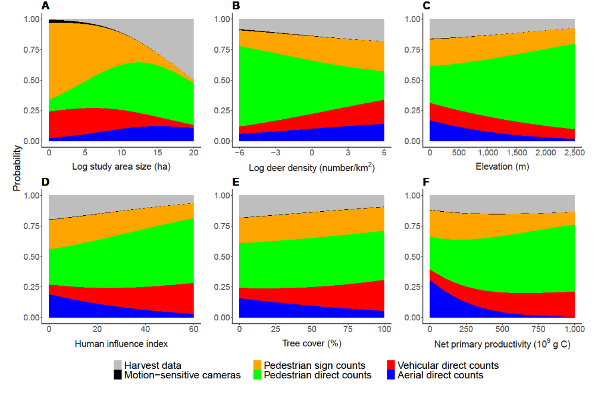
Figure S4.2. Probability of each of the 6 first-order methods being used to estimate deer abundance or density in articles published during 2004–2018.
Pedestrian sign counts.—A total of 615 deer abundance or density estimates were based on pedestrian sign counts (Table S4.1). Fecal pellet counts were the main method (74.5%), followed by fecal pellet distance sampling (12.2%), capture–recapture using DNA from fecal pellets (4.9%), and snow-track counts (6.2%). Fourteen estimates (2.3%) were based on browsing intensity, but due to the small sample size we did not include this method in the analysis. The best model explaining the relative use of pedestrian sign counts methods was the full model (Tables S4.4 and S4.5).
Fecal pellet counts were the preferred method in almost all situations, except for low tree cover (<20%) (Fig. S4.3). Distance sampling and capture–recapture using DNA (the latter since 2010) have emerged as alternatives to traditional fecal pellet count methods. Distance sampling has been used mostly for large areas (>500,000 ha) with high deer densities (>10 deer/km²) in high elevation (>1,000 m) and low tree cover (<50%). Capture–recapture using DNA was used in small areas (<5,000 ha) with high net primary productivity (>400 × 10⁹ g C), low deer density (<1 deer/km²), and low human influence (<20). Snow track counts were mostly used in the 1980s but thereafter declined and were seldom used after 2010. Snow track counts were used for large areas (>500,000 ha) with high deer densities (>20 deer/km²), at low elevation (<750 m), with high tree cover (>50%), and with high human influence (>40).

Table S4.4. Summary of the stepwise selection process identifying the best model (shown in bold) explaining the relative use of the 4 pedestrian sign count methods to estimate deer abundance or density in articles published during 2004–2018. AIC_{c}: Akaike Information Criterion corrected for small sample size. w_{i}: model weight.
Modelª | df | logLik | AIC_{c} | ΔAIC_{c} | w_{i} | Pseudo R²
Year + area + density + elev + GHII + tree + NPP | 24 | –272 | 595 | 0 | 0.99 | 0.43
Year + area + density + elev + GHII + tree | 21 | –281 | 607 | 11 | 0.00 | 0.41
Year + area + density + elev + GHII + NPP | 21 | –332 | 708 | 112 | 0.00 | 0.30
Year + area + density + elev + tree + NPP | 21 | –293 | 631 | 35 | 0.00 | 0.38
Year + area + density + GHII + tree + NPP | 21 | –282 | 607 | 12 | 0.00 | 0.41
Year + area + elev + GHII + tree + NPP | 21 | –298 | 640 | 45 | 0.00 | 0.37
Year + density + elev + GHII + tree + NPP | 21 | –295 | 634 | 38 | 0.00 | 0.38
area + density + elev + GHII + tree + NPP | 21 | –289 | 621 | 26 | 0.00 | 0.39
ªElev: elevation. GHII: Global Human Influence Index. NPP: net primary productivity.

Table S4.5. Coefficients from the best model (see Table S4.4) explaining the relative use of the 4 pedestrian sign count methods to estimate deer abundance or density in articles published during 2004–2018.
 | Fecal pellet DNA |  |  | Fecal pellet distance sampling |  |  | Snow track counts
Variableª | Estimate | SE | Z-value | Estimate | SE | Z-value | Estimate | SE | Z-value
Intercept: fecal pellet counts | –664.0958 | 0.0001 | –4,973,766.3 | 25.8772 | 2.85E–05 | 908,012.8 | 180.4425 | 4.23E–06 | 42,704,028.6
Area | 0.3309 | 0.0007 | 447.4322 | –0.0147 | 0.0006 | –23.7116 | –0.0952 | 0.0009 | –103.6239
Density | –0.3150 | 0.0881 | –3.5754 | 0.2314 | 0.0749 | 3.0879 | 0.4798 | 0.1155 | 4.1554
Elevation | –0.7526 | 0.1866 | –4.0320 | 0.3301 | 0.1294 | 2.5517 | 0.4644 | 0.1565 | 2.9674
GHII | –0.0003 | 0.0005 | –0.5877 | 0.0013 | 0.0005 | 2.9610 | –0.0027 | 0.0012 | –2.2499
Tree | –0.1670 | 0.0362 | –4.6099 | 0.0110 | 0.0139 | 0.7926 | 0.0605 | 0.0191 | 3.1752
NPP | 0.0241 | 0.0100 | 2.4098 | –0.0901 | 0.0138 | –6.5374 | 0.0057 | 0.0087 | 0.6513
ªGHII: Global Human Influence Index. NPP: net primary productivity.
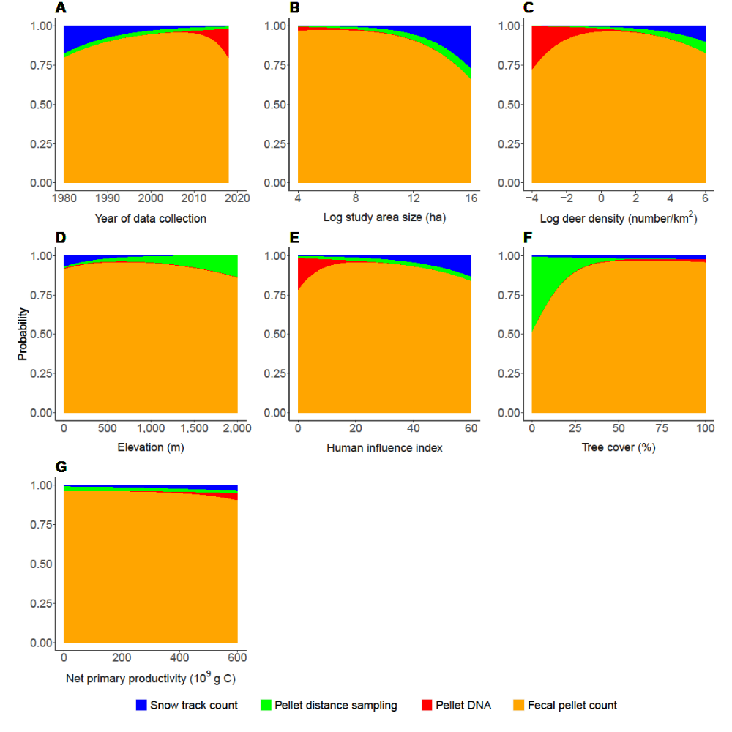Figure S4.3. Probability of using each of 4 pedestrian sign count methods to estimate deer abundance or density in articles published during 2004–2018.

Pedestrian direct counts.—There were 1,151 estimates from pedestrian direct counts (Table S4.1). More than half of these (58.2%) were from walked counts, and the remainder similarly divided between vantage point (21.0%) and drive counts (20.8%). The best model explaining the use of the 3 methods included all explanatory variables except for the year of data collection (Tables S4.6 and S4.7).
Walked visual counts were used mostly in small study areas (<20,000 ha) at low and medium elevations (<1,500 m; Fig. S4.4). It was the dominant method in areas with dense tree cover (>50%), high net primary productivity (>400 × 10⁹ g C), but low to medium human influence (<40). The use of vantage point counts increased in larger areas (>20,000 ha), in denser tree cover (>50%), and at lower deer densities (<1 deer/km²) and lower net primary productivity (<250 × 10⁹ g C). Vantage point counts was almost the only method used at elevations >1,500 m and at human influence >40. Drive counts were mostly used at low elevation (<1,000 m), with low tree cover (<50%), and where human influence was low (<20).

Table S4.6. Summary of the stepwise selection process identifying the best model explaining the relative use of the 3 pedestrian direct count methods to estimate deer abundance or density in articles published during 2004–2018. For each step the best model is shown in bold, with the overall best model in step 2. AIC_{c}: Akaike Information Criterion corrected for small sample size. w_{i}: model weight.
Modelª | df | logLik | AIC_{c} | ΔAIC_{c} | w_{i} | Pseudo R²
Step 1:
Year + area + density + elev + GHII + tree + NPP | 16 | –437 | 907 | 3 | 0.17 | 0.61
Year + area + density + elev + GHII + tree | 14 | –441 | 911 | 8 | 0.02 | 0.60
Year + area + density + elev + GHII + NPP | 14 | –462 | 954 | 50 | 0.00 | 0.59
Year + area + density + elev + tree + NPP | 14 | –528 | 1,085 | 181 | 0.00 | 0.53
Year + area + density + GHII + tree + NPP | 14 | –559 | 1,147 | 244 | 0.00 | 0.50
Year + area + elev + GHII + tree + NPP | 14 | –453 | 935 | 31 | 0.00 | 0.59
Year + density + elev + GHII + tree + NPP | 14 | –553 | 1,135 | 231 | 0.00 | 0.50
area + density + elev + GHII + tree + NPP | 14 | –437 | 904 | 0 | 0.81 | 0.61
Step 2:
area + density + elev + GHII + tree + NPP | 14 | –437 | 904 | 0 | 0.91 | 0.61
area + density + elev + GHII + tree | 12 | –442 | 908 | 5 | 0.09 | 0.60
area + density + elev + GHII + NPP | 12 | –464 | 952 | 49 | 0.00 | 0.58
area + density + elev + tree + NPP | 12 | –534 | 1,093 | 189 | 0.00 | 0.52
area + density + GHII + tree + NPP | 12 | –562 | 1,149 | 246 | 0.00 | 0.50
area + elev + GHII + tree + NPP | 12 | –454 | 933 | 29 | 0.00 | 0.59
density + elev + GHII + tree + NPP | 12 | –554 | 1,132 | 229 | 0.00 | 0.50
ªElev: elevation. GHII: Global Human Influence Index. NPP: net primary productivity.

Table S4.7. Coefficients from the best model (see Table S4.6) explaining the relative use of the 3 pedestrian direct count methods to estimate deer abundance or density in articles published during 2004–2018.
 | Vantage point |  |  | Walked visual count
Variableª | Estimate | SE | Z-value | Estimate | SE | Z-value
Intercept: drive count | –8.4922 | 0.0756 | –112.3017 | 1.4828 | 0.5832 | 2.5427
Area | 0.1074 | 0.0565 | 1.9004 | –0.3767 | 0.0499 | –7.5439
Density | –0.1888 | 0.0961 | –1.9647 | –0.0812 | 0.0569 | –1.4253
Elevation | 0.0044 | 0.0003 | 13.2421 | 0.0016 | 0.0003 | 5.7498
GHII | 0.1627 | 0.0134 | 12.1241 | 0.0325 | 0.0098 | 3.3215
Tree | 0.0307 | 0.0092 | 3.3482 | 0.0230 | 0.0043 | 5.2933
NPP | –0.0044 | 0.0017 | –2.6430 | 0.0005 | 0.0006 | 0.7705
ªGHII: Global Human Influence Index. NPP: net primary productivity.

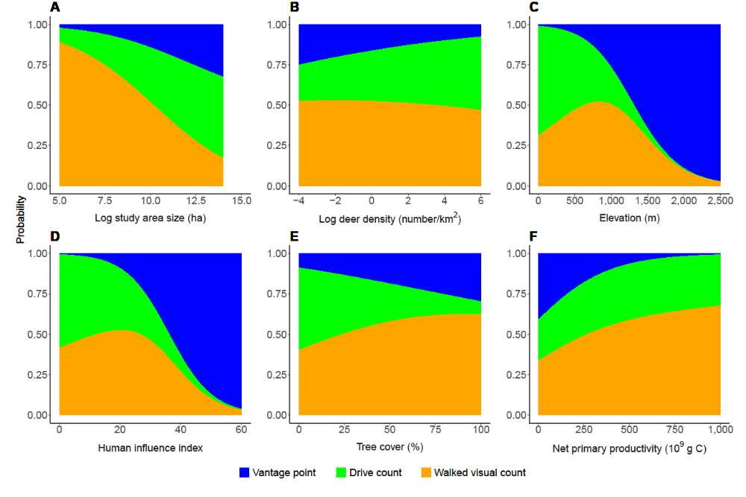
Figure S4.4. Probability of using each of 3 pedestrian direct count methods to estimate deer abundance or density in articles published during 2004–2018.

Vehicular direct counts.—A total of 477 estimates of deer abundance or density used direct observation from a vehicle on the ground (Table S4.1). These estimates were similarly divided between diurnal (37.9%), nocturnal spotlight (38.6%), and nocturnal thermal imaging (23.5%) methods. The best model explaining the relative use of the 3 methods from a vehicle included all explanatory variables (Tables S4.8 and S4.9).
Since 1980, diurnal counts have been steadily replaced by nocturnal spotlight counts and, since 2000, by nocturnal thermal imaging counts (Fig. S4.5). Diurnal and thermal counts were mostly used at low elevation (<1,000 m and <500 m, respectively). Compared with diurnal counts, spotlight and thermal counts were used for large areas (>10,000 ha), areas with lower net primary productivity (<500 × 10⁹ g C), and areas with denser tree cover (>50%). Thermal imagery was strongly preferred when tree cover was >80%. The use of nocturnal (spotlight and thermal imaging) counts was strongly positively associated with medium to high human influence and deer densities >1 deer/km².

Table S4.8. Summary of the stepwise selection process identifying the best model (shown in bold) explaining the relative use of the three vehicular direct count methods to estimate deer abundance or density in articles published during 2004–2018. AIC_{c}: Akaike Information Criterion corrected for small sample size. w_{i}: model weight.
Model | df | logLik | AICc | ΔAICc | w_{i} | Pseudo R²
Year + area + density + elev + GHII + tree + NPP | 16 | –238 | 510 | 0 | 1.00 | 0.54
Year + area + density + elev + GHII + tree | 14 | –253 | 535 | 25 | 0.00 | 0.51
Year + area + density + elev + GHII + NPP | 14 | –322 | 673 | 163 | 0.00 | 0.37
Year + area + density + elev + tree + NPP | 14 | –298 | 626 | 116 | 0.00 | 0.42
Year + area + density + GHII + tree + NPP | 14 | –288 | 605 | 94 | 0.00 | 0.44
Year + area + elev + GHII + tree + NPP | 14 | –259 | 546 | 36 | 0.00 | 0.50
Year + density + elev + GHII + tree + NPP | 14 | –262 | 553 | 43 | 0.00 | 0.49
area + density + elev + GHII + tree + NPP | 14 | –255 | 538 | 28 | 0.00 | 0.50
Elev: elevation. GHII: Global Human Influence Index. NPP: net primary productivity.

Table S4.9. Coefficients from the best model (see Table S4.8) explaining the relative use of the 3 vehicular direct count methods to estimate deer abundance or density in articles published during 2004–2018.
 | Nocturnal thermal |  |  | Diurnal
 | Estimate | SE | Z-value | Estimate | SE | Z-value
Intercept: Nocturnal spotlight | –343.3816 | 2.75E–05 | –12,491,409.2 | 147.2600 | 7.55E–05 | 1,951,686.6
Year | 0.1697 | 0.0011 | 160.2632 | –0.0677 | 0.0008 | –89.4727
Area | 0.0793 | 0.1230 | 0.6445 | –0.6312 | 0.1133 | –5.5734
Density | –0.0758 | 0.1227 | –0.6175 | –0.6290 | 0.1105 | –5.6900
Elevation | –0.0036 | 0.0008 | –4.5337 | –0.0027 | 0.0004 | –6.1570
GHII | 0.0080 | 0.0236 | 0.3378 | –0.1406 | 0.0179 | –7.8471
Tree | 0.0498 | 0.0090 | 5.5091 | –0.0565 | 0.0098 | –5.7386
NPP | –0.0030 | 0.0015 | –1.9717 | 0.0066 | 0.0018 | 3.6621
GHII: Global Human Influence Index. NPP: net primary productivity.

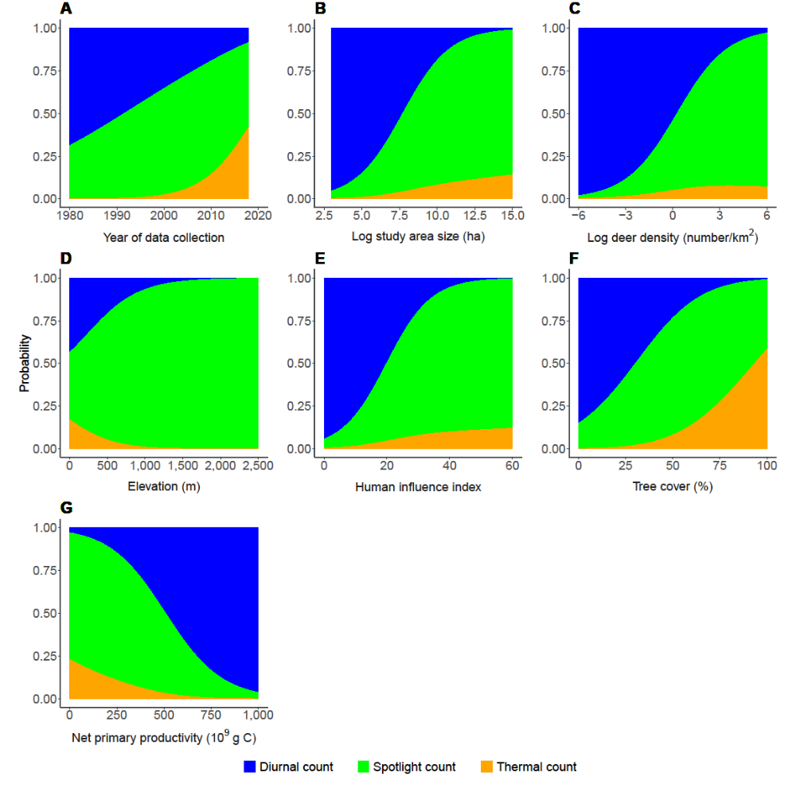
Figure S4.5. Probability of using each of 3 vehicular direct count methods to estimate deer abundance or density in articles published during 2004–2018.

Aerial direct counts.—Aerial direct counts were used in 640 estimates of deer abundance or density (Table S4.1) and were further divided by the type of aircraft used. Most estimates used visual observation from a helicopter (49.7%) or fixed-wing aircraft (28.0%). Thermal imagery was used in 6% of estimates, almost always from fixed-wing aircraft (88.9%). The only use of unmanned aerial vehicles (UAVs) was to supplement walked visual counts of Père David’s deer in China when grass was considered too high for the latter to be useful (Yuan et al. 2017). There was no information about the type of aircraft used in 16.4% of the estimates: these were removed from subsequent analyses. The best model explaining the use of helicopter or fixed-wing aircraft included all explanatory variables (Tables S4.10 and S4.11).
Fixed-wing aircraft dominated in the 1980s, but thereafter were rapidly replaced by helicopters (Fig. S4.6). Thermal imagery has been used, uncommonly, since the 2000s. Helicopters were used in almost all situations. In contrast, fixed-wing aircraft were mostly used at low elevation (<1,000 m), dense tree cover (>60%), and high net primary productivity (>400 × 10⁹ g C), and with low human influence and low deer densities (<0.5 deer/km²). Thermal imagery was used in areas <1,000 ha at low elevation (<500 m).

Table S4.10. Summary of the stepwise selection process identifying the best model (shown in bold) explaining the relative use of helicopter or fixed-wing aircraft in aerial direct counts to estimate deer abundance or density in articles published during 2004–2018. AIC_{c}, Akaike Information Criterion corrected for small sample size; w_{i}, model weight.
Model | df | logLik | AICc | ΔAICc | w_{i} | Pseudo R²
Year + area + rain + elev + GHII + tree + NPP | 16 | –214 | 460 | 0 | 0.98 | 0.54
Year + area + density + elev + GHII + tree | 14 | –233 | 495 | 34 | 0.00 | 0.50
Year + area + density + elev + GHII + NPP | 14 | –232 | 493 | 32 | 0.00 | 0.50
Year + area + density + elev + tree + NPP | 14 | –220 | 469 | 8 | 0.02 | 0.53
Year + area + density + GHII + tree + NPP | 14 | –225 | 480 | 19 | 0.00 | 0.51
Year + area + elev + GHII + tree + NPP | 14 | –221 | 470 | 10 | 0.01 | 0.52
Year + density + elev + GHII + tree + NPP | 14 | –241 | 512 | 51 | 0.00 | 0.48
area + density + elev + GHII + tree + NPP | 14 | –232 | 493 | 33 | 0.00 | 0.50
Elev: elevation. GHII: Global Human Influence Index. NPP: net primary productivity.

Table S4.11. Coefficients from the best model (see Table S4.10) explaining the relative use of helicopter or fixed-wing aircraft in aerial direct counts to estimate deer abundance or density in articles published during 2004–2018.
 | Fixed-wing visual |  |  | Thermal imagery
 | Estimate | SE | Z-value | Estimate | SE | Z-value
Intercept: Helicopters visual | 312.2175 | 2.89E-05 | 10,808,547.8 | –33.0336 | 1.89E-05 | –1,748,486.1
Year | –0.1554 | 0.0006 | –242.7607 | 0.0208 | 0.0012 | 17.6794
Area | –0.3145 | 0.0807 | –3.8981 | –0.9987 | 0.1703 | –5.8643
Density | –0.4339 | 0.1194 | –3.6344 | –0.1104 | 0.2166 | –0.5095
Elevation | –0.0014 | 0.0005 | –2.8772 | –0.0053 | 0.0018 | –2.9159
GHII | –0.0434 | 0.0140 | –3.1031 | –0.0531 | 0.0237 | –2.2399
Tree | 0.0276 | 0.0049 | 5.6121 | –0.0150 | 0.0127 | –1.1754
NPP | 0.0080 | 0.0011 | 7.1378 | 0.0068 | 0.0019 | 3.5607
GHII: Global Human Influence Index. NPP: net primary productivity.

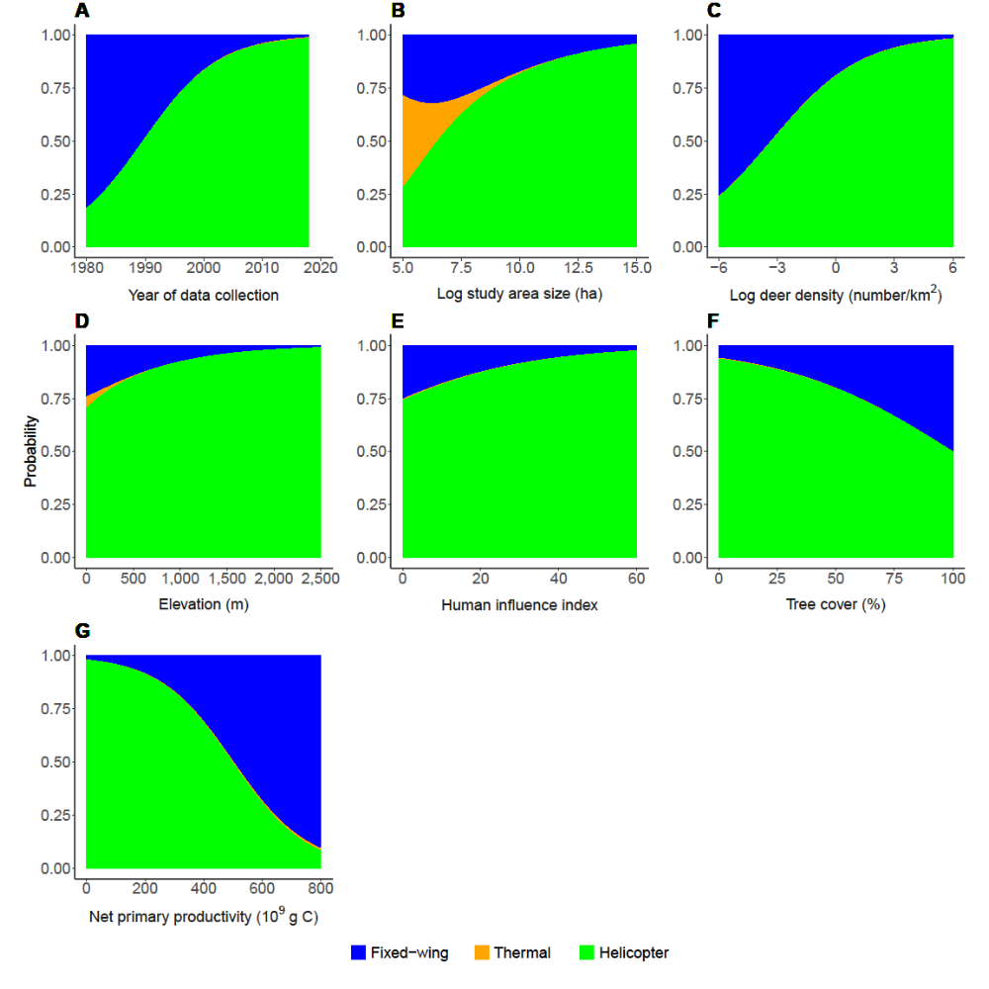
Figure S4.6. Probability of using each of 3 aerial direct count methods to estimate deer abundance or density in articles published during 2004–2018.

Harvest data.—Harvest data were used for 730 estimates of deer abundance or density. Of these, 41.9% used harvest data and accounted for sex and age at date of harvest (population reconstruction models; review in Skalski et al. 2005), 38.4% used harvest data and at least one other independent index of deer abundance or density (integrated models; Stergar and Jerina 2017), and 19.7% used hunting bags (Koh et al. 2010, Larouche and Ruel 2015).
The best model explaining the relative use of the 3 methods included all predictor variables (Tables S4.12 and S4.13). The use of hunting bags increased since the 1980s (Fig. S4.7). This method was mostly used for areas at low elevation (<1000 m), low net primary productivity (<250 10⁹ g C), and at deer densities >10 deer/km². Integrated models dominated in 1980, but rapidly declined thereafter and were seldom used after 2010. These models were mostly used over very large areas (>500,000 ha), at high elevation (>1,000 m), and were the dominant method in areas of high tree cover (>60%). Population reconstruction models were increasingly used during 1980–2018. Although used in a wide range of conditions, population reconstruction models dominated at low deer densities (<1 deer/km²), low elevation (<1,500 m), low tree cover (<50%) and at medium to high net primary productivity (>200 × 10⁹ g C).

Table S4.12. Summary of the stepwise selection process identifying the best model (shown in bold) explaining the relative use of harvest data to estimate deer abundance or density in articles published during 2004–2018. AIC_{c} Akaike Information Criterion corrected for small sample size; w_{i}, model weight.
Model | df | logLik | AICc | ΔAICc | w_{i} | Pseudo R²
Year + area + density + elev + GHII + tree + NPP | 16 | –358 | 749 | 0 | 0.88 | 0.53
Year + area + density + elev + GHII + tree | 14 | –379 | 786 | 38 | 0.00 | 0.51
Year + area + density + elev + GHII + NPP | 14 | –378 | 784 | 35 | 0.00 | 0.51
Year + area + density + elev + tree + NPP | 14 | –362 | 753 | 4 | 0.12 | 0.53
Year + area + density + GHII + tree + NPP | 14 | –487 | 1,003 | 254 | 0.00 | 0.37
Year + area + elev + GHII + tree + NPP | 14 | –378 | 784 | 36 | 0.00 | 0.51
Year + density + elev + GHII + tree + NPP | 14 | –407 | 843 | 94 | 0.00 | 0.47
area + density + elev + GHII + tree + NPP | 14 | –369 | 766 | 17 | 0.00 | 0.52
Elev: elevation. GHII: Global Human Influence Index. NPP: net primary productivity.

Table S4.13. Coefficients from the best model (see Table S4.12) explaining the relative use of harvest data to estimate deer abundance or density in articles published during 2004–2018.
 | Integrated models |  |  | Population reconstruction
Variableª | Estimate | SE | Z-value | Estimate | SE | Z-value
Intercept: Hunting bags | 213.1108 | 7.88E-05 | 2,704,542.5 | 28.1041 | 3.90E-05 | 721,402.4
Year | –0.1147 | 0.0009 | –128.5434 | –0.0131 | 0.0004 | –36.8648
Area | 0.6611 | 0.0943 | 7.0099 | –0.1566 | 0.0412 | –3.7998
Density | –0.2233 | 0.1511 | –1.4778 | –0.2749 | 0.0767 | –3.5865
Elevation | 0.0051 | 0.0006 | 8.8877 | 0.0010 | 0.0004 | 2.5017
GHII | 0.0094 | 0.0234 | 0.4022 | –0.0259 | 0.0102 | –2.5298
Tree | 0.0528 | 0.0105 | 5.0080 | –0.0023 | 0.0041 | –0.5684
NPP | 0.0036 | 0.0026 | 1.4137 | 0.0055 | 0.0008 | 6.5133
GHII: Global Human Influence Index. NPP: net primary productivity.

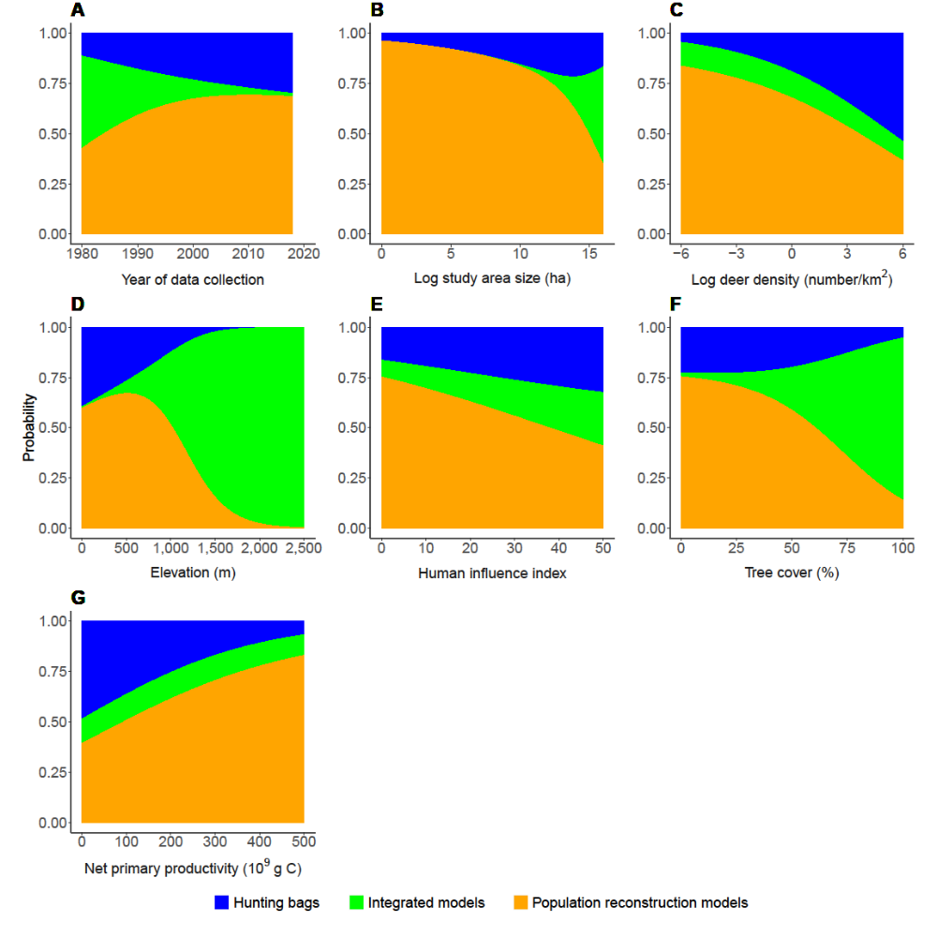
Figure S4.7. Probability of using each of the 3 harvest data methods to estimate deer abundance or density in articles published during 2004–2018.

Literature Cited
Burnham, K. P., and D. R. Anderson. 2002. Model selection and multimodel inference: a practical information-theoretic approach. Springer-Verlag, New York, USA.
Forsyth, D. M., S. Comte, N. E. Davis, A. J. Bengsen, S. D. Côté, D. G. Hewitt, N. Morellet, and A. Mysterud. 2022. Data and code for 'Methodology Matters When Estimating Deer Abundance: a Global Systematic Review and Recommendations for Improvements'. figshare. https://doi.org/10.6084/m9.figshare.18846647.v1
Koh, S., D. R. Bazely, A. J. Tanentzap, D. R. Voigt, and E. Da Silva. 2010. Trillium grandiflorum height is an indicator of white-tailed deer density at local and regional scales. Forest Ecology and Management 259:1472–1479.
Larouche, C., and J. C. Ruel. 2015. Development of northern white-cedar regeneration following partial cutting, with and without deer browsing. Forests 6:344–359.
Murtaugh, P. A. 2009. Performance of several variable-selection methods applied to real ecological data. Ecology Letters 12:1061–1068.
R Core Team. 2020. R: a language and environment for statistical computing. R Foundation for Statistical Computing, Vienna, Austria.
Skalski, J. R., K. E. Ryding, and J. J. Millspaugh. 2005. Wildlife demography: analysis of sex, age, and count data. Elsevier Academic Press, Burlington, Massachusetts, USA.
Stergar, M., and K. Jerina. 2017. Wildlife and forest management measures significantly impact red deer population density. Šumarski List 141:139–150.
Venables, W. N., and B. D. Ripley. 2002. Modern applied statistics with S. Springer, New York, New York, USA.
Yuan, B. D., L. B. Wang, S. B. Xie, Y. J. Ren, B. Liu, Y. Y. Jia, H. Shen, D. M. Sun, and H. H. Ruan. 2017. Density dependence effects on demographic parameters—a case study of Père David’s deer (Elaphurus davidianus) in captive and wild habitats. Biology and Environment—Proceedings of the Royal Irish Academy 117B:139–144.

