INFO ENTRY - QUESTION INFO

ENTRY NOTES:
- green = does not need to be editted
- yellow = info for the inputter
- ref_id = “refs_glossary_2024-08-09.xls > “references” tab
  - if the reference not present, either add it (if you’re confident that you can follow the format), or add a comment in this doc with the info and I will adjust
- images – file name in “refs_glossary_2024-08-09.xls > “references” tab
- Ignore everything in the “POPULATE MARKDOWN” section
- Size of columns in tables and text format do not matter; see note on bold and italize below
- Any content with “glue}`` prefix or surrounded by “{{ “ / “ }}” indicates where text will be inserted from the keys
- You may see “<br>“ throughout, you can ignore these
- additional formatting notes (optional)
  - **bold**
  - *italics*
- Topic Info
  - If the topic is NOT related to a question, you can leave “question” as NULL
  - “question” here is more for your reference
- Assumptions, Pros, Cons
  - Only for modelling approaches; can ignore otherwise (leave table here)
  - [WILL BE HERE, BUT INSERTED DIRECTLY FROM CSV FILE (THUS NO INPUT NEEDED)]
- Advanced
  - If the topic doesn’t warrant inclusion, you can leave as NULL
- Figures
  - Placeholders here as “filename” can leave in if not <5 images
- Video
  - no “<“ before the URL text and a “>“ after URL in this case
  - ref_id in this example is not correct, just for illustrative purposes
- Analytical tools & resources
  - The ref_id should be included in the reference column (and the full text reference in the master reference file). If you aren’t sure if the reference is in the master doc, add the full text ref as a comment.
  - Please add a “<“ before the URL text and a “>“ after (e.g., <http://www.somesitelink.com>)
  - Type can be something similar to: Article, App/Program, R package
- References / Glossary
  - items in-text above (IGNORE FOR NOW)
- Notes
  - (future ref / not included in markdown conversion)

Topic Info
info_id | sp_asymptote
question | Do you wish to sample long enough to reach the species-accumulation asymptote?

Overview
To understand what we mean when we say, “species-accumulation asymptote”, we must first explain species accumulation curves. A **species accumulation curve** shows you the relationship between the number of species detected and sampling effort ({{ rtxt_deng_et_al_2015 }}) (e.g., how you might expect to “accumulate” detections of new species as cameras are deployed for longer). Species accumulation curves are used “to assess and compare diversity across populations, or to evaluate the benefits of additional sampling” ({{ rtxt_vandooren_2016 }}). The **species-accumulation *asymptote*** refers to the point on the curve where you’ve sampled long enough to observe *most* of the species present.

Consider the figure below. You can see that as the “number of records” (on the x-axis) increases, at first (where the line is the steepest), you detect new species quickly. This is because many species that are easy to detect and/or common, and thus you’re more likely to encounter them in less time. As time goes on (you collect more samples), the rate at which you detect *new* species starts to slow down (fewer and fewer new species detected over the same amount of time). This is because, in general, rare species, occurring much less often, may be missed if sampling is not long enough to detect it (or to be sure that they will not be detected). The curve starts to level off as after you’ve detected most (or all) of the easily detectable/common species and are slowly detecting those that are less detectable and/or rarer. As this line flattens out, eventually, barely any new species are detected (if any).

:::{figure} ../03_images/03_image_files/loreau_2010_fig4_clipped.png
:width: 300px
:align: center
:::
> **Loreau (2010) - Fig. 4** - “Species accumulation and rarefaction curves. Species accumulation curves show the number of species obtained by successively censusing either individual organisms (individual-based accumulation curves) or samples (sample-based accumulation curves).... Credit: Rob Colwell, after Gotelli and Colwell (2001)”

**<font size=“4”><span style=“color:#2F5496”>How does this relate to study design?</font></span>**

This question is related to the state variable “Species Diversity & Richness”

Whether or not you choose to sample long enough to ensure to reach the species-accumulation asymptote will impact the number of cameras recommended; published species-accumulation curves for remote camera data seem to suggest that species level off between 20 and 100 locations ({{ rtxt_ahumada_et_al_2011 }}; {{ rtxt_li_et_al_2012 }}; {{ rtxt_wearn_et_al_2016 }}).

It will also impact the available modelling approaches since it not always necessary; some non-parametric methods are thought to estimate asymptotic richness fairly well “even when extrapolating to double or triple the size of the sample” ({{ rtxt_colwell_et_al_2012 }}; {{ rtxt_wearn_gloverkapfer_2017 }}).

> **If you’re not sure, select the conservative answer of “Yes”**

Alt:
:::{figure} ../03_images/03_image_files/vandooren_2016_fig1_clipped.png
:width: 400px
:align: center
:::
**Van Dooren (2016) – Fig. 1** Species accumulation curves. Species richness is the asymptote of a species accumulation curve, which expresses the dependence on sampling effort of the number of species sampled from an assemblage”

Advanced
```{figure} ../03_images/03_image_files/00_coming_soon.png
:width: 300px
:align: center
```

Figures
Image | file_name | Caption (if applicable) | ref_id
a 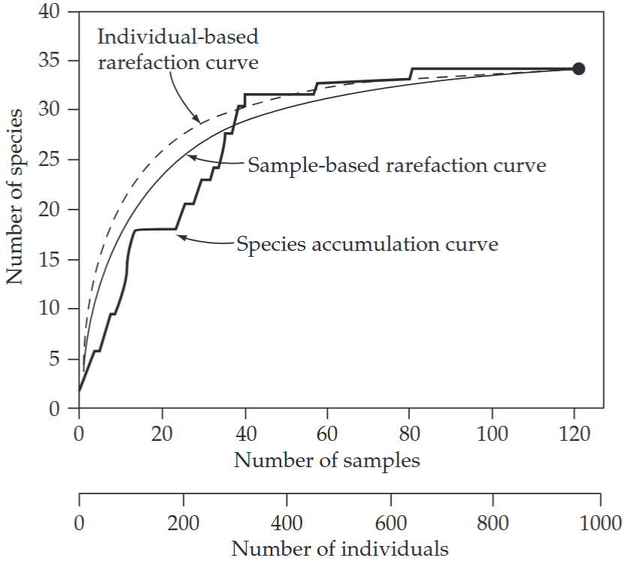 | gotelli_and_colwell_2011_fig4_1_clipped.png | **Gotelli & Colwell (2011) - Fig. 4.1** Species accumulation and rarefaction curves.  :::{dropdown}  The jagged line is the species accumulation curve for one of many possible orderings of 121 soil seedbank samples, yielding a total of 952 individual tree seedlings, from an intensive census of a plot of Costa Rican rainforest (Butler & Chazdon 1998). The cumulative number of tree species (y-axis) is plotted as a function of the cumulative number of samples (upper x-axis), pooled in random order. The smooth, solid line is the sample-based rarefaction curve for the same data set, showing the mean number of species for all possible combinations of 1, 2, . . . , m∗, . . . , 121 actual samples from the dataset—this curve plots the statistical expectation of the (sample-based) species accumulation curve. The dashed line is the individual-based rarefaction curve for the same data set—the expected number of species for (m∗) (952/121) individuals, randomly chosen from all 952 individuals (lower x-axis). The black dot indicates the total richness for all samples (or all individuals) pooled. The sample-based rarefaction curve lies below the individual-based rarefaction curve because of spatial aggregation within species. This is a very typical pattern for empirical comparisons of sample-based and individual-based rarefaction curves.  ::: | gotelli_colwell_2011
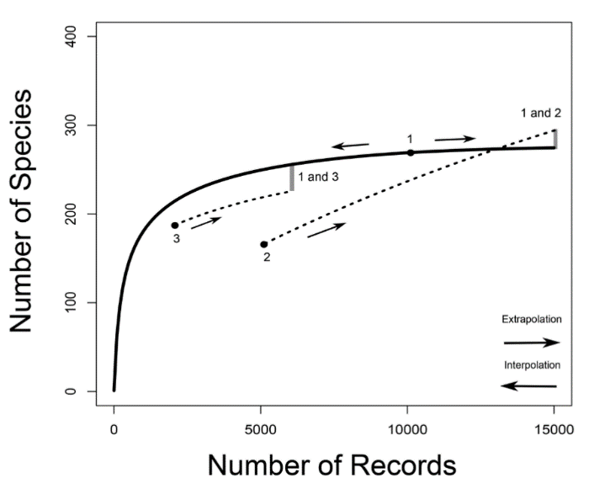 | vandooren_2016_fig1_clipped.png | **Van Dooren (2015) – Fig. 1** “Species accumulation curves. Species richness is the asymptote of a species accumulation curve, which expresses the dependence on sampling effort of the number of species sampled from an assemblage.  :::{dropdown}  In CA2013, sampling effort is given by the number of records from which the number of species is calculated. For illustrative purposes, an example with three arbitrary samples (for 10000, 5000 and 2000 records, labeled from one to three) is drawn. For sample one, a predicted species accumulation curve is added that gradually increases from one species sampled to the predicted species richness for that assemblage (full line). Such curves are constructed on the basis of interpolation and extrapolation. For samples two and three only segments of extrapolated curves are drawn (dotted lines). For sample two, a curve that crosses the species accumulation curve of sample one is sketched. For samples one and three species accumulation curves are more or less proportional. The way in which the species richness differences between samples are assessed in CA2013 is illustrated by indicating on the species accumulation curves at which numbers of records pairwise comparisons would be made between two sample pairs (1 vs. 2 and 1 vs. 3). The number of species of the sample with the smallest number of records is extrapolated to the number expected at three times the number of records. When the number of records of the other sample is still larger than that, the number of species of the second sample is interpolated (rarefied), otherwise it is extrapolated as well.  ::: | vandooren_2016
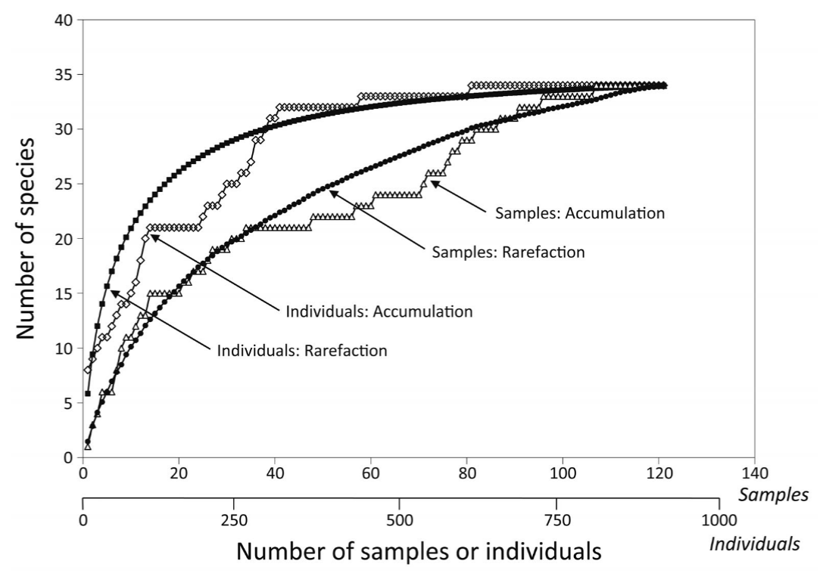 | loreau_2010_fig4_clipped.png | **Loreau (2010) – Fig. 4** - Species accumulation and rarefaction curves. Species accumulation curves show the number of species obtained by successively censusing either individual organisms (individual-based accumulation curves) or samples (sample-based accumulation curves). Smoothed species rarefaction curves represent the statistical expectation of the corresponding accumulation curves. Credit: Rob Colwell, after Gotelli and Colwell (2001) | loreau_2010
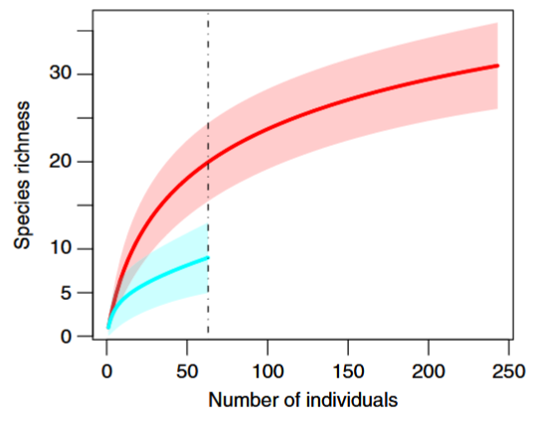 | gotelli_chao_2013_fig4_clipped.png | **Gotelli & Chao (2013) – Fig. 4** Standardized comparison of species richness for two individual-based rarefaction curves. </font>  :::{dropdown}  The data represent summary counts of carabid beetles that were pitfall-trapped from a set of young pine plantations (o20 years old; upper curve) and a set of old pine plantations (20–60 years old; lower curve). The solid lines are the rarefaction curves, calculated from eqn [2], and the shaded polygons are the 95% confidence intervals, calculated from the unconditional variance eqn [5]. The young plantation samples contained 243 individuals representing 31 species, and the old plantation samples contained 63 individuals representing nine species. The dashed and dotted vertical line illustrates a species richness comparison standardized to 63 individuals, which was the observed abundance in the smaller of the two data sets. Data from Niemel ̈a J, Haila Y, Halme E, et al. (1988) The distribution of carabid beetles in fragments of old coniferous taiga and adjacent managed forest. Annales Zoologici Fennici 25: 107–199.  ::: | gotelli_chao_2013
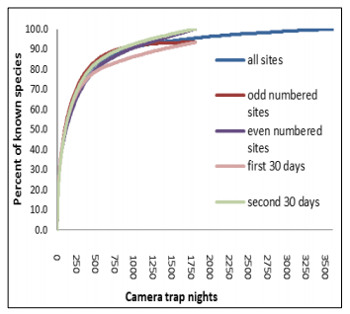 | molloy_2018_fig9_clipped.png | **Molloy (2018) – Fig. 9** Species accumulation curve for camera trap data collected in Dryandra Woodland. Sourced from Thomas & Cowan (2016) | molloy_2018
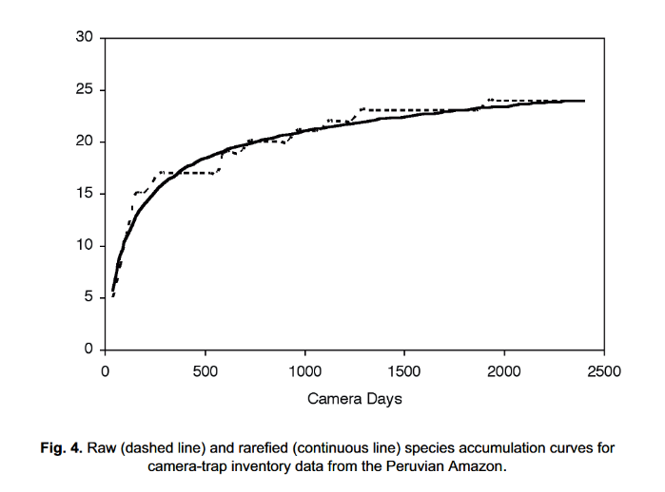 | rovero_tobler_2010_fig4.png | **Rovero & Tobler (2010) - Fig. 4** Raw (dashed line) and rarefied (continuous line) species accumulation curves for camera-trap inventory data from the Peruvian Amazon. | rovero_tobler_2010

Video
caption | URL (no < / > before/after URL | ref_id
Species Accumulation Curves (11 minutes) | https://www.youtube.com/embed/Jj7LYrU_6RA?si=odfIIBoC2w9h3_CU | rk_stats_2018
Generating a species accumulation plot in excel for BBS data | https://www.youtube.com/embed/OEWdPm3zg9I?si=2RG41LmTRvWfMiEr | styring_2020b
Rarefied Species Accumulation Curves (the simple way) tutorial: How to create beautiful rarefied species accumulation curves with species richness, shannon wiener or the simpson index with abundance data, or species richness with incidence data using the iNext Online interface (which runs the iNext R package in the backgroundl  Video to accompany the “iNext Online” R Shiny App | https://www.youtube.com/embed/h3MLWK9IJ4A?si=qOKB8jyALD3cwgAe | wildlifedegree_2022
vid4_caption | vid4_url | vid4_ref_id
vid5_caption | vid5_url | vid5_ref_id
vid6_caption | vid6_url | vid6_ref_id

Shiny
Shiny name = iNext Online
Shiny caption = Software for interpolation and extrapolation of species diversity
Shiny URL = https://chao.shinyapps.io/iNEXTOnline

Analytical tools & resources
Type | Name | Note | URL | ref_id
R package / Tutorial | Species Accumulation Curves |  | <https://www.pisces-conservation.com/sdrhelp/index.html?specaccum.html> | chao_et_al_2016
R package / Tutorial | Species Accumulation Curves with vegan, BiodiversityR and ggplot2 |  | <https://rpubs.com/Roeland-KINDT/694021> | roeland_2020
R Shiny App | iNext Online |  | <https://chao.shinyapps.io/iNEXTOnline> | chao_et_al_2016
R package | Package ‘iNEXT’ - Interpolation and Extrapolation for Species Diversity |  | <https://cran.r-project.org/web/packages/iNEXT/iNEXT.pdf> | chao_et_al_2016
resource6_type | resource6_name | resource6_note | resource6_url | resource6_ref_id
resource7_type | resource7_name | resource7_note | resource7_url | resource7_ref_id
resource8_type | resource8_name | resource8_note | resource8_url | resource8_ref_id
resource9_type | resource9_name | resource9_note | resource9_url | resource9_ref_id
resource10_type | resource10_name | resource10_note | resource10_url | resource10_ref_id
resource11_type | resource11_name | resource11_note | resource11_url | resource11_ref_id
resource12_type | resource12_name | resource12_note | resource12_url | resource12_ref_id
resource13_type | resource13_name | resource13_note | resource13_url | resource13_ref_id
resource14_type | resource14_name | resource14_note | resource14_url | resource14_ref_id
resource15_type | resource15_name | resource15_note | resource15_url | resource15_ref_id

References / Glossary
ref_id | glossary_keys
{{ rbib_ahumada_et_al_2011 }}  {{ rbib_chao_et_al_2016 }}  {{ rbib_colwell_et_al_2012 }  {{ rbib_deng_et_al_2015 }}  {{ rbib_gotelli_colwell_2001 }}  {{ rbib_gotelli_colwell_2011 }}  {{ rbib_li_et_al_2012 }}  {{ rbib_loreau_2010 }}  {{ rbib_molloy_2018 }}  {{ rbib_roeland_2020 }}  {{ rbib_rk_stats_2018 }}  {{ rbib_ rovero_tobler_2010 }}  {{ rbib_si_et_al_2014 }}  {{ rbib_styring_2020b }}  {{ rbib_vandooren_2016 }}  {{ rbib_wearn_gloverkapfer_2017 }}  {{ rbib_wearn_et_al_2016 }}  {{ rbib_wildlifedegree_2022 }} | keys_here

Notes
- The species accumulation curve of a population gives the expected number of observed species as a function of sampling effort (Deng, Daley, and Smith 2015)
- The few species-accumulation curves for camera trap data that have been published seem to level off between 20 and 100 locations (Ahumada et al. 2011; Li et al. 2012; Wearn et al. 2016). Helpfully, it may not always be necessary to sample until species-accumulation curves have begun to reach their asymptote. Non-parametric methods of estimating asymptotic richness are thought to yield good results even when extrapolating to double or triple the size of the sample
- Robero & Tobler, 2010)

- “Species accumulation curves have been widely used to visually assess the completeness of an inventory and to compare diversity between surveys with different sampling effort (Colwell & Coddington, 1994; Krebs, 1999; Gotelli & Colwell, 2001). They plot the cumulative number of species detected against the survey effort and reach an asymptote when all species have been recorded. Raw species accumulation curves have a stepped shape that makes it hard to detect an asymptote (Fig. 4). This problem is solved by rarefied species accumulation curves which smooth the curve by randomly re-sampling the data and calculating the average number of species expected to be found at a given sampling intensity (Gotelli & Colwell, 2001). While species accumulation curves can be used to compare diversity between different samples, the shape of the curve can vary with the relative abundance of different species (Thompson & Withers, 2003). Communities with a high proportion of abundant species have a steeper initial slope than communities with a high proportion of rare species.
- (Si et al., 2014) - Species accumulation curve: “the relationship of the number of species and the sampling effort, which may depend on the time or area sampled. One expects curves to approach an asymptote, and thus give a judgment of sampling adequacy (Daubenmire, 1968). In long-term monitoring projects, sampling over gradients in time is logically similar to sampling over gradients in space (Colwell & Coddington, 1994).
- https://www.pisces-conservation.com/sdrhelp/index.html?specaccum.htm

POPULATE – INFO

File from = 00_00_template-master.docx

---
jupytext:
formats: md:myst
text_representation:
extension: .md
format_name: myst
format_version: 0.17.2 <!--0.13-->
jupytext_version: 1.16.4 <!-- 6.5.4-->
kernelspec:
display_name: Python 3
language: python
name: python3
editor_options:
markdown:
wrap: none
<!--template v2024-09-30-->
---
(i_sp_rarity)=
# {{ title_i_sp_rarity }}

:::{seealso}
{bdg-link-primary-line}`Species-accumulation curves<https://ab-rcsc.github.io/rc-decision-support-tool_concept-library/02_dialog-boxes/01_10_sp_asymptote.html>`
{bdg-link-primary-line}`Species rarity<https://ab-rcsc.github.io/rc-decision-support-tool_concept-library/02_dialog-boxes/01_19_sp_rarity.html>`
:::

**{{ term_sp_rarity }}**: {{ term_def_sp_rarity }}

:::::::{tab-set}

::::::{tab-item} Overview
**Species rarity** describes how many individuals present of the species, relative to the total number of individuals of all species (or how “represented” is the species when considering the total number of individuals of all species). Generally, species rarity can be thought of as the probability that the species occupies the site, for a given species (or study area, depending on the scale of interest) {{rtxt_kays_et_al_2020}}.

While technically “how rare” a species is will be fairly dynamic from place to place (e.g., will depend on geographic range, habitat specificity, local abundance, etc.; {{rtxt_crisfield_et_al_2024}}), for the purposes of informing study design recommendations, the **species rarity categories are defined as follows**:

- **Common**: probability of occupancy > ~0.75-0.8 (> 0.75 [{{rtxt_kinnaird_obrien_2012}}; {{rtxt_kays_et_al_2020}}]; > 0.8 [{{rtxt_shannon_et_al_2014}}; {{rtxt_wearn_gloverkapfer_2017}}])

- **Less common**: 0.25-0.75

- **Rare**: probability of occupancy < 0.25 {{rtxt_kays_et_al_2020}}

- **Very-rare**: probability of occupancy < 0.001 ({{rtxt_wearn_gloverkapfer_2017}}; {{rtxt_rowcliffe_et_al_2008}}; {{rtxt_obrien_2010}})

- **Unknown**: select this option if you’re not sure of the rarity of your Target Species (single or multiple species)

- **Multiple**: select this option if your study includes multiple Target Species that vary in rarity.

::: {note}
Species rarity can be generally thought of as a species characteristic, however, “not in the same sense that hair colour or wing venation… it’ an emergent trait of a species' population and its environment rather than a trait of an individual organism” {{rtxt_kunin_1997}}
:::

**<font size=“4”><span style=“color:#2F5496”>How does this relate to study design?</font></span>**

**Species' rarity can influence the ideal camera arrangement. ** For example, when monitoring rare or cryptic species that are unlikely to be detected with other designs, it may be appropriate to use a *Targeted design* where cameras are placed in areas that are known or suspected to have higher activity levels (e.g., game trails, mineral licks, etc.).

**Species' rarity can influence the ideal number of cameras and {{ survey_tl }} length** ({{ rtxt_chatterjee_et_al_2021 }}). Low [detection probability](#detection_probability) of rare or cryptic species can result in imprecise estimates if there are too few cameras or if cameras are not deployed for long enough (e.g., Steenweg et al. 2019). Chatterjee et al. (2021) suggested that for [occupancy models](#mods_occupancy) ({{rtxt_mackenzie_et_al_2002 }}) of common species, to survey a minimum of 50 sites for 15–20 days. For rare, elusive species, they recommended surveying 100 sites at a minimum for 20–30 days ({{rtxt_chatterjee_et_al_2021 }}).

**Species' rarity can influence the appropriate modelling approach.** For measures of species richness or diversity, it is presumed that a camera is active long enough to detect rare species that may occur at a specific location ({{ rtxt_wearn_gloverkapfer_2017 }}). If this is not the case, the results will indicate that the species was not present when it was (i.e., a “false negative”).
::::::

::::::{tab-item} In-depth
Add some info here

:::::

:::::{grid} 3
:gutter: 1
:padding: 0
:margin: 0

::::{grid-item-card} {{ rtxt_leroy_2024 }}
:::{figure} ../03_images/03_image_files/leroy_2024_Rarity_cutoff-point.png
:class: img_grid
:::
**Leroy (2024)** The rarity cut-off point is here defined as the threshold of occurrence below which species are considered rare.
::::

::::{grid-item-card} {{ rtxt_leroy_2024 }}
:::{figure} ../03_images/03_image_files/leroy_2024_Weight_assignation-curve.png

:class: img_grid
:::

**Leroy (2024)**Weight assignation curve adjusted to an arbitrary rarity cut-off.

::::

::::{grid-item-card} {{ rtxt_figure3_ref_id }}
:::{figure} ../03_images/03_image_files/figure3_filename.png
:class: img_grid
:::
figure4_caption
::::
:::::

:::::{grid} 3
:gutter: 1
:padding: 0
:margin: 0

::::{grid-item-card} {{ rtxt_figure4_ref_id }}
:::{figure} ../03_images/03_image_files/figure4_filename.png
:class: img_grid
:::
figure4_caption

::::

::::{grid-item-card} {{ rtxt_figure5_ref_id }}
:::{figure} ../03_images/03_image_files/figure5_filename.png
:class: img_grid
:::
figure5_caption

::::

::::{grid-item-card} {{ rtxt_figure6_ref_id }}
:::{figure} ../03_images/03_image_files/figure6_filename.png
:class: img_grid
:::
figure6_caption

::::
:::::

:::::{grid} 3
:gutter: 1
:padding: 0
:margin: 0

::::{grid-item-card} {{ rtxt_Error! Reference source not found. }}

:::{figure} ../03_images/03_image_files/Error! Reference source not found.
:class: img_grid
:::
Error! Reference source not found.
::::

::::{grid-item-card} {{ rtxt_Error! Reference source not found. }}
:::{figure} ../03_images/03_image_files/Error! Reference source not found.
:class: img_grid
:::
Error! Reference source not found.
::::

::::{grid-item-card} {{ rtxt_Error! Reference source not found. }}
:::{figure} ../03_images/03_image_files/Error! Reference source not found.

:class: img_grid

:::

Error! Reference source not found.

::::
:::::

:::::{grid} 3
:gutter: 1
:padding: 0
:margin: 0

::::{grid-item-card} {{ rtxt_Error! Reference source not found. }}

:::{figure} ../03_images/03_image_files/Error! Reference source not found.
:class: img_grid
:::
Error! Reference source not found.
::::

::::{grid-item-card} {{ rtxt_Error! Reference source not found. }}
:::{figure} ../03_images/03_image_files/Error! Reference source not found.
:class: img_grid
:::
Error! Reference source not found.
::::

::::{grid-item-card} {{ rtxt_Error! Reference source not found. }}
:::{figure} ../03_images/03_image_files/Error! Reference source not found.

:class: img_grid

:::

Error! Reference source not found.

::::
:::::

:::::{grid} 3
:gutter: 1
:padding: 0
:margin: 0

::::{grid-item-card} {{ rtxt_mecks100_2018 }}
<div>
<div style=“position:relative;padding-top:56.25%;”>
<iframe src=“https://www.youtube.com/embed/4gcmAUpo9TU?si=_S-JYDDskR8QbHs5“ loading=“lazy” frameborder=“0” allowfullscreen
style=“position:absolute;top:0;left:0;width:100%;height:100%;”></iframe>
</div>
</div>

Species accumulation and rarefaction curves
::::

::::{grid-item-card} {{ rtxt_riffomonas_project_2022b }}
<div>
<div style=“position:relative;padding-top:56.25%;”>
<iframe src=“https://www.youtube.com/embed/ywHVb0Q-qsM?si=_xJ5jbFc6MDEQlAh “ loading=“lazy” frameborder=“0” allowfullscreen

style=“position:absolute;top:0;left:0;width:100%;height:100%;”></iframe>
</div>

</div>

Generating a rarefaction curve from collector's curves in R within the tidyverse (CC198)

::::

::::{grid-item-card} {{ rtxt_vid3_ref_id }}
<div>
<div style=“position:relative;padding-top:56.25%;”>
<iframe src=“vid3_url“ loading=“lazy” frameborder=“0” allowfullscreen
style=“position:absolute;top:0;left:0;width:100%;height:100%;”></iframe>
</div>
</div>

vid3_caption
::::
:::::

:::::{grid} 3
:gutter: 1
:padding: 0
:margin: 0

::::{grid-item-card} {{ rtxt_vid4_ref_id }}
<div>
<div style=“position:relative;padding-top:56.25%;”>
<iframe src=“vid4_url“ loading=“lazy” frameborder=“0” allowfullscreen
style=“position:absolute;top:0;left:0;width:100%;height:100%;”></iframe>
</div>
</div>

vid4_caption

::::

::::{grid-item-card} {{ rtxt_vid5_ref_id }}
<div>
<div style=“position:relative;padding-top:56.25%;”>
<iframe src=“vid5_url“ loading=“lazy” frameborder=“0” allowfullscreen
style=“position:absolute;top:0;left:0;width:100%;height:100%;”></iframe>
</div>
</div>

vid5_caption

::::

::::{grid-item-card} {{ rtxt_vid6_ref_id }}
<div>
<div style=“position:relative;padding-top:56.25%;”>
<iframe src=“vid6_url“ loading=“lazy” frameborder=“0” allowfullscreen
style=“position:absolute;top:0;left:0;width:100%;height:100%;”></iframe>
</div>
</div>

vid6_caption

::::
:::::

:::::{grid} 3
:gutter: 1
:padding: 0
:margin: 0

::::{grid-item-card} {{ rtxt_Error! Reference source not found. }}
<div>
<div style=“position:relative;padding-top:56.25%;”>
<iframe src=“Error! Reference source not found.“ loading=“lazy” frameborder=“0” allowfullscreen
style=“position:absolute;top:0;left:0;width:100%;height:100%;”></iframe>
</div>
</div>

Generating a rarefaction curve from collector's curves in R within the tidyverse (CC198)
::::

::::{grid-item-card} {{ rtxt_Error! Reference source not found. }}
<div>
<div style=“position:relative;padding-top:56.25%;”>
<iframe src=“Error! Reference source not found.“ loading=“lazy” frameborder=“0” allowfullscreen
style=“position:absolute;top:0;left:0;width:100%;height:100%;”></iframe>
</div>
</div>

Error! Reference source not found.
::::

::::{grid-item-card} {{ rtxt_Error! Reference source not found. }}

<div>

<div style=“position:relative;padding-top:56.25%;”>
<iframe src=“Error! Reference source not found.“ loading=“lazy” frameborder=“0” allowfullscreen
style=“position:absolute;top:0;left:0;width:100%;height:100%;”></iframe>
</div>
</div>

Error! Reference source not found.
::::
:::::

::::::

::::::{tab-item} Shiny apps/Widgets
Check back in the future!
::::::

::::::{tab-item} Shiny apps/Widgets

:::::{card} Error! Reference source not found.

Error! Reference source not found.

<iframe
width=“100%”
height=“900”
src=“Error! Reference source not found.“
loading=“lazy”
frameborder=“0”
allow=“accelerometer; autoplay; clipboard-write; encrypted-media; gyroscope; picture-in-picture”
allowfullscreen>
</iframe>
:::::
::::::

::::::{tab-item} Shiny apps/Widgets

:::::{card}

::::{dropdown} Error! Reference source not found.

Error! Reference source not found.

<iframe
width=“100%”
height=“900”
src=“Error! Reference source not found.“
loading=“lazy”
frameborder=“0”
allow=“accelerometer; autoplay; clipboard-write; encrypted-media; gyroscope; picture-in-picture”
allowfullscreen>
</iframe>
::::
::::{dropdown} Error! Reference source not found.
Error! Reference source not found.

<iframe
width=“100%”
height=“900”
src=“Error! Reference source not found.“
loading=“lazy”
frameborder=“0”

allow=“accelerometer; autoplay; clipboard-write; encrypted-media; gyroscope; picture-in-picture”

allowfullscreen>

</iframe>

::::

:::::
::::::

:::::{tab-item} Analytical tools & resources
| Type | Name | Note | URL |Reference |
|:----------------|:-------------------------------|:----------------------------------------------------------------|:----------------------|:----------------------------------------|
| R package | Package ‘Rarity’: Calculation of Rarity Indices for Species and Assemblages of Species | Allows calculation of rarity weights for species and indices of rarity for assemblages of species according to different methods (Leroy et al. 2012, Insect. Conserv. Divers. 5:159-168 <doi:10.1111/j.1752-4598.2011.00148.x>; Leroy et al. 2013, Divers. Distrib. 19:794-803 <doi:10.1111/ddi.12040>). | <https://cran.r-project.org/web/packages/Rarity/> | {{ rbib_leroy_2023 }} |
| resource2_type | resource2_name | resource2_note | resource2_url | {{ rbib_resource2_ref_id }} |
| resource3_type | resource3_name | resource3_note | resource3_url | {{ rbib_resource3_ref_id }} |
| resource4_type | resource4_name | resource4_note | resource4_url | {{ rbib_resource4_ref_id }} |
| resource5_type | resource5_name | resource5_note | resource5_url | {{ rbib_resource5_ref_id }} |
| resource6_type | resource6_name | resource6_note | resource6_url | {{ rbib_resource6_ref_id }} |
| resource7_type | resource7_name | resource7_note | resource7_url | {{ rbib_resource7_ref_id }} |
| resource8_type | resource8_name | resource8_note | resource8_url| {{ rbib_resource8_ref_id}} |
| resource9_type | resource9_name | resource9_note | resource9_url | {{ rbib_resource9_ref_id }} |
| resource10_type | resource10_name | resource10_note | resource10_url | {{ rbib_resource10_ref_id }} |
| resource11_type | resource11_name | resource11_note | resource11_url | {{ rbib_resource11_ref_id }} |
| resource12_type | resource12_name | resource12_note | resource12_url | {{ rbib_resource12_ref_id }} |
| resource13_type | resource13_name | resource13_note | resource13_url | {{ rbib_resource13_ref_id }} |
| resource14_type | resource14_name | resource14_note | resource14_url | {{ rbib_resource14_ref_id }} |
| resource15_type | resource15_name | resource15_note | resource15_url | {{ rbib_resource15_ref_id }} |
| Error! Reference source not found. | Error! Reference source not found. | Error! Reference source not found. | Error! Reference source not found. | {{ rbib_Error! Reference source not found. }} |
| Error! Reference source not found. | Error! Reference source not found. | Error! Reference source not found. | Error! Reference source not found. | {{ rbib_Error! Reference source not found. }} |
| Error! Reference source not found. | Error! Reference source not found. | Error! Reference source not found. | Error! Reference source not found.| {{ rbib_Error! Reference source not found.}} |
| Error! Reference source not found. | Error! Reference source not found. | Error! Reference source not found. | Error! Reference source not found. | {{ rbib_Error! Reference source not found. }} |
| Error! Reference source not found. | Error! Reference source not found. | Error! Reference source not found. | Error! Reference source not found. | {{ rbib_Error! Reference source not found. }} |
::::::

::::::{tab-item} References
{{ rbib_chatterjee_et_al_2021 }}

{{ rbib_kinnaird_obrien_2012 }}

{{ rbib_kays_et_al_2020 }}

{{ rbib_shannon_et_al_2014 }}

{{ rbib_wearn_gloverkapfer_2017 }}

{{ rbib_rowcliffe_et_al_2008)

{{ rbib_southwell_et_al_2019 }}

{{ rbib_flather_sieg_2007 }}

{{ rbib_kunin_1997 }}

::::::

:::::::

