Topic Info
info_id | sp_hr_size
question | Question: Is home range size information available for your Target Species (can be taken from the literature)? If so, enter the home range diameter (in metres).

Note banner
:::{hint}
Unsure about the home range size of your Target Species? There may be information available in the “Species home range / body size lookup”; see the**Shiny Apps/Widgets** tab below.
:::

Overview
**Home range**: the area within which an animal normally lives and finds what it needs to survive and reproduce.

Home range size will not be exactly the same for every animal of a certain species; when thinking of home range size in the context of study design, we are really thinking about the average home range size for individuals of that species for the duration of your study.

:::{figure} ../03_images/03_image_files/00_home_range.jpg
:align: center
:width: 300px
:::

**<font size=“4”><span style=“color:#2F5496”>How does this relate to study design?</font></span>**

Many aspect of site selection and study duration are often linked to the home range size of the {{ target_species_tu }}; this is because many [modelling approaches](#mods_modelling_approach) (e.g. [occupancy models](#mods_occupancy) [{{ rtxt_mackenzie_et_al_2004 }}] assume “site closure” (i.e., that there is no change in state (e.g. species presence/ absence, immigration/ emigration, births/deaths) during the {{ survey_tl }} period ({{ rtxt_mackenzie_et_al_2004 }}). For some approaches, violation of the site closure [assumption](#mods_modelling_assumption) can result in an underestimate of {{ detection_probability_tl_pl }} and, in turn, over-estimate {{ density_tl }} (e.g., with spatial recapture models) or result in simply averaging detections over the sampling period (e.g., [REM](#mods_rem) [{{ rtxt_rowcliffe_et_al_2008 }}; {{ rtxt_rowcliffe_et_al_2013 }}], [REST](#mods_rest) [{{ rtxt_nakashima_et_al_2017 }}] models). To meet the “site closure” [assumption](#mods_modelling_assumption), the study design might include spacing cameras far enough apart that the same individual is not detected at multiple sites (e.g., larger than the species' home range size); this is often referred to as “independent camera locations”.

The {{ survey_tl }} duration must also be short enough that the probability of {{ occupancy_tl }} does not change (i.e., not confounded by other processes, e.g., by changes in the population) ({{ rtxt_oconnell_et_al_2011 }}).
:::{note}
Home range size information should, ideally, be chosen to reflect the conditions of your study (as closely as possible). For example, using data on home range size from a study that only reported home range size for one season (e.g., summer home range size) might bias placement if your study aims to evaluate occupancy over the entire year if the species' movement is highly varies between seasons (e.g., moves more in summer).
:::

For example, home range size “has implications for the interpretation of occupancy. If animals range over a much larger area than a single site, then a) they may conceivably be unavailable for capture during a sampling occasion, and b) the “occupancy” of a site is more related to the ranging patterns and habitat preferences of an individual, rather than the coarse-scale distribution of a species” (Wearn & Glover-Kapfer, 2017).

Species with higher dispersal ability (i.e., able to travel further distances) are more likely to be absent during the survey (Wearn & Glover-Kapfer, 2017).

In-depth
```{include} include/00_coming_soon.md
```

Figures
Image | file_name | Caption (if applicable) | ref_id
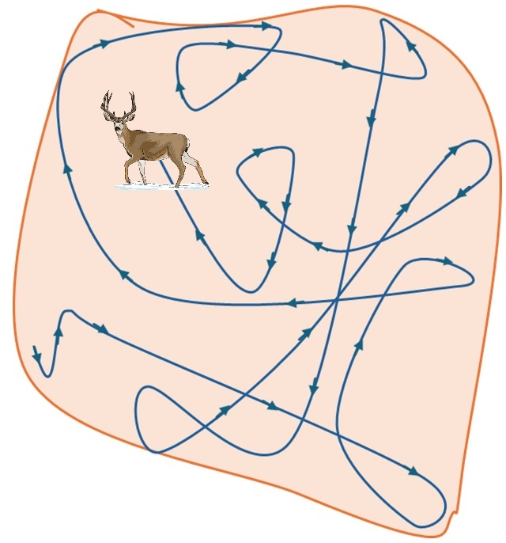 | 00_home_range.jpg | **Home range**: the area within which an animal normally lives and finds what it needs to survive and reproduce. | rcsc_2024b
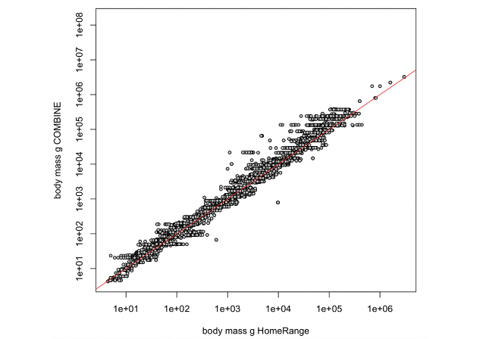 | hoeks_et_al_2024_body_mass.png |  | hoeks_et_al_2024
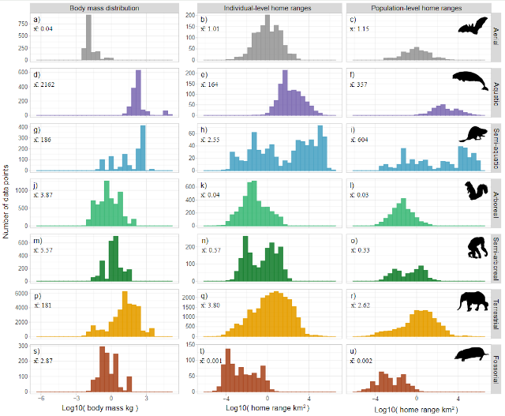 | hoeks_et_al_2024_summary.png |  | hoeks_et_al_2024
 | figure4_filename.png | figure4_caption | figure4_ref_id
 | figure5_filename.png | figure5_caption | figure5_ref_id
 | figure6_filename.png | figure6_caption | figure6_ref_id

Video
caption | URL (no < / > before/after URL | ref_id
vid1_caption | vid1_url | vid1_ref_id
vid2_caption | vid2_url | vid2_ref_id
vid3_caption | vid3_url | vid3_ref_id
vid4_caption | vid4_url | vid4_ref_id
vid5_caption | vid5_url | vid5_ref_id
vid6_caption | vid6_url | vid6_ref_id

Shiny
Shiny name = Species home range / body size lookup
Shiny caption = A R Shiny app created for the RC Decision Support Tool to allows users lookup information on species home range size / body size; information pulled directly from the following sources:
- Burton et al. (2015) supplementary material “S2. Average body mass and home range size for a sample of species and studies among the reviewed set of camera trap publications”
- PanTHERIA database ({{ rtxt_jones_et_al_2009 }}) “a species-level database of life history, ecology, and geography of extant and recently extinct mammals
- HomeRange: A global database of mammalian home ranges ({{ rtxt_broekman_et_al_2022 }})
Shiny URL = https://7e2l38-cassondra-stevenson.shinyapps.io/lu_species_homerange

Shiny name = shiny_name2
Shiny caption =shiny_caption2
Shiny URL = shiny_url2

Analytical tools & resources
Type | Name | Note | URL | ref_id
Data/Database | HomeRange: A global database of mammalian home range | HomeRange, a global database with 75,611 home- range values across 960 different species of mammals, including terrestrial, aquatic and aerial species | Article:<https://onlinelibrary.wiley.com/doi/epdf/10.1111/geb.13625>;<br>Data:https://github.com/SHoeks/HomeRange>; <https://shoeks.github.io/HomeRange/> | broekman_et_al_2022
Data/Database | Supplementary material; PanTHERIA | PanTHERIA: a species-level database of life history, ecology,and geography of extant and recently extinct mammals | <https://ecologicaldata.org/wiki/pantheria> | jones_et_al_2009
Data/Database | Supplementary material; Wildlife camera trapping: a review and recommendations for linking surveys to ecological processes | **Burton et al. (2015)**<br> - Table S2. Data on body size and home range size for a sample of surveyed species.<br>-”Table S1. Bibliographic details and data summarized from camera trap publications included in the review.” | Article: <https://besjournals.onlinelibrary.wiley.com/doi/full/10.1111/1365-2664.12432>;<br>[Download Table S2 XLS](https://besjournals.onlinelibrary.wiley.com/action/downloadSupplement?doi=10.1111%2F1365-2664.12432&file=jpe12432-sup-0006-TableS2.csv) and/or<br>[Download the related references; CSV ](https://besjournals.onlinelibrary.wiley.com/action/downloadSupplement?doi=10.1111%2F1365-2664.12432&file=jpe12432-sup-0005-TableS1.xlsx) | burton_et_al_2015
R package | Package ‘HomeRange’ | HomeRange data: the R package can be used to download and import the HomeRange data | <https://github.com/SHoeks/HomeRange> | hoeks_et_al_2024
resource5_type | resource5_name | resource5_note | resource5_url | resource5_ref_id
resource6_type | resource6_name | resource6_note | resource6_url | resource6_ref_id
resource7_type | resource7_name | resource7_note | resource7_url | resource7_ref_id
resource8_type | resource8_name | resource8_note | resource8_url | resource8_ref_id
resource9_type | resource9_name | resource9_note | resource9_url | resource9_ref_id
resource10_type | resource10_name | resource10_note | resource10_url | resource10_ref_id
resource11_type | resource11_name | resource11_note | resource11_url | resource11_ref_id
resource12_type | resource12_name | resource12_note | resource12_url | resource12_ref_id
resource13_type | resource13_name | resource13_note | resource13_url | resource13_ref_id
resource14_type | resource14_name | resource14_note | resource14_url | resource14_ref_id
resource15_type | resource15_name | resource15_note | resource15_url | resource15_ref_id
 | Animal Home Range Estimation in R

References / Glossary
ref_id
{{ rbib_broekman_et_al_2022 }}

{{ rbib_burton_et_al_2015 }}

{{ rbib_hoeks_et_al_2024 }}

{{ rbib_jones_et_al_2009 }}

{{ rbib_mackenzie_et_al_2004 }}

{{ rbib_nakashima_et_al_2017 }}

{{ rbib_oconnell_et_al_2011 }}

{{ rbib_rowcliffe_et_al_2008 }}

{{ rbib_rowcliffe_et_al_2013 }}

Notes

- “Home range size is used as a means to control spacing between detectors when point sampling, but it is not related to the occupancy-abundance relationship and the potential for bias in estimates of occupancy. Rather, the importance of home range size to control spacing is related to bias in the standard errors if the independence of occupancy status assumption (e.g., sites are closed to changes in the state of occupancy for the duration of sampling) is violated. Investigators choose grain size, yet many studies fail to report justification for the selected grain size (Devarajan et al., 2020), and frequently use grid cell size to space traps/detectors under aerial sampling in discrete space and point sampling in continuous space. A final concern related to the site grainsize and assumptionthat the occupancy states across sites are independent relates to spatial correlation in the occupancy process. If individual home ranges overlap more than one point detector (e.g., point sampling of use), there is potential for spatial correlation in neighboring site occupancy states that could lead to false positives in testing hypotheses about ψ, as for example,in incorrectly concluding that occupancy changed (increased or decreased) over time. The outcome of spatial correlation in the occupancy process is that measures of precision will be overestimated (MacKenzie et al., 2017). To our knowledge, these types of false positive errors have not been formally investigated in occupancy models. The choice of grain is therefore an important consideration in occupancy studies since that choice will affect model assumptions and interpretation and is dependent on whether the study involves areal or point sampling (Efford and Dawson, 2012). Finally, point sampling in continuous space may result in unmodeled site-level heterogeneity in detection, resulting in underestimates in both ψ in occupancy models and site-level abundance in Royle-Nichols models (Efford and Dawson, 2012). This form of heterogeneity may arise because the probability of detecting an individual should increase with increasing overlap of its home range and a detector, and the number of individuals varies among occupied sites; the probability of detecting the species given presence may therefore be heterogeneous due to both variation in home-range overlap with sites and abundance at sites, while Royle-Nichols models only account for variation in abundance across sites..” (Fuller et al., 2022, p. 4) (pdf)

Markdown

POPULATE – INFO

File from = 00_00_template-master.docx

---
jupytext:
formats: md:myst
text_representation:
extension: .md
format_name: myst
format_version: 0.17.2 <!--0.13-->
jupytext_version: 1.16.4 <!-- 6.5.4-->
kernelspec:
display_name: Python 3
language: python
name: python3
editor_options:
markdown:
wrap: none
<!--template v2024-09-30-->
---
(i_sp_rarity)=
# {{ title_i_sp_rarity }}

:::{seealso}
{bdg-link-primary-line}`Species-accumulation curves<https://ab-rcsc.github.io/rc-decision-support-tool_concept-library/02_dialog-boxes/01_10_sp_asymptote.html>`
{bdg-link-primary-line}`Species rarity<https://ab-rcsc.github.io/rc-decision-support-tool_concept-library/02_dialog-boxes/01_19_sp_rarity.html>`
:::

**{{ term_sp_rarity }}**: {{ term_def_sp_rarity }}

:::::::{tab-set}

::::::{tab-item} Overview
**Species rarity** describes how many individuals present of the species, relative to the total number of individuals of all species (or how “represented” is the species when considering the total number of individuals of all species). Generally, species rarity can be thought of as the probability that the species occupies the site, for a given species (or study area, depending on the scale of interest) {{rtxt_kays_et_al_2020}}.

While technically “how rare” a species is will be fairly dynamic from place to place (e.g., will depend on geographic range, habitat specificity, local abundance, etc.; {{rtxt_crisfield_et_al_2024}}), for the purposes of informing study design recommendations, the **species rarity categories are defined as follows**:

- **Common**: probability of occupancy > ~0.75-0.8 (> 0.75 [{{rtxt_kinnaird_obrien_2012}}; {{rtxt_kays_et_al_2020}}]; > 0.8 [{{rtxt_shannon_et_al_2014}}; {{rtxt_wearn_gloverkapfer_2017}}])

- **Less common**: 0.25-0.75

- **Rare**: probability of occupancy < 0.25 {{rtxt_kays_et_al_2020}}

- **Very-rare**: probability of occupancy < 0.001 ({{rtxt_wearn_gloverkapfer_2017}}; {{rtxt_rowcliffe_et_al_2008}}; {{rtxt_obrien_2010}})

- **Unknown**: select this option if you’re not sure of the rarity of your Target Species (single or multiple species)

- **Multiple**: select this option if your study includes multiple Target Species that vary in rarity.

::: {note}
Species rarity can be generally thought of as a species characteristic, however, “not in the same sense that hair colour or wing venation… it’ an emergent trait of a species' population and its environment rather than a trait of an individual organism” {{rtxt_kunin_1997}}
:::

**<font size=“4”><span style=“color:#2F5496”>How does this relate to study design?</font></span>**

**Species' rarity can influence the ideal camera arrangement. ** For example, when monitoring rare or cryptic species that are unlikely to be detected with other designs, it may be appropriate to use a *Targeted design* where cameras are placed in areas that are known or suspected to have higher activity levels (e.g., game trails, mineral licks, etc.).

**Species' rarity can influence the ideal number of cameras and {{ survey_tl }} length** ({{ rtxt_chatterjee_et_al_2021 }}). Low [detection probability](#detection_probability) of rare or cryptic species can result in imprecise estimates if there are too few cameras or if cameras are not deployed for long enough (e.g., Steenweg et al. 2019). Chatterjee et al. (2021) suggested that for [occupancy models](#mods_occupancy) ({{rtxt_mackenzie_et_al_2002 }}) of common species, to survey a minimum of 50 sites for 15–20 days. For rare, elusive species, they recommended surveying 100 sites at a minimum for 20–30 days ({{rtxt_chatterjee_et_al_2021 }}).

**Species' rarity can influence the appropriate modelling approach.** For measures of species richness or diversity, it is presumed that a camera is active long enough to detect rare species that may occur at a specific location ({{ rtxt_wearn_gloverkapfer_2017 }}). If this is not the case, the results will indicate that the species was not present when it was (i.e., a “false negative”).
::::::

::::::{tab-item} In-depth
Add some info here

:::::

:::::{grid} 3
:gutter: 1
:padding: 0
:margin: 0

::::{grid-item-card} {{ rtxt_leroy_2024 }}
:::{figure} ../03_images/03_image_files/leroy_2024_Rarity_cutoff-point.png
:class: img_grid
:::
**Leroy (2024)** The rarity cut-off point is here defined as the threshold of occurrence below which species are considered rare.
::::

::::{grid-item-card} {{ rtxt_leroy_2024 }}
:::{figure} ../03_images/03_image_files/leroy_2024_Weight_assignation-curve.png

:class: img_grid
:::

**Leroy (2024)**Weight assignation curve adjusted to an arbitrary rarity cut-off.

::::

::::{grid-item-card} {{ rtxt_figure3_ref_id }}
:::{figure} ../03_images/03_image_files/figure3_filename.png
:class: img_grid
:::
figure4_caption
::::
:::::

:::::{grid} 3
:gutter: 1
:padding: 0
:margin: 0

::::{grid-item-card} {{ rtxt_figure4_ref_id }}
:::{figure} ../03_images/03_image_files/figure4_filename.png
:class: img_grid
:::
figure4_caption

::::

::::{grid-item-card} {{ rtxt_figure5_ref_id }}
:::{figure} ../03_images/03_image_files/figure5_filename.png
:class: img_grid
:::
figure5_caption

::::

::::{grid-item-card} {{ rtxt_figure6_ref_id }}
:::{figure} ../03_images/03_image_files/figure6_filename.png
:class: img_grid
:::
figure6_caption

::::
:::::

:::::{grid} 3
:gutter: 1
:padding: 0
:margin: 0

::::{grid-item-card} {{ rtxt_Error! Reference source not found. }}

:::{figure} ../03_images/03_image_files/Error! Reference source not found.
:class: img_grid
:::
Error! Reference source not found.
::::

::::{grid-item-card} {{ rtxt_Error! Reference source not found. }}
:::{figure} ../03_images/03_image_files/Error! Reference source not found.
:class: img_grid
:::
Error! Reference source not found.
::::

::::{grid-item-card} {{ rtxt_Error! Reference source not found. }}
:::{figure} ../03_images/03_image_files/Error! Reference source not found.

:class: img_grid

:::

Error! Reference source not found.

::::
:::::

:::::{grid} 3
:gutter: 1
:padding: 0
:margin: 0

::::{grid-item-card} {{ rtxt_Error! Reference source not found. }}

:::{figure} ../03_images/03_image_files/Error! Reference source not found.
:class: img_grid
:::
Error! Reference source not found.
::::

::::{grid-item-card} {{ rtxt_Error! Reference source not found. }}
:::{figure} ../03_images/03_image_files/Error! Reference source not found.
:class: img_grid
:::
Error! Reference source not found.
::::

::::{grid-item-card} {{ rtxt_Error! Reference source not found. }}
:::{figure} ../03_images/03_image_files/Error! Reference source not found.

:class: img_grid

:::

Error! Reference source not found.

::::
:::::

:::::{grid} 3
:gutter: 1
:padding: 0
:margin: 0

::::{grid-item-card} {{ rtxt_mecks100_2018 }}
<div>
<div style=“position:relative;padding-top:56.25%;”>
<iframe src=“https://www.youtube.com/embed/4gcmAUpo9TU?si=_S-JYDDskR8QbHs5“ loading=“lazy” frameborder=“0” allowfullscreen
style=“position:absolute;top:0;left:0;width:100%;height:100%;”></iframe>
</div>
</div>

Species accumulation and rarefaction curves
::::

::::{grid-item-card} {{ rtxt_riffomonas_project_2022b }}
<div>
<div style=“position:relative;padding-top:56.25%;”>
<iframe src=“https://www.youtube.com/embed/ywHVb0Q-qsM?si=_xJ5jbFc6MDEQlAh “ loading=“lazy” frameborder=“0” allowfullscreen

style=“position:absolute;top:0;left:0;width:100%;height:100%;”></iframe>
</div>

</div>

Generating a rarefaction curve from collector's curves in R within the tidyverse (CC198)

::::

::::{grid-item-card} {{ rtxt_vid3_ref_id }}
<div>
<div style=“position:relative;padding-top:56.25%;”>
<iframe src=“vid3_url“ loading=“lazy” frameborder=“0” allowfullscreen
style=“position:absolute;top:0;left:0;width:100%;height:100%;”></iframe>
</div>
</div>

vid3_caption
::::
:::::

:::::{grid} 3
:gutter: 1
:padding: 0
:margin: 0

::::{grid-item-card} {{ rtxt_vid4_ref_id }}
<div>
<div style=“position:relative;padding-top:56.25%;”>
<iframe src=“vid4_url“ loading=“lazy” frameborder=“0” allowfullscreen
style=“position:absolute;top:0;left:0;width:100%;height:100%;”></iframe>
</div>
</div>

vid4_caption

::::

::::{grid-item-card} {{ rtxt_vid5_ref_id }}
<div>
<div style=“position:relative;padding-top:56.25%;”>
<iframe src=“vid5_url“ loading=“lazy” frameborder=“0” allowfullscreen
style=“position:absolute;top:0;left:0;width:100%;height:100%;”></iframe>
</div>
</div>

vid5_caption

::::

::::{grid-item-card} {{ rtxt_vid6_ref_id }}
<div>
<div style=“position:relative;padding-top:56.25%;”>
<iframe src=“vid6_url“ loading=“lazy” frameborder=“0” allowfullscreen
style=“position:absolute;top:0;left:0;width:100%;height:100%;”></iframe>
</div>
</div>

vid6_caption

::::
:::::

:::::{grid} 3
:gutter: 1
:padding: 0
:margin: 0

::::{grid-item-card} {{ rtxt_Error! Reference source not found. }}
<div>
<div style=“position:relative;padding-top:56.25%;”>
<iframe src=“Error! Reference source not found.“ loading=“lazy” frameborder=“0” allowfullscreen
style=“position:absolute;top:0;left:0;width:100%;height:100%;”></iframe>
</div>
</div>

Generating a rarefaction curve from collector's curves in R within the tidyverse (CC198)
::::

::::{grid-item-card} {{ rtxt_Error! Reference source not found. }}
<div>
<div style=“position:relative;padding-top:56.25%;”>
<iframe src=“Error! Reference source not found.“ loading=“lazy” frameborder=“0” allowfullscreen
style=“position:absolute;top:0;left:0;width:100%;height:100%;”></iframe>
</div>
</div>

Error! Reference source not found.
::::

::::{grid-item-card} {{ rtxt_Error! Reference source not found. }}

<div>

<div style=“position:relative;padding-top:56.25%;”>
<iframe src=“Error! Reference source not found.“ loading=“lazy” frameborder=“0” allowfullscreen
style=“position:absolute;top:0;left:0;width:100%;height:100%;”></iframe>
</div>
</div>

Error! Reference source not found.
::::
:::::

::::::

::::::{tab-item} Shiny apps/Widgets
Check back in the future!
::::::

::::::{tab-item} Shiny apps/Widgets

:::::{card} Error! Reference source not found.

Error! Reference source not found.

<iframe
width=“100%”
height=“900”
src=“Error! Reference source not found.“
loading=“lazy”
frameborder=“0”
allow=“accelerometer; autoplay; clipboard-write; encrypted-media; gyroscope; picture-in-picture”
allowfullscreen>
</iframe>
:::::
::::::

::::::{tab-item} Shiny apps/Widgets

:::::{card}

::::{dropdown} Error! Reference source not found.

Error! Reference source not found.

<iframe
width=“100%”
height=“900”
src=“Error! Reference source not found.“
loading=“lazy”
frameborder=“0”
allow=“accelerometer; autoplay; clipboard-write; encrypted-media; gyroscope; picture-in-picture”
allowfullscreen>
</iframe>
::::
::::{dropdown} Error! Reference source not found.
Error! Reference source not found.

<iframe
width=“100%”
height=“900”
src=“Error! Reference source not found.“
loading=“lazy”
frameborder=“0”

allow=“accelerometer; autoplay; clipboard-write; encrypted-media; gyroscope; picture-in-picture”

allowfullscreen>

</iframe>

::::

:::::
::::::

:::::{tab-item} Analytical tools & resources
| Type | Name | Note | URL |Reference |
|:----------------|:-------------------------------|:----------------------------------------------------------------|:----------------------|:----------------------------------------|
| R package | Package ‘Rarity’: Calculation of Rarity Indices for Species and Assemblages of Species | Allows calculation of rarity weights for species and indices of rarity for assemblages of species according to different methods (Leroy et al. 2012, Insect. Conserv. Divers. 5:159-168 <doi:10.1111/j.1752-4598.2011.00148.x>; Leroy et al. 2013, Divers. Distrib. 19:794-803 <doi:10.1111/ddi.12040>). | <https://cran.r-project.org/web/packages/Rarity/> | {{ rbib_leroy_2023 }} |
| resource2_type | resource2_name | resource2_note | resource2_url | {{ rbib_resource2_ref_id }} |
| resource3_type | resource3_name | resource3_note | resource3_url | {{ rbib_resource3_ref_id }} |
| resource4_type | resource4_name | resource4_note | resource4_url | {{ rbib_resource4_ref_id }} |
| resource5_type | resource5_name | resource5_note | resource5_url | {{ rbib_resource5_ref_id }} |
| resource6_type | resource6_name | resource6_note | resource6_url | {{ rbib_resource6_ref_id }} |
| resource7_type | resource7_name | resource7_note | resource7_url | {{ rbib_resource7_ref_id }} |
| resource8_type | resource8_name | resource8_note | resource8_url| {{ rbib_resource8_ref_id}} |
| resource9_type | resource9_name | resource9_note | resource9_url | {{ rbib_resource9_ref_id }} |
| resource10_type | resource10_name | resource10_note | resource10_url | {{ rbib_resource10_ref_id }} |
| resource11_type | resource11_name | resource11_note | resource11_url | {{ rbib_resource11_ref_id }} |
| resource12_type | resource12_name | resource12_note | resource12_url | {{ rbib_resource12_ref_id }} |
| resource13_type | resource13_name | resource13_note | resource13_url | {{ rbib_resource13_ref_id }} |
| resource14_type | resource14_name | resource14_note | resource14_url | {{ rbib_resource14_ref_id }} |
| resource15_type | resource15_name | resource15_note | resource15_url | {{ rbib_resource15_ref_id }} |
| Error! Reference source not found. | Error! Reference source not found. | Error! Reference source not found. | Error! Reference source not found. | {{ rbib_Error! Reference source not found. }} |
| Error! Reference source not found. | Error! Reference source not found. | Error! Reference source not found. | Error! Reference source not found. | {{ rbib_Error! Reference source not found. }} |
| Error! Reference source not found. | Error! Reference source not found. | Error! Reference source not found. | Error! Reference source not found.| {{ rbib_Error! Reference source not found.}} |
| Error! Reference source not found. | Error! Reference source not found. | Error! Reference source not found. | Error! Reference source not found. | {{ rbib_Error! Reference source not found. }} |
| Error! Reference source not found. | Error! Reference source not found. | Error! Reference source not found. | Error! Reference source not found. | {{ rbib_Error! Reference source not found. }} |
::::::

::::::{tab-item} References
{{ rbib_chatterjee_et_al_2021 }}

{{ rbib_kinnaird_obrien_2012 }}

{{ rbib_kays_et_al_2020 }}

{{ rbib_shannon_et_al_2014 }}

{{ rbib_wearn_gloverkapfer_2017 }}

{{ rbib_rowcliffe_et_al_2008)

{{ rbib_southwell_et_al_2019 }}

{{ rbib_flather_sieg_2007 }}

{{ rbib_kunin_1997 }}

::::::

:::::::

