Topic Info
info_id | sp_behav
question | Question: Is the Target Species known or likely to investigate the camera (e.g., moose, coyote) or be camera shy (e.g., lynx)?  # **Target Species – Behaviour**  need more info here to help user choose  + why this matter- include as warning / info-- correction factors down the road  Examples of comparable species users can refer to in order to select the most appropriate option

Overview
It's important to consider how your Target Species may react to the camera being placed.

While remote cameras are fairly non-invasive survey method, their presence on the landscape, in and of itself, can alter the behaviour of the species you aim to measure (potential attraction to, or avoidance of, the camera), ultimately interfering with detection rates / detection probability ({{ rtxt_meek_et_al_2014) (e.g., “trap-shy” tigers are thought to avoid cameras due to the white flash emitted [{{ rtxt_wegge_et_al_2004 }}; {{ rtxt_sharma_et_al_2010 }}).

Examples of comparable species that can be used to select the most appropriate option:

- **Exploratory**: (e.g., moose, coyote)

- **Neutral**: [INSERT HERE]

- **Avoidant**: (e.g., lynx)

- **I'm not sure**: select this option if you’re not sure of the investigative behaviour of your Target Species (single or multiple species)

- **Variable**: select this option if you’re targetting multiple species and you expect that the investigative behaviour of these species is variable (e.g., you’re targetting coyote and lynx).

In-depth
```{include} include/00_coming_soon.md
```

Notes for later
- How much sound and illumination (or flash) is emitted will depend on the users’ settings, and the camera make and model (type of flash available; xenon light, white LED or infrared LED illumination). However, the extent to which the camera interferes with behaviour will also depend upon the physical and behavioural characteristics of the species (e.g., perceptive range of hearing, boldness, etc.).

-Many modelling approaches need to incorporate aspects of time as it relates to the animals’ presence at the camera location (e.g., the amount of time spent in the camera’s field-of-view), and thus, you might imagine the bias in the resulting estimates (e.g., density) becomes increasingly problematic for species that are particularly avoidant or exploratory (e.g., moose spend considerable time investigating, which affects effective detection distance in TIFC models; {{ rtxt_becker_et_al_2022 }}). Such models usually have the assumption that animals’ behaviour is unbiased by the camera.

Figures
Image | file_name | Caption (if applicable) | ref_id
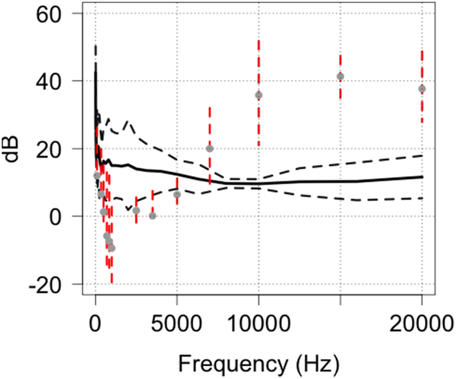 | meek_et_al_2014_fig11.png | **Meek et al. (2014b) - Fig. 11.** Comparison of the predicted hearing range of the red fox in relation to the outputs of HC600 camera traps and as a function of frequency | meek_et_al_2014b
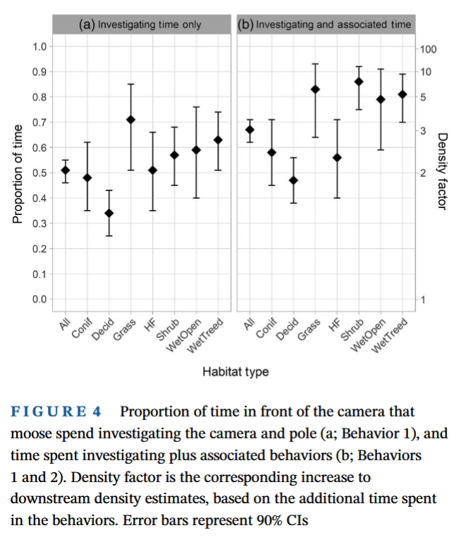 | becker_et_al_2022_fig4.png | **Becker et al. (2022) - Fig 4.**Proportion of time in front of the camera that moose spend investigating the camera and pole (a; Behavior 1), and time spent investigating plus associated behaviors (b; Behaviors 1 and 2). Density factor is the corresponding increase to downstream density estimates, based on the additional time spent in the behaviors. Error bars represent 90% Cis. | becker_et_al_2022
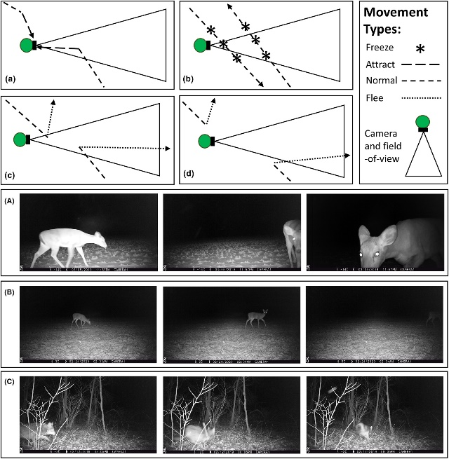 | delisle_et_al_2023_fig1.jpg | figu  Conceptual movement paths in which animals exhibit a variety of different reactive behaviours towards camera traps: (A) attraction towards the camera trap; (B) freezing normal travel; (C) fleeing in response to being detected by the camera trap; and (d) fleeing in response to the presence of the camera trap regardless of being detected. Panels depicting actual animals exhibiting a variety of reactive behaviours towards camera traps: (A) white-tailed deer (Odocoileus virginianus) that is attracted towards the camera trap; (B) white-tailed deer that freezes in front of a camera trap; and (C) coyote (Canis latrans) that flees in response to being detected by a camera trap.  caption | figure3_ref_id
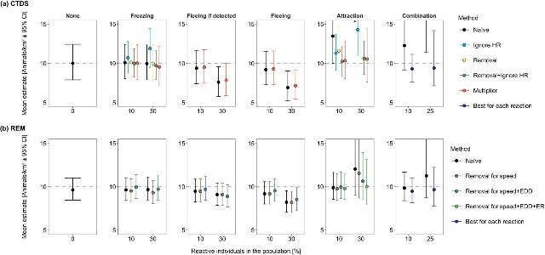 | figure4_filename.png | figure4_  The average density estimates (animals/km2 ± 95% confidence intervals [CI]) from detections of simulated animals at camera traps across 100 total simulations for each reaction type. Densities were estimated using camera trap distance sampling (CTDS; a) and the random encounter model (REM; b). Simulated populations contained a fraction of the population (reactive individuals in the population [%]) that froze in response to cameras (Freezing), fled from the camera when the camera detected the individual (Fleeing if detected), fled from the camera regardless of being detected by the camera (Fleeing) and were attracted to cameras (Attraction). Additionally, we simulated a population that did not contain any reactive individuals (None). For each density estimate, we enacted a specific method to reduce bias associated with reactive movement (Method). Methods for CTDS included doing nothing (Naïve), removing detections of reactive individuals from consideration (Removal), ignoring the hazard rate key function (Ignore HR), combining Ignore HR and Removal, and using the ratio of average number of detections of reactive and nonreactive individuals as a multiplier (Multiplier). Methods for REM included doing nothing (Naïve), removing reactive encounters when estimating the speed parameter (Removal for speed), removing reactive encounters when estimating the speed parameter and the effective detection distance (Removal for speed +EDD) and removing reactive encounters when estimating the speed parameter, effective detection distance and the encounter rate (Removal for speed +EDD + ER). The grey dotted line represents true density (10 animals/km2). Some density estimates are above the upper limit of the y-axis due to severe bias (see Tables S1 and S2 for these estimates and the extent of their confidence intervals in the Supporting Information).  ::: | figure4_ref_id
 | figure5_filename.png | figure5_caption | figure5_ref_id
 | figure6_filename.png | figure6_caption | figure6_ref_id

Video
caption | URL (no < / > before/after URL | ref_id
vid1_caption | vid1_url | vid1_ref_id
vid2_caption | vid2_url | vid2_ref_id
vid3_caption | vid3_url | vid3_ref_id
vid4_caption | vid4_url | vid4_ref_id
vid5_caption | vid5_url | vid5_ref_id
vid6_caption | vid6_url | vid6_ref_id

Analytical tools & resources

Type | Name | Note | URL | ref_id
Correction factors (Marcus) | resource1_name | resource1_note | resource1_url | resource1_ref_id
resource2_type | resource2_name | resource2_note | resource2_url | resource2_ref_id
resource3_type | resource3_name | resource3_note | resource3_url | resource3_ref_id
resource4_type | resource4_name | resource4_note | resource4_url | resource4_ref_id
resource5_type | resource5_name | resource5_note | resource5_url | resource5_ref_id
resource6_type | resource6_name | resource6_note | resource6_url | resource6_ref_id
resource7_type | resource7_name | resource7_note | resource7_url | resource7_ref_id
resource8_type | resource8_name | resource8_note | resource8_url | resource8_ref_id
resource9_type | resource9_name | resource9_note | resource9_url | resource9_ref_id
resource10_type | resource10_name | resource10_note | resource10_url | resource10_ref_id
resource11_type | resource11_name | resource11_note | resource11_url | resource11_ref_id
resource12_type | resource12_name | resource12_note | resource12_url | resource12_ref_id
resource13_type | resource13_name | resource13_note | resource13_url | resource13_ref_id
resource14_type | resource14_name | resource14_note | resource14_url | resource14_ref_id
resource15_type | resource15_name | resource15_note | resource15_url | resource15_ref_id

References / Glossary
ref_id | glossary_keys
{{ rbib_caravaggi_et_al_2017 }}  {{ rbib_caravaggi_et_al_2020 }}  {{ rbib_delisle_et_al_2023 }}  {{ rbib_meek_et_al_2014b }}  {{ rbib_sharma_et_al_2010 }}  {{ rbib_wegge_et_al_2004 }} | keys_here

Notes
- NOTE: Unbiased behaviour in assumptions for = (“mod_scr_secr”,”mod_ds”,”mod_2flankspim”,”mod_rem”,”mod_rest”,”mod_tifc”)
Meek et al., 2014
Observations of responses to mensurative devices strongly imply that learning can occur as a consequence of exposure to the devices. For examples, camera traps could be detected by animals for the following reasons:
1. Auditory – by the emission of sounds from the electronic and mechanical components of the device: these could be in the infra, audible and ultra-sound ranges.
2. Olfactory – metal, plastic and human scents on the device [6,9], 3. Learned association – avoidance of the camera trap through wariness of human presence at a site [6] or attraction to the camera trap through lures and food baits,
4. Visual (day) – neophobia towards foreign objects introduced into their environment; regular-shaped objects (essentially rectangular prisms) attached to trees or posts [12,13],
5. Visual (night) – the flash of xenon light, white LED or infrared LED illumination [7].

For example, the bold or exploratory behaviour of one species may result in more frequent detections than the number of animals of that species that would have passed through the detection zone if no camera was present (e.g., coyotes; Caravaggi et al., 2020; Rowcliffe et al., 2011).

POPULATE – INFO

File from = 00_00_template-master.docx

---
jupytext:
formats: md:myst
text_representation:
extension: .md
format_name: myst
format_version: 0.17.2 <!--0.13-->
jupytext_version: 1.16.4 <!-- 6.5.4-->
kernelspec:
display_name: Python 3
language: python
name: python3
editor_options:
markdown:
wrap: none
<!--template v2024-09-30-->
---
(i_sp_rarity)=
# {{ title_i_sp_rarity }}

:::{seealso}
{bdg-link-primary-line}`Species-accumulation curves<https://ab-rcsc.github.io/rc-decision-support-tool_concept-library/02_dialog-boxes/01_10_sp_asymptote.html>`
{bdg-link-primary-line}`Species rarity<https://ab-rcsc.github.io/rc-decision-support-tool_concept-library/02_dialog-boxes/01_19_sp_rarity.html>`
:::

**{{ term_sp_rarity }}**: {{ term_def_sp_rarity }}

:::::::{tab-set}

::::::{tab-item} Overview
**Species rarity** describes how many individuals present of the species, relative to the total number of individuals of all species (or how “represented” is the species when considering the total number of individuals of all species). Generally, species rarity can be thought of as the probability that the species occupies the site, for a given species (or study area, depending on the scale of interest) {{rtxt_kays_et_al_2020}}.

While technically “how rare” a species is will be fairly dynamic from place to place (e.g., will depend on geographic range, habitat specificity, local abundance, etc.; {{rtxt_crisfield_et_al_2024}}), for the purposes of informing study design recommendations, the **species rarity categories are defined as follows**:

- **Common**: probability of occupancy > ~0.75-0.8 (> 0.75 [{{rtxt_kinnaird_obrien_2012}}; {{rtxt_kays_et_al_2020}}]; > 0.8 [{{rtxt_shannon_et_al_2014}}; {{rtxt_wearn_gloverkapfer_2017}}])

- **Less common**: 0.25-0.75

- **Rare**: probability of occupancy < 0.25 {{rtxt_kays_et_al_2020}}

- **Very-rare**: probability of occupancy < 0.001 ({{rtxt_wearn_gloverkapfer_2017}}; {{rtxt_rowcliffe_et_al_2008}}; {{rtxt_obrien_2010}})

- **Unknown**: select this option if you’re not sure of the rarity of your Target Species (single or multiple species)

- **Multiple**: select this option if your study includes multiple Target Species that vary in rarity.

::: {note}
Species rarity can be generally thought of as a species characteristic, however, “not in the same sense that hair colour or wing venation… it’ an emergent trait of a species' population and its environment rather than a trait of an individual organism” {{rtxt_kunin_1997}}
:::

**<font size=“4”><span style=“color:#2F5496”>How does this relate to study design?</font></span>**

**Species' rarity can influence the ideal camera arrangement. ** For example, when monitoring rare or cryptic species that are unlikely to be detected with other designs, it may be appropriate to use a *Targeted design* where cameras are placed in areas that are known or suspected to have higher activity levels (e.g., game trails, mineral licks, etc.).

**Species' rarity can influence the ideal number of cameras and {{ survey_tl }} length** ({{ rtxt_chatterjee_et_al_2021 }}). Low [detection probability](#detection_probability) of rare or cryptic species can result in imprecise estimates if there are too few cameras or if cameras are not deployed for long enough (e.g., Steenweg et al. 2019). Chatterjee et al. (2021) suggested that for [occupancy models](#mods_occupancy) ({{rtxt_mackenzie_et_al_2002 }}) of common species, to survey a minimum of 50 sites for 15–20 days. For rare, elusive species, they recommended surveying 100 sites at a minimum for 20–30 days ({{rtxt_chatterjee_et_al_2021 }}).

**Species' rarity can influence the appropriate modelling approach.** For measures of species richness or diversity, it is presumed that a camera is active long enough to detect rare species that may occur at a specific location ({{ rtxt_wearn_gloverkapfer_2017 }}). If this is not the case, the results will indicate that the species was not present when it was (i.e., a “false negative”).
::::::

::::::{tab-item} In-depth
Add some info here

:::::

:::::{grid} 3
:gutter: 1
:padding: 0
:margin: 0

::::{grid-item-card} {{ rtxt_leroy_2024 }}
:::{figure} ../03_images/03_image_files/leroy_2024_Rarity_cutoff-point.png
:class: img_grid
:::
**Leroy (2024)** The rarity cut-off point is here defined as the threshold of occurrence below which species are considered rare.
::::

::::{grid-item-card} {{ rtxt_leroy_2024 }}
:::{figure} ../03_images/03_image_files/leroy_2024_Weight_assignation-curve.png

:class: img_grid
:::

**Leroy (2024)**Weight assignation curve adjusted to an arbitrary rarity cut-off.

::::

::::{grid-item-card} {{ rtxt_figure3_ref_id }}
:::{figure} ../03_images/03_image_files/figure3_filename.png
:class: img_grid
:::
figure4_caption
::::
:::::

:::::{grid} 3
:gutter: 1
:padding: 0
:margin: 0

::::{grid-item-card} {{ rtxt_figure4_ref_id }}
:::{figure} ../03_images/03_image_files/figure4_filename.png
:class: img_grid
:::
figure4_caption

::::

::::{grid-item-card} {{ rtxt_figure5_ref_id }}
:::{figure} ../03_images/03_image_files/figure5_filename.png
:class: img_grid
:::
figure5_caption

::::

::::{grid-item-card} {{ rtxt_figure6_ref_id }}
:::{figure} ../03_images/03_image_files/figure6_filename.png
:class: img_grid
:::
figure6_caption

::::
:::::

:::::{grid} 3
:gutter: 1
:padding: 0
:margin: 0

::::{grid-item-card} {{ rtxt_Error! Reference source not found. }}

:::{figure} ../03_images/03_image_files/Error! Reference source not found.
:class: img_grid
:::
Error! Reference source not found.
::::

::::{grid-item-card} {{ rtxt_Error! Reference source not found. }}
:::{figure} ../03_images/03_image_files/Error! Reference source not found.
:class: img_grid
:::
Error! Reference source not found.
::::

::::{grid-item-card} {{ rtxt_Error! Reference source not found. }}
:::{figure} ../03_images/03_image_files/Error! Reference source not found.

:class: img_grid

:::

Error! Reference source not found.

::::
:::::

:::::{grid} 3
:gutter: 1
:padding: 0
:margin: 0

::::{grid-item-card} {{ rtxt_Error! Reference source not found. }}

:::{figure} ../03_images/03_image_files/Error! Reference source not found.
:class: img_grid
:::
Error! Reference source not found.
::::

::::{grid-item-card} {{ rtxt_Error! Reference source not found. }}
:::{figure} ../03_images/03_image_files/Error! Reference source not found.
:class: img_grid
:::
Error! Reference source not found.
::::

::::{grid-item-card} {{ rtxt_Error! Reference source not found. }}
:::{figure} ../03_images/03_image_files/Error! Reference source not found.

:class: img_grid

:::

Error! Reference source not found.

::::
:::::

:::::{grid} 3
:gutter: 1
:padding: 0
:margin: 0

::::{grid-item-card} {{ rtxt_mecks100_2018 }}
<div>
<div style=“position:relative;padding-top:56.25%;”>
<iframe src=“https://www.youtube.com/embed/4gcmAUpo9TU?si=_S-JYDDskR8QbHs5“ loading=“lazy” frameborder=“0” allowfullscreen
style=“position:absolute;top:0;left:0;width:100%;height:100%;”></iframe>
</div>
</div>

Species accumulation and rarefaction curves
::::

::::{grid-item-card} {{ rtxt_riffomonas_project_2022b }}
<div>
<div style=“position:relative;padding-top:56.25%;”>
<iframe src=“https://www.youtube.com/embed/ywHVb0Q-qsM?si=_xJ5jbFc6MDEQlAh “ loading=“lazy” frameborder=“0” allowfullscreen

style=“position:absolute;top:0;left:0;width:100%;height:100%;”></iframe>
</div>

</div>

Generating a rarefaction curve from collector's curves in R within the tidyverse (CC198)

::::

::::{grid-item-card} {{ rtxt_vid3_ref_id }}
<div>
<div style=“position:relative;padding-top:56.25%;”>
<iframe src=“vid3_url“ loading=“lazy” frameborder=“0” allowfullscreen
style=“position:absolute;top:0;left:0;width:100%;height:100%;”></iframe>
</div>
</div>

vid3_caption
::::
:::::

:::::{grid} 3
:gutter: 1
:padding: 0
:margin: 0

::::{grid-item-card} {{ rtxt_vid4_ref_id }}
<div>
<div style=“position:relative;padding-top:56.25%;”>
<iframe src=“vid4_url“ loading=“lazy” frameborder=“0” allowfullscreen
style=“position:absolute;top:0;left:0;width:100%;height:100%;”></iframe>
</div>
</div>

vid4_caption

::::

::::{grid-item-card} {{ rtxt_vid5_ref_id }}
<div>
<div style=“position:relative;padding-top:56.25%;”>
<iframe src=“vid5_url“ loading=“lazy” frameborder=“0” allowfullscreen
style=“position:absolute;top:0;left:0;width:100%;height:100%;”></iframe>
</div>
</div>

vid5_caption

::::

::::{grid-item-card} {{ rtxt_vid6_ref_id }}
<div>
<div style=“position:relative;padding-top:56.25%;”>
<iframe src=“vid6_url“ loading=“lazy” frameborder=“0” allowfullscreen
style=“position:absolute;top:0;left:0;width:100%;height:100%;”></iframe>
</div>
</div>

vid6_caption

::::
:::::

:::::{grid} 3
:gutter: 1
:padding: 0
:margin: 0

::::{grid-item-card} {{ rtxt_Error! Reference source not found. }}
<div>
<div style=“position:relative;padding-top:56.25%;”>
<iframe src=“Error! Reference source not found.“ loading=“lazy” frameborder=“0” allowfullscreen
style=“position:absolute;top:0;left:0;width:100%;height:100%;”></iframe>
</div>
</div>

Generating a rarefaction curve from collector's curves in R within the tidyverse (CC198)
::::

::::{grid-item-card} {{ rtxt_Error! Reference source not found. }}
<div>
<div style=“position:relative;padding-top:56.25%;”>
<iframe src=“Error! Reference source not found.“ loading=“lazy” frameborder=“0” allowfullscreen
style=“position:absolute;top:0;left:0;width:100%;height:100%;”></iframe>
</div>
</div>

Error! Reference source not found.
::::

::::{grid-item-card} {{ rtxt_Error! Reference source not found. }}

<div>

<div style=“position:relative;padding-top:56.25%;”>
<iframe src=“Error! Reference source not found.“ loading=“lazy” frameborder=“0” allowfullscreen
style=“position:absolute;top:0;left:0;width:100%;height:100%;”></iframe>
</div>
</div>

Error! Reference source not found.
::::
:::::

::::::

::::::{tab-item} Shiny apps/Widgets
Check back in the future!
::::::

::::::{tab-item} Shiny apps/Widgets

:::::{card} Error! Reference source not found.

Error! Reference source not found.

<iframe
width=“100%”
height=“900”
src=“Error! Reference source not found.“
loading=“lazy”
frameborder=“0”
allow=“accelerometer; autoplay; clipboard-write; encrypted-media; gyroscope; picture-in-picture”
allowfullscreen>
</iframe>
:::::
::::::

::::::{tab-item} Shiny apps/Widgets

:::::{card}

::::{dropdown} Error! Reference source not found.

Error! Reference source not found.

<iframe
width=“100%”
height=“900”
src=“Error! Reference source not found.“
loading=“lazy”
frameborder=“0”
allow=“accelerometer; autoplay; clipboard-write; encrypted-media; gyroscope; picture-in-picture”
allowfullscreen>
</iframe>
::::
::::{dropdown} Error! Reference source not found.
Error! Reference source not found.

<iframe
width=“100%”
height=“900”
src=“Error! Reference source not found.“
loading=“lazy”
frameborder=“0”

allow=“accelerometer; autoplay; clipboard-write; encrypted-media; gyroscope; picture-in-picture”

allowfullscreen>

</iframe>

::::

:::::
::::::

:::::{tab-item} Analytical tools & resources
| Type | Name | Note | URL |Reference |
|:----------------|:-------------------------------|:----------------------------------------------------------------|:----------------------|:----------------------------------------|
| R package | Package ‘Rarity’: Calculation of Rarity Indices for Species and Assemblages of Species | Allows calculation of rarity weights for species and indices of rarity for assemblages of species according to different methods (Leroy et al. 2012, Insect. Conserv. Divers. 5:159-168 <doi:10.1111/j.1752-4598.2011.00148.x>; Leroy et al. 2013, Divers. Distrib. 19:794-803 <doi:10.1111/ddi.12040>). | <https://cran.r-project.org/web/packages/Rarity/> | {{ rbib_leroy_2023 }} |
| resource2_type | resource2_name | resource2_note | resource2_url | {{ rbib_resource2_ref_id }} |
| resource3_type | resource3_name | resource3_note | resource3_url | {{ rbib_resource3_ref_id }} |
| resource4_type | resource4_name | resource4_note | resource4_url | {{ rbib_resource4_ref_id }} |
| resource5_type | resource5_name | resource5_note | resource5_url | {{ rbib_resource5_ref_id }} |
| resource6_type | resource6_name | resource6_note | resource6_url | {{ rbib_resource6_ref_id }} |
| resource7_type | resource7_name | resource7_note | resource7_url | {{ rbib_resource7_ref_id }} |
| resource8_type | resource8_name | resource8_note | resource8_url| {{ rbib_resource8_ref_id}} |
| resource9_type | resource9_name | resource9_note | resource9_url | {{ rbib_resource9_ref_id }} |
| resource10_type | resource10_name | resource10_note | resource10_url | {{ rbib_resource10_ref_id }} |
| resource11_type | resource11_name | resource11_note | resource11_url | {{ rbib_resource11_ref_id }} |
| resource12_type | resource12_name | resource12_note | resource12_url | {{ rbib_resource12_ref_id }} |
| resource13_type | resource13_name | resource13_note | resource13_url | {{ rbib_resource13_ref_id }} |
| resource14_type | resource14_name | resource14_note | resource14_url | {{ rbib_resource14_ref_id }} |
| resource15_type | resource15_name | resource15_note | resource15_url | {{ rbib_resource15_ref_id }} |
| Error! Reference source not found. | Error! Reference source not found. | Error! Reference source not found. | Error! Reference source not found. | {{ rbib_Error! Reference source not found. }} |
| Error! Reference source not found. | Error! Reference source not found. | Error! Reference source not found. | Error! Reference source not found. | {{ rbib_Error! Reference source not found. }} |
| Error! Reference source not found. | Error! Reference source not found. | Error! Reference source not found. | Error! Reference source not found.| {{ rbib_Error! Reference source not found.}} |
| Error! Reference source not found. | Error! Reference source not found. | Error! Reference source not found. | Error! Reference source not found. | {{ rbib_Error! Reference source not found. }} |
| Error! Reference source not found. | Error! Reference source not found. | Error! Reference source not found. | Error! Reference source not found. | {{ rbib_Error! Reference source not found. }} |
::::::

::::::{tab-item} References
{{ rbib_chatterjee_et_al_2021 }}

{{ rbib_kinnaird_obrien_2012 }}

{{ rbib_kays_et_al_2020 }}

{{ rbib_shannon_et_al_2014 }}

{{ rbib_wearn_gloverkapfer_2017 }}

{{ rbib_rowcliffe_et_al_2008)

{{ rbib_southwell_et_al_2019 }}

{{ rbib_flather_sieg_2007 }}

{{ rbib_kunin_1997 }}

::::::

:::::::

