INFO ENTRY

ENTRY NOTES:
- green = does not need to be editted
- yellow = info for the inputter
- ref_id = “refs_glossary_2024-08-09.xls > “references” tab
  - if the reference not present, either add it (if you’re confident that you can follow the format), or add a comment in this doc with the info and I will adjust
- images – file name in “refs_glossary_2024-08-09.xls > “references” tab
- Ignore everything in the “POPULATE MARKDOWN” section
- Size of columns in tables and text format do not matter; see note on bold and italize below
- Any content with “glue}`` prefix or surrounded by “{{ “ / “ }}” indicates where text will be inserted from the keys
- You may see “<br>“ throughout, you can ignore these
- additional formatting notes (optional)
  - **bold**
  - *italics*
- Topic Info
  - If the topic is NOT related to a question, you can leave “question” as NULL
  - “question” here is more for your reference
- Assumptions, Pros, Cons
  - Only for modelling approaches; can ignore otherwise (leave table here)
  - [WILL BE HERE, BUT INSERTED DIRECTLY FROM CSV FILE (THUS NO INPUT NEEDED)]
- Advanced
  - If the topic doesn’t warrant inclusion, you can leave as NULL
- Figures
  - Placeholders here as “filename” can leave in if not <5 images
- Video
  - no “<“ before the URL text and a “>“ after URL in this case
  - ref_id in this example is not correct, just for illustrative purposes
- Analytical tools & resources
  - The ref_id should be included in the reference column (and the full text reference in the master reference file). If you aren’t sure if the reference is in the master doc, add the full text ref as a comment.
  - Please add a “<“ before the URL text and a “>“ after (e.g., <http://www.somesitelink.com>)
  - Type can be something similar to: Article, App/Program, R package
- References / Glossary
  - items in-text above (IGNORE FOR NOW)
- Notes
  - (future ref / not included in markdown conversion)

Topic Info
info_id | cam_makemod
question | Discuss potential effects of using multiple make/models / how you might address in analysis; loop into analytical recommendations below

Overview
```{include} include/00_coming_soon.md
```

In-depth
```{include} include/00_coming_soon.md
```

Figures
Image | file_name | Caption (if applicable) | ref_id
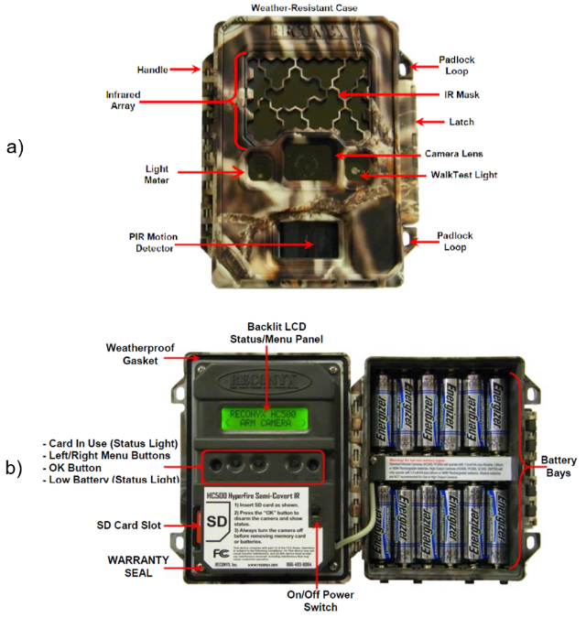 | rcsc_et_al_2024_CamFeatures.png | figure1_caption | figure1_ref_id
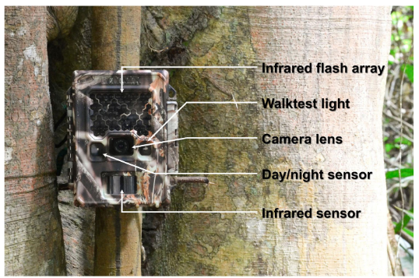 | wearn_gloverkapfer_2017_fig4_3_clipped.png | figure2_caption | figure2_ref_id
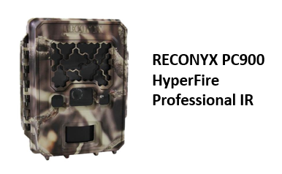 | model_reconyxpc900_hf_pir.png | figure4_caption | figure3_ref_id
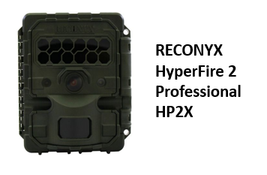 | model_reconyxhp2x.png | figure4_caption | figure4_ref_id
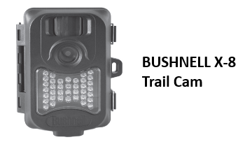 | model_bushnellx_8.png | figure5_caption | figure5_ref_id
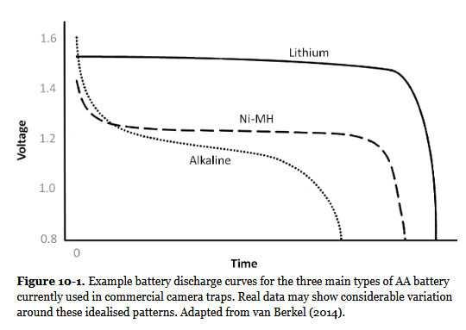 | wearn_gloverkapfer_2017_fig10_1.png | figure6_caption | figure6_ref_id

Video
caption | URL (no < / > before/after URL | ref_id
vid1_caption | vid1_url | vid1_ref_id
vid2_caption | vid2_url | vid2_ref_id
vid3_caption | vid3_url | vid3_ref_id
vid4_caption | vid4_url | vid4_ref_id
vid5_caption | vid5_url | vid5_ref_id
vid6_caption | vid6_url | vid6_ref_id

Shiny
Shiny name = shiny_name
Shiny caption = shiny_caption
Shiny URL = shiny_url

Analytical tools & resources
Type | Name | Note | URL | ref_id
resource1_type | resource1_name | resource1_note | resource1_url | resource1_ref_id
resource2_type | resource2_name | resource2_note | resource2_url | resource2_ref_id
resource3_type | resource3_name | resource3_note | resource3_url | resource3_ref_id
resource4_type | resource4_name | resource4_note | resource4_url | resource4_ref_id
resource5_type | resource5_name | resource5_note | resource5_url | resource5_ref_id
resource6_type | resource6_name | resource6_note | resource6_url | resource6_ref_id
resource7_type | resource7_name | resource7_note | resource7_url | resource7_ref_id
resource8_type | resource8_name | resource8_note | resource8_url | resource8_ref_id
resource9_type | resource9_name | resource9_note | resource9_url | resource9_ref_id
resource10_type | resource10_name | resource10_note | resource10_url | resource10_ref_id
resource11_type | resource11_name | resource11_note | resource11_url | resource11_ref_id
resource12_type | resource12_name | resource12_note | resource12_url | resource12_ref_id
resource13_type | resource13_name | resource13_note | resource13_url | resource13_ref_id
resource14_type | resource14_name | resource14_note | resource14_url | resource14_ref_id
resource15_type | resource15_name | resource15_note | resource15_url | resource15_ref_id

References / Glossary
ref_id | glossary_keys
Refs | keys_here

Notes
“Which camera trap type and how many do I need?” A review of camera features and study designs for a range of wildlife research applications, Francesco Rovero et al.

Camera Trap Recommendations, eMammal

https://wildcams.ca/site/assets/files/1390/wildcam_network_camera_trapping_best_practices_literature_synthesis.pdf

below from lit synthesis????
Often the first choice one would like to make when designing a camera trap survey is to decide on a make and model of camera. There are many different options and features to choose from, which differ in their impacts on the detection process (see also sections 4.1 and 5.5.3). For that reason, deploying multiple types of camera models is not advisable (Palencia et al., 2022). There may be specific camera specifications and settings that are ideal or required to meet the survey objectives; thus, this step should occur after the survey objective(s) have been considered carefully. For example, if the intent is to estimate density via REM, a camera with a fast trigger speed and an infrared (IR) flash is ideal, whereas Xenon white flash may be best for mark-recapture methods (Wearn & Glover-Kapfer, 2017). As another example, faunal detections generally require high sensitivity, fast trigger speeds, wide detection zones (i.e., the area in which a camera can detect a subject through the sensor) and good autonomy (Rovero et al., 2013). Occupancy studies need a fast trigger speed and high sensitivity, although the extent to which is species-dependent (Rovero et al., 2013). As a third example, mark-recapture studies for density or abundance require white flashes, a short recovery time, and a high trigger speed (Rovero et al., 2013). As a final example, random encounter models for density or abundance estimates require a fast trigger speed, large detection zone, no-glow flashes, and the ability to take bursts of photos (Rovero et al., 2013).
Although this is not a complete list, the most important settings/specifications to pay attention to include (see section 5.2): Trigger Speed, Trigger Sensitivity, Flash Type, Flash Sensitivity, Detection Zone, The Number of Photos per Trigger, Quiet Period (aka recovery time), and the Image Quality (resolution/sharpness/clarity; Rovero et al., 2014; Wearn & Glover-Kapfer, 2017). Wearn & Glover-Kapfer (2017) also noted the highly variable detection zones of different sensors.
A detailed comparison of the various hardware options has not been included here, nor is a specific model recommended. Given the numerous camera models available and the frequent release of new models, it would be difficult to provide a recommended make and model that will fit all users' needs. However, there are many studies and reviews that compare the specifications and the appropriateness of different camera models for certain objectives. Refer to the following papers for a more in-depth exploration of camera hardware options:
- Rovero et al. (2014), Glover-Kapfer (2017), Rovero and Zimmermann (2016; sections 2.3 and 2.4.1) for detailed reviews of settings and key features
- Weingarth et al. (2013) compared the image quality and trigger speed of six camera types in relation to detections of elusive species with identifiable markings; only one model was suitable (Cuddeback CaptureTM).
- Wellington et al. (2014) compared two types of cameras with substantially different features/specifications. The Reconyx model, which had a larger detection zone and higher sensitivity sensor, was found to have recorded twice as many independent captures as the other model (Wellington et al. 2014).
- Newey et al. (2015) describe the trade-off between quality vs. cost (cheaper, 'recreational' vs more expensive 'professional' models) and presented two case studies that illustrated that cheaper, recreational models result in higher rates of both false positives and false negative detections.
- Trolliet et al. (2014) reviewed the technical aspects of cameras and suggested that trigger speed is crucial when bait is not deployed or when the target species is slow-moving (since camera traps do not have wide-angle lenses). Trolliet et al. (2014) also suggested that the area of the detection zone is important and should be as large as possible to maximize detection and that recovery time may be very important (objective-dependent) but pointed out that it also varies greatly (for identifying individuals and behaviours, a short recovery time is ideal). Finally, battery life should be as long as possible, but if cameras are frequently serviced, Trolliet et al. (2014) suggested that cheaper cameras may be more cost-effective overall.
- The Zoological Society of London (Seccombe, 2017) empirically tested the detection range and accuracy, burst speed, and image quality of a variety of the most common camera models in a camera trap “buyer's guide.”
- Apps and McNutt (2018) outline their reproducible test for camera specifications and offer suggestions as to the most important specifications for specific purposes.
- Palencia et al. (2022) compared six brands of cameras to identify factors that affect the probability of detection. They found that the period (day/ night), the distance between the camera and the animal, camera model, species, deployment height and trigger sensitivity were all significantly related to detection probability (Palencia et al., 2022).

| Type | Name | Note | URL |Reference |
|:----------------|:---------------------------------------|:----------------------------------------------------------------|:----------------------------------------------------------------|:----------------------------------------------------------------|

POPULATE MARKDOWN
---
jupytext:
formats: md:myst
text_representation:
extension: .md
format_name: myst
format_version: '1.16'
jupytext_version: 1.16.1
kernelspec:
display_name: Python 3
language: python
name: python3
editor_options:
markdown:
wrap: none
---
(i_mod_divers_rich)=
# {{ name_mod_divers_rich }}

:::::::::{div} full-width

:::::::{tab-set}

::::::{tab-item} Overview

**{{ term_mod_divers_rich }}**: {{ term_def_mod_divers_rich }}
<br>
“Species richness is simply the number of species in an area ({{ rtxt_wearn_gloverkapfer_2017 }})

Species diversity is more complex, and includes a measure of the number of species in a community, and a measure of the abundance of each species. Species diversity is usually described by an index, such as Shannon's Index H'.” {{ rtxt_pyron_2010 }}

```{figure} ../03_images/03_image_files/pyron_2010_fig1.png
:align: center
:scale: 60%
```

::::::

::::::{tab-item} Advanced

Parameters:
- **α-richness (alpha richness)**: species richness at the level of an individual camera location {{ rtxt_wearn_gloverkapfer_2019 }}
- **γ-richness (gamma richness)**: species richness across a whole study area {{ rtxt_wearn_gloverkapfer_2019 }}
- **β-diversity (betadiversity)**: the differences between the communities or, more formally, the variance among the communities {{ rtxt_wearn_gloverkapfer_2019 }}
<br>

**Observed *vs* estimated species richness** (from {{ rtxt_wearn_gloverkapfer_2019 }}):
- **Observed species richness**: the sum of the number of species seen (e.g. {{ rtxt_kitamura_et_al_2010 }}; {{ rtxt_pettorelli_et_al_2010 }}; {{ rtxt_ahumada_et_al_2011 }}; {{ rtxt_samejima_et_al_2012 }})
- Observed species richness will not, in general, be a reliable index of actual species richness because, even if sampling effort is strictly controlled, the detectability of species will vary across samples

- **Estimated species richness**: when the “sum of the number of species seen” is adjusted based on corrections for “imperfect detection” (i.e. the fact that some species in a given sample may have been missed)
- (e.g. {{ rtxt_tobler_et_al_2008 }}; {{ rtxt_kinnaird-&-obrien-2012 }}; {{ rtxt_brodie_et_al_2015 }}; {{ rtxt_yue_et_al_2015 }}; {{ rtxt_wearn_et_al_2016 }})
- The **two principal ways of estimating species richness from remote camera data ** are (from {{ rtxt_wearn_gloverkapfer_2019 }}):<br>
- non-parametric estimators ({{ rtxt_gotelli_chao_2013 }}), which use information about the rarest species in the sample to provide a minimum estimate of the number of true species (e.g. {{ rtxt_tobler_et_al_2008 }}),
- or 2) occupancy models ({{ rtxt_mackenzie_et_al_2006 }})

::::::

::::::{tab-item} Visual resources

:::::{grid} 3
:gutter: 1
:padding: 0
:margin: 0

::::{grid-item-card} {{ rtxt_pyron_2010 }}
```{figure} ../03_images/03_image_files/pyron_2010_fig1.png
:height: 300px
:align: center
```

**Pyron (2010) - Figure 1**: Species evenness and species richness for animalcule communities
<!-- Both communities contain five species of animalcules. Species richness is the same. The community on the left is dominated by one of the species. The community on the right has equal proportions of each species. Evenness is higher when species are present in similar proportions. Thus the community on the left has higher species diversity, because evenness is higher. -->

::::

::::{grid-item-card} {{ rtxt_gotelli_colwell_2011 }}
```{figure} ../03_images/03_image_files/gotelli_and_colwell_2011_fig4_1.png
:width: 300px
:align: center
```
NULL

::::

::::{grid-item-card} {{ rtxt_vandooren_2016 }}
```{figure} ../03_images/03_image_files/vandooren_2016_fig1.png
:width: 300px
:align: center
```
**Vandooren (2016) – Figure 1**: Species accumulation curves. Species richness is the asymptote of a species accumulation curve, which expresses the dependence on sampling effort of the number of species sampled from an assemblage….

::::

:::::

:::::{grid} 3
:gutter: 1
:padding: 0
:margin: 0

::::{grid-item-card} {{ rtxt_molloy_2018 }}
```{figure} ../03_images/03_image_files/molloy_2018_fig9.png
:width: 300px
:align: center
```
NULL

::::

::::{grid-item-card} {{ rtxt_loreau_2010 }}
```{figure} ../03_images/03_image_files/loreau_2010_fig4.png
:width: 300px
:align: center
```
**Loreau et al. (2010) – Figure 4.** Species accumulation and rarefaction curves. Species accumulation curves show the number of species obtained by successively censusing either individual organisms (individual-based accumulation curves) or samples (sample-based accumulation curves). Smoothed species rarefaction curves represent the statistical expectation of the corresponding accumulation curves. Credit: Rob Colwell, after Gotelli and Colwell (2001)

::::

::::{grid-item-card} {{ rtxt_loreau_2010 }}
```{figure} ../03_images/03_image_files/loreau_2010_fig3.png
:width: 300px
:align: center
```
**Loreau et al. (2010) – Figure 3.** The various levels of organisation and components that define the multiple facets
of biodiversity

::::

:::::

:::::{grid} 3
:gutter: 1
:padding: 0
:margin: 0

::::{grid-item-card} {{ ref_intext riffomonas_project_2022a }}
<iframe
width=“300”
height=“200”
src=“https://www.youtube.com/embed/ghhZClDRK_g?si=khprL1u5NJrFduTb“
frameborder=“0”
allow=“accelerometer; autoplay; clipboard-write; encrypted-media; gyroscope; picture-in-picture”
allowfullscreen>
</iframe>

Abundance, species richness, and diversity

::::

::::{grid-item-card} {{ ref_intext mecks100_2018 }}
<iframe
width=“300”
height=“200”
src=“https://www.youtube.com/embed/4gcmAUpo9TU?si=_S-JYDDskR8QbHs5“
frameborder=“0”
allow=“accelerometer; autoplay; clipboard-write; encrypted-media; gyroscope; picture-in-picture”
allowfullscreen>
</iframe>

Species accumulation and rarefaction curves

::::

::::{grid-item-card} {{ ref_intext riffomonas_project_2022a }}
<iframe
width=“300”
height=“200”
src=“https://www.youtube.com/embed/wq1SXGQYgCs?si=Re5tglERblfkCNhDl“
frameborder=“0”
allow=“accelerometer; autoplay; clipboard-write; encrypted-media; gyroscope; picture-in-picture”
allowfullscreen>
</iframe>

Using vegan to calculate alpha diversity metrics within the tidyverse in R (CC196)

::::

:::::

:::::{grid} 3
:gutter: 1
:padding: 0
:margin: 0

::::{grid-item-card} {{ ref_intext vsn_international_2022 }}

<iframe
width=“300”
height=“200”
src=“https://www.youtube.com/embed/wBx7f4PP8RE?si=D6mtAMNMLlk3aH8H“
frameborder=“0”
allow=“accelerometer; autoplay; clipboard-write; encrypted-media; gyroscope; picture-in-picture”
allowfullscreen>
</iframe>

Species abundance tools in Genstat

::::

::::{grid-item-card} {{ rtxt_baylor_tutoring_center_2021 }}

<iframe
width=“300”
height=“200”
src=“https://www.youtube.com/embed/UXJ0r4hjbqI?si=gYR6rOmIMgyibyvR“
frameborder=“0”
allow=“accelerometer; autoplay; clipboard-write; encrypted-media; gyroscope; picture-in-picture”
allowfullscreen>
</iframe>

Species Diversity and Species Richness

::::

::::{grid-item-card} {{ ref_intext styring_2020 }}
<iframe
width=“300”
height=“200”
src=“https://www.youtube.com/embed/KBByV3kR3IA?si=RPcG1lFQ-v0Shwaw“
frameborder=“0”
allow=“accelerometer; autoplay; clipboard-write; encrypted-media; gyroscope; picture-in-picture”
allowfullscreen>
</iframe>

Field Ecology - Diversity Metrics in R

::::

:::::

::::::

::::::{tab-item} Shiny apps/Widgets

:::::{card}
** iNEXTOnline **

shiny_caption

<iframe
width=“100%”
height=“900”
src=“https://chao.shinyapps.io/iNEXTOnline“
frameborder=“0”
allow=“accelerometer; autoplay; clipboard-write; encrypted-media; gyroscope; picture-in-picture”
allowfullscreen>
</iframe>

:::::

::::::

::::::{tab-item} Analytical tools & resources

Error! Not a valid filename.
| R package | Chapter 9 Community composition | \- | <https://bookdown.org/c_w_beirne/wildCo-Data-Analysis/composition.html#estimated-richnes> | {{ rbib_wildco_lab_2021b }} |
| R package | R package “vegan | \- | <https://cran.r-project.org/web/packages/vegan/index.html> | {{ rbib_oksanen_et_al_2024 }} |
| Program | EstimateS | Dedicated software for estimating diversity, using asymptotic or rarefaction methods. Mac version available | <https://www.robertkcolwell.org/pages/1407> | {{ rbib_colwell_2022 }} |
| R package | Package ‘iNEXT’ - Interpolation and Extrapolation for Species Diversity | The iNext package (INterpolation and EXTrapolation of species richness) - is both easy to use and rapid to compute. It also comes with a wealth of plotting functions - see the iNext Quick Introduction for a great walk through tutorial. Its core functionality is based on: Chao, Anne, et al. ”Rarefaction and extrapolation with Hill numbers: a framework for sampling and estimation in species diversity studies.” Ecological monographs 84.1 (2014): 45-67. | <https://cran.r-project.org/web/packages/iNEXT/iNEXT.pdf> | {{ rbib_hsieh_et_al_2015 }} |
| Exercise/Tutorial | 2.2: Measuring Species Diversity | Easy to interpet explanation of species richness vs evenness, species area curves, rarefaction, and how to calculate diversity | <https://bio.libretexts.org/Courses/University_of_California_Davis/BIS_2B%3A_Introduction_to_Biology_-_Ecology_and_Evolution/02%3A_Biodiversity/2.02%3A_Measuring_Species_Diversity> | {{ rbib_gerhartbarley_nd }} |
| R package / Tutorial | Species Accumulation Curves with vegan, BiodiversityR and ggplot2 | Software for interpolation and extrapolation of species diversityRarefied Species Accumulation Curves (the simple way) | <https://rpubs.com/Roeland-KINDT/694021> | {{ rbib_resource6_ref_id }} |
| resource7_type | resource7_name | resource7_note | resource7_note | {{ rbib_resource7_ref_id }} |
::::::

::::::{tab-item} References
<font size=“3”>

{{ rbib_ahumada_et_al_2011 }}

{{ rbib_baylor_tutoring_center_2021 }}

{{ rbib_brodie_et_al_2015 }}

{{ chao_et_al_2016 }}

{{ chao_et_al_2014 }}

{{ rbib_colwell_2022 }}

{{ rbib_gerhartbarley_nd }}

{{ rbib_gotelli_colwell_2001 }}

{{ rbib_gotelli_colwell_2010 }}

{{ rbib_hsieh_et_al_2015 }}

{{ rbib_iknayan_et_al_2014 }}

{{ rbib_kinnaird_obrien_2012 }}

{{ rbib_kitamura_et_al_2010 }}

{{ rbib_mackenzie_et_al_2006 }}

{{ rbib_mecks100_2018 }}

{{ rbib_oksanen_et_al_2024 }}

{{ rbib_pettorelli_et_al_2010 }}

{{ rbib_project_dragonfly_2019 }}

{{ rbib_pyron_2010 }}

{{ rbib_riffomonas_project_2022 }}

{{ rbib_samejima_et_al_2012 }}

{{ rbib_styring_2020 }}

{{ rbib_tobler_et_al_2008 }}

{{ rbib_vsn_international_2022 }}

{{ rbib_wearn_et_al_2016 }}

{{ rbib_wildco_lab_2021b }}

{{ rbib_yue_et_al_2015 }}
</font>\

::::::

:::::::

:::::::::

