Topic Info
info_id | bait_lure
question | Do you plan to use bait or lure? If so, will you use the same type of bait or lure, or multiple types?  Will bait/lure be placed at all or a subset of Camera Locations?  Bait/lure  Bait/lure (All or subset of camera locations)

Overview
```{include} include/00_coming_soon.md
```

In-depth
```{include} include/00_coming_soon.md
```

Figures
Image | file_name | Caption (if applicable) | ref_id
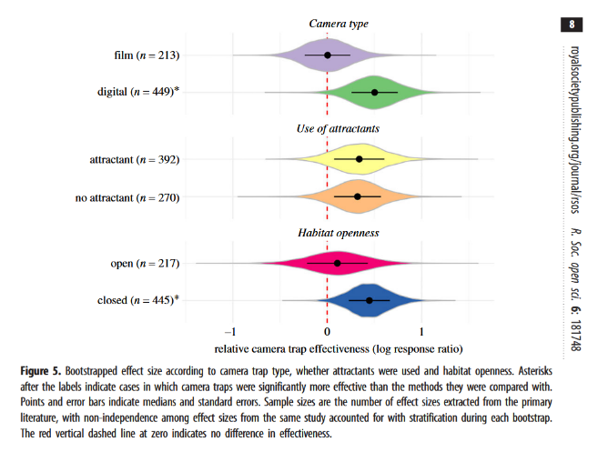 | wearn_gloverkapfer_2019_fig5.png | figure1_caption | wearn_gloverkapfer_2019
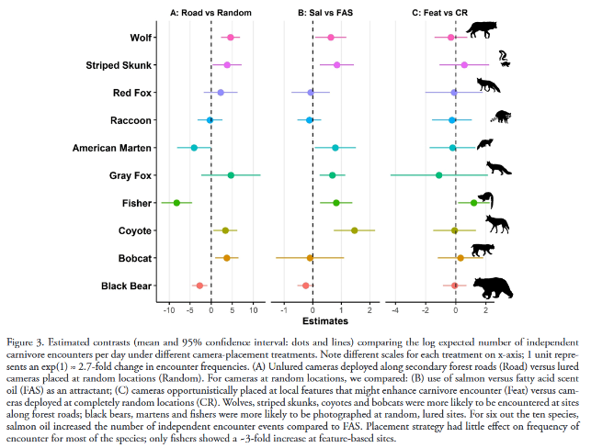 | iannarilli_et_al_2021_fig3.png | figure2_caption | iannarilli_et_al_2021
 | molloy_2018_fig8.png | Figure 8: Average time spent per visit per lure (non- reward) station. Sourced from Thomas & Cowan (2016) | figure3_ref_id
 | figure4_filename.png | figure4_caption | figure4_ref_id
 | figure5_filename.png | figure5_caption | figure5_ref_id
 | figure6_filename.png | figure6_caption | figure6_ref_id

Video
caption | URL (no < / > before/after URL | ref_id
vid1_caption | vid1_url | vid1_ref_id
vid2_caption | vid2_url | vid2_ref_id
vid3_caption | vid3_url | vid3_ref_id
vid4_caption | vid4_url | vid4_ref_id
vid5_caption | vid5_url | vid5_ref_id
vid6_caption | vid6_url | vid6_ref_id

Shiny
Shiny name = shiny_name
Shiny caption = shiny_caption
Shiny URL = shiny_url

Analytical tools & resources
Type | Name | Note | URL | ref_id
resource1_type | resource1_name | resource1_note | resource1_url | resource1_ref_id
resource2_type | resource2_name | resource2_note | resource2_url | resource2_ref_id
resource3_type | resource3_name | resource3_note | resource3_url | resource3_ref_id
resource4_type | resource4_name | resource4_note | resource4_url | resource4_ref_id
resource5_type | resource5_name | resource5_note | resource5_url | resource5_ref_id
resource6_type | resource6_name | resource6_note | resource6_url | resource6_ref_id
resource7_type | resource7_name | resource7_note | resource7_url | resource7_ref_id
resource8_type | resource8_name | resource8_note | resource8_url | resource8_ref_id
resource9_type | resource9_name | resource9_note | resource9_url | resource9_ref_id
resource10_type | resource10_name | resource10_note | resource10_url | resource10_ref_id
resource11_type | resource11_name | resource11_note | resource11_url | resource11_ref_id
resource12_type | resource12_name | resource12_note | resource12_url | resource12_ref_id
resource13_type | resource13_name | resource13_note | resource13_url | resource13_ref_id
resource14_type | resource14_name | resource14_note | resource14_url | resource14_ref_id
resource15_type | resource15_name | resource15_note | resource15_url | resource15_ref_id

References / Glossary
ref_id | glossary_keys
Refs | keys_here

Notes

