Topic Info
info_id | design_camera_arrangement  02_02_camera_arrangement
question

Note banner
<!--
:::{hint}
replace me with text
:::
-->

Overview
:::::::{tab-set}

::::::{tab-item} Overview
Remote {{ cam_location_tl_pl }} (or {{ sample_station_tl_pl }}) and their spatial arrangement are integral components of any study design; these choices will affect the user’s ability to draw inference(s) about the species or question of interest. There are many species-specific characteristics (e.g., body size, behaviour, rarity, etc.) and environmental factors (e.g., vegetation cover, snow depth) that influence the [detection probability](#detection_probability) and probability of occurrence of a species, as well as the size of the area that should be surveyed (e.g., {{ rtxt_becker_et_al_2022 }}; {{ rtxt_hofmeester_et_al_2019 }}; {{ rtxt_iknayan_et_al_2014 }}; {{ rtxt_steenweg_et_al_2019 }}). When there are multiple {{ target_species_tu }}, a mix of study designs may be valuable ({{ rtxt_iannarilli_et_al_2021 }}; {{ rtxt_vanwilgenburg_et_al_2020 }}).

The {{ survey_tl_objectives_abrv }} of the {{ survey_tl }} will determine the most appropriate study design ([Appendix A - Table A2](https://ab-rcsc.github.io/RCSC-WildCAM_Remote-Camera-Survey-Guidelines-and-Metadata-Standards/1_survey-guidelines/1_10.1_AppendixA-Tables.html)). There are five commonly used study designs in camera studies: [simple random](#sampledesign_random), [systematic random](#sampledesign_systematic_random) (grid), [stratified random](#sampledesign_stratified_random), [clustered](#sampledesign_clustered) (including {{ sampledesign_paired_tl }}) and [targeted](#sampledesign_targeted) (or opportunistic) (Wearn & Glover-Kapfer 2017). A [convenience sampling](#sampledesign_convenience) study design is also used when it is impractical to use another design. Sampling design can occur hierarchically, where one approach is used at a larger scale (i.e., to select grids to place cameras within), and another approach is used at a smaller scale (i.e., to select the location within each grid to place the camera). Refer to the following literature for additional recommendations on study design: {{ rtxt_burton_et_al_2015 }}; {{ rtxt_cusack_et_al_2015 }}; {{ rtxt_fisher_burton_2012 }}; Kolowski and Forrester, 2017; {{ rtxt_kolowski_forrester_et_al_2017 }}; {{ rtxt_oconnell_et_al_2011 }}; {{ rtxt_rovero_et_al_2013 }}; {{ rtxt_steenweg_et_al_2015 }}; {{ rtxt_wearn_gloverkapfer_2017 }} and WildCAM’s [“sampling design & effort section section”](https://wildcams.ca/library/camera-trapping-papers-directory/) of their resource library (<https://wildcams.ca/library/camera-trapping-papers-directory/>).

Note that we refer to different configurations of cameras more generally as study design and sampling design; however, the term “[**Survey Design**](#survey_design)” is how the study design is referred to when it applies to an individual {{ survey_tl }}. There may be multiple {{ survey_tu_design_pl }} for {{ survey_tl_pl }} within a {{ project_tl }}; the {{ survey_tu_design }} should be reported separately for each {{ survey_tl }} within a {{ project_tl }}. When the {{ survey_tu_design }} is hierarchical, “Hierarchical (multiple)\*” should be reported and additional details should be included in the {{ survey_tu_design_description }}. Refer to the [AB Metadata Standards](https://ab-rcsc.github.io/RCSC-WildCAM_Remote-Camera-Survey-Guidelines-and-Metadata-Standards/2_metadata-standards/2_0.1_Citation-and-Info.html) (RCSC, 2024) for more information.

(TOC_surv_guidelines_fig_3)=

```{figure} ../03_images/03_image_files/rcsc_et_al_2024_camconfig.png
:align: center
```

**Figure 3.** Examples of sampling designs: (a) simple {{ sampledesign_random_tl_abrv }}, (b) [systematic](#sampledesign_systematic_random), (c) [stratified](#sampledesign_stratified) (each grid cell is a stratum), and (d) [clustered](#sampledesign_clustered) (adapted from {{ rtxt_schweiger_2020 }}).
::::::

::::::{tab-item} Random (or “simple random”)
**Random (or “simple random”) design** ([Figure 3a](#TOC_surv_guidelines_fig_3)) – cameras occur at randomized locations (or sample stations) across the {{ study_area_tl }}, sometimes with a predetermined minimum distance between {{ cam_location_tl_pl }} (or {{ sample_station_tl_pl }}). A {{ sampledesign_random_tl_nu }} may help reduce biases that arise from selecting {{ cam_location_tl_pl }} deliberately. It may also allow the user to make inferences about areas that were not surveyed when employing use-based approaches (e.g. [occupancy models](#mods_occupancy) [{{ rtxt_mackenzie_et_al_2002 }}]; [intensity of use](#intensity_of_use) methods [{{ rtxt_keim_et_al_2019 }}]). Some [modelling approaches](#mods_modelling_approach) (e.g., [random encounter and staying time [REST]](#mods_rest); {{ rtxt_nakashima_et_al_2017 }}) and [random encounter models [REM](#mods_rem); {{ rtxt_rowcliffe_et_al_2008 }}, 2013]) require a simple {{ sampledesign_random_tl_nu }} ([Appendix A - Table A2](https://ab-rcsc.github.io/RCSC-WildCAM_Remote-Camera-Survey-Guidelines-and-Metadata-Standards/1_survey-guidelines/1_10.1_AppendixA-Tables.html)).

A disadvantage of using a simple random design is the tendency to see fewer animals (i.e., is less efficient) when animals are [clustered](#sampledesign_clustered) or exhibit habitat preferences, and the possibility of missing rare habitat types. The proportion of different strata (e.g., habitat types) sampled should be the same as (or close to) the true proportion in the {{ study_area_tl }}. For example, if the {{ study_area_tl }} consists of 25% young deciduous forest, then 25% of randomly selected sites should be within young deciduous forest, on average.
::::::

::::::{tab-item} Systematic
**Systematic design** ([Figure 3b](#TOC_surv_guidelines_fig_3)) – {{ cam_location_tl_pl }} occur within a regular pattern (e.g., a grid pattern) across the {{ study_area_tl }}.

**Systematic random** – {{ cam_location_tl_pl }} are selected using a two-stage approach. Firstly, grids are selected systematically (to occur within a regular pattern) across the {{ study_area_tl }}. The location of the camera within each grid is then selected randomly. This method is similar to the [simple random](#sampledesign_random) design. The same advantages apply in terms of unbiased landscape representation, and the same [modelling approaches](#mods_modelling_approach) can be used. The disadvantage of using a [systematic random](#sampledesign_systematic_random) (or [simple random](#sampledesign_random) design) is that rare habitat types may be missed.

**Systematic non-random** design – sets of [clustered](#sampledesign_clustered) cameras can be deployed within a [systematic non-random](#sampledesign_systematic) approach (i.e., “systematic clustered” or “systematic paired”) to assess the effects of disturbance along a gradient, over time, at multiple scales and/or with control (i.e., reference) {{ sample_station_tl_pl }}. **Hierarchical Before-After Dose-Response (BADR)** is one such method that requires cameras to be placed within a systematic non-random approach, where {{ cam_location_tl_pl }} occur along transects or in [clustered](#sampledesign_clustered) arrays ({{ sample_station_tl_pl }}), selected using a nested spatial hierarchy of sampling to control for variability in land-use type and large-scale patterns ({{ rtxt_bayne_et_al_2022 }}). The {{ study_area_tl }} is divided into land-use regions based on land-use type, then into landscape units, which are assessed for environmental variability to determine where {{ sample_station_tl_pl }} should be placed ({{ rtxt_bayne_et_al_2022 }}). The “Before-After” component of BADR incorporates the phase of stressors (i.e., proposed or current development) ({{ rtxt_bayne_et_al_2022 }}). The “Dose-Response” component of BADR controls for the variable distribution of activity (and the potential impacts) by incorporating control (or reference) {{ sample_station_tl_pl }} and/or by placing cameras in {{ sample_station_tl_pl }} along a gradient of disturbance ({{ rtxt_bayne_et_al_2022 }}).
::::::

::::::{tab-item} Stratified
**Stratified random design** ([Figure 3c](#TOC_surv_guidelines_fig_3)) – the area of interest is divided into smaller strata (e.g., habitat type, disturbance levels), and then a proportional random sample of sites is selected within each stratum (e.g., 15%, 35% and 50% of sites within high, medium and low disturbance strata). This design can help ensure that the sample adequately reflects the major or uncommon strata of interest and may be an efficient approach when users are limited by accessibility constraints ({{ rtxt_wearn_gloverkapfer_2017 }}). This design can also be used to increase precision if animal densities are known to be highly variable ({{ rtxt_junker_et_al_2021 }}) or when a species is expected to occur in certain habitat types more often ({{ rtxt_gillespie_et_al_2015 }}). For example, studies that wish to assess species richness, or {{ occupancy_tl }} rates for a particular species, amongst strata would use a [stratified random](#sampledesign_stratified_random) design.
::::::

::::::{tab-item} Clustered / Paired
**Clustered** design ([Figure 3d](#TOC_surv_guidelines_fig_3)) – multiple cameras are deployed at a {{ sample_station_tl }}. The distance between cameras ({{ cam_spacing_tl }}) will be influenced by the chosen sampling design, the {{ survey_tu_objectives }}, the {{ target_species_tu }} and data analysis. A {{ sampledesign_clustered_tl }} can be used within a [systematic](#sampledesign_systematic) or [stratified](#sampledesign_stratified) approach (i.e., systematic clustered design or as a clustered random design) ({{ rtxt_wearn_gloverkapfer_2017 }}). A {{ sampledesign_clustered_tl }} is common when users are interested in individual identification, such as {{ density_tl }} estimation from [marked](#typeid_marked) or [partially marked populations](#typeid_partially_marked) (e.g., [spatially explicit capture-recapture [SECR](#mods_scr_secr); {{ rtxt_borchers_efford_2008 }}; {{ rtxt_efford_2004 }}; {{ rtxt_royle_young_2008 }}] or [spatial mark-resight [SMR](#mods_smr); {{ rtxt_doran_myers_2018 }}]). A [clustered](#sampledesign_clustered) design can also be used in an [occupancy framework](#mods_occupancy) (O'Connell & Bailey, 2011; {{ rtxt_pacifici_et_al_2016 }}) when interested in measures of species richness ({{ rtxt_obrien_et_al_2011 }}).

A [clustered](#sampledesign_clustered) design can be a cost-efficient approach to increase the number of replicates at each site (especially when accessibility is limiting; {{ rtxt_galvez_et_al_2016 }}) and to reduce measurement error and improve precision (Clarke et al., 2019). However, {{ spatial_autocorrelation_tl }} may occur with this design ({{ rtxt_moqanaki_et_al_2021 }}), depending on the {{ cam_spacing_tl }}.<!-- (see [section 6.2.7](#TOC_surv_guidelines_pseudoreplication)).-->

- Cluster Sampling (Hines et al. 2010): https://doi.org/10.1890/09-0321.1

**Paired design** – a form of “{{ sampledesign_clustered_tl }}” where two cameras that are placed closely together to increase detection probability (“paired cameras”), to evaluate certain conditions (“paired sites,” e.g., on- or off trails), etc. Paired placements can help to account for other variability that might occur (i.e., variation in habitat quality). For some {{ survey_tl_objectives_abrv }}, pairs of cameras might be considered subsamples within another sampling design (e.g., [simple random](#sampledesign_random), [stratified random](#sampledesign_systematic_random), [systematic](#sampledesign_systematic)).
::::::

::::::{tab-item} Targeted
**Targeted design** – cameras are placed in areas that are known or suspected to have higher activity levels (e.g., game trails, mineral licks, etc.). This design is useful when monitoring rare or cryptic species that are unlikely to be detected with other designs. This design is commonly used when estimating densities of [marked populations](#typeid_marked) (e.g., [spatially explicit capture-recapture [SECR](#mods_scr_secr); {{ rtxt_borchers_efford_2008 }}; {{ rtxt_efford_2004 }}; {{ rtxt_royle_young_2008 }}]) or behaviour studies. It is, however, important to understand that [targeted](#sampledesign_targeted) sampling may impede one’s ability to make inferences beyond the {{ survey_tl }} area. For some {{ survey_tl_objectives_abrv }}, [targeted](#sampledesign_targeted) sampling may be used within another sampling design (e.g., a [stratified random](#sampledesign_stratified_random) sample of game trails and seismic lines; {{ rtxt_keim_et_al_2021}}).
::::::

::::::{tab-item} Convenience
**Convenience design** – {{ cam_location_tl_pl }} or {{ sample_station_tl_pl }} are chosen based on logistic considerations (e.g., remoteness, access constraints, costs). When cost is a key consideration, other more rigorous sampling designs (e.g., stratified; {{ rtxt_vanwilgenburg_et_al_2020 }}) that can incorporate cost should be considered first. One should be cautious when generalizing or drawing conclusions from data collected using [convenience sampling](#sampledesign_convenience), given that estimates can be biased if the sample poorly represents the population of interest. The [convenience sampling](#sampledesign_convenience) design can be used where the goal is to {{ survey_tl }} a specific location(s) without the intent to generalize to un-surveyed areas ({{ rtxt_gillespie_et_al_2015 }}; e.g., Kusi et al., 2020) or to {{ survey_tl }} an area following a report of the occurrence of a rare species. Both [randomized](#sampledesign_random) (e.g., {{ rtxt_found_patterson_2020 }}) or [targeted](#sampledesign_targeted) approaches can be used within a [convenience sampling](#sampledesign_convenience) approach, although the user should still be cautious about extrapolating inferences to areas (or habitat types in an [occupancy framework](#mods_occupancy) [{{ rtxt_mackenzie_et_al_2002 }}]) that were not sampled and, therefore, not represented in the data ({{ rtxt_gillespie_et_al_2015 }}).
::::::
:::::::

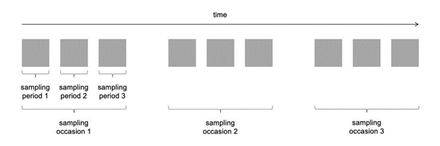
clarke_et_al_2023_fig10_clipped.png

In-depth
This section will be available soon! In the meantime, check out the information in the other tabs!

:::{figure} ../03_images/03_image_files/00_coming_soon.png
:width: 300px
:align: center
:::

Figures
Image | file_name | Caption (if applicable) | ref_id
 | figure1_filename.png | figure1_caption | figure1_ref_id
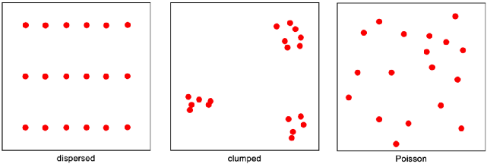  clarke_et_al_2023_fig11_clipped.png | figure2_filename.png | figure2_caption | figure2_ref_id
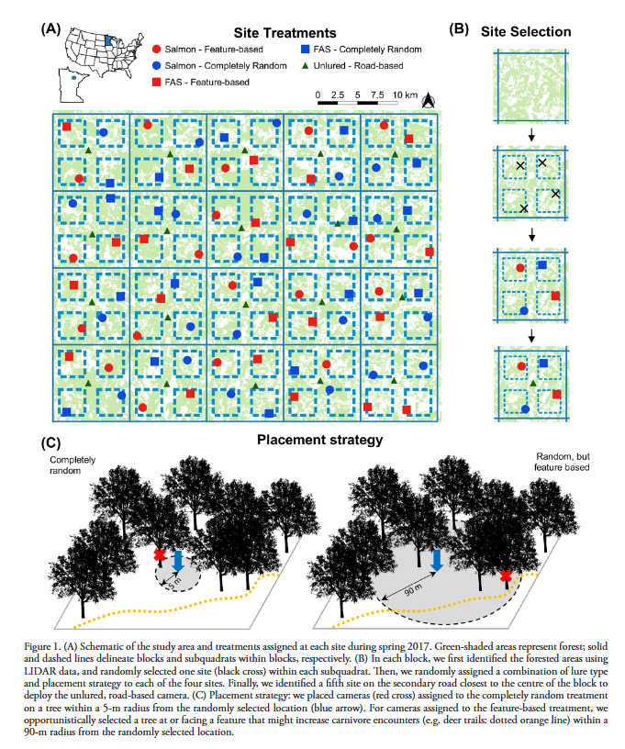 | iannarilli_et_al_2021_fig1.png | figure3_caption | figure3_ref_id
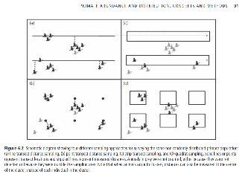 | junker_et_al_2021_fig6_2.png | figure4_caption | figure4_ref_id
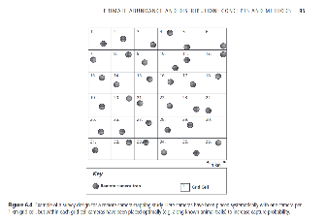 | junker_et_al_2021_fig6_4.png | figure5_caption | figure5_ref_id
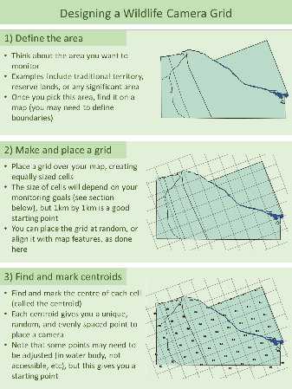 | kemp_et_al_2022_pg12_fig1.png | figure6_caption | figure6_ref_id
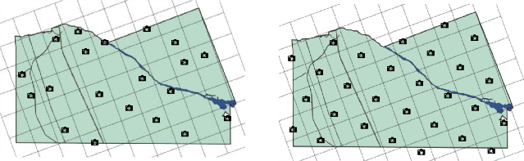 | kemp_et_al_2022_pg13_fig1.png | figure7_caption | figure7_ref_id
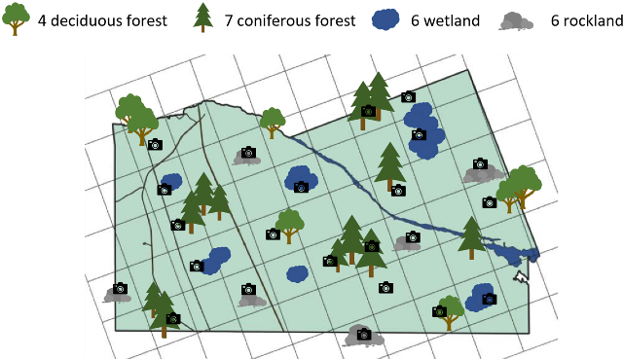 | kemp_et_al_2022_pg13_fig2.png | figure8_caption | figure8_ref_id
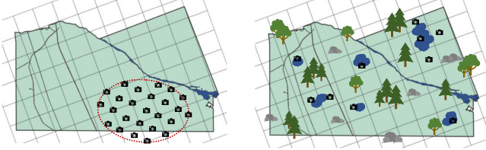 | kemp_et_al_2022_pg14_fig1.png | figure9_caption | figure9_ref_id
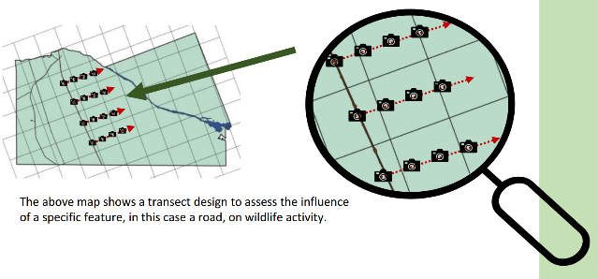 | kemp_et_al_2022_pg14_fig2.png | figure10_caption | figure10_ref_id
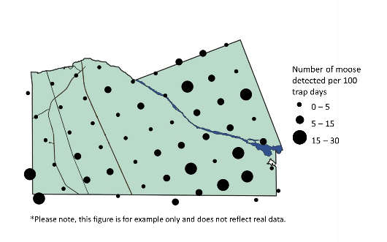 | kemp_et_al_2022_pg28_fig1.png | figure11_caption | figure11_ref_id
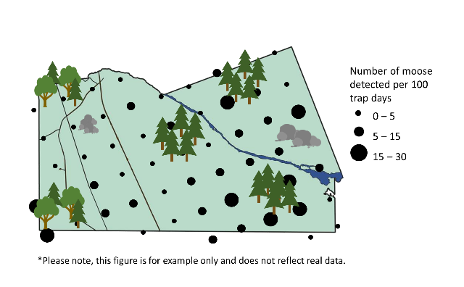 | kemp_et_al_2022_pg29_fig1.png | figure12_caption | figure12_ref_id
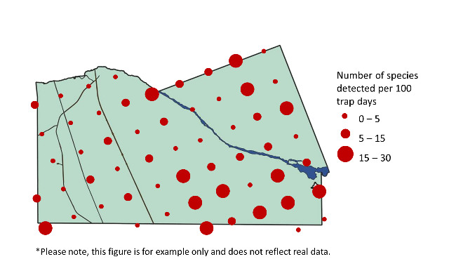 | kemp_et_al_2022_pg30_fig1.png
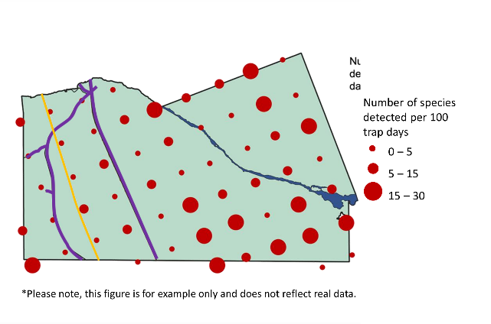 | kemp_et_al_2022_pg30_fig2.png
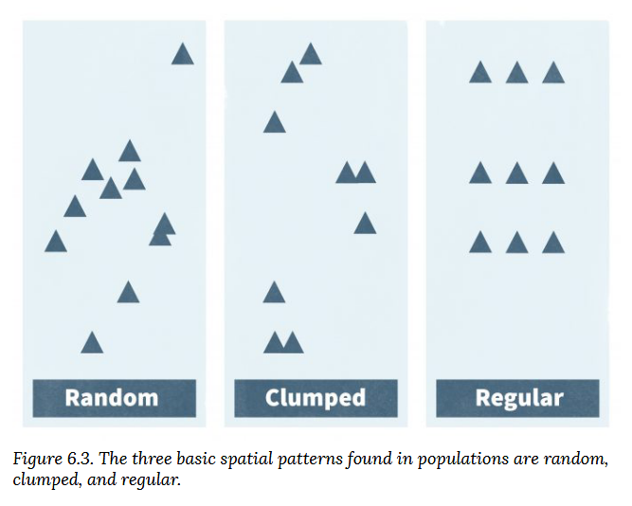 | mccomb_et_al_2010_fig6_3.png
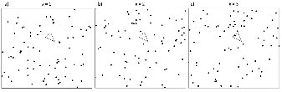 | moeller_et_al_2018_fig2_clipped.png
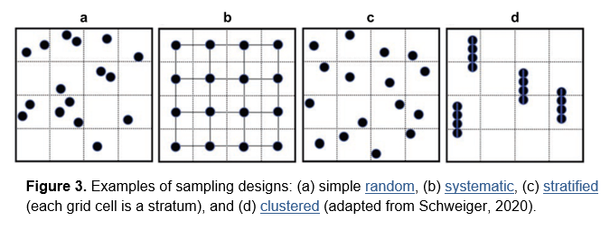
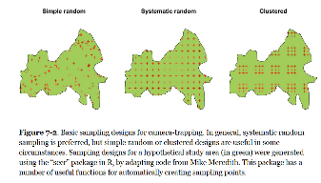 | wearn_gloverkapfer_2017_fig7_2.png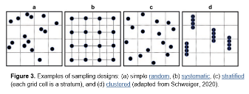
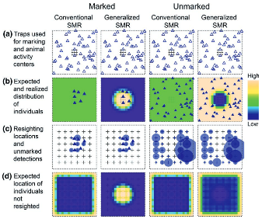 | whittington_et_al_2018_fig1_clipped.png
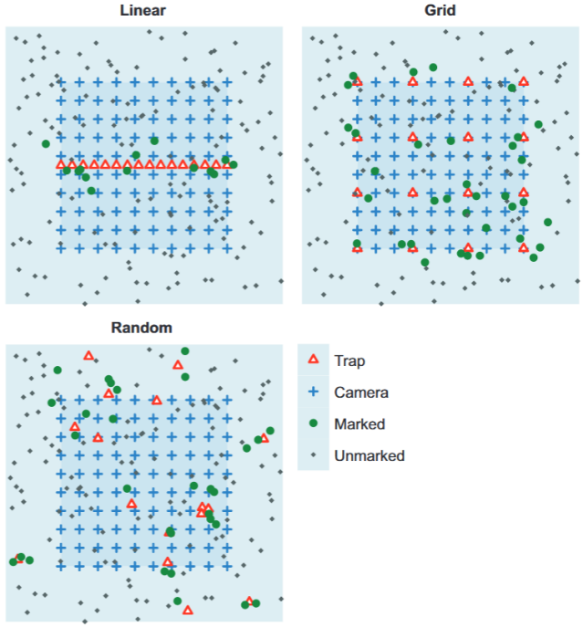 | whittington_et_al_2018_fig2_clipped.png

Video
caption | URL (no < / > before/after URL | ref_id
vid1_caption | vid1_url | vid1_ref_id
vid2_caption | vid2_url | vid2_ref_id
vid3_caption | vid3_url | vid3_ref_id
vid4_caption | vid4_url | vid4_ref_id
vid5_caption | vid5_url | vid5_ref_id
vid6_caption | vid6_url | vid6_ref_id
vid7_caption | vid7_url | vid7_ref_id
vid8_caption | vid8_url | vid8_ref_id
vid9_caption | vid9_url | vid9_ref_id
vid10_caption | vid10_url | vid10_ref_id
vid11_caption | vid11_url | vid11_ref_id
vid12_caption | vid12_url | vid12_ref_id
vid13_caption | vid13_url | vid13_ref_id
vid14_caption | vid14_url | vid14_ref_id
vid15_caption | vid15_url | vid15_ref_id
vid16_caption | vid16_url | vid16_ref_id
vid17_caption | vid17_url | vid17_ref_id
vid18_caption | vid18_url | vid18_ref_id

Shiny
Shiny name = shiny_name
Shiny caption = shiny_caption
Shiny URL = shiny_url

Shiny name = shiny_name2
Shiny caption =shiny_caption2
Shiny URL = shiny_url2

Analytical tools & Resources
Type | Name | Note | URL | ref_id
resource1_type | resource1_name | resource1_note | resource1_url | resource1_ref_id
resource2_type | resource2_name | resource2_note | resource2_url | resource2_ref_id
resource3_type | resource3_name | resource3_note | resource3_url | resource3_ref_id
resource4_type | resource4_name | resource4_note | resource4_url | resource4_ref_id
resource5_type | resource5_name | resource5_note | resource5_url | resource5_ref_id
resource6_type | resource6_name | resource6_note | resource6_url | resource6_ref_id
resource7_type | resource7_name | resource7_note | resource7_url | resource7_ref_id
resource8_type | resource8_name | resource8_note | resource8_url | resource8_ref_id
resource9_type | resource9_name | resource9_note | resource9_url | resource9_ref_id
resource10_type | resource10_name | resource10_note | resource10_url | resource10_ref_id
resource11_type | resource11_name | resource11_note | resource11_url | resource11_ref_id
resource12_type | resource12_name | resource12_note | resource12_url | resource12_ref_id
resource13_type | resource13_name | resource13_note | resource13_url | resource13_ref_id
resource14_type | resource14_name | resource14_note | resource14_url | resource14_ref_id
resource15_type | resource15_name | resource15_note | resource15_url | resource15_ref_id
resource16_type | resource16_name | resource16_note | resource16_url | resource16_ref_id
resource17_type | resource17_name | resource17_note | resource17_url | resource17_ref_id
resource18_type | resource18_name | resource18_note | resource18_url | resource18_ref_id
resource19_type | resource19_name | resource19_note | resource19_url | resource19_ref_id
resource20_type | resource20_name | resource20_note | resource20_url | resource20_ref_id
resource21_type | resource21_name | resource21_note | resource21_url | resource21_ref_id
resource22_type | resource22_name | resource22_note | resource22_url | resource22_ref_id
resource23_type | resource23_name | resource23_note | resource23_url | resource23_ref_id
resource24_type | resource24_name | resource24_note | resource24_url | resource24_ref_id
resource25_type | resource25_name | resource25_note | resource25_url | resource25_ref_id

References / Glossary
ref_id
Refs

Notes

