Topic Info
info_id | mod_smr

Note banner
<!--
:::{hint}
replace me with text
:::
-->

Overview
```{include} include/00_coming_soon.md
```

In-depth
```{include} include/note_adapted_clarke_et_al_2023.md
```

We have already discussed spatially-explicit density models for completely marked populations (spatial capture-recapture, SCR; see {bdg-link-primary-line}`Spatial capture-recapture (SCR) / Spatially explicit capture recapture (SECR)<https://ab-rcsc.github.io/rc-decision-support-tool_concept-library/02_dialog-boxes/03_11_mod_scr_secr.html>`) and completely unmarked populations (spatial count, SC; see {bdg-link-primary-line}`Spatial count<https://ab-rcsc.github.io/rc-decision-support-tool_concept-library/02_dialog-boxes/03_14_mod_sc.html>`) – but what about the “intermediate” situation, in which only a fraction of a population carries marks? Spatial mark-resight (SMR) models were developed for such scenarios.

First, let’s familiarize ourselves with non-spatial mark-resight models (or simply markresight models). Mark-resight models are similar to capture-recapture (CR; see {bdg-link-primary-line}`Capture-recapture (CR) / Capture-mark-recapture (CMR)<https://ab-rcsc.github.io/rc-decision-support-tool_concept-library/02_dialog-boxes/03_10_mod_cr_cmr.html>`) models, but relax CR’s stipulation that all animals in a study population are individually identifiable – that is, that all animals carry unique natural marks, or that all animals are trapped and tagged ({{ rtxt_royle_et_al_2014 }}; {{ rtxt_sollmann_et_al_2013a }}). Instead, mark-resight models need only a subset of the population to be marked (either naturally or from a single trapping-and-tagging event; {{ rtxt_sollmann_et_al_2013a }}). The entire population is then resighted using a “non-invasive” survey technique (i.e., a method that does not require the handling of animals, like an aerial or camera trap survey; {{ rtxt_royle_et_al_2014 }}, {{ rtxt_sollmann_et_al_2013a }}) and population size is calculated using the equation:

:::{figure} ../03_images/03_image_files/clarke_et_al_2023_eqn_smr1.png
:width: 150px
:align: center
:::

where *𝑚* is the number of marked animals, *𝑢* is the number of unmarked animals and *𝑝* is detection probability – the latter of which is determined using data from marked individuals only ({{ rtxt_chandler_royle_2013 }}). Dividing *𝑁* by the area of the sampling frame *𝐴* produces an estimate of total population density.

SMR models integrate spatial information into the mark-resight framework. The result is a hybrid model that combines data from the detection histories of marked individuals, as per SCR, with site-specific counts of unmarked individuals, as per SC ({{ rtxt_royle_et_al_2014 }}). For the remainder of this section, we will discuss camera trap SMR, for which animals are resighted using camera trap arrays.

The first SMR model, developed by Chandler and Royle (2013) and Sollmann et al. (2013a) and now coined “conventional SMR,” models the resighting process only (i.e., ignores the marking process; {{ rtxt_whittington_et_al_2018 }}). In doing so, conventional SMR makes the implicit assumption that marked animals are a random subset of the study population, and thus that 1) marked and unmarked animals are distributed similarly across the landscape, and 2) marked and unmarked animals have equal detection probabilities ({{ rtxt_royle_et_al_2014 }}; {{ rtxt_whittington_et_al_2018 }}). Such assumptions can hold – for example, when a random subset of the population carries natural marks, or when a closed population of animals is trapped and tagged at random locations ({{ rtxt_sollmann_et_al_2013a }}; {{ rtxt_rich_et_al_2014 }}; {{ rtxt_whittington_et_al_2018 }}). These assumptions are violated, however, when animals are trapped and tagged non-randomly (e.g., owing to inaccessibility, rough terrain) before resighting, since the distribution of marked animals will be clustered around trapping-and-tagging sites, and marked animals will have a higher chance of being detected at camera traps near where they were tagged ({{ rtxt_whittington_et_al_2018 }}).

To ease the assumptions and address the limitations of conventional SMR, Whittington et al. (2018) developed generalized SMR, which models the marking and resighting processes separately. The marking sub-model describes where animals were trapped and tagged on the study landscape – that is, how marked individuals are distributed in space ({{ rtxt_jimenez_et_al_2021 }}). Explicitly modelling the marking process allows practitioners to trap and tag animals non-randomly (e.g., using linear or grid trap layouts) without biasing density estimates ({{ rtxt_whittington_et_al_2018 }}). The resighting submodel combines marked individuals’ detection histories, camera trap-specific counts of unmarked individuals and estimates of detection probability to determine population density ({{ rtxt_whittington_et_al_2018 }}).

Practitioners should note that the number of marked animals in a population can influence the precision of SMR studies. The general trend in precision, based on previous SMR studies (both conventional and generalized), is: the more marked animals, the more precise the density estimation (see {{ rtxt_whittington_et_al_2018 }}). Of the four studies compared, only those with 22 or more marked individuals achieved coefficients of variation (CVs) below the accepted threshold for wildlife management (i.e., CV ≤ 0.2; {{ rtxt_sollmann_et_al_2013a }}; {{ rtxt_whittington_et_al_2018 }}; {{ rtxt_williams_et_al_2002 }}).

Figures
Image | file_name | Caption (if applicable) | ref_id
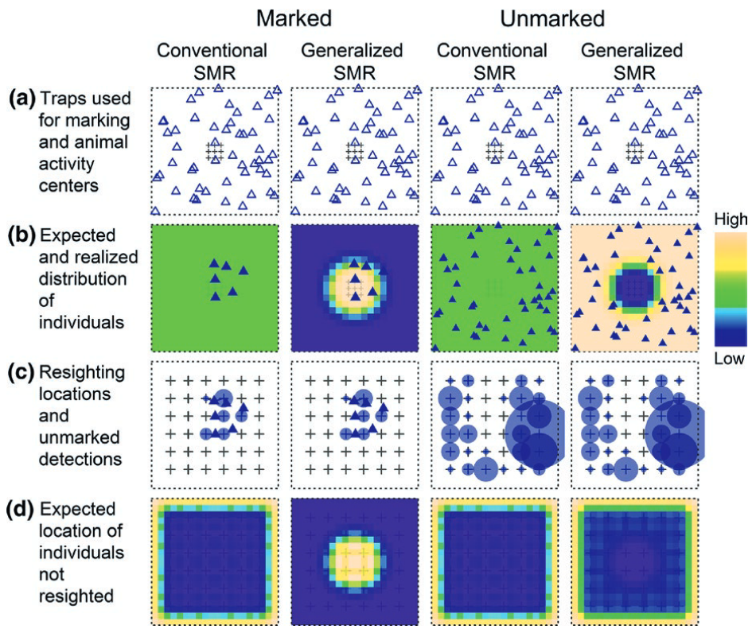 | whittington_et_al_2018_fig1_clipped.png | **Whittington et al. (2018) - Fig. 1** Differences in the distributions of marked and unmarked animals lead to bias in conventional SMR models but not generalized SMR models. (a) Animals (blue triangles) in the state-space are subject to trapping (+) and marking. (b) The expected distributions of marked and unmarked animals are assumed to be identical for conventional SMR models but depend on trap distribution for generalized SMR. (c) Marked and unmarked animals are observed during resight surveys. (d) The expected distribution of marked animals not resighted is incorrectly assumed to be highest near the edge of the state-space for conventional SMR, whereas generalized SMR models correctly assume it is highest closest to traps. | whittington_et_al_2018
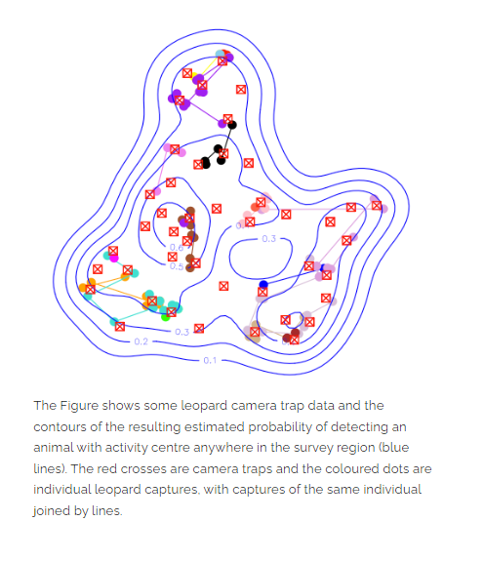 | SECR_creemmural_org_secr.png | figure2_caption | figure2_ref_id
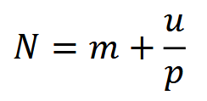 | clarke_et_al_2023_eqn_smr1.png | figure3_caption | clarke_et_al_2023
 | figure4_filename.png | figure4_caption | figure4_ref_id
 | figure5_filename.png | figure5_caption | figure5_ref_id
 | figure6_filename.png | figure6_caption | figure6_ref_id
 | figure7_filename.png | figure7_caption | figure7_ref_id
 | figure8_filename.png | figure8_caption | figure8_ref_id
 | figure9_filename.png | figure9_caption | figure9_ref_id
 | figure10_filename.png | figure10_caption | figure10_ref_id
 | figure11_filename.png | figure11_caption | figure11_ref_id
 | figure12_filename.png | figure12_caption | figure12_ref_id

Video
caption | URL (no < / > before/after URL | ref_id
vid1_caption | vid1_url | vid1_ref_id
vid2_caption | vid2_url | vid2_ref_id
vid3_caption | vid3_url | vid3_ref_id
vid4_caption | vid4_url | vid4_ref_id
vid5_caption | vid5_url | vid5_ref_id
vid6_caption | vid6_url | vid6_ref_id
vid7_caption | vid7_url | vid7_ref_id
vid8_caption | vid8_url | vid8_ref_id
vid9_caption | vid9_url | vid9_ref_id
vid10_caption | vid10_url | vid10_ref_id
vid11_caption | vid11_url | vid11_ref_id
vid12_caption | vid12_url | vid12_ref_id
vid13_caption | vid13_url | vid13_ref_id
vid14_caption | vid14_url | vid14_ref_id
vid15_caption | vid15_url | vid15_ref_id

Shiny
Shiny name = shiny_name
Shiny caption = shiny_caption
Shiny URL = shiny_url

Shiny name = shiny_name2
Shiny caption =shiny_caption2
Shiny URL = shiny_url2

Analytical tools & resources
Type | Name | Note | URL | ref_id
resource1_type | resource1_name | resource1_note | resource1_url | resource1_ref_id
resource2_type | resource2_name | resource2_note | resource2_url | resource2_ref_id
resource3_type | resource3_name | resource3_note | resource3_url | resource3_ref_id
resource4_type | resource4_name | resource4_note | resource4_url | resource4_ref_id
resource5_type | resource5_name | resource5_note | resource5_url | resource5_ref_id
resource6_type | resource6_name | resource6_note | resource6_url | resource6_ref_id
resource7_type | resource7_name | resource7_note | resource7_url | resource7_ref_id
resource8_type | resource8_name | resource8_note | resource8_url | resource8_ref_id
resource9_type | resource9_name | resource9_note | resource9_url | resource9_ref_id
resource10_type | resource10_name | resource10_note | resource10_url | resource10_ref_id
resource11_type | resource11_name | resource11_note | resource11_url | resource11_ref_id
resource12_type | resource12_name | resource12_note | resource12_url | resource12_ref_id
resource13_type | resource13_name | resource13_note | resource13_url | resource13_ref_id
resource14_type | resource14_name | resource14_note | resource14_url | resource14_ref_id
resource15_type | resource15_name | resource15_note | resource15_url | resource15_ref_id

References / Glossary
ref_id
{{ rbib_chandler_royle_2013 }}

{{ rbib_clarke_et_al_2023 }}

{{ rbib_jimenez_et_al_2021 }}

{{ rbib_sollmann_et_al_2013a }}

{{ rbib_rich_et_al_2014 }}

{{ rbib_royle_et_al_2014 }}

{{ rbib_whittington_et_al_2018 }}

{{ rbib_williams_et_al_2002 }}

Notes

POPULATE - MOD

File from = 00_00_template-master.docx
Error! Not a valid filename.
(i_mod_occupancy)=
# {{ name_mod_occupancy }}

<!--
:::{hint}
replace me with text
:::
-->

**{{ term_mod_occupancy }}**: {{ term_def_mod_occupancy }}

:::::::{dropdown} Assumptions, Pros, Cons
:::::{grid}

::::{grid-item-card} Assumptions
- {{ mod_occupancy_assump_01 }}
- {{ mod_occupancy_assump_02 }}
- {{ mod_occupancy_assump_03 }}
- {{ mod_occupancy_assump_04 }}
- {{ mod_occupancy_assump_05 }}
::::
::::{grid-item-card} Pros
- {{ mod_occupancy_pro_01 }}
- {{ mod_occupancy_pro_02 }}
- {{ mod_occupancy_pro_03 }}
- {{ mod_occupancy_pro_04 }}
- {{ mod_occupancy_pro_05 }}
::::
::::{grid-item-card} Cons
- {{ mod_occupancy_con_01 }}
- {{ mod_occupancy_con_02 }}
::::
:::::
:::::::

:::::::{tab-set}

::::::{tab-item} Overview
This section will be available soon! In the meantime, check out the information in the other tabs!

:::{figure} ../03_images/03_image_files/00_coming_soon.png
:width: 300px
:align: center
:::

::::::

::::::{tab-item} In-depth
:::{note}
**This content was adapted from**: The Density Handbook, “[Using Camera Traps to Estimate Medium and Large Mammal Density: Comparison of Methods and Recommendations for Wildlife Managers](https://www.researchgate.net/publication/368601884_Using_Camera_Traps_to_Estimate_Medium_and_Large_Mammal_Density_Comparison_of_Methods_and_Recommendations_for_Wildlife_Managers)” (Clarke et al., 2024)
:::

text
:::::

:::::{grid} 3
:gutter: 1
:padding: 0
:margin: 0

::::{grid-item-card} {{ rtxt_leroy_2024 }}
:::{figure} ../03_images/03_image_files/leroy_2024_Rarity_cutoff-point.png
:class: img_grid
:::
**Leroy (2024)** The rarity cut-off point is here defined as the threshold of occurrence below which species are considered rare.
::::

::::{grid-item-card} {{ rtxt_leroy_2024 }}
:::{figure} ../03_images/03_image_files/leroy_2024_Weight_assignation-curve.png
:class: img_grid
:::
**Leroy (2024)**Weight assignation curve adjusted to an arbitrary rarity cut-off.
::::

::::{grid-item-card} {{ rtxt_figure3_ref_id }}
:::{figure} ../03_images/03_image_files/figure3_filename.png
:class: img_grid
:::
figure4_caption
::::
:::::

:::::{grid} 3
:gutter: 1
:padding: 0
:margin: 0

::::{grid-item-card} {{ rtxt_figure1_ref_id }}
:::{figure} ../03_images/03_image_files/figure1_filename.png
:class: img_grid
:::
figure1_caption
::::

::::{grid-item-card} {{ rtxt_figure2_ref_id }}
:::{figure} ../03_images/03_image_files/figure2_filename.png
:class: img_grid
:::
figure2_caption
::::

::::{grid-item-card} {{ rtxt_figure3_ref_id }}
:::{figure} ../03_images/03_image_files/figure3_filename.png
:class: img_grid
:::
figure3_caption
::::
:::::

::::::

::::::{tab-item} Shiny apps/Widgets
Check back in the future!
::::::

::::::{tab-item} Shiny apps/Widgets
:::::{card} shiny_name
shiny_caption

<iframe
width=“100%”
height=“900”
src=“shiny_url“
loading=“lazy”
frameborder=“0”
allow=“accelerometer; autoplay; clipboard-write; encrypted-media; gyroscope; picture-in-picture”
allowfullscreen>
</iframe>
:::::
::::::

::::::{tab-item} Shiny apps/Widgets
:::::{card}
::::{dropdown} shiny_name
shiny_caption

<iframe
width=“100%”
height=“900”
src=“shiny_url“
loading=“lazy”
frameborder=“0”
allow=“accelerometer; autoplay; clipboard-write; encrypted-media; gyroscope; picture-in-picture”
allowfullscreen>
</iframe>
::::
::::{dropdown} shiny_name2
shiny_caption2

<iframe
width=“100%”
height=“900”
src=“shiny_url2“
loading=“lazy”
frameborder=“0”
allow=“accelerometer; autoplay; clipboard-write; encrypted-media; gyroscope; picture-in-picture”
allowfullscreen>
</iframe>
::::
:::::
::::::

:::::{tab-item} Analytical tools & resources
| Type | Name | Note | URL |Reference |
|:----------------|:-------------------------------|:----------------------------------------------------------------|:----------------------|:----------------------------------------|
| resource1_type | resource1_name | resource1_note | resource1_url | {{ rbib_resource1_ref_id }} |
| resource2_type | resource2_name | resource2_note | resource2_url | {{ rbib_resource2_ref_id }} |
| resource3_type | resource3_name | resource3_note | resource3_url | {{ rbib_resource3_ref_id }} |
| resource4_type | resource4_name | resource4_note | resource4_url | {{ rbib_resource4_ref_id }} |
| resource5_type | resource5_name | resource5_note | resource5_url | {{ rbib_resource5_ref_id }} |
| resource6_type | resource6_name | resource6_note | resource6_url | {{ rbib_resource6_ref_id }} |
| resource7_type | resource7_name | resource7_note | resource7_url | {{ rbib_resource7_ref_id }} |
| resource8_type | resource8_name | resource8_note | resource8_url| {{ rbib_resource8_ref_id}} |
| resource9_type | resource9_name | resource9_note | resource9_url | {{ rbib_resource9_ref_id }} |
| resource10_type | resource10_name | resource10_note | resource10_url | {{ rbib_resource10_ref_id }} |
| resource11_type | resource11_name | resource11_note | resource11_url | {{ rbib_resource11_ref_id }} |
| resource12_type | resource12_name | resource12_note | resource12_url | {{ rbib_resource12_ref_id }} |
| resource13_type | resource13_name | resource13_note | resource13_url | {{ rbib_resource13_ref_id }} |
| resource14_type | resource14_name | resource14_note | resource14_url | {{ rbib_resource14_ref_id }} |
| resource15_type | resource15_name | resource15_note | resource15_url | {{ rbib_resource15_ref_id }} |
| resource16_type | resource16_name | resource16_note | resource16_url | {{ rbib_resource16_ref_id }} |
| resource17_type | resource17_name | resource17_note | resource17_url | {{ rbib_resource17_ref_id }} |
| resource18_type | resource18_name | resource18_note | resource18_url| {{ rbib_resource18_ref_id}} |
| resource19_type | resource19_name | resource19_note | resource19_url | {{ rbib_resource19_ref_id }} |
| resource20_type | resource20_name | resource20_note | resource20_url | {{ rbib_resource20_ref_id }} |
::::::

::::::{tab-item} References
{{ rbib_burton_et_al_2015 }}

{{ rbib_cove_2020a }}
::::::

:::::::

