Topic Info
info_id | mod_rest

Note banner
<!--
:::{hint}
replace me with text
:::
-->

Overview
```{include} include/00_coming_soon.md
```

“The REST model describes the relationship among population density, mean number of detections by a camera trap during a survey period, and staying time of individual animals in a predetermined detection zone in which individuals are certain to be detected by the camera trap.” ({{ rtxt_nakashima_et_al_2017 }}).

In-depth
```{include} include/note_adapted_clarke_et_al_2023.md
```

The random encounter and staying time (REST) model is an extension of the random encounter model (REM; ({{ rtxt_gilbert_et_al_2020 }}). Like the REM, the REST treats animals like ideal gas particles (i.e., like randomly and independently moving entities); unlike the REM, the REST does not require measures of animal movement speed. Instead, the model uses the time animals spend in the camera viewshed (i.e., their “staying time”) as a proxy for animal movement speed, since the two measures are inversely proportional ({{ rtxt_nakashima_et_al_2017 }}).

The REST equation is a modified version of the REM equation which substitutes staying time for movement speed, and a detection area of set size for detection zone radius and angle, such that:

```{figure} ../03_images/03_image_files/clarke_et_al_2023_eqn_rest1.png
:align: center
```

where *𝑌* is the number of detections, *𝑇* is the staying time, *𝑠* is the area within which all individuals are certain to be detected (hereafter, focal area), and *𝐻* is the total research period (i.e., the total sampling time; {{ rtxt_nakashima_et_al_2017 }}). This equation produces an estimate of density *𝐷* at a single camera; to determine population density for the study area, density estimates must be averaged across camera stations.

To implement the REST model, practitioners must first establish the focal area *𝑠*. Methods at practitioners’ disposal include testing focal areas of different sizes under controlled conditions (e.g., using domestic animals) and determining detection probabilities ({{ rtxt_nakashima_et_al_2017 }}; {{ rtxt_rowcliffe_et_al_2014 }}), or using distance sampling (DS) functions to delineate the zone of certain detection (as described in Hofmeester et al. [2017] and implemented in Palencia et al. [2021]). Although it can be any shape, a triangular focal area maximizes the number of usable detections (fewer captures fall outside of the focal area; {{ rtxt_nakashima_et_al_2017 }}).

Once established, the focal area is staked out in front of every camera in the field (e.g., using ropes and pegs), a reference image is taken, and any staking equipment is removed before the camera is left to collect images or videos ({{ rtxt_nakashima_et_al_2017 }}; {{ rtxt_palencia_et_al_2021 }}; {{ rtxt_nakajima_2021a }}). During image processing, captures of animals are overlaid on reference images (Figure 8A; {{ rtxt_nakajima_2021a }}). Alternatively, the focal area can be superimposed on captures of animals as in Figure 8B. Markers (e.g., stones) placed at known distances from the camera are used as a guide for placing the focal area ({{ rtxt_palencia_et_al_2021 }}). Staying time *𝑇* is the time an animal spends in the focal area; it is measured from the moment an animal’s hind leg enters the focal area until it exits (i.e.,* 𝑇<sub>𝑒𝑥𝑖𝑡</sub> − 𝑇<sub>𝑒𝑛𝑡𝑒𝑟</sub>*).

Importantly, estimates of density *𝐷* must be corrected for activity level – that is, the proportion of time animals are active – such that:

```{figure} ../03_images/03_image_files/clarke_et_al_2023_eqn_rest2.png
:width: 300px
:align: center
```

where *𝐷̂* is the corrected density estimate and *𝑎* is the activity level ({{ rtxt_palencia_et_al_2021 }}, ({{ rtxt_rowcliffe_et_al_2014 }}). Activity level is determined as per Rowcliffe et al. (2014).

```{figure} ../03_images/03_image_files/clarke_et_al_2023_fig8_clipped.png
:width: 300px
:align: center
```

> **Clarke et al. 2023 - Fig. 8.** A) Still from 中島啓裕’s (2021a) video series. Example of overlaying a video recording of an animal on a Reference image of the focal area (faint triangle) to determine staying time *𝑇*. B) Still from Appendix S2 from Palencia et al. (2021). Example of superimposing the focal area on an image capture.

## Simulations and Field Experiments

Nakashima et al. (2017) ran random walk simulations to test the REST’s performance. In its simplest form, a random walk models the series of steps an animal (the “walker”) takes – each in a completely arbitrary direction, or in a pattern informed by behaviour, ecology and environment ({{ rtxt_codling_et_al_2008 }}). Nakashima et al.’s (2017) simulations showed that the REST model was robust to grouping behaviour and variation in animal movement speed. More specifically, the REST produced accurate estimates of density when animals travelled in pairs, and when animals covered different distances during the sampling period ({{ rtxt_nakashima_et_al_2017 }}). The model produced biased results, however, when captures of animals resting in the focal area were included in staying times ({{ rtxt_nakashima_et_al_2017 }}). To minimize bias: 1) any detections with exceedingly long staying times (i.e., right outliers) should be discarded; and 2) density estimates should be corrected for activity level *𝑎* using the method outlined in Rowcliffe et al. (2014; {{ rtxt_nakashima_et_al_2017 }}).

Garland et al. (2020) ran a “real life” simulation of the REST using human volunteers. The researchers found that the model produced accurate density estimates, even when home range size, population size and movement patterns varied – but that scenarios in which people moved at a constant rate yielded more precise estimates than those in which people rested periodically ({{ rtxt_garland_et_al_2020 }}). Larger populations were also associated with lower-precision estimates (i.e., the bigger the population, the less precise the density estimate) – as population size increases, so too does the variation in staying times, reducing the overall precision of REST estimates ({{ rtxt_garland_et_al_2020 }}). Note than humans were fully agnostic to detectors – an assumption often violated by animals ({{ rtxt_caravaggi_et_al_2020 }}).

Both Garland et al. (2020) and Nakashima et al. (2018) tested the effect of sampling effort on the REST; both concluded that the model can yield accurate results, even when effort is relatively small (1% of study area sampled or 10 cameras deployed for 10 days, respectively). Note, however, that these results pertain to very high-density populations – animal density was 125 to 750 individuals per km<sup>2</sup> in Garland et al. (2020) and 10 individuals per km<sup>2</sup> in Nakashima et al. (2018) – and likely do not apply to average-to-low density populations. Low sampling effort was also linked to imprecision – the fewer cameras deployed, the less precise the density estimate ({{ rtxt_garland_et_al_2020 }}; {{ rtxt_nakashima_et_al_2017 }}). Thus, although little sampling effort is needed to produce accurate density estimates for very dense populations, considerable sampling effort will be necessary for most populations, and to produce precise estimates.

### In the field
- The REST was initially validated by Nakashima et al. (2018), who compared density estimates of forest-dwelling antelopes from the camera data-based model and line-transect surveys (see {bdg-link-primary-line}`Distance sampling<https://ab-rcsc.github.io/rc-decision-support-tool_concept-library/02_dialog-boxes/03_20_mod_ds.html>`). In this system, both methods produced similar estimates of antelope density, with similar precision ({{ rtxt_nakashima_et_al_2017 }}). A follow-up study in the same area further demonstrated that the model can produce unbiased estimates of density ({{ rtxt_nakashima_et_al_2020 }}).
- The model produced estimates of snowshoe hare density comparable to livetrapping SCR in the boreal forest of the northwestern United States ({{ rtxt_jensen_et_al_2022 }}). REST- and REM-based estimates were also consistent with each other, and both models outperformed the time-to-event model (TTE; see {bdg-link-primary-line}`Time-to-event<https://ab-rcsc.github.io/rc-decision-support-tool_concept-library/02_dialog-boxes/03_20_mod_tte.html>`; {{ rtxt_jensen_et_al_2022 }}).
- Palencia et al. (2021) found that REST-derived density estimates were consistent with line-transect surveys of deer, but not with drive-count surveys of boar; the REST underestimated density compared to the latter. The model was, however, highly consistent with the REM and camera trap distance sampling (DS; {{ rtxt_palencia_et_al_2021 }}). Furthermore, the REST was more precise than the other two camera models – although not significantly ({{ rtxt_palencia_et_al_2021 }}).

Practitioners should be aware that population densities were quite high in the studies listed above (about 1 to 160 animals per km<sup>2</sup>; {{ rtxt_jensen_et_al_2022 }}; {{ rtxt_nakashima_et_al_2017 }}). Thus, while the REST model applies well to very dense populations, it may not be appropriate for average-to-low density populations (e.g., wildlife populations in BC, with densities often <1 animal/km<sup>2</sup>); further investigation is needed ({{ rtxt_morin_et_al_2022 }}). The precision of the REST is also inversely related to population size – the smaller the population, the less precise the density estimate ({{ rtxt_morin_et_al_2022 }}).

Figures
Image | file_name | Caption (if applicable) | ref_id
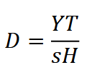 | clarke_et_al_2023_eqn_rest1.png |  | clarke_et_al_2023
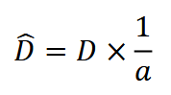 | clarke_et_al_2023_eqn_rest2.png |  | clarke_et_al_2023
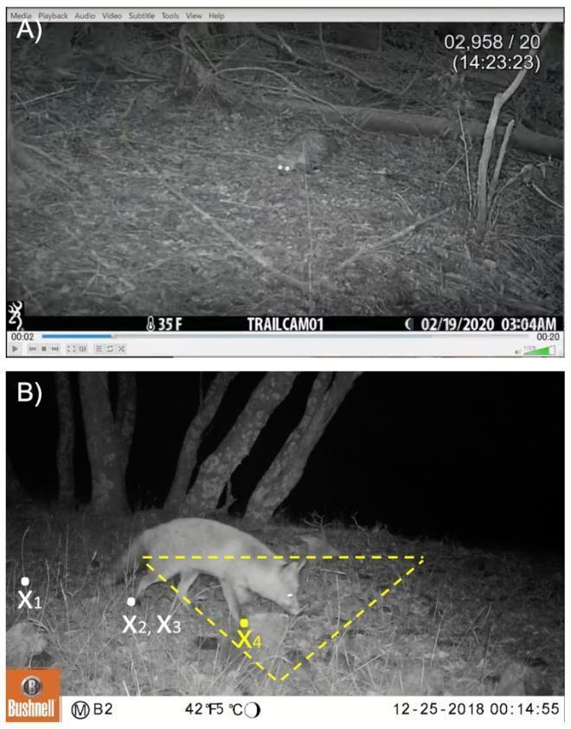 | clarke_et_al_2023_fig8_clipped.png | **Clarke et al. (2023) - Fig. 8 ** A) Still from 中島啓裕’s (2021) video series. Example of overlaying a video recording of an animal on a Reference image of the focal area (faint triangle) to determine staying time *𝑇*. B) Still from Appendix S2 from Palencia et al. (2021). Example of superimposing the focal area on an image capture. | clarke_et_al_2023
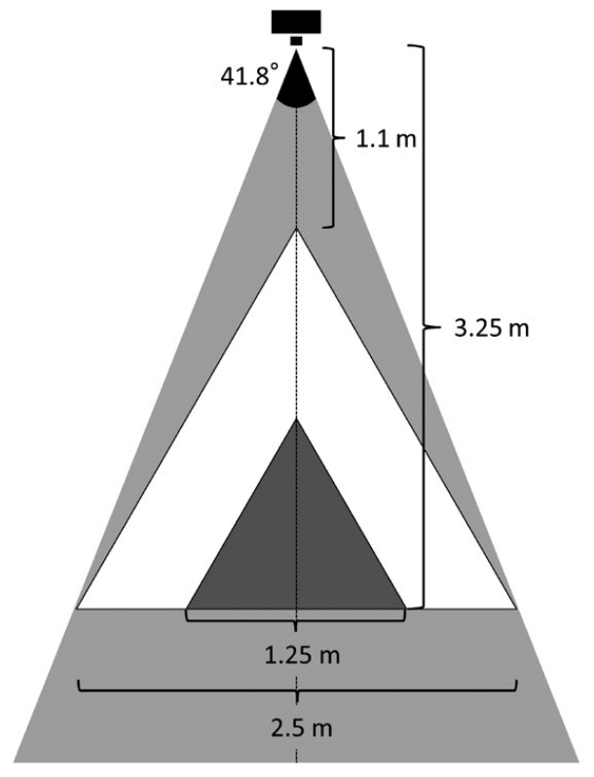 | nakashima_et_al_2017_fig1_clipped.png | **Nakashima et al. (2017) - Fig. 1** The view-angle and total area in which camera traps (Bushnell Trophy Cam 2010) can successfully detect passing animals and capture video images of them (grey triangle). Only video data capturing animals that passed within the larger (white; 2.67 m2) or smaller focal area (black; 0.67 m2) were used for density estimations. See text for the details. | nakashima_et_al_2017
 | figure5_filename.png | figure5_caption | figure5_ref_id
 | figure6_filename.png | figure6_caption | figure6_ref_id
 | figure7_filename.png | figure7_caption | figure7_ref_id
 | figure8_filename.png | figure8_caption | figure8_ref_id
 | figure9_filename.png | figure9_caption | figure9_ref_id
 | figure10_filename.png | figure10_caption | figure10_ref_id
 | figure11_filename.png | figure11_caption | figure11_ref_id
 | figure12_filename.png | figure12_caption | figure12_ref_id

Video
caption | URL (no < / > before/after URL | ref_id
Density Estimation with the REST Model > REST_01_Set_Focal_Area | https://www.youtube.com/embed/pUa9rgxSGVA?si=pOIqFPL6AxNuUYJtl | nakajima_2021b
Density Estimation with the REST Model > REST_02_Set_Up_Emv | https://www.youtube.com/embed/wqEF_up7EGs?si=IL2_moYR0XpdR-Fk | nakajima_2021c
Density Estimation with the REST Model > REST_03_MeasureStayingTime | https://www.youtube.com/embed/s-d81K72yWs?si=PqWOR_dvvkCfoLY7 | nakajima_2021d
vid4_caption | vid4_url | vid4_ref_id
vid5_caption | vid5_url | vid5_ref_id
vid6_caption | vid6_url | vid6_ref_id

Shiny
Shiny name = shiny_name
Shiny caption = shiny_caption
Shiny URL = shiny_url

Analytical tools & resources
Type | Name | Note | URL | ref_id
resource1_type | resource1_name | resource1_note | resource1_url | resource1_ref_id
resource2_type | resource2_name | resource2_note | resource2_url | resource2_ref_id
resource3_type | resource3_name | resource3_note | resource3_url | resource3_ref_id
resource4_type | resource4_name | resource4_note | resource4_url | resource4_ref_id
resource5_type | resource5_name | resource5_note | resource5_url | resource5_ref_id
resource6_type | resource6_name | resource6_note | resource6_url | resource6_ref_id
resource7_type | resource7_name | resource7_note | resource7_url | resource7_ref_id
resource8_type | resource8_name | resource8_note | resource8_url | resource8_ref_id
resource9_type | resource9_name | resource9_note | resource9_url | resource9_ref_id
resource10_type | resource10_name | resource10_note | resource10_url | resource10_ref_id
resource11_type | resource11_name | resource11_note | resource11_url | resource11_ref_id
resource12_type | resource12_name | resource12_note | resource12_url | resource12_ref_id
resource13_type | resource13_name | resource13_note | resource13_url | resource13_ref_id
resource14_type | resource14_name | resource14_note | resource14_url | resource14_ref_id
resource15_type | resource15_name | resource15_note | resource15_url | resource15_ref_id

References / Glossary
ref_id | glossary_keys
{{ rbib_caravaggi_et_al_2020 }}  {{ rbib_clarke_et_al_2023 }}  {{ rbib_codling_et_al_2008 }}  {{ rbib_garland_et_al_2020 }}  {{ rbib_gilbert_et_al_2020 }})  {{ rbib_hofmeester_et_al_2017 }})  {{ rbib_jensen_et_al_2022 }}  {{ rbib_morin_et_al_2022 }}  {{ rbib_nakashima_et_al_2017 }}  {{ rbib_nakashima_et_al_2020 }}  {{ rbib_palencia_et_al_2021 }}  {{ rbib_rowcliffe_et_al_2014 }}  {{ rbib_nakajima_2021a }}  {{ rbib_nakajima_2021b }}  {{ rbib_nakajima_2021c }}  {{ rbib_nakajima_2021d }} | keys_here

Notes
- UBC_CAMERA_Report1_Density_31Jan2023.pdf
- Garland_et_al_(2020) advise that the REST model should not be used for species that exhibit heterogeneous patterns of moving and resting.

Markdown

File from = 00_00_template-master.docx

POPULATE - MOD
---
jupytext:
formats: md:myst
text_representation:
extension: .md
format_name: myst
format_version: 0.17.2 <!--0.13-->
jupytext_version: 1.16.4 <!-- 6.5.4-->
kernelspec:
display_name: Python 3
language: python
name: python3
editor_options:
markdown:
wrap: none
---
(i_mod_occupancy)=
# {{ name_mod_occupancy }}

<!--
:::{hint}
replace me with text
:::
-->

**{{ term_mod_occupancy }}**: {{ term_def_mod_occupancy }}

:::::::{dropdown} Assumptions, Pros, Cons
:::::{grid}

::::{grid-item-card} Assumptions
- {{ mod_occupancy_assump_01 }}
- {{ mod_occupancy_assump_02 }}
- {{ mod_occupancy_assump_03 }}
- {{ mod_occupancy_assump_04 }}
- {{ mod_occupancy_assump_05 }}
::::
::::{grid-item-card} Pros
- {{ mod_occupancy_pro_01 }}
- {{ mod_occupancy_pro_02 }}
- {{ mod_occupancy_pro_03 }}
- {{ mod_occupancy_pro_04 }}
- {{ mod_occupancy_pro_05 }}
::::
::::{grid-item-card} Cons
- {{ mod_occupancy_con_01 }}
- {{ mod_occupancy_con_02 }}
::::
:::::
:::::::

:::::::{tab-set}

::::::{tab-item} Overview
This section will be available soon! In the meantime, check out the information in the other tabs!

:::{figure} ../03_images/03_image_files/00_coming_soon.png
:width: 300px
:align: center
:::

::::::

::::::{tab-item} In-depth
:::{note}
**This content was adapted from**: The Density Handbook, “[Using Camera Traps to Estimate Medium and Large Mammal Density: Comparison of Methods and Recommendations for Wildlife Managers](https://www.researchgate.net/publication/368601884_Using_Camera_Traps_to_Estimate_Medium_and_Large_Mammal_Density_Comparison_of_Methods_and_Recommendations_for_Wildlife_Managers)” (Clarke et al., 2024)
:::

text
:::::

:::::{grid} 3
:gutter: 1
:padding: 0
:margin: 0

::::{grid-item-card} {{ rtxt_leroy_2024 }}
:::{figure} ../03_images/03_image_files/leroy_2024_Rarity_cutoff-point.png
:class: img_grid
:::
**Leroy (2024)** The rarity cut-off point is here defined as the threshold of occurrence below which species are considered rare.
::::

::::{grid-item-card} {{ rtxt_leroy_2024 }}
:::{figure} ../03_images/03_image_files/leroy_2024_Weight_assignation-curve.png
:class: img_grid
:::
**Leroy (2024)**Weight assignation curve adjusted to an arbitrary rarity cut-off.
::::

::::{grid-item-card} {{ rtxt_figure3_ref_id }}
:::{figure} ../03_images/03_image_files/figure3_filename.png
:class: img_grid
:::
figure4_caption
::::
:::::

:::::{grid} 3
:gutter: 1
:padding: 0
:margin: 0

::::{grid-item-card} {{ rtxt_figure1_ref_id }}
:::{figure} ../03_images/03_image_files/figure1_filename.png
:class: img_grid
:::
figure1_caption
::::

::::{grid-item-card} {{ rtxt_figure2_ref_id }}
:::{figure} ../03_images/03_image_files/figure2_filename.png
:class: img_grid
:::
figure2_caption
::::

::::{grid-item-card} {{ rtxt_figure3_ref_id }}
:::{figure} ../03_images/03_image_files/figure3_filename.png
:class: img_grid
:::
figure3_caption
::::
:::::

:::::{grid} 3
:gutter: 1
:padding: 0
:margin: 0

::::{grid-item-card} {{ rtxt_figure4_ref_id }}
:::{figure} ../03_images/03_image_files/figure4_filename.png
:class: img_grid
:::
figure4_caption
::::

::::{grid-item-card} {{ rtxt_figure5_ref_id }}
:::{figure} ../03_images/03_image_files/figure5_filename.png
:class: img_grid
:::
figure5_caption
::::

::::{grid-item-card} {{ rtxt_figure6_ref_id }}
:::{figure} ../03_images/03_image_files/figure6_filename.png
:class: img_grid
:::
figure6_caption
::::
:::::

:::::{grid} 3
:gutter: 1
:padding: 0
:margin: 0

::::{grid-item-card} {{ rtxt_figure7_ref_id }}
:::{figure} ../03_images/03_image_files/figure7_filename.png
:class: img_grid
:::
figure7_caption
::::

::::{grid-item-card} {{ rtxt_figure8_ref_id }}
:::{figure} ../03_images/03_image_files/figure8_filename.png
:class: img_grid
:::
figure8_caption
::::

::::{grid-item-card} {{ rtxt_figure9_ref_id }}
:::{figure} ../03_images/03_image_files/figure9_filename.png
:class: img_grid
:::
figure9_caption
::::
:::::

:::::{grid} 3
:gutter: 1
:padding: 0
:margin: 0

::::{grid-item-card} {{ rtxt_figure10_ref_id }}
:::{figure} ../03_images/03_image_files/figure10_filename.png
:class: img_grid
:::
figure10_caption
::::

::::{grid-item-card} {{ rtxt_figure11_ref_id }}
:::{figure} ../03_images/03_image_files/figure11_filename.png
:class: img_grid
:::
figure11_caption
::::

::::{grid-item-card} {{ rtxt_figure12_ref_id }}
:::{figure} ../03_images/03_image_files/figure12_filename.png
:class: img_grid
:::
figure12_caption
::::
:::::

:::::{grid} 3
:gutter: 1
:padding: 0
:margin: 0

::::{grid-item-card} {{ rtxt_vid1_ref_id }}
<div>
<div style=“position:relative;padding-top:56.25%;”>
<iframe src=“vid1_url“ frameborder=“0” allowfullscreen
style=“position:absolute;top:0;left:0;width:100%;height:100%;”></iframe>
</div>
</div>

vid1_caption
::::

::::{grid-item-card} {{ rtxt_vid2_ref_id }}
<div>
<div style=“position:relative;padding-top:56.25%;”>
<iframe src=“vid2_url“ frameborder=“0” allowfullscreen
style=“position:absolute;top:0;left:0;width:100%;height:100%;”></iframe>
</div>
</div>

vid2_caption
::::

::::{grid-item-card} {{ rtxt_vid3_ref_id }}
<div>
<div style=“position:relative;padding-top:56.25%;”>
<iframe src=“vid3_url“ frameborder=“0” allowfullscreen
style=“position:absolute;top:0;left:0;width:100%;height:100%;”></iframe>
</div>
</div>

vid3_caption
::::
:::::

:::::{grid} 3
:gutter: 1
:padding: 0
:margin: 0

::::{grid-item-card} {{ rtxt_vid4_ref_id }}
<div>
<div style=“position:relative;padding-top:56.25%;”>
<iframe src=“vid4_url“ frameborder=“0” allowfullscreen
style=“position:absolute;top:0;left:0;width:100%;height:100%;”></iframe>
</div>
</div>

vid4_caption
::::

::::{grid-item-card} {{ rtxt_vid5_ref_id }}
<div>
<div style=“position:relative;padding-top:56.25%;”>
<iframe src=“vid5_url“ frameborder=“0” allowfullscreen
style=“position:absolute;top:0;left:0;width:100%;height:100%;”></iframe>
</div>
</div>

vid5_caption
::::

::::{grid-item-card} {{ rtxt_vid6_ref_id }}
<div>
<div style=“position:relative;padding-top:56.25%;”>
<iframe src=“vid6_url“ frameborder=“0” allowfullscreen
style=“position:absolute;top:0;left:0;width:100%;height:100%;”></iframe>
</div>
</div>

vid6_caption
::::
:::::

:::::{grid} 3
:gutter: 1
:padding: 0
:margin: 0

::::{grid-item-card} {{ rtxt_vid7_ref_id }}
<div>
<div style=“position:relative;padding-top:56.25%;”>
<iframe src=“vid7_url“ frameborder=“0” allowfullscreen
style=“position:absolute;top:0;left:0;width:100%;height:100%;”></iframe>
</div>
</div>

vid7_caption
::::

::::{grid-item-card} {{ rtxt_vid8_ref_id }}
<div>
<div style=“position:relative;padding-top:56.25%;”>
<iframe src=“vid8_url“ frameborder=“0” allowfullscreen
style=“position:absolute;top:0;left:0;width:100%;height:100%;”></iframe>
</div>
</div>

vid8_caption
::::

::::{grid-item-card} {{ rtxt_vid9_ref_id }}
<div>
<div style=“position:relative;padding-top:56.25%;”>
<iframe src=“vid9_url“ frameborder=“0” allowfullscreen
style=“position:absolute;top:0;left:0;width:100%;height:100%;”></iframe>
</div>
</div>

vid9_caption
::::
:::::

::::::

::::::{tab-item} Shiny apps/Widgets
Check back in the future!
::::::

::::::{tab-item} Shiny apps/Widgets
:::::{card} shiny_name
shiny_caption

<iframe
width=“100%”
height=“900”
src=“shiny_url“
loading=“lazy”
frameborder=“0”
allow=“accelerometer; autoplay; clipboard-write; encrypted-media; gyroscope; picture-in-picture”
allowfullscreen>
</iframe>
:::::
::::::

::::::{tab-item} Shiny apps/Widgets
:::::{card}
::::{dropdown} shiny_name
shiny_caption

<iframe
width=“100%”
height=“900”
src=“shiny_url“
loading=“lazy”
frameborder=“0”
allow=“accelerometer; autoplay; clipboard-write; encrypted-media; gyroscope; picture-in-picture”
allowfullscreen>
</iframe>
::::
::::{dropdown} shiny_name2
shiny_caption2

<iframe
width=“100%”
height=“900”
src=“shiny_url2“
loading=“lazy”
frameborder=“0”
allow=“accelerometer; autoplay; clipboard-write; encrypted-media; gyroscope; picture-in-picture”
allowfullscreen>
</iframe>
::::
:::::
::::::

:::::{tab-item} Analytical tools & resources
| Type | Name | Note | URL |Reference |
|:----------------|:-------------------------------|:----------------------------------------------------------------|:----------------------|:----------------------------------------|
| resource1_type | resource1_name | resource1_note | resource1_url | {{ rbib_resource1_ref_id }} |
| resource2_type | resource2_name | resource2_note | resource2_url | {{ rbib_resource2_ref_id }} |
| resource3_type | resource3_name | resource3_note | resource3_url | {{ rbib_resource3_ref_id }} |
| resource4_type | resource4_name | resource4_note | resource4_url | {{ rbib_resource4_ref_id }} |
| resource5_type | resource5_name | resource5_note | resource5_url | {{ rbib_resource5_ref_id }} |
| resource6_type | resource6_name | resource6_note | resource6_url | {{ rbib_resource6_ref_id }} |
| resource7_type | resource7_name | resource7_note | resource7_url | {{ rbib_resource7_ref_id }} |
| resource8_type | resource8_name | resource8_note | resource8_url| {{ rbib_resource8_ref_id}} |
| resource9_type | resource9_name | resource9_note | resource9_url | {{ rbib_resource9_ref_id }} |
| resource10_type | resource10_name | resource10_note | resource10_url | {{ rbib_resource10_ref_id }} |
| resource11_type | resource11_name | resource11_note | resource11_url | {{ rbib_resource11_ref_id }} |
| resource12_type | resource12_name | resource12_note | resource12_url | {{ rbib_resource12_ref_id }} |
| resource13_type | resource13_name | resource13_note | resource13_url | {{ rbib_resource13_ref_id }} |
| resource14_type | resource14_name | resource14_note | resource14_url | {{ rbib_resource14_ref_id }} |
| resource15_type | resource15_name | resource15_note | resource15_url | {{ rbib_resource15_ref_id }} |
| resource16_type | resource16_name | resource16_note | resource16_url | {{ rbib_resource16_ref_id }} |
| resource17_type | resource17_name | resource17_note | resource17_url | {{ rbib_resource17_ref_id }} |
| resource18_type | resource18_name | resource18_note | resource18_url| {{ rbib_resource18_ref_id}} |
| resource19_type | resource19_name | resource19_note | resource19_url | {{ rbib_resource19_ref_id }} |
| resource20_type | resource20_name | resource20_note | resource20_url | {{ rbib_resource20_ref_id }} |
::::::

::::::{tab-item} References
{{ rbib_burton_et_al_2015 }}

{{ rbib_cove_2020a }}
::::::

:::::::

