Topic Info
info_id | mod_tifc

Note banner
<!--
:::{hint}
replace me with text
:::
-->

Overview
```{include} include/00_coming_soon.md
```

In-depth
```{include} include/note_adapted_clarke_et_al_2023.md
```

The time in front of the camera (TIFC) model is based on quadrat sampling. Typically, quadrats are used to sample slow- or non-moving organisms at a moment in time; as a simple example, a researcher lays a quadrat on the ground, counts the number of mussels in it and divides the count by the quadrat area. TIFC treats the camera viewshed like a vertical quadrat ({{ rtxt_becker_et_al_2022 }}; {{ rtxt_dickie_2022 }}). Unlike a conventional quadrat, however, the camera viewshed samples highly mobile organisms in a relatively small sliver of space and over long periods time ({{ rtxt_becker_et_al_2022 }}; {{ rtxt_dickie_2022 }}). The count of animals in the camera viewshed “quadrat,” then, can be thought of in “animal time” and the area covered by the quadrat in “area-time,” such that: </p><br>

```{figure} ../03_images/03_image_files/clarke_et_al_2023_eqn_tifc1.png
:width: 200px
:align: center
```

**Clarke et al. (2023) - Fig. 8** A) Still from 中島啓裕’s (2021) video series. Example of overlaying a video recording of an animal on a reference image of the focal area (faint triangle) to determine staying time *T*. B) Still from Appendix S2 from Palencia et al. (2021). Example of superimposing the focal area on an image capture.

where the numerator, animal-time, is the number of animals *N* multiplied by the time those animals spend in the viewshed *T<sub>O</sub>*, summed over all detections; and the denominator, area-time, is the area of the viewshed *A<sub>V</sub>* multiplied by the total camera operating time *T<sub>O</sub>* ({{ rtxt_becker_et_al_2022 }}). Using this equation, density must be calculated for each species at each camera station, then averaged across the camera network.

To calculate *A<sub>V</sub>*: in the field, markers (e.g., poles) must be placed at known distances from the camera to divide the viewshed into distance bins; during analysis, the proportion of detections in each bin is determined ({{ rtxt_becker_et_al_2022 }}). The camera angle of view – which varies with make and model – is also needed to solve for *A<sub>V</sub>*. In most cases, *T<sub>O</sub>* will be the time from initial camera deployment to final camera collection ({{ rtxt_becker_et_al_2022 }}). In case of displacement, damage or failure, cameras should be programmed to take time-lapse images, so end-of-operation time can be traced back to a specific day or hour ({{ rtxt_becker_et_al_2022 }}).

```{figure} ../03_images/03_image_files/clarke_et_al_2023_fig9_clipped.png
:width: 500px
:align: center
```

> **Clarke et al. (2023) - Fig. 9** Examples of behaviours that increase time in the viewshed (*𝑇~_{𝑣}~*). A) A mule deer inspects a camera trap. &copy Cole Burton, Wildlife Coexistence Lab. B) A black bear pulls on the lock securing a camera trap to a tree. &copy Michael Procko, Wildlife Coexistence Lab.

## Simulations and Field Experiments (Clarke et al., 2023)

</p>The TIFC model has been field-tested on several different species. For moose, TIFC produced similar density estimates as aerial distance sampling (DS) after TIFC-derived estimates were corrected for the time animals spent investigating equipment (camera and 5 m pole; {{ rtxt_becker_et_al_2022 }})). This study used image data collected in Alberta at 2,990 camera stations over the course of 6 years; despite the large sample size and long study duration, estimates were not very precise.

A study of five ungulate species (moose, bison, elk, mule and white-tailed deer) in two enclosed parks in Alberta found that TIFC- and aerial survey-derived density estimates were similar for moose and bison, but that TIFC significantly overestimated elk density compared with aerial surveys ({{ rtxt_foca_2021 }}). Two potential reasons for the discrepancy in elk density are: 1) that aerial surveys underestimated density, since elk in the study area occupy forested habitats, do not form large herds during the survey period, and estimates were not corrected for sightability; and 2) cameras may have been disproportionately set in areas elk prefer ({{ rtxt_foca_2021 }}). Group travelling behaviour may also have affected elk TIFC estimates, since detection probability and time in the viewshed (*T<sub>V</sub>*) can change with group size ({{ rtxt_foca_2021 }}). Estimates of mule and white-tailed deer densities could not be compared with aerial survey results, since deer are not surveyed by air in this area. Foca’s (2021) TIFC analyses produced the first density estimates for deer in both parks.

In Uganda, TIFC-derived estimates of antelope were comparable to results from camera trap spatial capture-recapture (SCR; {{ rtxt_brownlee_et_al_2022 }}; {{ rtxt_warbington_boyce_2020 }}). The model performed inconsistently for black bears, caribou, white-tailed deer and other species, however, compared to camera-based spatial count (SC), DNA markre capture and aerial survey methods (Fisher et al. in review).

Figures
Image | file_name | Caption (if applicable) | ref_id
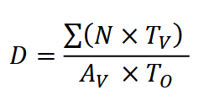 | clarke_et_al_2023_eqn_tifc1.png | **Clarke et al. (2023) - Fig. 8** A) Still from 中島啓裕’s (2021) video series. Example of overlaying a video recording of an animal on a reference image of the focal area (faint triangle) to determine staying time *T*. B) Still from Appendix S2 from Palencia et al. (2021). Example of superimposing the focal area on an image capture. | clarke_et_al_2023
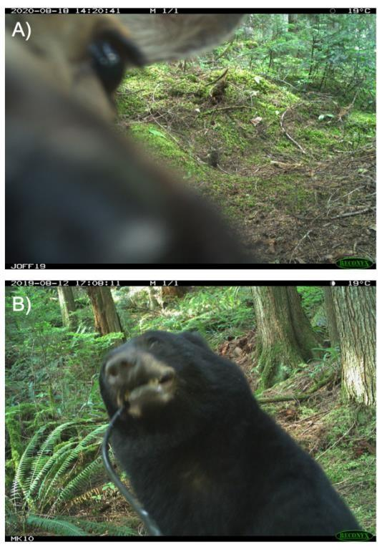 | clarke_et_al_2023_fig9_clipped.png | **Clarke et al. (2023) - Fig. 9** Examples of behaviours that increase time in the viewshed (*𝑇~_{𝑣}~*). A) A mule deer inspects a camera trap. &copy Cole Burton, Wildlife Coexistence Lab. B) A black bear pulls on the lock securing a camera trap to a tree. &copy Michael Procko, Wildlife Coexistence Lab. | clarke_et_al_2023
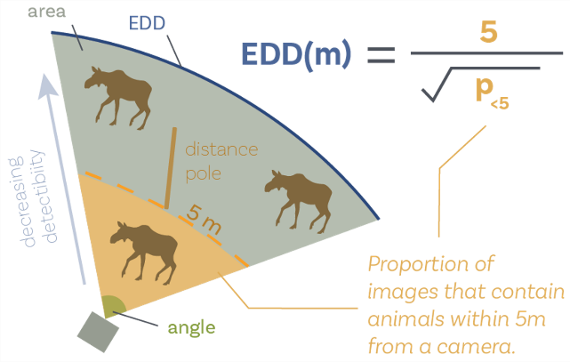 | becker_2024_slide8.png | [  FROM MARCUS PPT SLIDE 8; NEED PERMISSION | becker_2024
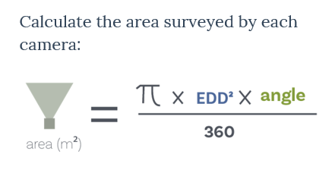 | becker_2024_slide9a.png | FROM MARCUS PPT SLIDE 8; NEED PERMISSION | becker_2024
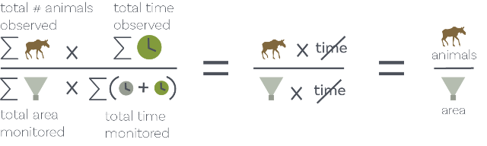 | becker_2024_slide12.png | FROM MARCUS PPT SLIDE 8; NEED PERMISSION | becker_2024
 | figure6_filename.png | figure6_caption | figure6_ref_id

Video
caption | URL (no < / > before/after URL | ref_id
How to estimate density using TIFC;  Video clip from presentation titled “Comparisons between moose densities with aerial surveys and integrated camera projects”  FROM MARCUS PPT; NEED PERMISSION | https://drive.google.com/file/d/1IdxQScbzkHd2griu-dEYM4FTFjaXalKe/preview | becker_2024
vid2_caption | vid2_url | vid2_ref_id
vid3_caption | vid3_url | vid3_ref_id
vid4_caption | vid4_url | vid4_ref_id
vid5_caption | vid5_url | vid5_ref_id
vid6_caption | vid6_url | vid6_ref_id

Shiny
Shiny name = shiny_name
Shiny caption = shiny_caption
Shiny URL = shiny_url

Analytical tools & resources
Type | Name | Note | URL | ref_id
Tutorial | Estimating animal density using TIFC (Time In Front of Camera) | Created by author of TIFC method. | <https://github.com/mabecker89/tifc-method> | becker_et_al_2021
R package | abmi.camera.extras |  | <https://mabecker89.github.io/abmi.camera.extras> | becker_et_al_2020
Tutorial | abmi.camera.extras: Animal Density from Camera Data |  | Main resource page <https://mabecker89.github.io/abmi.camera.extras/index.html> includes:<br>- [Overview]<https://mabecker89.github.io/abmi.camera.extras/articles/overview.html><br>- [Probabilistic gaps]<https://mabecker89.github.io/abmi.camera.extras/articles/gaps.html><br>- [Time in the camera field of view]<https://mabecker89.github.io/abmi.camera.extras/articles/fov.html><br>- [Effective detection distance]<https://mabecker89.github.io/abmi.camera.extras/articles/edd.html><br>- [Density at individual deployments]<https://mabecker89.github.io/abmi.camera.extras/articles/dep-density.html>- [Lure adjustments]<https://mabecker89.github.io/abmi.camera.extras/articles/lure.html><br>- [Density in an area of interest (AOI)]<https://mabecker89.github.io/abmi.camera.extras/articles/aoi-density.html><br>- [Important assumptions]<https://mabecker89.github.io/abmi.camera.extras/articles/assumptions.html> | becker_et_al_2020
resource4_type | resource4_name | resource4_note | resource4_url | resource4_ref_id
resource5_type | resource5_name | resource5_note | resource5_url | resource5_ref_id
resource6_type | resource6_name | resource6_note | resource6_url | resource6_ref_id
resource7_type | resource7_name | resource7_note | resource7_url | resource7_ref_id
resource8_type | resource8_name | resource8_note | resource8_url | resource8_ref_id
resource9_type | resource9_name | resource9_note | resource9_url | resource9_ref_id
resource10_type | resource10_name | resource10_note | resource10_url | resource10_ref_id
resource11_type | resource11_name | resource11_note | resource11_url | resource11_ref_id
resource12_type | resource12_name | resource12_note | resource12_url | resource12_ref_id
resource13_type | resource13_name | resource13_note | resource13_url | resource13_ref_id
resource14_type | resource14_name | resource14_note | resource14_url | resource14_ref_id
resource15_type | resource15_name | resource15_note | resource15_url | resource15_ref_id

References / Glossary
ref_id
{{ rbib_becker_et_al_2022 }}

{{ rbib_becker_2024 }}

{{ rbib_clarke_et_al_2023 }}

{{ rbib_dickie_2022 }}

{{ rbib_foca_2021 }}

{{ rbib_palencia_et_al_2022 }}

{{ rbib_warbington_boyce_2020 }}

Notes

Markdown

File from = 00_00_template-master.docx

POPULATE - MOD
---
jupytext:
formats: md:myst
text_representation:
extension: .md
format_name: myst
format_version: 0.17.2 <!--0.13-->
jupytext_version: 1.16.4 <!-- 6.5.4-->
kernelspec:
display_name: Python 3
language: python
name: python3
editor_options:
markdown:
wrap: none
---
(i_mod_occupancy)=
# {{ name_mod_occupancy }}

<!--
:::{hint}
replace me with text
:::
-->

**{{ term_mod_occupancy }}**: {{ term_def_mod_occupancy }}

:::::::{dropdown} Assumptions, Pros, Cons
:::::{grid}

::::{grid-item-card} Assumptions
- {{ mod_occupancy_assump_01 }}
- {{ mod_occupancy_assump_02 }}
- {{ mod_occupancy_assump_03 }}
- {{ mod_occupancy_assump_04 }}
- {{ mod_occupancy_assump_05 }}
::::
::::{grid-item-card} Pros
- {{ mod_occupancy_pro_01 }}
- {{ mod_occupancy_pro_02 }}
- {{ mod_occupancy_pro_03 }}
- {{ mod_occupancy_pro_04 }}
- {{ mod_occupancy_pro_05 }}
::::
::::{grid-item-card} Cons
- {{ mod_occupancy_con_01 }}
- {{ mod_occupancy_con_02 }}
::::
:::::
:::::::

:::::::{tab-set}

::::::{tab-item} Overview
This section will be available soon! In the meantime, check out the information in the other tabs!

:::{figure} ../03_images/03_image_files/00_coming_soon.png
:width: 300px
:align: center
:::

::::::

::::::{tab-item} In-depth
:::{note}
**This content was adapted from**: The Density Handbook, “[Using Camera Traps to Estimate Medium and Large Mammal Density: Comparison of Methods and Recommendations for Wildlife Managers](https://www.researchgate.net/publication/368601884_Using_Camera_Traps_to_Estimate_Medium_and_Large_Mammal_Density_Comparison_of_Methods_and_Recommendations_for_Wildlife_Managers)” (Clarke et al., 2024)
:::

text
:::::

:::::{grid} 3
:gutter: 1
:padding: 0
:margin: 0

::::{grid-item-card} {{ rtxt_leroy_2024 }}
:::{figure} ../03_images/03_image_files/leroy_2024_Rarity_cutoff-point.png
:class: img_grid
:::
**Leroy (2024)** The rarity cut-off point is here defined as the threshold of occurrence below which species are considered rare.
::::

::::{grid-item-card} {{ rtxt_leroy_2024 }}
:::{figure} ../03_images/03_image_files/leroy_2024_Weight_assignation-curve.png
:class: img_grid
:::
**Leroy (2024)**Weight assignation curve adjusted to an arbitrary rarity cut-off.
::::

::::{grid-item-card} {{ rtxt_figure3_ref_id }}
:::{figure} ../03_images/03_image_files/figure3_filename.png
:class: img_grid
:::
figure4_caption
::::
:::::

:::::{grid} 3
:gutter: 1
:padding: 0
:margin: 0

::::{grid-item-card} {{ rtxt_figure1_ref_id }}
:::{figure} ../03_images/03_image_files/figure1_filename.png
:class: img_grid
:::
figure1_caption
::::

::::{grid-item-card} {{ rtxt_figure2_ref_id }}
:::{figure} ../03_images/03_image_files/figure2_filename.png
:class: img_grid
:::
figure2_caption
::::

::::{grid-item-card} {{ rtxt_figure3_ref_id }}
:::{figure} ../03_images/03_image_files/figure3_filename.png
:class: img_grid
:::
figure3_caption
::::
:::::

:::::{grid} 3
:gutter: 1
:padding: 0
:margin: 0

::::{grid-item-card} {{ rtxt_figure4_ref_id }}
:::{figure} ../03_images/03_image_files/figure4_filename.png
:class: img_grid
:::
figure4_caption
::::

::::{grid-item-card} {{ rtxt_figure5_ref_id }}
:::{figure} ../03_images/03_image_files/figure5_filename.png
:class: img_grid
:::
figure5_caption
::::

::::{grid-item-card} {{ rtxt_figure6_ref_id }}
:::{figure} ../03_images/03_image_files/figure6_filename.png
:class: img_grid
:::
figure6_caption
::::
:::::

:::::{grid} 3
:gutter: 1
:padding: 0
:margin: 0

::::{grid-item-card} {{ rtxt_figure7_ref_id }}
:::{figure} ../03_images/03_image_files/figure7_filename.png
:class: img_grid
:::
figure7_caption
::::

::::{grid-item-card} {{ rtxt_figure8_ref_id }}
:::{figure} ../03_images/03_image_files/figure8_filename.png
:class: img_grid
:::
figure8_caption
::::

::::{grid-item-card} {{ rtxt_figure9_ref_id }}
:::{figure} ../03_images/03_image_files/figure9_filename.png
:class: img_grid
:::
figure9_caption
::::
:::::

:::::{grid} 3
:gutter: 1
:padding: 0
:margin: 0

::::{grid-item-card} {{ rtxt_figure10_ref_id }}
:::{figure} ../03_images/03_image_files/figure10_filename.png
:class: img_grid
:::
figure10_caption
::::

::::{grid-item-card} {{ rtxt_figure11_ref_id }}
:::{figure} ../03_images/03_image_files/figure11_filename.png
:class: img_grid
:::
figure11_caption
::::

::::{grid-item-card} {{ rtxt_figure12_ref_id }}
:::{figure} ../03_images/03_image_files/figure12_filename.png
:class: img_grid
:::
figure12_caption
::::
:::::

:::::{grid} 3
:gutter: 1
:padding: 0
:margin: 0

::::{grid-item-card} {{ rtxt_vid1_ref_id }}
<div>
<div style=“position:relative;padding-top:56.25%;”>
<iframe src=“vid1_url“ frameborder=“0” allowfullscreen
style=“position:absolute;top:0;left:0;width:100%;height:100%;”></iframe>
</div>
</div>

vid1_caption
::::

::::{grid-item-card} {{ rtxt_vid2_ref_id }}
<div>
<div style=“position:relative;padding-top:56.25%;”>
<iframe src=“vid2_url“ frameborder=“0” allowfullscreen
style=“position:absolute;top:0;left:0;width:100%;height:100%;”></iframe>
</div>
</div>

vid2_caption
::::

::::{grid-item-card} {{ rtxt_vid3_ref_id }}
<div>
<div style=“position:relative;padding-top:56.25%;”>
<iframe src=“vid3_url“ frameborder=“0” allowfullscreen
style=“position:absolute;top:0;left:0;width:100%;height:100%;”></iframe>
</div>
</div>

vid3_caption
::::
:::::

:::::{grid} 3
:gutter: 1
:padding: 0
:margin: 0

::::{grid-item-card} {{ rtxt_vid4_ref_id }}
<div>
<div style=“position:relative;padding-top:56.25%;”>
<iframe src=“vid4_url“ frameborder=“0” allowfullscreen
style=“position:absolute;top:0;left:0;width:100%;height:100%;”></iframe>
</div>
</div>

vid4_caption
::::

::::{grid-item-card} {{ rtxt_vid5_ref_id }}
<div>
<div style=“position:relative;padding-top:56.25%;”>
<iframe src=“vid5_url“ frameborder=“0” allowfullscreen
style=“position:absolute;top:0;left:0;width:100%;height:100%;”></iframe>
</div>
</div>

vid5_caption
::::

::::{grid-item-card} {{ rtxt_vid6_ref_id }}
<div>
<div style=“position:relative;padding-top:56.25%;”>
<iframe src=“vid6_url“ frameborder=“0” allowfullscreen
style=“position:absolute;top:0;left:0;width:100%;height:100%;”></iframe>
</div>
</div>

vid6_caption
::::
:::::

:::::{grid} 3
:gutter: 1
:padding: 0
:margin: 0

::::{grid-item-card} {{ rtxt_vid7_ref_id }}
<div>
<div style=“position:relative;padding-top:56.25%;”>
<iframe src=“vid7_url“ frameborder=“0” allowfullscreen
style=“position:absolute;top:0;left:0;width:100%;height:100%;”></iframe>
</div>
</div>

vid7_caption
::::

::::{grid-item-card} {{ rtxt_vid8_ref_id }}
<div>
<div style=“position:relative;padding-top:56.25%;”>
<iframe src=“vid8_url“ frameborder=“0” allowfullscreen
style=“position:absolute;top:0;left:0;width:100%;height:100%;”></iframe>
</div>
</div>

vid8_caption
::::

::::{grid-item-card} {{ rtxt_vid9_ref_id }}
<div>
<div style=“position:relative;padding-top:56.25%;”>
<iframe src=“vid9_url“ frameborder=“0” allowfullscreen
style=“position:absolute;top:0;left:0;width:100%;height:100%;”></iframe>
</div>
</div>

vid9_caption
::::
:::::

::::::

::::::{tab-item} Shiny apps/Widgets
Check back in the future!
::::::

::::::{tab-item} Shiny apps/Widgets
:::::{card} shiny_name
shiny_caption

<iframe
width=“100%”
height=“900”
src=“shiny_url“
loading=“lazy”
frameborder=“0”
allow=“accelerometer; autoplay; clipboard-write; encrypted-media; gyroscope; picture-in-picture”
allowfullscreen>
</iframe>
:::::
::::::

::::::{tab-item} Shiny apps/Widgets
:::::{card}
::::{dropdown} shiny_name
shiny_caption

<iframe
width=“100%”
height=“900”
src=“shiny_url“
loading=“lazy”
frameborder=“0”
allow=“accelerometer; autoplay; clipboard-write; encrypted-media; gyroscope; picture-in-picture”
allowfullscreen>
</iframe>
::::
::::{dropdown} shiny_name2
shiny_caption2

<iframe
width=“100%”
height=“900”
src=“shiny_url2“
loading=“lazy”
frameborder=“0”
allow=“accelerometer; autoplay; clipboard-write; encrypted-media; gyroscope; picture-in-picture”
allowfullscreen>
</iframe>
::::
:::::
::::::

:::::{tab-item} Analytical tools & resources
| Type | Name | Note | URL |Reference |
|:----------------|:-------------------------------|:----------------------------------------------------------------|:----------------------|:----------------------------------------|
| resource1_type | resource1_name | resource1_note | resource1_url | {{ rbib_resource1_ref_id }} |
| resource2_type | resource2_name | resource2_note | resource2_url | {{ rbib_resource2_ref_id }} |
| resource3_type | resource3_name | resource3_note | resource3_url | {{ rbib_resource3_ref_id }} |
| resource4_type | resource4_name | resource4_note | resource4_url | {{ rbib_resource4_ref_id }} |
| resource5_type | resource5_name | resource5_note | resource5_url | {{ rbib_resource5_ref_id }} |
| resource6_type | resource6_name | resource6_note | resource6_url | {{ rbib_resource6_ref_id }} |
| resource7_type | resource7_name | resource7_note | resource7_url | {{ rbib_resource7_ref_id }} |
| resource8_type | resource8_name | resource8_note | resource8_url| {{ rbib_resource8_ref_id}} |
| resource9_type | resource9_name | resource9_note | resource9_url | {{ rbib_resource9_ref_id }} |
| resource10_type | resource10_name | resource10_note | resource10_url | {{ rbib_resource10_ref_id }} |
| resource11_type | resource11_name | resource11_note | resource11_url | {{ rbib_resource11_ref_id }} |
| resource12_type | resource12_name | resource12_note | resource12_url | {{ rbib_resource12_ref_id }} |
| resource13_type | resource13_name | resource13_note | resource13_url | {{ rbib_resource13_ref_id }} |
| resource14_type | resource14_name | resource14_note | resource14_url | {{ rbib_resource14_ref_id }} |
| resource15_type | resource15_name | resource15_note | resource15_url | {{ rbib_resource15_ref_id }} |
| resource16_type | resource16_name | resource16_note | resource16_url | {{ rbib_resource16_ref_id }} |
| resource17_type | resource17_name | resource17_note | resource17_url | {{ rbib_resource17_ref_id }} |
| resource18_type | resource18_name | resource18_note | resource18_url| {{ rbib_resource18_ref_id}} |
| resource19_type | resource19_name | resource19_note | resource19_url | {{ rbib_resource19_ref_id }} |
| resource20_type | resource20_name | resource20_note | resource20_url | {{ rbib_resource20_ref_id }} |
::::::

::::::{tab-item} References
{{ rbib_burton_et_al_2015 }}

{{ rbib_cove_2020a }}
::::::

:::::::

