Topic Info
info_id | mod_behaviour

Note banner
<!--
:::{hint}
replace me with text
:::
-->

behaviour focused objectives vary greatly; they may be qualitative or quantitative (e.g., diel activity patterns, mating, boldness, predation, foraging, activity patterns, vigilance, parental care \[{{ rtxt_caravaggi_et_al_2022 }}; {{ rtxt_wearn_gloverkapfer_2017 }}\]).

vigilance - Schuttler et al. 2017

Overview
```{include} include/00_coming_soon.md
```

In-depth
```{include} include/00_coming_soon.md
```

Figures
Image | file_name | Caption (if applicable) | ref_id
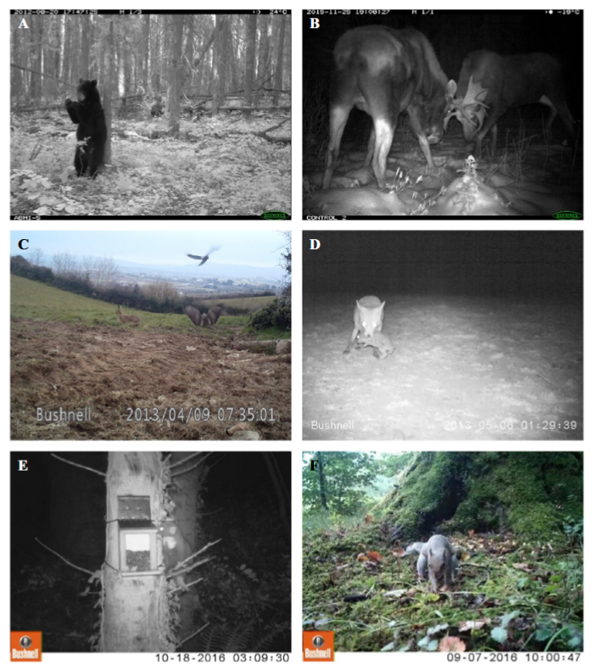 | caravaggi_et_al_2017_fig1_clipped.png | **Caravaggi et al. (2017) - Fig. 1.** Examples of animal behaviour captured by camera traps:  :::{dropdown}  (A) Scent marking by an American black bear (*Ursus americanus*); (B) intraspecific competition in moose (*Alces alces*); (C) interspecific interactions between a European hare (*Lepus europaeus*; anti-predator response), a common buzzard (*Buteo buteo*; avoidance and attempted predation) and a hooded crow (*Corvus cornix*; anti-predator behaviour) captured on video (available at 10.6084/m9.figshare.4508369); (D) predation of a European rabbit (*Oryctolagus cuniculus*) by a red fox (*Vulpes vulpes*); (E) investigation of a squirrel feeding station by a pine marten (*Martes martes*); (F) nut caching by a grey squirrel (*Sciurus carolinensis*). Images provided by A.C. Burton (a, b), A. Caravaggi (c, d) and C.M.V. Finlay (e, f).  ::: | caravaggi_et_al_2017
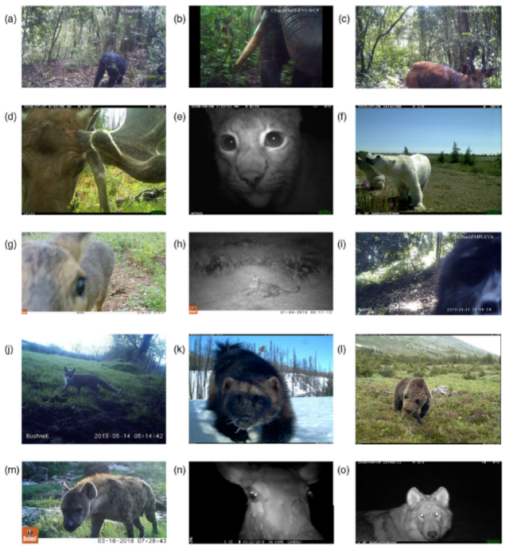 | caravaggi_et_al_2020_fig1_clipped.png | **Caravaggi et al. (2020) - Fig 1.** Examples of mammals detecting camera traps and/or olfactory cues associated with camera traps.  :::{dropdown}  (a) Chimpanzee, *Pan troglodytes*; (b) African elephant, *Loxodonta africana*; (c) sitatunga, *Tragelaphus spekii*; (d) moose, *Alces alces*; (e) Eurasian lynx, *Lynx lynx*; (f) polar bear, *Ursus maritimus*; (g) roe deer, *Capreolus capreolus*; (h) African leopard, *Panthera pardus*; (i) mountain gorilla, *Gorilla beringei*; (j) red fox, *Vulpes vulpes*; (k) wolverine, *Gulo gulo*; (l) grizzly bear, *Ursus arctos*; (m) spotted hyena, *Crocuta crocuta*; (n) red deer, *Cervus elaphus*; (o) grey wolf, *Canis lupus*. Images provided by Ammie K. Kalan (a–c,i), T. R. H. (d,e), D. R. (f,o), S. G. (g,n), A. C. (h,j), J. T. F. (k,l), A. G. (m). Visit <https://doi.org/10.6084/m9.figshare.c.4593902.v1> for selected source video.  ::: | caravaggi_et_al_2020
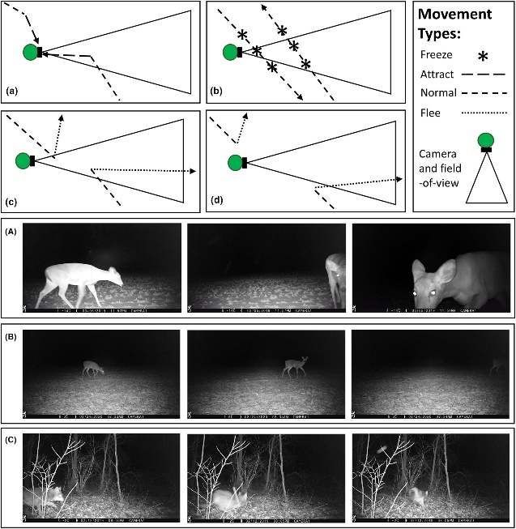 | delisle_et_al_2023_fig1.jpg | figure3_caption | figure3_ref_id
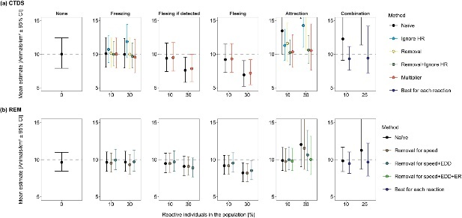 | delisle_et_al_2023_fig2.jpg | figure4_caption | figure4_ref_id
 | figure5_filename.png | figure5_caption | figure5_ref_id
 | figure6_filename.png | figure6_caption | figure6_ref_id
 | figure7_filename.png | figure7_caption | figure7_ref_id
 | figure8_filename.png | figure8_caption | figure8_ref_id
 | figure9_filename.png | figure9_caption | figure9_ref_id
 | figure10_filename.png | figure10_caption | figure10_ref_id
 | figure11_filename.png | figure11_caption | figure11_ref_id
 | figure12_filename.png | figure12_caption | figure12_ref_id

Video
caption | URL (no < / > before/after URL | ref_id
vid1_caption | vid1_url | vid1_ref_id
vid2_caption | vid2_url | vid2_ref_id
vid3_caption | vid3_url | vid3_ref_id
vid4_caption | vid4_url | vid4_ref_id
vid5_caption | vid5_url | vid5_ref_id
vid6_caption | vid6_url | vid6_ref_id

Shiny
Shiny name = Diel.Niche Shinyapp
Shiny caption = RShiny implementation of Diel.Niche. See Gerber et al. A model-based hypothesis framework to define and estimate the diel niche via the `Diel.Niche' R package. <br>{{ rbib_gerber_et_al_2023 }}
Shiny URL = https://shiny.uri.edu/bgerber/DielNiche/

Shiny name = Zone of Influence Effect Size and Buffer Distance Calculator
Shiny caption =This tool can identify optimal buffer distances for recreational features, such as hiking trails, in natural areas inhabited by grizzly bears and wolves, using the outputs of camera trap modelling work from the Canadian Rockies of Alberta. The models assessed the impact of faraway human use on trails relative to human use at a focal location to estimate the zone of influence of human use on each of these wary species.<br>{{ rbib_thompson_2024 }}
Shiny URL = https://pthompson234.shinyapps.io/calculate-zoi/

Analytical tools & resources
Type | Name | Note | URL | ref_id
Paper | A model-based hypothesis framework to define and estimate the diel niche via the ‘Diel.Niche’ R package | /- | <https://www.biorxiv.org/content/10.1101/2023.06.21.545898v1> | gerber_et_al_2023
R package | Diel-Niche-Modeling | “An R package to evaluate hypotheses of diel phenotypes based on empirical data and estimate the probabilitiy of activity during the crepuscular, daytime, and nighttime periods.” | <https://github.com/diel-project/Diel-Niche-Modeling> | gerber_et_al_2023
R Shiny | Diel.Niche Shinyapp | “RShiny implementation of Diel.Niche. See Gerber et al. A model-based hypothesis framework to define and estimate the diel niche via the `Diel.Niche' R package.” | <https://shiny.celsrs.uri.edu/bgerber/DielNiche/> | gerber_et_al_2023
Tutorial | An Introduction to Camera Trap Data Management and Analysis in R > Chapter 14 Behavior |  | <https://bookdown.org/c_w_beirne/wildCo-Data-Analysis/behavior.html> | wildco_lab_2021d
R Package | R Package ‘activity’ | “ Provides functions to express clock time data relative to anchor points (typically solar); fit kernel density functions to animal activity time data; plot activity distributions; quantify overall levels of activity; statistically compare activity metrics through bootstrapping; evaluate variation in linear variables with time (or other circular variables).” | <https://CRAN.R-project.org/package=activity> | rowcliffe_2023
Article | A simple statistical guide for the analysis of behaviour when data are constrained due to practical or ethical reasons |  | <https://www.researchgate.net/publication/289569231_A_simple_statistical_guide_for_the_analysis_of_behaviour_when_data_are_constrained_due_to_practical_or_ethical_reasons> | garamszegi_2016
resource7_type | resource7_name | resource7_note | resource7_url | resource7_ref_id
resource8_type | resource8_name | resource8_note | resource8_url | resource8_ref_id
resource9_type | resource9_name | resource9_note | resource9_url | resource9_ref_id
resource10_type | resource10_name | resource10_note | resource10_url | resource10_ref_id
resource11_type | resource11_name | resource11_note | resource11_url | resource11_ref_id
resource12_type | resource12_name | resource12_note | resource12_url | resource12_ref_id
resource13_type | resource13_name | resource13_note | resource13_url | resource13_ref_id
resource14_type | resource14_name | resource14_note | resource14_url | resource14_ref_id
resource15_type | resource15_name | resource15_note | resource15_url | resource15_ref_id

References / Glossary
ref_id
{ rbib_caravaggi_et_al_2017 }}

{{ rbib_caravaggi_et_al_2020 }}

{{ rbib_ gerber_et_al_2023 }}

{{ rbib_meek_et_al_2014b }}

{{ rbib_wildco_lab_2021d }}

Notes

- The focus of the study could be on a particular location (such as a lekking site or a fruiting tree) or on a particular species. However, as for the study types we have considered above, the starting point is to establish what the key assumptions of the modelling are, and then design the sampling appropriately with this in mind.
- For example, imagine you are interested in the rate at which a given behaviour occurs in a species (e.g. vigilance: Schuttler et al. 2017), and how this differs across major habitat types in your study area. If your aim was to make inferences about the population in your study area as a whole, then you would want to take a representative sample of individuals, and you would want to observe them at random locations and random times of the day. All of this could be achieved using random sampling points, stratified by habitat type, with camera traps set to trigger throughout the 24 hr period. Cameras would ideally be sufficiently spaced apart to obtain samples from lots of different individuals (e.g. 1 km apart, depending on the species). Similarly, the number of sampling points, and how long each is sampled for, would have to be sufficient in order to obtain a reasonable number of behavioural observations in each habitat type (> 20 per stratum would be a sensible minimum target). The length of the study would ideally not be too long, for example restricted to a single season, so as to provide a snapshot of the prevalence of the behaviour in different habitat types in the absence of any temporal trends in the behaviour (temporal or seasonal trends could be a focus of follow-up surveys). This basic approach to sampling design for a behavioural study would be suitable for the study of activity patterns, which is a common use of camera traps. In this case, some aspects of sample size have been investigated (Ridout & Linkie 2009; Rowcliffe et al. 2014). This work suggests that a sample size of 20-25 observations will offer useful insights into activity patterns over a 24 hr period, but that larger samples (> 100) will be needed to characterise the activity patterns with any reasonable level of precision, especially if the pattern has a complicated shape (Ridout & Linkie 2009; Rowcliffe et al. 2014).
- species interactions and niche partitioning via comparisons of co-occurrence and activity patterns (de Almeida Jacomo et al. 2004; Kukielka et al. 2013; Farris et al. 2014; Wang et al. 2015; Bu et al. 2016; Cusack et al. 2016; Sweitzer and Furnas 2016).

Markdown

File from = 00_00_template-master.docx

POPULATE - MOD
---
jupytext:
formats: md:myst
text_representation:
extension: .md
format_name: myst
format_version: 0.17.2 <!--0.13-->
jupytext_version: 1.16.4 <!-- 6.5.4-->
kernelspec:
display_name: Python 3
language: python
name: python3
editor_options:
markdown:
wrap: none
---
(i_mod_behaviour)=
# {{ name_mod_behaviour }}

Error! Reference source not found.

**{{ term_mod_behaviour }}**: {{ term_def_mod_behaviour }}

:::::::{dropdown} Assumptions, Pros, Cons
:::::{grid}

::::{grid-item-card} Assumptions
- {{ mod_behaviour_assump_01 }}
- {{ mod_behaviour_assump_02 }}
::::
::::{grid-item-card} Pros
- {{ mod_behaviour_pro_01 }}
- {{ mod_behaviour_pro_02 }}
- {{ mod_behaviour_pro_03 }}
- {{ mod_behaviour_pro_04 }}
::::
::::{grid-item-card} Cons
- {{ mod_behaviour_con_01 }}
- {{ mod_behaviour_con_02 }}
- {{ mod_behaviour_con_03 }}
::::
:::::
:::::::

:::::::{tab-set}

::::::{tab-item} Overview
```{figure} ../03_images/03_image_files/00_coming_soon.png
:width: 300px
:align: center
```

::::::

::::::{tab-item} In-depth
```{figure} ../03_images/03_image_files/00_coming_soon.png
:width: 300px
:align: center
```

:::::

:::::{grid} 3
:gutter: 1
:padding: 0
:margin: 0

::::{grid-item-card} {{ rtxt_caravaggi_et_al_2017 }}
:::{figure} ../03_images/03_image_files/caravaggi_et_al_2017_fig1_clipped.png
:class: img_grid
:::
**Caravaggi et al. (2017) - Fig. 1.** Examples of animal behaviour captured by camera traps:
:::{dropdown}
(A) Scent marking by an American black bear (*Ursus americanus*); (B) intraspecific competition in moose (*Alces alces*); (C) interspecific interactions between a European hare (*Lepus europaeus*; anti-predator response), a common buzzard (*Buteo buteo*; avoidance and attempted predation) and a hooded crow (*Corvus cornix*; anti-predator behaviour) captured on video (available at 10.6084/m9.figshare.4508369); (D) predation of a European rabbit (*Oryctolagus cuniculus*) by a red fox (*Vulpes vulpes*); (E) investigation of a squirrel feeding station by a pine marten (*Martes martes*); (F) nut caching by a grey squirrel (*Sciurus carolinensis*). Images provided by A.C. Burton (a, b), A. Caravaggi (c, d) and C.M.V. Finlay (e, f).
:::
::::

::::{grid-item-card} {{ rtxt_caravaggi_et_al_2020 }}
:::{figure} ../03_images/03_image_files/caravaggi_et_al_2020_fig1_clipped.png
:class: img_grid
:::
**Caravaggi et al. (2020) - Fig 1.** Examples of mammals detecting camera traps and/or olfactory cues associated with camera traps.

:::{dropdown}
(a) Chimpanzee, *Pan troglodytes*; (b) African elephant, *Loxodonta africana*; (c) sitatunga, *Tragelaphus spekii*; (d) moose, *Alces alces*; (e) Eurasian lynx, *Lynx lynx*; (f) polar bear, *Ursus maritimus*; (g) roe deer, *Capreolus capreolus*; (h) African leopard, *Panthera pardus*; (i) mountain gorilla, *Gorilla beringei*; (j) red fox, *Vulpes vulpes*; (k) wolverine, *Gulo gulo*; (l) grizzly bear, *Ursus arctos*; (m) spotted hyena, *Crocuta crocuta*; (n) red deer, *Cervus elaphus*; (o) grey wolf, *Canis lupus*. Images provided by Ammie K. Kalan (a–c,i), T. R. H. (d,e), D. R. (f,o), S. G. (g,n), A. C. (h,j), J. T. F. (k,l), A. G. (m). Visit <https://doi.org/10.6084/m9.figshare.c.4593902.v1> for selected source video.
:::
::::

::::{grid-item-card} {{ rtxt_figure3_ref_id }}
:::{figure} ../03_images/03_image_files/figure3_filename.png
:class: img_grid
:::
figure3_caption
::::
:::::

:::::{grid} 3
:gutter: 1
:padding: 0
:margin: 0

::::{grid-item-card} {{ rtxt_caravaggi_et_al_2017 }}
:::{figure} ../03_images/03_image_files/caravaggi_et_al_2017_fig1_clipped.png
:class: img_grid
:::
**Caravaggi et al. (2017) - Fig. 1.** Examples of animal behaviour captured by camera traps:
:::{dropdown}
(A) Scent marking by an American black bear (*Ursus americanus*); (B) intraspecific competition in moose (*Alces alces*); (C) interspecific interactions between a European hare (*Lepus europaeus*; anti-predator response), a common buzzard (*Buteo buteo*; avoidance and attempted predation) and a hooded crow (*Corvus cornix*; anti-predator behaviour) captured on video (available at 10.6084/m9.figshare.4508369); (D) predation of a European rabbit (*Oryctolagus cuniculus*) by a red fox (*Vulpes vulpes*); (E) investigation of a squirrel feeding station by a pine marten (*Martes martes*); (F) nut caching by a grey squirrel (*Sciurus carolinensis*). Images provided by A.C. Burton (a, b), A. Caravaggi (c, d) and C.M.V. Finlay (e, f).
:::
::::

::::{grid-item-card} {{ rtxt_caravaggi_et_al_2020 }}
:::{figure} ../03_images/03_image_files/caravaggi_et_al_2020_fig1_clipped.png
:class: img_grid
:::
**Caravaggi et al. (2020) - Fig 1.** Examples of mammals detecting camera traps and/or olfactory cues associated with camera traps.

:::{dropdown}
(a) Chimpanzee, *Pan troglodytes*; (b) African elephant, *Loxodonta africana*; (c) sitatunga, *Tragelaphus spekii*; (d) moose, *Alces alces*; (e) Eurasian lynx, *Lynx lynx*; (f) polar bear, *Ursus maritimus*; (g) roe deer, *Capreolus capreolus*; (h) African leopard, *Panthera pardus*; (i) mountain gorilla, *Gorilla beringei*; (j) red fox, *Vulpes vulpes*; (k) wolverine, *Gulo gulo*; (l) grizzly bear, *Ursus arctos*; (m) spotted hyena, *Crocuta crocuta*; (n) red deer, *Cervus elaphus*; (o) grey wolf, *Canis lupus*. Images provided by Ammie K. Kalan (a–c,i), T. R. H. (d,e), D. R. (f,o), S. G. (g,n), A. C. (h,j), J. T. F. (k,l), A. G. (m). Visit <https://doi.org/10.6084/m9.figshare.c.4593902.v1> for selected source video.
:::
::::

::::{grid-item-card} {{ rtxt_figure3_ref_id }}
:::{figure} ../03_images/03_image_files/figure3_filename.png
:class: img_grid
:::
figure3_caption
::::
:::::

:::::{grid} 3
:gutter: 1
:padding: 0
:margin: 0

::::{grid-item-card} {{ rtxt_figure4_ref_id }}
:::{figure} ../03_images/03_image_files/figure4_filename.png
:class: img_grid
:::
figure4_caption
::::

::::{grid-item-card} {{ rtxt_figure5_ref_id }}
:::{figure} ../03_images/03_image_files/figure5_filename.png
:class: img_grid
:::
figure5_caption
::::

::::{grid-item-card} {{ rtxt_figure6_ref_id }}
:::{figure} ../03_images/03_image_files/figure6_filename.png
:class: img_grid
:::
figure6_caption
::::
:::::

:::::{grid} 3
:gutter: 1
:padding: 0
:margin: 0

::::{grid-item-card} {{ rtxt_vid1_ref_id }}
<div>
<div style=“position:relative;padding-top:56.25%;”>
<iframe src=“vid1_url“ loading=“lazy” frameborder=“0” allowfullscreen
style=“position:absolute;top:0;left:0;width:100%;height:100%;”></iframe>
</div>
</div>

vid1_caption
::::

::::{grid-item-card} {{ rtxt_vid2_ref_id }}
<div>
<div style=“position:relative;padding-top:56.25%;”>
<iframe src=“vid2_url“ loading=“lazy” frameborder=“0” allowfullscreen
style=“position:absolute;top:0;left:0;width:100%;height:100%;”></iframe>
</div>
</div>

vid2_caption
::::

::::{grid-item-card} {{ rtxt_vid3_ref_id }}
<div>
<div style=“position:relative;padding-top:56.25%;”>
<iframe src=“vid3_url“ loading=“lazy” frameborder=“0” allowfullscreen
style=“position:absolute;top:0;left:0;width:100%;height:100%;”></iframe>
</div>
</div>

vid3_caption
::::
:::::

::::::

::::::{tab-item} Shiny apps/Widgets
:::::{card}
::::{dropdown} Diel.Niche Shinyapp
RShiny implementation of Diel.Niche. See Gerber et al. A model-based hypothesis framework to define and estimate the diel niche via the `Diel.Niche' R package. <br>{{ rbib_gerber_2023 }}

<iframe
width=“100%”
height=“900”
src=“https://shiny.uri.edu/bgerber/DielNiche/“
loading=“lazy”
frameborder=“0”
allow=“accelerometer; autoplay; clipboard-write; encrypted-media; gyroscope; picture-in-picture”
allowfullscreen>
</iframe>
::::
::::{dropdown} Zone of Influence Effect Size and Buffer Distance Calculator
This tool can identify optimal buffer distances for recreational features, such as hiking trails, in natural areas inhabited by grizzly bears and wolves, using the outputs of camera trap modelling work from the Canadian Rockies of Alberta. The models assessed the impact of faraway human use on trails relative to human use at a focal location to estimate the zone of influence of human use on each of these wary species.<br>{{ rbib_thompson_2024 }}

<iframe
width=“100%”
height=“900”
src=“https://pthompson234.shinyapps.io/calculate-zoi/“
loading=“lazy”
frameborder=“0”
allow=“accelerometer; autoplay; clipboard-write; encrypted-media; gyroscope; picture-in-picture”
allowfullscreen>
</iframe>
::::
:::::
::::::

:::::{tab-item} Analytical tools & resources
| Type | Name | Note | URL |Reference |
|:----------------|:-------------------------------|:----------------------------------------------------------------|:----------------------|:----------------------------------------|
| Paper | A model-based hypothesis framework to define and estimate the diel niche via the ‘Diel.Niche’ R package | /- | <https://www.biorxiv.org/content/10.1101/2023.06.21.545898v1> | {{ rbib_gerber_et_al_2023 }} |
| R package | Diel-Niche-Modeling | “An R package to evaluate hypotheses of diel phenotypes based on empirical data and estimate the probabilitiy of activity during the crepuscular, daytime, and nighttime periods.” | <https://github.com/diel-project/Diel-Niche-Modeling> | {{ rbib_resource2_ref_id }} |
| R Shiny | Diel.Niche Shinyapp | “RShiny implementation of Diel.Niche. See Gerber et al. A model-based hypothesis framework to define and estimate the diel niche via the `Diel.Niche' R package.” | <https://shiny.celsrs.uri.edu/bgerber/DielNiche/> | {{ rbib_resource3_ref_id }} |
| Tutorial | An Introduction to Camera Trap Data Management and Analysis in R > Chapter 14 Behavior | | <https://bookdown.org/c_w_beirne/wildCo-Data-Analysis/behavior.html> | {{ rbib_wildco_lab_2021d }} |
| R Package | R Package ‘activity’
resource5_name | “ Provides functions to express clock time data relative to anchor points (typically solar); fit kernel density functions to animal activity time data; plot activity distributions; quantify overall levels of activity; statistically compare activity metrics through bootstrapping; evaluate variation in linear variables with time (or other circular variables).”
| <https://CRAN.R-project.org/package=activity> | {{ rbib_rowcliffe_2023 }} |
| Article | A simple statistical guide for the analysis of behaviour when data are constrained due to practical or ethical reasons | | <https://www.researchgate.net/publication/289569231_A_simple_statistical_guide_for_the_analysis_of_behaviour_when_data_are_constrained_due_to_practical_or_ethical_reasons> | {{ rbib_garamszegi_2016 }} |
| resource7_type | resource7_name | resource7_note | resource7_url | {{ rbib_resource7_ref_id }} |
| resource8_type | resource8_name | resource8_note | resource8_url| {{ rbib_resource8_ref_id}} |
| resource9_type | resource9_name | resource9_note | resource9_url | {{ rbib_resource9_ref_id }} |
| resource10_type | resource10_name | resource10_note | resource10_url | {{ rbib_resource10_ref_id }} |
| resource11_type | resource11_name | resource11_note | resource11_url | {{ rbib_resource11_ref_id }} |
| resource12_type | resource12_name | resource12_note | resource12_url | {{ rbib_resource12_ref_id }} |
| resource13_type | resource13_name | resource13_note | resource13_url | {{ rbib_resource13_ref_id }} |
| resource14_type | resource14_name | resource14_note | resource14_url | {{ rbib_resource14_ref_id }} |
| resource15_type | resource15_name | resource15_note | resource15_url | {{ rbib_resource15_ref_id }} |
| Error! Reference source not found. | Error! Reference source not found. | Error! Reference source not found. | Error! Reference source not found. | {{ rbib_Error! Reference source not found. }} |
| Error! Reference source not found. | Error! Reference source not found. | Error! Reference source not found. | Error! Reference source not found. | {{ rbib_Error! Reference source not found. }} |
| Error! Reference source not found. | Error! Reference source not found. | Error! Reference source not found. | Error! Reference source not found.| {{ rbib_Error! Reference source not found.}} |
| Error! Reference source not found. | Error! Reference source not found. | Error! Reference source not found. | Error! Reference source not found. | {{ rbib_Error! Reference source not found. }} |
| Error! Reference source not found. | Error! Reference source not found. | Error! Reference source not found. | Error! Reference source not found. | {{ rbib_Error! Reference source not found. }} |
::::::

::::::{tab-item} References
{ rbib_caravaggi_et_al_2017 }}

{{ rbib_caravaggi_et_al_2020 }}

{{ rbib_ gerber_et_al_2023 }}

{{ rbib_meek_et_al_2014b }}

{{ rbib_wildco_lab_2021d }}

::::::

:::::::

