Topic Info
info_id | objective
question | Which variable of interest (or "state variable") do you hope to measure?  Select "Unknown" if you're not sure.

Note banner
::::::::{hint}
**{{ term_state_variable }}**: {{ def_state_variable }}

- Hover over each term to see its definition
- Refer to the "overview" tab of the concept infobox for the full definition list (with figures!)
- Refer to the "in-depth" tab of the concept infobox if you would like to understand more about how a "{{ state_variable_tl }}" differs from an "objective."
::::::::

Overview
Definitions for each option are as follows (with a few additional notes):

::::::{card}
**<font size="4"><span style="color:#2F5496">Species diversity *vs* Richness</font></span>**
::::{note}
This tool currently provides one set of recommendations for **{{ term_mod_divers_rich }}**; we hope to expand this in the future to provide recommendations more fine-tuned to Richness vs. Diversity as well as the as multiple "levels" described below.
::::

:::::{grid} 3
:gutter: 4
:padding: 1
:margin: 2

::::{grid-item}
**{{ term_mod_divers_rich_rich }}**: {{ def_mod_divers_rich_rich }}
<br>
<br>
:::{card}
:class-card: card-whitesmoke

*<span style="color:#2F5496">Examples of possible questions include:</span>*
- How many different species occur in the study area?
- How does the number of species in the study area during the year?
- How many different species live in forest 'A' compared to forest 'B'?
- What factors affect the number of species that live in the study area?
:::
::::

::::{grid-item}
**{{ term_mod_divers_rich_divers }}**: {{ def_mod_divers_rich_divers }}

:::{card}
:class-card: card-whitesmoke

*<span style="color:#2F5496">Examples of possible questions include:</span>*
- What happens to the diversity of species in a forest when it is cut down for development?
- How do human activities (such as farming) impact the balance of species in a meadow?
- Does the diversity of species in the study area decrease when pesticides are used, and are some species more impacted than others?
:::
::::

::::{grid-item-card}
:class-card: card-whitesmoke

```{figure} ../03_images/03_image_files/state_var/pyron_2010_fig1_clipped.png
:align: center
:width: 100%
```
<div style="font-size: 12px;line-height: 1.1">
<b>Pyron (2010) - Fig. 1</b> Species evenness and species richness for animalcule communities. Both communities contain five species of animalcules. Species richness is the same. The community on the left is dominated by one of the species. The community on the right has equal proportions of each species. Evenness is higher when species are present in similar proportions. Thus the community on the left has higher species diversity, because evenness is higher.</div>
::::

:::::

***

:::::{grid} 2
:gutter: 0
:padding: 0
:margin: 2

::::{grid-item}
:columns: 9

Note that there are multiple "levels" to Species diversity & richness, these include:
- **{{ term_mod_divers_rich_alpha }}**: {{ def_mod_divers_rich_alpha }}
- **{{ term_mod_divers_rich_beta}}**: {{ def_mod_divers_rich_beta }}
- **{{ term_mod_divers_rich_gamma }}**: {{ def_mod_divers_rich_gamma }}
::::

::::{grid-item}
:columns: 3

```{figure} ../03_images/03_image_files/state_var/eco_intel.jpeg
:align: center
:width: 100%
```
*<div style="font-size: 12px;line-height: 1.0">({{ rtxt_babu_nd }})</div>*
::::

:::::

::::::

::::::{card}
**<font size="4"><span style="color:#2F5496">Species inventory (presence) *vs.* Occupancy </font></span>**

:::::{grid} 2
:gutter: 4
:padding: 1
:margin: 2

::::{grid-item}
**{{ term_obj_inventory }}**: {{ def_obj_inventory }}
::::

::::{grid-item}
**{{ term_obj_occupancy }}**: {{ def_obj_occupancy }}
::::
:::::

:::::{grid} 2
:gutter: 4
:padding: 1
:margin: 2

::::{grid-item-card}
:class-card: card-whitesmoke

*<span style="color:#2F5496">Examples of possible questions include:</span>*
- Is the species there?
- Are deer present in this forest during the winter?
- Is the endangered butterfly species present in this park?
- Do wolves appear in the northern region of the country?
::::

::::{grid-item-card}
:class-card: card-whitesmoke

*<span style="color:#2F5496">Examples of possible questions include:</span>*
- Is the species living or actively using an area?
- Is the species more likely to occupy habitat A or habitat B?
- How often do bears occupy different areas of the forest throughout the year?
- Do different types of birds occupy the same tree species in the forest?
- How does the availability of food affect the occupancy of wolves in a specific area?
::::
:::::
::::::

::::::{card}
**<font size="4"><span style="color:#2F5496">Absolute abundance *vs.* Relative abundance *vs.* Density</font></span>**

:::::{grid} 3
:gutter: 4
:padding: 1
:margin: 2

::::{grid-item}
**{{ term_obj_abundance }}**: {{ def_obj_abundance }}
::::

::::{grid-item}
**{{ term_obj_rel_abund }}**: {{ def_obj_rel_abund }}
::::

::::{grid-item}
**{{ term_obj_density }}**: {{ def_obj_density }}
::::
:::::

:::::{grid} 3
:padding: 0
:margin: 2

::::{grid-item}
```{figure} ../03_images/03_image_files/state_var/abundance.png
:width: 80%
```
*<center><div style="font-size: 12px;line-height: 1.0">Figure modified from Becker (2024)</div></center>*
::::

::::{grid-item}
```{figure} ../03_images/03_image_files/state_var/relative_abundance.png
:width: 100%
```
*<center><div style="font-size: 12px;line-height: 1.0">Figure modified from Becker (2024)</div></center>*
::::

::::{grid-item}
```{figure} ../03_images/03_image_files/state_var/density.png
:width: 100%
```
*<center><div style="font-size: 12px;line-height: 1.0">Figure modified from Becker (2024)</div></center>*
::::
:::::

:::::{grid} 3
:gutter: 4
:padding: 1
:margin: 2

::::{grid-item-card}
:class-card: card-whitesmoke

*<span style="color:#2F5496">Examples of possible questions include:</span>*<!--Abundance-->
- How many animals were there?
- How have moose numbers changed over time?
::::
::::{grid-item-card}
:class-card: card-whitesmoke

*<span style="color:#2F5496">Examples of possible questions include:</span>*<!--Relative abundance-->
- Do moose spend more time in wetlands than dense forests? Does this change in summer vs winter?
- Do moose spend less time near roads?
::::
::::{grid-item-card}
:class-card: card-whitesmoke

*<span style="color:#2F5496">Examples of possible questions include:</span>*<!--Density-->
- How many animals were there per km<sup>2</sup>?
::::
:::::

::::::

::::::{grid} 2
:gutter: 1
:padding: 0
:margin: 0

:::::{grid-item-card}
**<font size="4"><span style="color:#2F5496">Vital rates</font></span>**

**{{ term_obj_vital_rate }}**: {{ def_obj_vital_rate }}

Such as:
- **{{ term_obj_vital_rate_birth }}**: {{ def_obj_vital_rate_birth }}
- **{{ term_obj_vital_rate_recruitment }}**: {{ def_obj_vital_rate_recruitment }}
- **{{ term_obj_vital_rate_popln_growth }}**: {{ def_obj_vital_rate_popln_growth }}

::::{card}
:class-card: card-whitesmoke
*<span style="color:#2F5496">Examples of possible questions include:</span>*
- Does a certain disturbance result in a lower birth rate of deer?
- Are fewer individuals surviving to adulthood in area 'A' vs area 'B'?
- Is the population in area 'A' growing faster than in area 'B'?
::::
:::::

:::::{grid-item-card}
**<font size="4"><span style="color:#2F5496">Behaviour</font></span>**

**{{ term_obj_behaviour }}**: {{ def_obj_behaviour }}

```{figure} ../03_images/03_image_files/state_var/caravaggi_et_al_2017_fig1_clipped.png
:width: 200px
```
**Caravaggi et al. (2017) - Fig. 1.** Examples of animal behaviour captured by camera traps:
::::{dropdown}
(A) Scent marking by an American black bear (*Ursus americanus*); (B) intraspecific competition in moose (*Alces alces*); (C) interspecific interactions between a European hare (*Lepus europaeus*; anti-predator response), a common buzzard (*Buteo buteo*; avoidance and attempted predation) and a hooded crow (*Corvus cornix*; anti-predator behaviour) captured on video (available at 10.6084/m9.figshare.4508369); (D) predation of a European rabbit (*Oryctolagus cuniculus*) by a red fox (*Vulpes vulpes*); (E) investigation of a squirrel feeding station by a pine marten (*Martes martes*); (F) nut caching by a grey squirrel (*Sciurus carolinensis*). Images provided by A.C. Burton (a, b), A. Caravaggi (c, d) and C.M.V. Finlay (e, f).
::::

::::{card}
:class-card: card-whitesmoke

*<span style="color:#2F5496">Examples of possible questions include:</span>*
- Are animals more active at night in areas with high human activity?
- Are animals closer to disturbance less likely to display anti-predator behaviour?
- Is foraging behaviour impacted by disturbance?
::::
:::::
::::::

In-depth
**<font size="4"><span style="color:#2F5496">Objective *vs.* State Variable</font></span>**

One of the first choices you will make when designing your study, is what it is that you plan to measure (or your "{{ state_variable_tl }}"; a formal measure that summarizes the state of a community or population at a particular time \[{{ rtxt_wearn_gloverkapfer_2017 }}\]). Since this concept might be easy to confuse with {{ survey_objectives_tu }} (they are often referred to interchangeably), consider the following figure:

```{figure} ../03_images/03_image_files/00_FIG_obj_state_var.png
:width: 800px
:align: center
```

**<font size="4"><span style="color:#2F5496">What should objectives include?</font></span>**

To expand upon the figure above, {{ survey_objectives_tu }} should be specific, measurable, achievable, relevant and time-bound (i.e., SMART). {{ survey_objectives_tu }} should describe the following:
- **{{ target_species_tu }}** - the species that the {{ survey_tl }} is designed to detect,
- **{{ state_variable_tu }}** - a formal measure that summarizes the state of a community or population at a particular time ({{ rtxt_wearn_gloverkapfer_2017 }}) (e.g., species richness or population abundance), and
- **Proposed {{ mod_approach_tl }}** - the method used to analyze the camera data, which should depend on the {{ state_variable_tl }} (e.g., {{ mod_occupancy_tl }} [{{ rtxt_mackenzie_et_al_2002 }}], {{ mod_scr_secr_tl }} [e.g., {{ rtxt_royle_2009 }}] for {{ obj_density_tl }} estimation, etc.) and the {{ target_species_tu }}.

An example of a clearly defined {{ survey_objectives_tu }} could be "to monitor trends in wolverine {{ obj_occupancy_tl }} at 5-year intervals from March – December 2020 to 2030 in wildlife management unit 539".

The {{ survey_objectives_tu }} will determine the appropriate study design and {{ deployment_tl }} considerations (e.g., {{ cam_spacing_tl }}, {{ survey_tl }} effort, attractants or not). For example, based on the above objective for our wolverine {{ obj_occupancy_tl }} project, we "randomly selected {{ camera_location_tl_pl }} within a 15 km x 15 km grid cell with one camera per location and a total of 60 stations across our {{ study_area_tl }}. We will place {{ baitlure_lure_tl}} dispensers at each {{ camera_location_tl }} to increase the likelihood of detecting a wolverine." to increase the likelihood of detecting a wolverine."

Figures
Image | file_name | Caption (if applicable) | ref_id
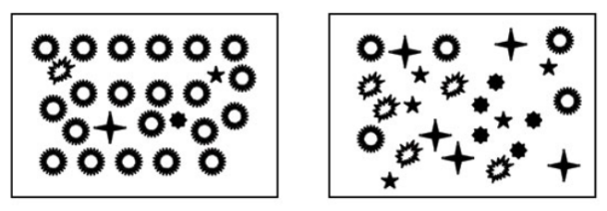 | state_var/pyron_2010_fig1_clipped.png | **Pyron (2010) - Fig. 1** Species evenness and species richness for animalcule communities. Both communities contain five species of animalcules. Species richness is the same. The community on the left is dominated by one of the species. The community on the right has equal proportions of each species. Evenness is higher when species are present in similar proportions. Thus the community on the left has higher species diversity, because evenness is higher. | pyron_2010
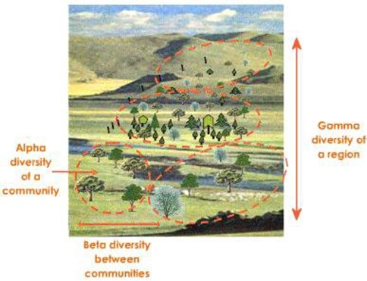 | state_var/eco_intel.jpeg | Note that there are multiple "levels" to Species diversity & richness, these include:  - **Alpha richness (α)**: The number of species at the level of an individual camera location ({{ rtxt_wearn_gloverkapfer_2017 }}).  - **Beta-diversity (β)**: The differences between the communities or, more formally, the variance among the communities ({{ rtxt_wearn_gloverkapfer_2017 }}).  - **Gamma richness (γ)**: The number of species across a whole study area ({{ rtxt_wearn_gloverkapfer_2017 }}). | babu_nd
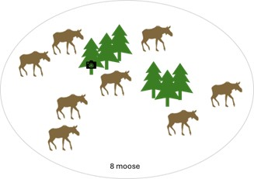 | state_var/abundance.png | *<center>Figure modified from Becker (2024)</center>*  **Absolute abundance**: The number of individuals in a population ({{ rtxt_wearn_gloverkapfer_2017 }}). | rcsc_2024a }}; {{ rtxt_becker_2024
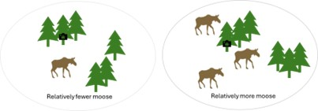 | state_var/relative_abundance.png | *<center>Figure modified from Becker (2024)</center>*  **Relative abundance**: The number of animals detected from one camera/area compared to another camera/area. | rcsc_2024a }}; {{ rtxt_becker_2024
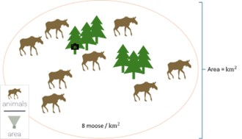 | state_var/density.png | *<center>Figure modified from Becker (2024)</center>*  **Density**: The number of individuals per unit area ({{ rtxt_wearn_gloverkapfer_2017 }}) | rcsc_2024a }}; {{ rtxt_becker_2024
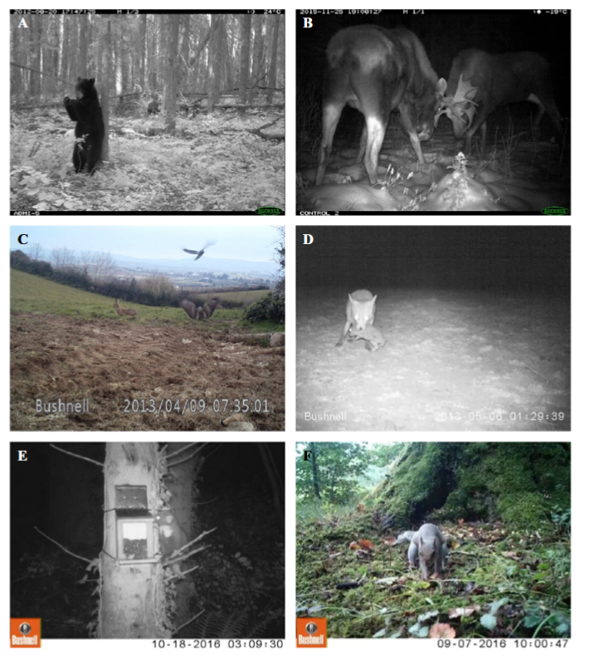 | caravaggi_et_al_2017_fig1_clipped.png | **Behaviour**: behaviour focused objectives vary greatly; they may be qualitative or quantitative (e.g., diel activity patterns, mating, boldness, predation, foraging, activity patterns, vigilance, parental care ({{ rtxt_caravaggi_et_al_2020 }}; {{ rtxt_wearn_gloverkapfer_2017 }}).  **Caravaggi et al. (2017) - Fig. 1** Examples of animal behaviour captured by camera traps:  :::{dropdown}  (A) Scent marking by an American black bear (*Ursus americanus*); (B) intraspecific competition in moose (*Alces alces*); (C) interspecific interactions between a European hare (*Lepus europaeus*; anti-predator response), a common buzzard (*Buteo buteo*; avoidance and attempted predation) and a hooded crow (*Corvus cornix*; anti-predator behaviour) captured on video (available at 10.6084/m9.figshare.4508369); (D) predation of a European rabbit (*Oryctolagus cuniculus*) by a red fox (*Vulpes vulpes*); (E) investigation of a squirrel feeding station by a pine marten (*Martes martes*); (F) nut caching by a grey squirrel (*Sciurus carolinensis*). Images provided by A.C. Burton (a, b), A. Caravaggi (c, d) and C.M.V. Finlay (e, f).  ::: | caravaggi_et_al_2017
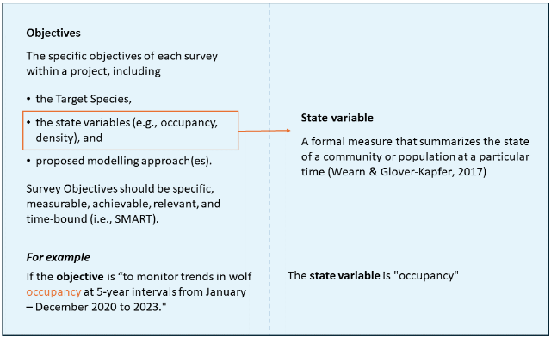 | 00_FIG_obj_state_var.png |  | rcsc_2024a
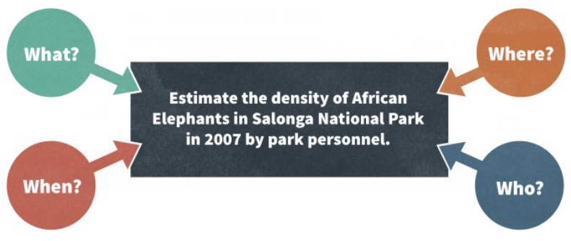 | mccomb_et_al_2010_fig4_3_clipped.png | **McComb et al. (2010) - Fig 4.3**: The components of a monitoring objective. | mccomb_et_al_2010
 | figure9_filename.png | figure9_caption | figure9_ref_id
 | figure10_filename.png | figure10_caption | figure10_ref_id
 | figure11_filename.png | figure11_caption | figure11_ref_id
 | figure12_filename.png | figure12_caption | figure12_ref_id
 | figure13_filename.png | figure13_caption | figure13_ref_id
 | figure14_filename.png | figure14_caption | figure14_ref_id
 | figure15_filename.png | figure15_caption | figure15_ref_id
 | figure16_filename.png | figure16_caption | figure16_ref_id
 | figure17_filename.png | figure17_caption | figure17_ref_id
 | figure18_filename.png | figure18_caption | figure18_ref_id
 | figure19_filename.png | figure19_caption | figure19_ref_id
 | figure20_filename.png | figure20_caption | figure20_ref_id

Video
caption | URL (no < / > before/after URL | ref_id
vid1_caption | vid1_url | vid1_ref_id
vid2_caption | vid2_url | vid2_ref_id
vid3_caption | vid3_url | vid3_ref_id
vid4_caption | vid4_url | vid4_ref_id
vid5_caption | vid5_url | vid5_ref_id
vid6_caption | vid6_url | vid6_ref_id

References / Glossary
ref_id
{{ rbib_babu_nd }}
{{ rbib_becker_2024 }}
{{ rbib_caravaggi_et_al_2017 }}
{{ rbib_caravaggi_et_al_2020 }}
{{ rbib_caughley_1977 }}
{{ rbib_gotelli_chao_2013 }}
{{ rbib_mackenzie_et_al_2002 }}
{{ rbib_mccomb_et_al_2010 }}
{{ rbib_nbckc_2024a }}
{{ rbib_obrien_2011 }}
{{ rbib_pyron_2010 }}
{{ rbib_royle_2009 }}
{{ rbib_wearn_gloverkapfer_2017 }}

Notes

Species inventory

Species diversity & richness

"It’s important to note that the scale over which species richness is calculated can affect the conclusions drawn, and may make it difficult to compare estimates from different studies. Some camera trap studies calculate species richness at the level of an individual camera location – often called α-richness (alpha richness) – whilst other studies calculate species richness across a whole study area – often called γ-richness (gamma richness). The scale used is important because of the species-area relationship: species richness accumulates as the area covered increases, but the rate of this increase may vary in different study sites, meaning that conclusions about which study site is the most diverse may change with scale." {{ rtxt_wearn_gloverkapfer_2017 }}

Pg 62 wearn
6-2 Community variance or β-diversity

When considering two (or more) communities, it is possible to calculate a state variable which reflects the differences between the communities or, more formally, the variance among the communities. We sometimes call this community variance "β-diversity" (betadiversity). This is useful, for example, for assessing the degree to which communities subject to different management differ (e.g. comparing an old-growth site, a selectively-logged site and a plantation forest site). This is sometimes called "across-site" β-diversity, because it is being used to assess community variance across heterogeneous habitat types.

β-diversity measures can also be used to assess community variance within single habitat types, at a smaller scale. This is sometimes called "within-site" β-diversity (although the distinction from across-site β-diversity may not always be clear-cut). This can be important because changes in community variance within a study site may reflect changes in the fundamental processes which generate biodiversity at local scales (such as habitat heterogeneity and the connectivity of populations).

β-diversity should also play an important role in spatial conservation planning, for example in designing networks of reserves. All else being equal, if β-diversity is high, it will be important to establish a network of reserves so that all species in the landscape are covered. On the other hand, if β-diversity is low and communities are similar across space, then a single large reserve may be the best option.

Communities can also be compared across time, rather than across space, giving rise to temporal β-diversity. This can be used to track how much, and how quickly, communities are changing at a single site over time.

Camera trap studies typically sample a large number of locations, making them highly suitable for quantifying β-diversity, but this has rarely been done (but see: Wearn et al. 2016). At least in part, this is probably because the importance of β-diversity is poorly appreciated amongst wildlife biologists and conservationists. In addition, there are many different ways β-diversity can be calculated, each with their own strengths and weaknesses, with no single best measure. This can be confusing and lead to "analysis paralysis". In common with species richness, β-diversity is also dependent on spatial scale (Olivier & Aarde 2014). For example, some habitats such as logged forests may show high β-diversity (rapid community turnover) at fine spatial scales, but low β-diversity (homogenous communities) at coarse spatial scales (Wearn et al. 2016). Finally, interpreting and communicating measures of β-diversity can be hard, because they are often in meaningless units, or because they do not lend themselves directly to comparisons across different studies.

Abundance (Relative vs. Absolute)

Abundance is a deceptively difficult state variable to measure. This applies to camera traps just as it does to other methods. A huge benefit of camera traps is that they are continuously running, and it is possible to count every individual animal that walks past a camera, unlike say a single-catch live trap which effectively stops recording once it has caught one animal. However, it is usually difficult to tell individual animals apart in camera trap images, so that over the course of a week’s sampling you often don’t know if you have 10 captures of one individual or one capture for each of 10 different individuals. As for species richness, abundance measures are also affected by imperfect detection, so that even if you could tell individuals apart, you will likely have missed some individuals in the population. This is the case especially using camera traps, which typically each "see" only a tiny 100 m2 portion of the ground, and even less in dense vegetation or if the ground surface is not flat. Even if you were to add up the area covered by all of your cameras, and all of the time that they have spent "watching" for individuals, you are unlikely to have achieved a full census of the population.

There are two broad approaches to these fundamental problems: 1) control the sampling methods as much as possible and use an index of true abundance, or 2) explicitly try to model the process by which animals are detected and obtain an estimate of absolute abundance. We focus here on abundance (the number of individuals in a population), and then deal with density (the number of individuals per unit area).

Relative abundance

is an an indirect measure of abundance

Relative abundance can be evaluated via "indices"

The simplest way of analysing the data is to use the frequency of animal detections, or trapping rate (typically, detections per 100 nights of camera trap sampling), as an indirect measure of abundance (see Box 6-2 for how detections are counted in practice). This is often referred to as relative abundance – to distinguish it from actual absolute abundance – and the resulting measure is often called a relative abundance index (RAI). Clearly, trapping rates are going to be influenced by much more than just the abundance of animals. For this reason, they have been highly controversial (e.g. Anderson 2001; Sollmann et al. 2013c).
- For example, trapping rates will be affected by how active animals are (animals which are active for longer or cover more ground will trigger the cameras more) and
- how large they are (animals which are larger are more likely to be detected by the passive infrared sensors on most camera traps).
- However, attempts can be made to standardise at least some of the factors that affect trapping rates by very carefully designing the study (see Chapter 7-6). It is also possible to estimate the size of the detection zone of the camera traps in different habitats or for different species and apply corrections to the indices (Rowcliffe et al. 2011).

A simple way of estimating the effective detection distance (i.e. the detection zone’s radius) is to place markers in the field of view at known distances, and then record the approximate distance at which animals are detected (Caravaggi et al. 2016; Hofmeester et al. 2017; Fig. 6-1). The effective detection distance can then be estimated using distance sampling methods (Hofmeester et al. 2017). A short cut to controlling for variation in detection distances is to only count animal detections within a short distance that is unobstructed and well sampled across all cameras and all species (e.g. 3 m, indicated by a marker placed in the field of view). However, this will necessarily involve discarding a portion of the dataset.

Despite the controversy that RAIs invoke, their judicial use can still offer meaningful insights into wildlife populations. In addition, where RAIs have been compared to robust density estimates, the correlations across space (Rovero & Marshall 2009), across studies (Carbone et al. 2001), and even across species (O’Brien et al. 2003; Rowcliffe et al. 2008; Kinnaird & O’Brien 2012) have usually been positive and apparently linear.

Absolute abundance / Population size
6-3-2 Capture-recapture, mark-resight and the Royle-Nichols model
The second broad approach to estimating abundance from camera trap data is to attempt to describe, using a model, the ecological and methodological processes which gave rise to the data. By doing this, it is possible to obtain an estimate of absolute abundance, i.e. the number of individuals in a population. This could be the number of individuals in a fenced reserve or on an island. Note that in a continuous habitat, what a "population" is can be difficult to define, and density is often a more useful target for monitoring.

Vital rates
Capture-recapture and mark-resight models can also offer a window into population vital rates, such as survival probabilities and recruitment rates --- (Wearn & Glover-Kapfer, 2017).

File from = 00_tools\00_00_template-master.docx

POPULATE - INFO
---
jupytext:
[[space2]]formats: md:myst
[[space2]]text_representation:
[[space4]]extension: .md
[[space4]]format_name: myst
kernelspec:
[[space2]]display_name: Python 3
[[space2]]language: python
[[space2]]name: python3
editor_options:
[[space2]]markdown:
[[space4]]wrap: none
---
(i_objective)=
# {{ title_i_objective }}

::::::::{hint}
**{{ term_state_variable }}**: {{ def_state_variable }}

- Hover over each term to see its definition
- Refer to the "overview" tab of the concept infobox for the full definition list (with figures!)
- Refer to the "in-depth" tab of the concept infobox if you would like to understand more about how a "{{ state_variable_tl }}" differs from an "objective."
::::::::

::::::::{tab-set}

:::::::{tab-item} Overview
Definitions for each option are as follows (with a few additional notes):

::::::{card}
**<font size="4"><span style="color:#2F5496">Species diversity *vs* Richness</font></span>**
::::{note}
This tool currently provides one set of recommendations for **{{ term_mod_divers_rich }}**; we hope to expand this in the future to provide recommendations more fine-tuned to Richness vs. Diversity as well as the as multiple "levels" described below.
::::

:::::{grid} 3
:gutter: 4
:padding: 1
:margin: 2

::::{grid-item}
**{{ term_mod_divers_rich_rich }}**: {{ def_mod_divers_rich_rich }}
<br>
<br>
:::{card}
:class-card: card-whitesmoke

*<span style="color:#2F5496">Examples of possible questions include:</span>*
- How many different species occur in the study area?
- How does the number of species in the study area during the year?
- How many different species live in forest 'A' compared to forest 'B'?
- What factors affect the number of species that live in the study area?
:::
::::

::::{grid-item}
**{{ term_mod_divers_rich_divers }}**: {{ def_mod_divers_rich_divers }}

:::{card}
:class-card: card-whitesmoke

*<span style="color:#2F5496">Examples of possible questions include:</span>*
- What happens to the diversity of species in a forest when it is cut down for development?
- How do human activities (such as farming) impact the balance of species in a meadow?
- Does the diversity of species in the study area decrease when pesticides are used, and are some species more impacted than others?
:::
::::

::::{grid-item-card}
:class-card: card-whitesmoke

```{figure} ../03_images/03_image_files/state_var/pyron_2010_fig1_clipped.png
:align: center
:width: 100%
```
<div style="font-size: 12px;line-height: 1.1">
<b>Pyron (2010) - Fig. 1</b> Species evenness and species richness for animalcule communities. Both communities contain five species of animalcules. Species richness is the same. The community on the left is dominated by one of the species. The community on the right has equal proportions of each species. Evenness is higher when species are present in similar proportions. Thus the community on the left has higher species diversity, because evenness is higher.</div>
::::

:::::

***

:::::{grid} 2
:gutter: 0
:padding: 0
:margin: 2

::::{grid-item}
:columns: 9

Note that there are multiple "levels" to Species diversity & richness, these include:
- **{{ term_mod_divers_rich_alpha }}**: {{ def_mod_divers_rich_alpha }}
- **{{ term_mod_divers_rich_beta}}**: {{ def_mod_divers_rich_beta }}
- **{{ term_mod_divers_rich_gamma }}**: {{ def_mod_divers_rich_gamma }}
::::

::::{grid-item}
:columns: 3

```{figure} ../03_images/03_image_files/state_var/eco_intel.jpeg
:align: center
:width: 100%
```
*<div style="font-size: 12px;line-height: 1.0">({{ rtxt_babu_nd }})</div>*
::::

:::::

::::::

::::::{card}
**<font size="4"><span style="color:#2F5496">Species inventory (presence) *vs.* Occupancy </font></span>**

:::::{grid} 2
:gutter: 4
:padding: 1
:margin: 2

::::{grid-item}
**{{ term_obj_inventory }}**: {{ def_obj_inventory }}
::::

::::{grid-item}
**{{ term_obj_occupancy }}**: {{ def_obj_occupancy }}
::::
:::::

:::::{grid} 2
:gutter: 4
:padding: 1
:margin: 2

::::{grid-item-card}
:class-card: card-whitesmoke

*<span style="color:#2F5496">Examples of possible questions include:</span>*
- Is the species there?
- Are deer present in this forest during the winter?
- Is the endangered butterfly species present in this park?
- Do wolves appear in the northern region of the country?
::::

::::{grid-item-card}
:class-card: card-whitesmoke

*<span style="color:#2F5496">Examples of possible questions include:</span>*
- Is the species living or actively using an area?
- Is the species more likely to occupy habitat A or habitat B?
- How often do bears occupy different areas of the forest throughout the year?
- Do different types of birds occupy the same tree species in the forest?
- How does the availability of food affect the occupancy of wolves in a specific area?
::::
:::::
::::::

::::::{card}
**<font size="4"><span style="color:#2F5496">Absolute abundance *vs.* Relative abundance *vs.* Density</font></span>**

:::::{grid} 3
:gutter: 4
:padding: 1
:margin: 2

::::{grid-item}
**{{ term_obj_abundance }}**: {{ def_obj_abundance }}
::::

::::{grid-item}
**{{ term_obj_rel_abund }}**: {{ def_obj_rel_abund }}
::::

::::{grid-item}
**{{ term_obj_density }}**: {{ def_obj_density }}
::::
:::::

:::::{grid} 3
:padding: 0
:margin: 2

::::{grid-item}
```{figure} ../03_images/03_image_files/state_var/abundance.png
:width: 80%
```
*<center><div style="font-size: 12px;line-height: 1.0">Figure modified from Becker (2024)</div></center>*
::::

::::{grid-item}
```{figure} ../03_images/03_image_files/state_var/relative_abundance.png
:width: 100%
```
*<center><div style="font-size: 12px;line-height: 1.0">Figure modified from Becker (2024)</div></center>*
::::

::::{grid-item}
```{figure} ../03_images/03_image_files/state_var/density.png
:width: 100%
```
*<center><div style="font-size: 12px;line-height: 1.0">Figure modified from Becker (2024)</div></center>*
::::
:::::

:::::{grid} 3
:gutter: 4
:padding: 1
:margin: 2

::::{grid-item-card}
:class-card: card-whitesmoke

*<span style="color:#2F5496">Examples of possible questions include:</span>*<!--Abundance-->
- How many animals were there?
- How have moose numbers changed over time?
::::
::::{grid-item-card}
:class-card: card-whitesmoke

*<span style="color:#2F5496">Examples of possible questions include:</span>*<!--Relative abundance-->
- Do moose spend more time in wetlands than dense forests? Does this change in summer vs winter?
- Do moose spend less time near roads?
::::
::::{grid-item-card}
:class-card: card-whitesmoke

*<span style="color:#2F5496">Examples of possible questions include:</span>*<!--Density-->
- How many animals were there per km<sup>2</sup>?
::::
:::::

::::::

::::::{grid} 2
:gutter: 1
:padding: 0
:margin: 0

:::::{grid-item-card}
**<font size="4"><span style="color:#2F5496">Vital rates</font></span>**

**{{ term_obj_vital_rate }}**: {{ def_obj_vital_rate }}

Such as:
- **{{ term_obj_vital_rate_birth }}**: {{ def_obj_vital_rate_birth }}
- **{{ term_obj_vital_rate_recruitment }}**: {{ def_obj_vital_rate_recruitment }}
- **{{ term_obj_vital_rate_popln_growth }}**: {{ def_obj_vital_rate_popln_growth }}

::::{card}
:class-card: card-whitesmoke
*<span style="color:#2F5496">Examples of possible questions include:</span>*
- Does a certain disturbance result in a lower birth rate of deer?
- Are fewer individuals surviving to adulthood in area 'A' vs area 'B'?
- Is the population in area 'A' growing faster than in area 'B'?
::::
:::::

:::::{grid-item-card}
**<font size="4"><span style="color:#2F5496">Behaviour</font></span>**

**{{ term_obj_behaviour }}**: {{ def_obj_behaviour }}

```{figure} ../03_images/03_image_files/state_var/caravaggi_et_al_2017_fig1_clipped.png
:width: 200px
```
**Caravaggi et al. (2017) - Fig. 1.** Examples of animal behaviour captured by camera traps:
::::{dropdown}
(A) Scent marking by an American black bear (*Ursus americanus*); (B) intraspecific competition in moose (*Alces alces*); (C) interspecific interactions between a European hare (*Lepus europaeus*; anti-predator response), a common buzzard (*Buteo buteo*; avoidance and attempted predation) and a hooded crow (*Corvus cornix*; anti-predator behaviour) captured on video (available at 10.6084/m9.figshare.4508369); (D) predation of a European rabbit (*Oryctolagus cuniculus*) by a red fox (*Vulpes vulpes*); (E) investigation of a squirrel feeding station by a pine marten (*Martes martes*); (F) nut caching by a grey squirrel (*Sciurus carolinensis*). Images provided by A.C. Burton (a, b), A. Caravaggi (c, d) and C.M.V. Finlay (e, f).
::::

::::{card}
:class-card: card-whitesmoke

*<span style="color:#2F5496">Examples of possible questions include:</span>*
- Are animals more active at night in areas with high human activity?
- Are animals closer to disturbance less likely to display anti-predator behaviour?
- Is foraging behaviour impacted by disturbance?
::::
:::::
::::::
:::::::

:::::::{tab-item} In-depth
**<font size="4"><span style="color:#2F5496">Objective *vs.* State Variable</font></span>**

One of the first choices you will make when designing your study, is what it is that you plan to measure (or your "{{ state_variable_tl }}"; a formal measure that summarizes the state of a community or population at a particular time \[{{ rtxt_wearn_gloverkapfer_2017 }}\]). Since this concept might be easy to confuse with {{ survey_objectives_tu }} (they are often referred to interchangeably), consider the following figure:

```{figure} ../03_images/03_image_files/00_FIG_obj_state_var.png
:width: 800px
:align: center
```

**<font size="4"><span style="color:#2F5496">What should objectives include?</font></span>**

To expand upon the figure above, {{ survey_objectives_tu }} should be specific, measurable, achievable, relevant and time-bound (i.e., SMART). {{ survey_objectives_tu }} should describe the following:
- **{{ target_species_tu }}** - the species that the {{ survey_tl }} is designed to detect,
- **{{ state_variable_tu }}** - a formal measure that summarizes the state of a community or population at a particular time ({{ rtxt_wearn_gloverkapfer_2017 }}) (e.g., species richness or population abundance), and
- **Proposed {{ mod_approach_tl }}** - the method used to analyze the camera data, which should depend on the {{ state_variable_tl }} (e.g., {{ mod_occupancy_tl }} [{{ rtxt_mackenzie_et_al_2002 }}], {{ mod_scr_secr_tl }} [e.g., {{ rtxt_royle_2009 }}] for {{ obj_density_tl }} estimation, etc.) and the {{ target_species_tu }}.

An example of a clearly defined {{ survey_objectives_tu }} could be "to monitor trends in wolverine {{ obj_occupancy_tl }} at 5-year intervals from March – December 2020 to 2030 in wildlife management unit 539".

The {{ survey_objectives_tu }} will determine the appropriate study design and {{ deployment_tl }} considerations (e.g., {{ cam_spacing_tl }}, {{ survey_tl }} effort, attractants or not). For example, based on the above objective for our wolverine {{ obj_occupancy_tl }} project, we "randomly selected {{ camera_location_tl_pl }} within a 15 km x 15 km grid cell with one camera per location and a total of 60 stations across our {{ study_area_tl }}. We will place {{ baitlure_lure_tl}} dispensers at each {{ camera_location_tl }} to increase the likelihood of detecting a wolverine." to increase the likelihood of detecting a wolverine."
:::::::

:::::::{tab-item} Visual resources
::::::{grid} 3
:gutter: 3
:class-container: wrapper
:::::{grid-item-card} {{ rtxt_pyron_2010 }}
<img src="../03_images/03_image_files/state_var/pyron_2010_fig1_clipped.png" class="img_grid"><br><br>**Pyron (2010) - Fig. 1** Species evenness and species richness for animalcule communities. Both communities contain five species of animalcules. Species richness is the same. The community on the left is dominated by one of the species. The community on the right has equal proportions of each species. Evenness is higher when species are present in similar proportions. Thus the community on the left has higher species diversity, because evenness is higher.
:::::

:::::{grid-item-card} {{ rtxt_babu_nd }}
<img src="../03_images/03_image_files/state_var/eco_intel.jpeg" class="img_grid"><br><br>Note that there are multiple "levels" to Species diversity & richness, these include:
- **Alpha richness (α)**: The number of species at the level of an individual camera location ({{ rtxt_wearn_gloverkapfer_2017 }}).
- **Beta-diversity (β)**: The differences between the communities or, more formally, the variance among the communities ({{ rtxt_wearn_gloverkapfer_2017 }}).
- **Gamma richness (γ)**: The number of species across a whole study area ({{ rtxt_wearn_gloverkapfer_2017 }}).
:::::

:::::{grid-item-card} {{ rtxt_rcsc_2024a }}; {{ rtxt_becker_2024 }}
<img src="../03_images/03_image_files/state_var/abundance.png" class="img_grid"><br><br>*<center>Figure modified from Becker (2024)</center>*

**Absolute abundance**: The number of individuals in a population ({{ rtxt_wearn_gloverkapfer_2017 }}).
:::::

:::::{grid-item-card} {{ rtxt_rcsc_2024a }}; {{ rtxt_becker_2024 }}
<img src="../03_images/03_image_files/state_var/relative_abundance.png" class="img_grid"><br><br>*<center>Figure modified from Becker (2024)</center>*

**Relative abundance**: The number of animals detected from one camera/area compared to another camera/area.
:::::

:::::{grid-item-card} {{ rtxt_rcsc_2024a }}; {{ rtxt_becker_2024 }}
<img src="../03_images/03_image_files/state_var/density.png" class="img_grid"><br><br>*<center>Figure modified from Becker (2024)</center>*

**Density**: The number of individuals per unit area ({{ rtxt_wearn_gloverkapfer_2017 }})
:::::

:::::{grid-item-card} {{ rtxt_caravaggi_et_al_2017 }}
<img src="../03_images/03_image_files/caravaggi_et_al_2017_fig1_clipped.png" class="img_grid"><br><br>**Behaviour**: behaviour focused objectives vary greatly; they may be qualitative or quantitative (e.g., diel activity patterns, mating, boldness, predation, foraging, activity patterns, vigilance, parental care ({{ rtxt_caravaggi_et_al_2020 }}; {{ rtxt_wearn_gloverkapfer_2017 }}).

**Caravaggi et al. (2017) - Fig. 1** Examples of animal behaviour captured by camera traps:
:::{dropdown}
(A) Scent marking by an American black bear (*Ursus americanus*); (B) intraspecific competition in moose (*Alces alces*); (C) interspecific interactions between a European hare (*Lepus europaeus*; anti-predator response), a common buzzard (*Buteo buteo*; avoidance and attempted predation) and a hooded crow (*Corvus cornix*; anti-predator behaviour) captured on video (available at 10.6084/m9.figshare.4508369); (D) predation of a European rabbit (*Oryctolagus cuniculus*) by a red fox (*Vulpes vulpes*); (E) investigation of a squirrel feeding station by a pine marten (*Martes martes*); (F) nut caching by a grey squirrel (*Sciurus carolinensis*). Images provided by A.C. Burton (a, b), A. Caravaggi (c, d) and C.M.V. Finlay (e, f).
:::
:::::

:::::{grid-item-card} {{ rtxt_rcsc_2024a }}
<img src="../03_images/03_image_files/00_FIG_obj_state_var.png" class="img_grid"><br><br>
:::::

:::::{grid-item-card} {{ rtxt_mccomb_et_al_2010 }}
<img src="../03_images/03_image_files/mccomb_et_al_2010_fig4_3_clipped.png" class="img_grid"><br><br>**McComb et al. (2010) - Fig 4.3**: The components of a monitoring objective.
:::::

:::::{grid-item-card} {{ rtxt_figure9_ref_id }}
<img src="../03_images/03_image_files/figure9_filename.png" class="img_grid"><br><br>figure9_caption
:::::

:::::{grid-item-card} {{ rtxt_figure10_ref_id }}
<img src="../03_images/03_image_files/figure10_filename.png" class="img_grid"><br><br>figure10_caption
:::::

:::::{grid-item-card} {{ rtxt_figure11_ref_id }}
<img src="../03_images/03_image_files/figure11_filename.png" class="img_grid"><br><br>figure11_caption
:::::

:::::{grid-item-card} {{ rtxt_figure12_ref_id }}
<img src="../03_images/03_image_files/figure12_filename.png" class="img_grid"><br><br>figure12_caption
:::::

::::::
:::::::

:::::::{tab-item} References
{{ rbib_babu_nd }}
{{ rbib_becker_2024 }}
{{ rbib_caravaggi_et_al_2017 }}
{{ rbib_caravaggi_et_al_2020 }}
{{ rbib_caughley_1977 }}
{{ rbib_gotelli_chao_2013 }}
{{ rbib_mackenzie_et_al_2002 }}
{{ rbib_mccomb_et_al_2010 }}
{{ rbib_nbckc_2024a }}
{{ rbib_obrien_2011 }}
{{ rbib_pyron_2010 }}
{{ rbib_royle_2009 }}
{{ rbib_wearn_gloverkapfer_2017 }}
:::::::

::::::::

