Topic Info
info_id | sp_info
question | Related to Wearn & Glover-Kapfer 2017 figure  7-4-5 Length of study  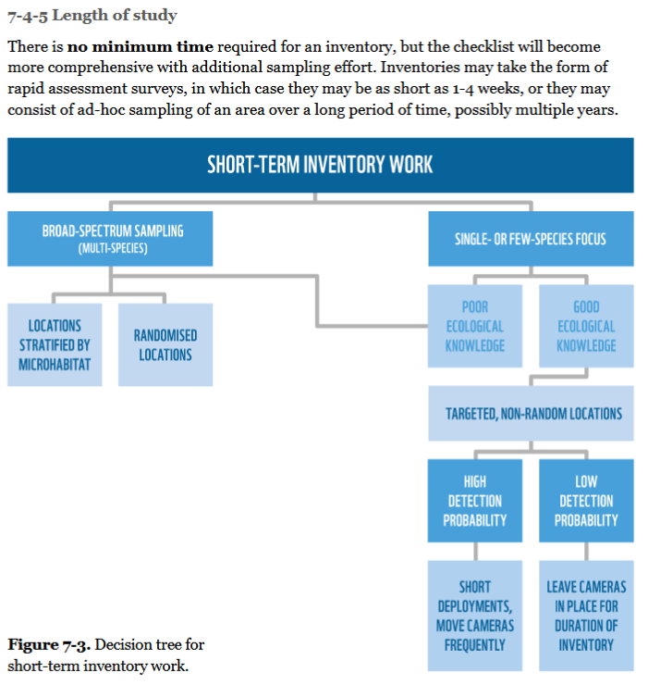

Note banner
<!--
:::{hint}
replace me with text
:::
-->

Overview
```{include} include/00_coming_soon.md
```

In-depth
```{include} include/00_coming_soon.md
```

Figures
Image | file_name | Caption (if applicable) | ref_id
 | figure1_filename.png | figure1_caption | figure1_ref_id
 | figure2_filename.png | figure2_caption | figure2_ref_id
 | figure3_filename.png | figure4_caption | figure3_ref_id
 | figure4_filename.png | figure4_caption | figure4_ref_id
 | figure5_filename.png | figure5_caption | figure5_ref_id
 | figure6_filename.png | figure6_caption | figure6_ref_id

Video
caption | URL (no < / > before/after URL | ref_id
vid1_caption | vid1_url | vid1_ref_id
vid2_caption | vid2_url | vid2_ref_id
vid3_caption | vid3_url | vid3_ref_id
vid4_caption | vid4_url | vid4_ref_id
vid5_caption | vid5_url | vid5_ref_id
vid6_caption | vid6_url | vid6_ref_id

Shiny
Shiny name = shiny_name
Shiny caption = shiny_caption
Shiny URL = shiny_url

Analytical tools & resources
Type | Name | Note | URL | ref_id
resource1_type | resource1_name | resource1_note | resource1_url | resource1_ref_id
resource2_type | resource2_name | resource2_note | resource2_url | resource2_ref_id
resource3_type | resource3_name | resource3_note | resource3_url | resource3_ref_id
resource4_type | resource4_name | resource4_note | resource4_url | resource4_ref_id
resource5_type | resource5_name | resource5_note | resource5_url | resource5_ref_id
resource6_type | resource6_name | resource6_note | resource6_url | resource6_ref_id
resource7_type | resource7_name | resource7_note | resource7_url | resource7_ref_id
resource8_type | resource8_name | resource8_note | resource8_url | resource8_ref_id
resource9_type | resource9_name | resource9_note | resource9_url | resource9_ref_id
resource10_type | resource10_name | resource10_note | resource10_url | resource10_ref_id
resource11_type | resource11_name | resource11_note | resource11_url | resource11_ref_id
resource12_type | resource12_name | resource12_note | resource12_url | resource12_ref_id
resource13_type | resource13_name | resource13_note | resource13_url | resource13_ref_id
resource14_type | resource14_name | resource14_note | resource14_url | resource14_ref_id
resource15_type | resource15_name | resource15_note | resource15_url | resource15_ref_id

References / Glossary
ref_id | glossary_keys
Refs | keys_here

Notes

POPULATE – INFO
File from = 00_tools\00_00_template-master.docx

---
jupytext:
[[space2]]formats: md:myst
[[space2]]text_representation:
[[space4]]extension: .md
[[space4]]format_name: myst
kernelspec:
[[space2]]display_name: Python 3
[[space2]]language: python
[[space2]]name: python3
editor_options:
[[space2]]markdown:
[[space4]]wrap: none
---
(i_sp_info)=
# {{ title_i_sp_info }}

<!--
:::{hint}
replace me with text
:::
-->

::::::::{tab-set}

:::::::{tab-item} Overview
```{include} include/00_coming_soon.md
```
:::::::

:::::::{tab-item} In-depth
```{include} include/00_coming_soon.md
```
:::::::

:::::::{tab-item} Visual resources
::::::{grid} 3
:gutter: 3
:class-container: wrapper
:::::{grid-item-card} {{ rtxt_figure1_ref_id }}
<img src="../03_images/03_image_files/figure1_filename.png" class="img_grid"><br><br>figure1_caption
:::::

:::::{grid-item-card} {{ rtxt_figure2_ref_id }}
<img src="../03_images/03_image_files/figure2_filename.png" class="img_grid"><br><br>figure2_caption
:::::

:::::{grid-item-card} {{ rtxt_figure3_ref_id }}
<img src="../03_images/03_image_files/figure3_filename.png" class="img_grid"><br><br>figure4_caption
:::::

::::::
:::::::

:::::::{tab-item} Analytical tools & Resources
| Type | Name | Note | URL | Reference |
|:----------------|:-------------------------------|:----------------------------------------------------------------|:----------------------|:----------------------------------------|
| resource1_type | resource1_name | resource1_note | resource1_url | {{ rbib_resource1_ref_id }} |
| resource2_type | resource2_name | resource2_note | resource2_url | {{ rbib_resource2_ref_id }} |
| resource3_type | resource3_name | resource3_note | resource3_url | {{ rbib_resource3_ref_id }} |
| resource4_type | resource4_name | resource4_note | resource4_url | {{ rbib_resource4_ref_id }} |
| resource5_type | resource5_name | resource5_note | resource5_url | {{ rbib_resource5_ref_id }} |
| resource6_type | resource6_name | resource6_note | resource6_url | {{ rbib_resource6_ref_id }} |
| resource7_type | resource7_name | resource7_note | resource7_url | {{ rbib_resource7_ref_id }} |
| resource8_type | resource8_name | resource8_note | resource8_url | {{ rbib_resource8_ref_id }} |
| resource9_type | resource9_name | resource9_note | resource9_url | {{ rbib_resource9_ref_id }} |
| resource10_type | resource10_name | resource10_note | resource10_url | {{ rbib_resource10_ref_id }} |
| resource11_type | resource11_name | resource11_note | resource11_url | {{ rbib_resource11_ref_id }} |
| resource12_type | resource12_name | resource12_note | resource12_url | {{ rbib_resource12_ref_id }} |
| resource13_type | resource13_name | resource13_note | resource13_url | {{ rbib_resource13_ref_id }} |
| resource14_type | resource14_name | resource14_note | resource14_url | {{ rbib_resource14_ref_id }} |
| resource15_type | resource15_name | resource15_note | resource15_url | {{ rbib_resource15_ref_id }} |
| Error! Reference source not found. | Error! Reference source not found. | Error! Reference source not found. | Error! Reference source not found. | {{ rbib_Error! Reference source not found. }} |
| Error! Reference source not found. | Error! Reference source not found. | Error! Reference source not found. | Error! Reference source not found. | {{ rbib_Error! Reference source not found. }} |
| Error! Reference source not found. | Error! Reference source not found. | Error! Reference source not found. | Error! Reference source not found. | {{ rbib_Error! Reference source not found. }} |
| Error! Reference source not found. | Error! Reference source not found. | Error! Reference source not found. | Error! Reference source not found. | {{ rbib_Error! Reference source not found. }} |
| Error! Reference source not found. | Error! Reference source not found. | Error! Reference source not found. | Error! Reference source not found. | {{ rbib_Error! Reference source not found. }} |
<!-- END_RESOURCE_TABLE -->
:::::::

:::::::{tab-item} References
Refs

:::::::

::::::::

