Topic Info
info_id | sp_hr_size
question | Question: Is home range size information available for your Target Species (can be taken from the literature)? If so, enter the home range diameter (in metres).

Note banner
::::{hint}
**{{ term_hr_size }}**: {{ def_hr_size }}

Unsure about the {{ hr_size_tl }} of your Target Species? There may be information available in the "Species home range / body size lookup"; see the **Shiny Apps/Widgets** tab of the info-box below.

**Note:**
- {{ hr_size_tu }} will not be exactly the same for every animal of a certain species; when thinking of home range size in the context of study design, we are really thinking about the average {{ hr_size_tl }} for individuals of that species for the duration of your study.
- {{ hr_size_tu }} information should, ideally, be chosen to reflect the conditions of your study (as closely as possible). For example, data from a study that only reported {{ hr_size_tl }} for one season (e.g., summer {{ hr_size_tl }}) might bias placement if your study aims to evaluate your variable of interest (e.g., 'occupancy') over multiple seasons, especially if the species' movement highly differs between seasons (e.g., moves more in summer).
::::

Overview
:::{figure} ../03_images/03_image_files/00_home_range.jpg
:align: center
:width: 300px
:::
**{{ term_hr_size }}**: {{ def_hr_size }}

:::{note}
- {{ hr_size_tu }} will not be exactly the same for every animal of a certain species; when thinking of home range size in the context of study design, we are really thinking about the average {{ hr_size_tl }} for individuals of that species for the duration of your study.
- {{ hr_size_tu }} information should, ideally, be chosen to reflect the conditions of your study (as closely as possible). For example, data from a study that only reported {{ hr_size_tl }} for one season (e.g., summer {{ hr_size_tl }}) might bias placement if your study aims to evaluate your variable of interest (e.g., 'occupancy') over multiple seasons, especially if the species' movement highly differs between seasons (e.g., moves more in summer).
:::

**<font size="4"><span style="color:#2F5496">How does this relate to study design?</font></span>**

{{ hr_size_tu }} information is used in this tool to determine 'camera spacing' and the 'number of cameras' required. This is because how far animals can move will ultimately affect whether the data collected from different locations (or observations of different individuals) are independent of one another.

This is one aspect of the "{{ closure_site_tl }}" (i.e., {{ def_closure_site }}) {{ mod_assumption_tl_abrv }} of many {{ mod_approach_tl_pl }} (e.g., {{ mod_occupancy_tl_abrv_pl }} [{{ rtxt_mackenzie_et_al_2004 }}]).'**Site independence**' is often used interchangeably with 'site closure', however, the concept of 'site independence' also considers {{ spatial_autocorrelation_tl }}, or "{{ def_spatial_autocorrelation }}." To meet these {{ mod_assumption_tl_abrv }}, its often suggested to space cameras far enough apart that the same individuals or groups of animals are not **influencing data** from multiple sites (e.g., either by being detected or influencing detection at multiple sites, i.e., camera spacing is larger than the diameter of the species' home range size). However, its not always ideal to space cameras far enough apart to ensure 'site closure' and 'site independence' assumptions are met. For some approaches, such as capture-recapture [CITE], the opposite is true; sites should be sufficiently close to one another such that individuals ARE picked up across more than one location ('dependence' is required). Meeting these assumptions (i.e., 'site independence' and/or 'site dependence' [approach-dependent]) is important to ensure that the model results are valid (avoid biased results and incorrect conclusions).

**Refer to the "in-depth" tab for more information.**
Diameter = 2√(Area/π)

----

In-depth
```{include} include/00_coming_soon.md
```
The {{ survey_duration_tl }} must also be short enough that the probability of {{ obj_occupancy_tl }} does not change (i.e., not confounded by other processes, e.g., by changes in the population) ({{ rtxt_oconnell_et_al_2011 }}).

Species with higher dispersal ability (i.e., able to travel further distances) are more likely to be absent during the survey (Wearn & Glover-Kapfer, 2017).

For example, home range size "**has implications for the interpretation of occupancy**. If animals range over a much larger area than a single site, then a) they may conceivably be unavailable for capture during a sampling occasion, and b) the "occupancy" of a site is more related to the ranging patterns and habitat preferences of an individual, rather than the coarse-scale distribution of a species" (Wearn & Glover-Kapfer, 2017).

For some approaches, violation of this {{ mod_assumption_tl_abrv }} can result in an **underestimate of {{ detection_probability_tl_pl }}** and, in turn, **over-estimate {{ obj_density_tl }}** (e.g., with spatial recapture models) or result in simply averaging detections over the sampling period (e.g., {{ mod_rem_tu_abrv }} [{{ rtxt_rowcliffe_et_al_2008 }}; {{ rtxt_rowcliffe_et_al_2013 }}], {{ mod_rest_tu_abrv }} [{{ rtxt_nakashima_et_al_2017 }}] models).

notes
"Home range size is used as a means to control spacing between detectors when point sampling, but it is not related to the occupancy-abundance relationship and the potential for bias in estimates of occupancy. Rather, the importance of home range size to control spacing is related to bias in the standard errors if the independence of occupancy status assumption (e.g., sites are closed to changes in the state of occupancy for the duration of sampling) is violated. Investigators choose grain size, yet many studies fail to report justification for the selected grain size (Devarajan et al., 2020), and frequently use grid cell size to space traps/detectors under aerial sampling in discrete space and point sampling in continuous space.

A final concern related to the site grain size and assumption that the occupancy states across sites are independent relates to spatial correlation in the occupancy process. If individual home ranges overlap more than one point detector (e.g., point sampling of use), there is potential for spatial correlation in neighboring site occupancy states that could lead to false positives in testing hypotheses about ψ, as for example,in incorrectly concluding that occupancy changed (increased or decreased) over time. The outcome of spatial correlation in the occupancy process is that measures of precision will be overestimated (MacKenzie et al., 2017). To our knowledge, these types of false positive errors have not been formally investigated in occupancy models. The choice of grain is therefore an important consideration in occupancy studies since that choice will affect model assumptions and interpretation and is dependent on whether the study involves areal or point sampling (Efford and Dawson, 2012). Finally, point sampling in continuous space may result in unmodeled site-level heterogeneity in detection, resulting in underestimates in both ψ in occupancy models and site-level abundance in Royle-Nichols models (Efford and Dawson, 2012). This form of heterogeneity may arise because the probability of detecting an individual should increase with increasing overlap of its home range and a detector, and the number of individuals varies among occupied sites; the probability of detecting the species given presence may therefore be heterogeneous due to both variation in home-range overlap with sites and abundance at sites, while Royle-Nichols models only account for variation in abundance across sites.." (Fuller et al., 2022, p. 4) (pdf)

Figures
Image | file_name | Caption (if applicable) | ref_id
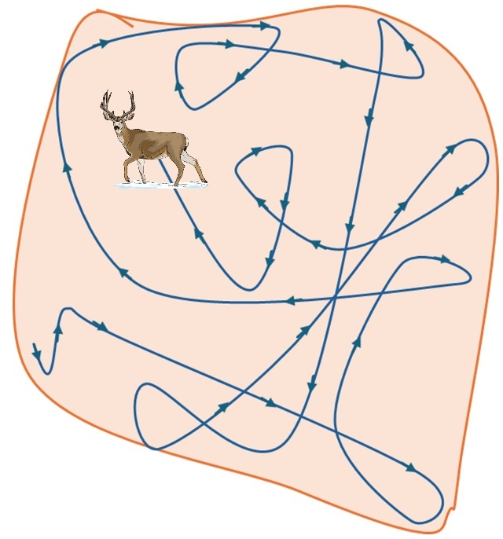 | 00_home_range.jpg | **Home range**: the area within which an animal normally lives and finds what it needs to survive and reproduce. | rcsc_2024b
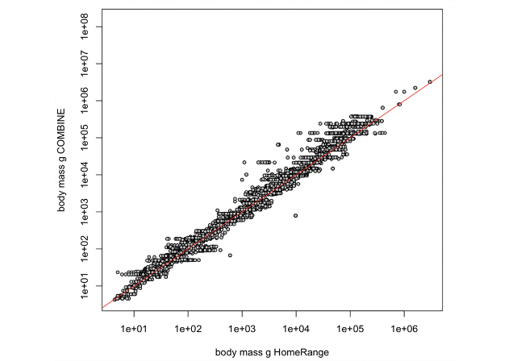 | hoeks_et_al_2024_body_mass.png | NA; no caption | hoeks_et_al_2024
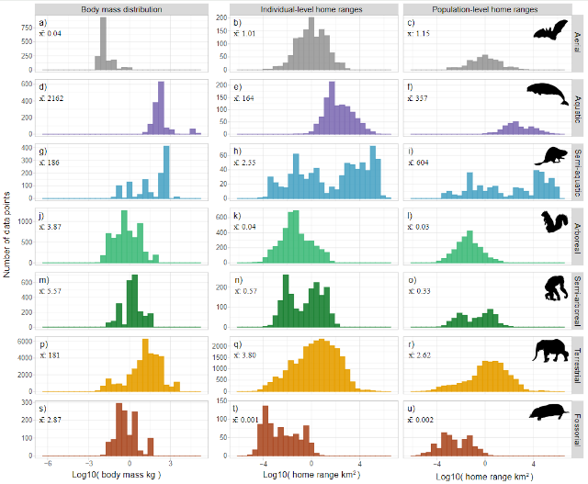 | hoeks_et_al_2024_summary.png | NA; no caption | hoeks_et_al_2024
 | figure4_filename.png | figure4_caption | figure4_ref_id
 | figure5_filename.png | figure5_caption | figure5_ref_id
 | figure6_filename.png | figure6_caption | figure6_ref_id

Video
caption | URL (no < / > before/after URL | ref_id
Dispersal & Animal Home Range | https://www.youtube.com/shorts/WZEHRu8JMYM" referrerpolicy="strict-origin-when-cross-origin | ferguson_2021
Occupancy modelling - home range vs grid cell size | https://www.youtube.com/embed/6TtVXy91AY4?si=4-C043iMoo5U17BI  <iframe width="560" height="315" src="https://www.youtube.com/embed/6TtVXy91AY4?si=4-C043iMoo5U17BI" title="YouTube video player" frameborder="0" allow="accelerometer; autoplay; clipboard-write; encrypted-media; gyroscope; picture-in-picture; web-share" referrerpolicy="strict-origin-when-cross-origin" allowfullscreen></iframe> | proteus_2018b
Animal Home Range Estimation in R;<br> Minimum convex polygon (MCP) and kernel density estimation (KDE) methods for calculating animal home range in R. | https://www.youtube.com/embed/dsPsRPZiOC0?si=oHw5qxjJU1-9I2jM | ecol_appl_r_2021
vid4_caption | vid4_url | vid4_ref_id
vid5_caption | vid5_url | vid5_ref_id
vid6_caption | vid6_url | vid6_ref_id

- UF Game Lab. (2021, Feb 4). Behavior, Home Range, Habitat Use. <https://www.youtube.com/watch?v=BxK8rRN4EXs>

Shiny
Shiny name = Species home range / body size lookup
Shiny caption = A R Shiny app created for the RC Decision Support Tool to allows users lookup information on species home range size / body size; information pulled directly from the following sources:
- Burton et al. (2015) supplementary material "S2. Average body mass and home range size for a sample of species and studies among the reviewed set of camera trap publications"
- PanTHERIA database ({{ rtxt_jones_et_al_2009 }}) "a species-level database of life history, ecology, and geography of extant and recently extinct mammals
- HomeRange: A global database of mammalian home ranges ({{ rtxt_broekman_et_al_2022 }})

:::{note}
Home range size information should, ideally, be chosen to reflect the conditions of your study (as closely as possible). For example, data from a study that only reported home range size for one season (e.g., summer home range size) might bias placement, if your study aims to evaluate occupancy over multiple seasons, especially if the species' movement highly differs between seasons (e.g., moves more in summer).
:::
Shiny URL = https://7e2l38-cassondra-stevenson.shinyapps.io/lu_species_homerange

Shiny name = shiny_name2
Shiny caption =shiny_caption2
Shiny URL = shiny_url2

Analytical tools & resources
Type | Name | Note | URL | ref_id
Data/Database | HomeRange: A global database of mammalian home range | HomeRange, a global database with 75,611 home- range values across 960 different species of mammals, including terrestrial, aquatic and aerial species | Article:<https://onlinelibrary.wiley.com/doi/epdf/10.1111/geb.13625>;<br>Data:https://github.com/SHoeks/HomeRange>; <https://shoeks.github.io/HomeRange/> | broekman_et_al_2022
Data/Database | Supplementary material; PanTHERIA | PanTHERIA: a species-level database of life history, ecology,and geography of extant and recently extinct mammals | <https://ecologicaldata.org/wiki/pantheria> | jones_et_al_2009
Data/Database | Supplementary material; Wildlife camera trapping: a review and recommendations for linking surveys to ecological processes | **Burton et al. (2015)**<br> - Table S2. Data on body size and home range size for a sample of surveyed species.<br>-"Table S1. Bibliographic details and data summarized from camera trap publications included in the review." | Article: <https://besjournals.onlinelibrary.wiley.com/doi/full/10.1111/1365-2664.12432>;<br>[Download Table S2 XLS](https://besjournals.onlinelibrary.wiley.com/action/downloadSupplement?doi=10.1111%2F1365-2664.12432&file=jpe12432-sup-0006-TableS2.csv) and/or<br>[Download the related references; CSV ](https://besjournals.onlinelibrary.wiley.com/action/downloadSupplement?doi=10.1111%2F1365-2664.12432&file=jpe12432-sup-0005-TableS1.xlsx) | burton_et_al_2015
R package | Package ‘HomeRange’ | HomeRange data: the R package can be used to download and import the HomeRange data | <https://github.com/SHoeks/HomeRange> | hoeks_et_al_2024
resource5_type | resource5_name | resource5_note | resource5_url | resource5_ref_id
resource6_type | resource6_name | resource6_note | resource6_url | resource6_ref_id
resource7_type | resource7_name | resource7_note | resource7_url | resource7_ref_id
resource8_type | resource8_name | resource8_note | resource8_url | resource8_ref_id
resource9_type | resource9_name | resource9_note | resource9_url | resource9_ref_id
resource10_type | resource10_name | resource10_note | resource10_url | resource10_ref_id
resource11_type | resource11_name | resource11_note | resource11_url | resource11_ref_id
resource12_type | resource12_name | resource12_note | resource12_url | resource12_ref_id
resource13_type | resource13_name | resource13_note | resource13_url | resource13_ref_id
resource14_type | resource14_name | resource14_note | resource14_url | resource14_ref_id
resource15_type | resource15_name | resource15_note | resource15_url | resource15_ref_id

References / Glossary
ref_id
{{ rbib_broekman_et_al_2022 }}
{{ rbib_burton_et_al_2015 }}
{{ rbib_ecol_appl_r_2021 }}
{{ rbib_ferguson_2021 }}
{{ rbib_hoeks_et_al_2024 }}
{{ rbib_jones_et_al_2009 }}
{{ rbib_mackenzie_et_al_2004 }}
{{ rbib_nakashima_et_al_2017 }}
{{ rbib_oconnell_et_al_2011 }}
{{ rbib_proteus_2018b }}
{{ rbib_rowcliffe_et_al_2008 }}
{{ rbib_rowcliffe_et_al_2013 }}

Notes
- Laver, Peter N., and Marcella J. Kelly. “A Critical Review of Home Range Studies.” Journal of Wildlife Management 72, no. 1 (January 2008): 290–98. https://doi.org/10.2193/2005-589.
- Bowman, Jeff, Jochen A. G. Jaeger, and Lenore Fahrig. “Dispersal Distance of Mammals Is Proportional to Home Range Size.” Ecology 83, no. 7 (July 2002): 2049–55. https://doi.org/10.1890/0012-9658(2002)083[2049:DDOMIP]2.0.CO;2.
- Benhamou, S. “Home Range in Terrestrial Mammals.” REVUE D ECOLOGIE-LA TERRE ET LA VIE 53, no. 4 (October 1998): 309–35.
- COOPER. “Home Range Size and Population Dynamics,” n.d.
- Spencer, Wayne D. “Home Ranges and the Value of Spatial Information.” Journal of Mammalogy 93, no. 4 (September 14, 2012): 929–47. https://doi.org/10.1644/12-MAMM-S-061.1.

Markdown

POPULATE – INFO

File from = 00_tools\00_00_template-master.docx

---
jupytext:
[[space2]]formats: md:myst
[[space2]]text_representation:
[[space4]]extension: .md
[[space4]]format_name: myst
kernelspec:
[[space2]]display_name: Python 3
[[space2]]language: python
[[space2]]name: python3
editor_options:
[[space2]]markdown:
[[space4]]wrap: none
---
(i_sp_hr_size)=
# {{ title_i_sp_hr_size }}

::::{hint}
**{{ term_hr_size }}**: {{ def_hr_size }}

Unsure about the {{ hr_size_tl }} of your Target Species? There may be information available in the "Species home range / body size lookup"; see the **Shiny Apps/Widgets** tab of the info-box below.

**Note:**
- {{ hr_size_tu }} will not be exactly the same for every animal of a certain species; when thinking of home range size in the context of study design, we are really thinking about the average {{ hr_size_tl }} for individuals of that species for the duration of your study.
- {{ hr_size_tu }} information should, ideally, be chosen to reflect the conditions of your study (as closely as possible). For example, data from a study that only reported {{ hr_size_tl }} for one season (e.g., summer {{ hr_size_tl }}) might bias placement if your study aims to evaluate your variable of interest (e.g., 'occupancy') over multiple seasons, especially if the species' movement highly differs between seasons (e.g., moves more in summer).
::::

::::::::{tab-set}

:::::::{tab-item} Overview
:::{figure} ../03_images/03_image_files/00_home_range.jpg
:align: center
:width: 300px
:::
**{{ term_hr_size }}**: {{ def_hr_size }}

:::{note}
- {{ hr_size_tu }} will not be exactly the same for every animal of a certain species; when thinking of home range size in the context of study design, we are really thinking about the average {{ hr_size_tl }} for individuals of that species for the duration of your study.
- {{ hr_size_tu }} information should, ideally, be chosen to reflect the conditions of your study (as closely as possible). For example, data from a study that only reported {{ hr_size_tl }} for one season (e.g., summer {{ hr_size_tl }}) might bias placement if your study aims to evaluate your variable of interest (e.g., 'occupancy') over multiple seasons, especially if the species' movement highly differs between seasons (e.g., moves more in summer).
:::

**<font size="4"><span style="color:#2F5496">How does this relate to study design?</font></span>**

{{ hr_size_tu }} information is used in this tool to determine 'camera spacing' and the 'number of cameras' required. This is because how far animals can move will ultimately affect whether the data collected from different locations (or observations of different individuals) are independent of one another.

This is one aspect of the "{{ closure_site_tl }}" (i.e., {{ def_closure_site }}) {{ mod_assumption_tl_abrv }} of many {{ mod_approach_tl_pl }} (e.g., {{ mod_occupancy_tl_abrv_pl }} [{{ rtxt_mackenzie_et_al_2004 }}]).'**Site independence**' is often used interchangeably with 'site closure', however, the concept of 'site independence' also considers {{ spatial_autocorrelation_tl }}, or "{{ def_spatial_autocorrelation }}." To meet these {{ mod_assumption_tl_abrv }}, its often suggested to space cameras far enough apart that the same individuals or groups of animals are not **influencing data** from multiple sites (e.g., either by being detected or influencing detection at multiple sites, i.e., camera spacing is larger than the diameter of the species' home range size). However, its not always ideal to space cameras far enough apart to ensure 'site closure' and 'site independence' assumptions are met. For some approaches, such as capture-recapture [CITE], the opposite is true; sites should be sufficiently close to one another such that individuals ARE picked up across more than one location ('dependence' is required). Meeting these assumptions (i.e., 'site independence' and/or 'site dependence' [approach-dependent]) is important to ensure that the model results are valid (avoid biased results and incorrect conclusions).

**Refer to the "in-depth" tab for more information.**
:::::::

:::::::{tab-item} In-depth
```{include} include/00_coming_soon.md
```
The {{ survey_duration_tl }} must also be short enough that the probability of {{ obj_occupancy_tl }} does not change (i.e., not confounded by other processes, e.g., by changes in the population) ({{ rtxt_oconnell_et_al_2011 }}).

Species with higher dispersal ability (i.e., able to travel further distances) are more likely to be absent during the survey (Wearn & Glover-Kapfer, 2017).

For example, home range size "**has implications for the interpretation of occupancy**. If animals range over a much larger area than a single site, then a) they may conceivably be unavailable for capture during a sampling occasion, and b) the "occupancy" of a site is more related to the ranging patterns and habitat preferences of an individual, rather than the coarse-scale distribution of a species" (Wearn & Glover-Kapfer, 2017).

For some approaches, violation of this {{ mod_assumption_tl_abrv }} can result in an **underestimate of {{ detection_probability_tl_pl }}** and, in turn, **over-estimate {{ obj_density_tl }}** (e.g., with spatial recapture models) or result in simply averaging detections over the sampling period (e.g., {{ mod_rem_tu_abrv }} [{{ rtxt_rowcliffe_et_al_2008 }}; {{ rtxt_rowcliffe_et_al_2013 }}], {{ mod_rest_tu_abrv }} [{{ rtxt_nakashima_et_al_2017 }}] models).

:::::::

:::::::{tab-item} Visual resources
::::::{grid} 3
:gutter: 3
:class-container: wrapper
:::::{grid-item-card} {{ rtxt_rcsc_2024b }}
<img src="../03_images/03_image_files/00_home_range.jpg" class="img_grid"><br><br>**Home range**: the area within which an animal normally lives and finds what it needs to survive and reproduce.
:::::

:::::{grid-item-card} {{ rtxt_hoeks_et_al_2024 }}
<img src="../03_images/03_image_files/hoeks_et_al_2024_body_mass.png" class="img_grid"><br><br>
:::::

:::::{grid-item-card} {{ rtxt_hoeks_et_al_2024 }}
<img src="../03_images/03_image_files/hoeks_et_al_2024_summary.png" class="img_grid"><br><br>
:::::

:::::{grid-item-card} {{ rtxt_figure4_ref_id }}
<img src="../03_images/03_image_files/figure4_filename.png" class="img_grid"><br><br>figure4_caption
:::::

:::::{grid-item-card} {{ rtxt_figure5_ref_id }}
<img src="../03_images/03_image_files/figure5_filename.png" class="img_grid"><br><br>figure5_caption
:::::

:::::{grid-item-card} {{ rtxt_figure6_ref_id }}
<img src="../03_images/03_image_files/figure6_filename.png" class="img_grid"><br><br>figure6_caption
:::::

::::::
:::::::

:::::::{tab-item} Shiny apps/Widgets
::::::{card} Species home range / body size lookup
A R Shiny app created for the RC Decision Support Tool to allows users lookup information on species home range size / body size; information pulled directly from the following sources:
- Burton et al. (2015) supplementary material "S2. Average body mass and home range size for a sample of species and studies among the reviewed set of camera trap publications"
- PanTHERIA database ({{ rtxt_jones_et_al_2009 }}) "a species-level database of life history, ecology, and geography of extant and recently extinct mammals
- HomeRange: A global database of mammalian home ranges ({{ rtxt_broekman_et_al_2022 }})

:::{note}
Home range size information should, ideally, be chosen to reflect the conditions of your study (as closely as possible). For example, data from a study that only reported home range size for one season (e.g., summer home range size) might bias placement, if your study aims to evaluate occupancy over multiple seasons, especially if the species' movement highly differs between seasons (e.g., moves more in summer).
:::
<div class="iframe-container-shiny"><iframe class="iframe-responsive-shiny" src="https://7e2l38-cassondra-stevenson.shinyapps.io/lu_species_homerange"></iframe></div>
::::::
:::::::

:::::::{tab-item} Analytical tools & Resources
| Type | Name | Note | URL | Reference |
|:----------------|:-------------------------------|:----------------------------------------------------------------|:----------------------|:----------------------------------------|
| Data/Database | HomeRange: A global database of mammalian home range | HomeRange, a global database with 75,611 home- range values across 960 different species of mammals, including terrestrial, aquatic and aerial species | Article:<https://onlinelibrary.wiley.com/doi/epdf/10.1111/geb.13625>;<br>Data:https://github.com/SHoeks/HomeRange>; <https://shoeks.github.io/HomeRange/> | {{ rbib_broekman_et_al_2022 }} |
| Data/Database | Supplementary material; PanTHERIA | PanTHERIA: a species-level database of life history, ecology,and geography of extant and recently extinct mammals | <https://ecologicaldata.org/wiki/pantheria> | {{ rbib_jones_et_al_2009 }} |
| Data/Database | Supplementary material; Wildlife camera trapping: a review and recommendations for linking surveys to ecological processes | **Burton et al. (2015)**<br> - Table S2. Data on body size and home range size for a sample of surveyed species.<br>-"Table S1. Bibliographic details and data summarized from camera trap publications included in the review." | Article: <https://besjournals.onlinelibrary.wiley.com/doi/full/10.1111/1365-2664.12432>;<br>[Download Table S2 XLS](https://besjournals.onlinelibrary.wiley.com/action/downloadSupplement?doi=10.1111%2F1365-2664.12432&file=jpe12432-sup-0006-TableS2.csv) and/or<br>[Download the related references; CSV ](https://besjournals.onlinelibrary.wiley.com/action/downloadSupplement?doi=10.1111%2F1365-2664.12432&file=jpe12432-sup-0005-TableS1.xlsx) | {{ rbib_burton_et_al_2015 }} |
| R package | Package ‘HomeRange’ | HomeRange data: the R package can be used to download and import the HomeRange data | <https://github.com/SHoeks/HomeRange> | {{ rbib_hoeks_et_al_2024 }} |
| resource5_type | resource5_name | resource5_note | resource5_url | {{ rbib_resource5_ref_id }} |
| resource6_type | resource6_name | resource6_note | resource6_url | {{ rbib_resource6_ref_id }} |
| resource7_type | resource7_name | resource7_note | resource7_url | {{ rbib_resource7_ref_id }} |
| resource8_type | resource8_name | resource8_note | resource8_url | {{ rbib_resource8_ref_id }} |
| resource9_type | resource9_name | resource9_note | resource9_url | {{ rbib_resource9_ref_id }} |
| resource10_type | resource10_name | resource10_note | resource10_url | {{ rbib_resource10_ref_id }} |
| resource11_type | resource11_name | resource11_note | resource11_url | {{ rbib_resource11_ref_id }} |
| resource12_type | resource12_name | resource12_note | resource12_url | {{ rbib_resource12_ref_id }} |
| resource13_type | resource13_name | resource13_note | resource13_url | {{ rbib_resource13_ref_id }} |
| resource14_type | resource14_name | resource14_note | resource14_url | {{ rbib_resource14_ref_id }} |
| resource15_type | resource15_name | resource15_note | resource15_url | {{ rbib_resource15_ref_id }} |
| Error! Reference source not found. | Error! Reference source not found. | Error! Reference source not found. | Error! Reference source not found. | {{ rbib_Error! Reference source not found. }} |
| Error! Reference source not found. | Error! Reference source not found. | Error! Reference source not found. | Error! Reference source not found. | {{ rbib_Error! Reference source not found. }} |
| Error! Reference source not found. | Error! Reference source not found. | Error! Reference source not found. | Error! Reference source not found. | {{ rbib_Error! Reference source not found. }} |
| Error! Reference source not found. | Error! Reference source not found. | Error! Reference source not found. | Error! Reference source not found. | {{ rbib_Error! Reference source not found. }} |
| Error! Reference source not found. | Error! Reference source not found. | Error! Reference source not found. | Error! Reference source not found. | {{ rbib_Error! Reference source not found. }} |
<!-- END_RESOURCE_TABLE -->
:::::::

:::::::{tab-item} References
{{ rbib_broekman_et_al_2022 }}
{{ rbib_burton_et_al_2015 }}
{{ rbib_ecol_appl_r_2021 }}
{{ rbib_ferguson_2021 }}
{{ rbib_hoeks_et_al_2024 }}
{{ rbib_jones_et_al_2009 }}
{{ rbib_mackenzie_et_al_2004 }}
{{ rbib_nakashima_et_al_2017 }}
{{ rbib_oconnell_et_al_2011 }}
{{ rbib_proteus_2018b }}
{{ rbib_rowcliffe_et_al_2008 }}
{{ rbib_rowcliffe_et_al_2013 }}
:::::::

::::::::

