Topic Info

info_id | sp_size
question | Question: What is the approximate size of the Target Species?  Discuss influence of body size on design choices + Include mention of potential season effects on movement / HR + motility; movement; home range size

Note banner
:::{hint}
Here are a few examples of comparable species for each body size options:
- **{{ term_sp_size_sm }}**: {{ def_sp_size_sm }}
- **{{ term_sp_size_md }}**: {{ def_sp_size_md }}
- **{{ term_sp_size_lg }}**: {{ def_sp_size_lg }}
- **{{ term_sp_size_mult }}**: *{{ def_sp_size_mult }}*

Unsure about the size of your Target Species? There may be information available in the "Species home range / body size lookup"; see the**Shiny Apps/Widgets** tab below.
:::

Overview
Here are a few examples of comparable species for each body size options:

- **{{ term_sp_size_sm }}**: {{ def_sp_size_sm }}
- **{{ term_sp_size_md }}**: {{ def_sp_size_md }}
- **{{ term_sp_size_lg }}**: {{ def_sp_size_lg }}
- **{{ term_sp_size_mult }}**: *{{ def_sp_size_mult }}*

:::{figure} ../03_images/03_image_files/kemp_et_al_2022_pg15_fig1.png
:align: center
:width: 50%
:::
**Kemp et al. (2022) - Pg 15 Fig 1** The graphic above shows how the height of the camera should reflect the size of the target animal to increase the chance of detection. In this case, the yellow area shows the field of view.

**<font size="4"><span style="color:#2F5496">How does this relate to study design?</font></span>**

Body size affects the detection process ({{ rtxt_obrien_et_al_2011 }}). Species with a larger body size are more likely to be detected; and therefore may require lower sampling effort than smaller species ({{ rtxt_chatterjee_et_al_2021 }}). Larger species moving through the camera’s detection zone are more likely to trigger the camera ({{ rtxt_chatterjee_et_al_2021 }}; {{ rtxt_rowcliffe_et_al_2011 }}; {{ rtxt_hofmeester_et_al_2017 }}); they can also be detected farther away or occur at wider angles ({{ rtxt_rowcliffe_et_al_2011 }}; {{{ rtxt_hofmeester_et_al_2017 }}). Whereas, small mammals are often undetected due to their small size ({{ rtxt_obrien_et_al_2011 }}; {{ rtxt_anile_devillard_2016 }}) and because "small species which routinely move at fast speeds, such as stoats and weasels, are likely to have especially small detection zones" ({{ rtxt_glen_et_al_2013 }}).

:::{figure} ../03_images/03_image_files/kays_et_al_2021_fig6_clipped.png
:align: center
:width: 40%
:::
> **Kays et al. (2021) - Fig. 6**: Relationship between trigger probability and body mass for four focal species (ascending order by weight: gray fox, raccoon, coyote, white-tailed deer). Error bars show standard deviation. Body mass values come from North Carolina animals in the mammal collections of the NC Museum of Natural Sciences.

When thinking beyond the camera's FOV, larger species generally also have larger home ranges ({{ rtxt_garland_1983 }}) and daily movement distances, making them more likely to be detected at multiple cameras ({{ rtxt_chatterjee_et_al_2021 }}), therefore there are also implications for which models may be appropriate (due to assumptions of "site closure" / "independent locations").

:::{note}
This is an especially important consideration when targetting multiple species of varying sizes.
:::

In-depth
```{include} include/00_coming_soon.md
```

Figures
Image | file_name | Caption (if applicable) | ref_id
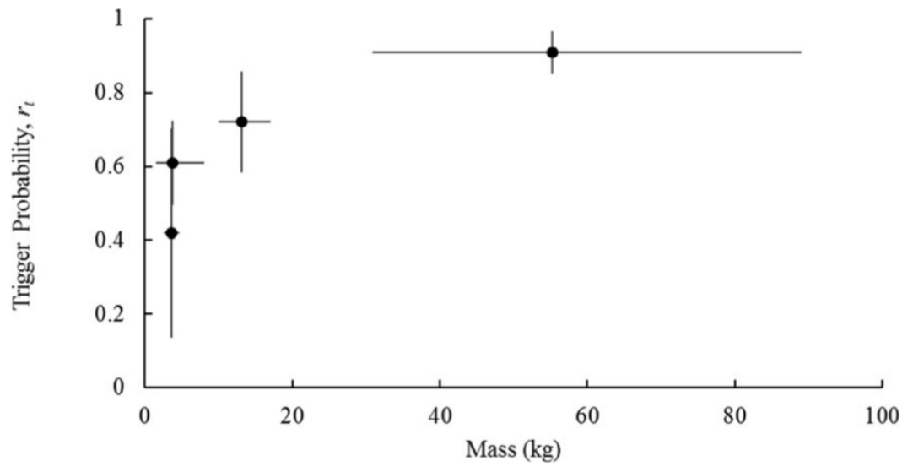 | kays_et_al_2021_fig6_clipped.png | **Kays et al. (2021) - Fig. 6** Relationship between trigger probability and body mass for four focal species (ascending order by weight: gray fox, raccoon, coyote, white-tailed deer). Error bars show standard deviation. Body mass values come from North Carolina animals in the mammal collections of the NC Museum of Natural Sciences | kays_et_al_2021
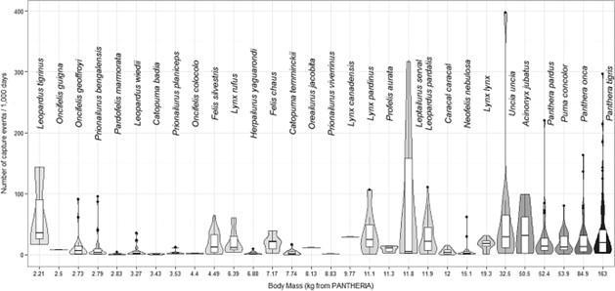 | anile_devillard_2016_fig2.jpg | **Anile & Devillard (2028) - Fig. 2** Violin plot of the trap rate, expressed as the number of capture events per 1000 days of camera trapping per species (*n* = 30) ordered by body mass (*n* = 513 records).  :::{dropdown}  Some records appeared as ‘outliers’ in this figure, that is, particularly high numbers of capture events/1000 trapping hours for large felids (*Uncia uncia, Panthera tigris*). These data were not included in the reduced dataset used in modelling as some data were lacking (either inter-trap distance, type and number of camera used as well as if they were used in pair). Consequently, these particular records were not responsible of the observed positive relationship between RAI and body mass.  ::: | anile_devillard_2016
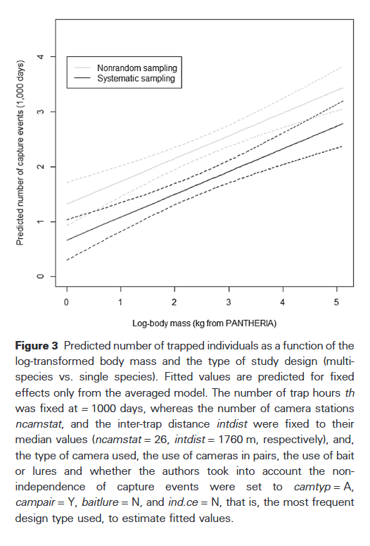 | anile_devillard_2016_fig3_clipped.png | **Anile & Devillard (2028) - Fig. 3** Predicted number of trapped individuals as a function of the log-transformed body mass and the type of study design (multispecies vs. single species).  :::{dropdown}  Fitted values are predicted for fixed effects only from the averaged model. The number of trap hours *th* was fixed at = 1000 days, whereas the number of camera stations *ncamstat*, and the inter-trap distance *intdist* were fixed to their median values (*ncamstat* = 26, *intdist* = 1760 m, respectively), and, the type of camera used, the use of cameras in pairs, the use of bait or lures and whether the authors took into account the nonindependence of capture events were set to *camtyp* = A, *campair* = Y, *baitlure* = N, and *ind.ce* = N, that is, the most frequent design type used, to estimate fitted values.  ::: | anile_devillard_2016
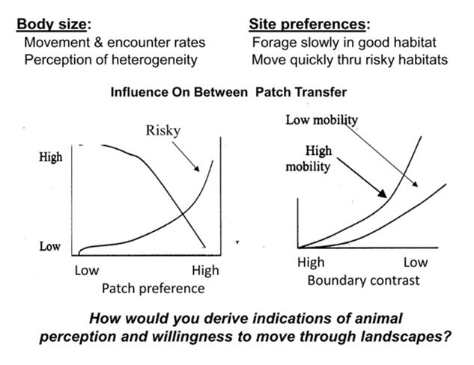 | bodysize_movement.png | figure4_caption | bodysize_movement.png
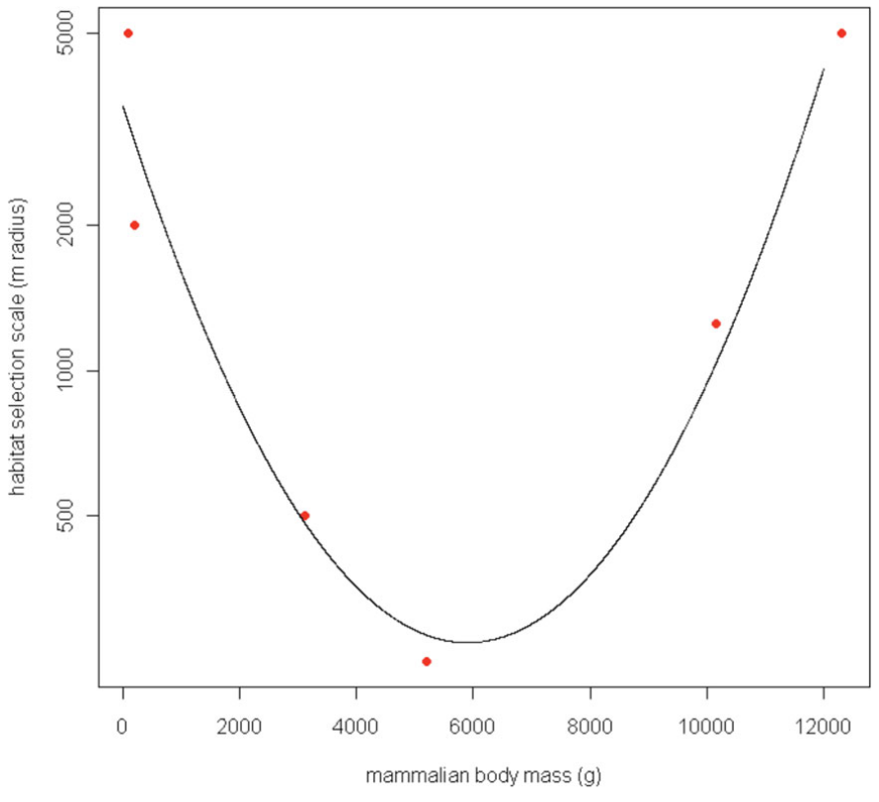 | fisher_et_al_2011_fig6_clipped.png | ** Fisher et al. (2011) - Fig. 6** Characteristic scale of habitat selection (determined by AIC weight, see Figs. 1 and 2), log-transformed and modeled against body mass of six mammal species for which a characteristic scale was detectable. Habitat quantified at large scales best predicts both small and large mammal occurrence, whereas habitat quantified at small scales best predicts occurrence of intermediate-sized mammals. | fisher_et_al_2011
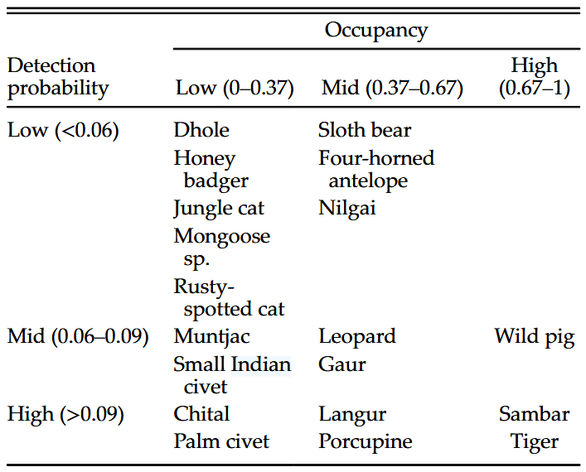 | chatterjee_et_al_2021_table2_clipped.png | **Chatterjee et al. (2021) - Table 2.** Broad classifications of mammals based on occupancy and detection probabilities. | chatterjee_et_al_2021
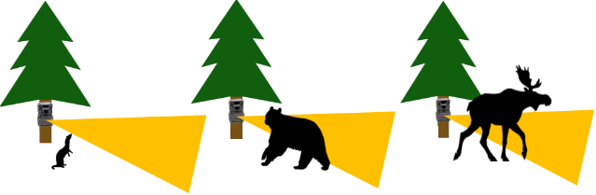 | kemp_et_al_2022_pg15_fig1.png | **Kemp et al. (2022) - Pg 15 Fig 1** The graphic above shows how the height of the camera should reflect the size of the target animal to increase the chance of detection. In this case, the yellow area shows the field of view. | kemp_et_al_2022
 | figure8_filename.png | figure8_caption | figure8_ref_id
 | figure9_filename.png | figure9_caption | figure9_ref_id
 | figure10_filename.png | figure10_caption | figure10_ref_id
 | figure11_filename.png | figure11_caption | figure11_ref_id
 | figure12_filename.png | figure12_caption | figure12_ref_id

Video
caption | URL (no < / > before/after URL | ref_id
vid1_caption | vid1_url | vid1_ref_id
vid2_caption | vid2_url | vid2_ref_id
vid3_caption | vid3_url | vid3_ref_id
vid4_caption | vid4_url | vid4_ref_id
vid5_caption | vid5_url | vid5_ref_id
vid6_caption | vid6_url | vid6_ref_id

Shiny
Shiny name = Species home range / body size lookup
Shiny caption = A R Shiny app created for the RC Decision Support Tool to lookup information on species home range size / body size; information pulled directly from the following sources:
- Burton et al. (2015) supplementary material "S2. Average body mass and home range size for a sample of species and studies among the reviewed set of camera trap publications"
- PanTHERIA database ({{ rtxt_jones_et_al_2009 }}) "a species-level database of life history, ecology,and geography of extant and recently extinct mammals
- HomeRange: A global database of mammalian home ranges ({{ rtxt_broekman_et_al_2022 }})
Shiny URL = https://7e2l38-cassondra-stevenson.shinyapps.io/lu_species_homerange/

Shiny name = shiny_name2
Shiny caption =shiny_caption2
Shiny URL = shiny_url2

Analytical tools & resources
Type | Name | Note | URL | ref_id
resource1_type | resource1_name | resource1_note | resource1_url | resource1_ref_id
resource2_type | resource2_name | resource2_note | resource2_url | resource2_ref_id
resource3_type | resource3_name | resource3_note | resource3_url | resource3_ref_id
resource4_type | resource4_name | resource4_note | resource4_url | resource4_ref_id
resource5_type | resource5_name | resource5_note | resource5_url | resource5_ref_id
resource6_type | resource6_name | resource6_note | resource6_url | resource6_ref_id
resource7_type | resource7_name | resource7_note | resource7_url | resource7_ref_id
resource8_type | resource8_name | resource8_note | resource8_url | resource8_ref_id
resource9_type | resource9_name | resource9_note | resource9_url | resource9_ref_id
resource10_type | resource10_name | resource10_note | resource10_url | resource10_ref_id
resource11_type | resource11_name | resource11_note | resource11_url | resource11_ref_id
resource12_type | resource12_name | resource12_note | resource12_url | resource12_ref_id
resource13_type | resource13_name | resource13_note | resource13_url | resource13_ref_id
resource14_type | resource14_name | resource14_note | resource14_url | resource14_ref_id
resource15_type | resource15_name | resource15_note | resource15_url | resource15_ref_id

References / Glossary
ref_id
{{ rbib_anile_devillard_2016 }}
{{ rbib_blackburn_gaston_1999 }}
{{ rbib_broekman_et_al_2022 }}
{{ rbib_burton_et_al_2015 }}
{{ rbib_chatterjee_et_al_2021 }}
{{ rbib_fisher_et_al_2011 }}
{{ rbib_garland_1983 }}
{{ rbib_glen_et_al_2013 }}
{{ rbib_hofmeester_et_al_2017 }}
{{ rbib_jones_et_al_2009 }}
{{ rbib_kays_et_al_2021 }}
{{ rbib_kemp_et_al_2022 }}
{{ rbib_labarbera_1989 }}
{{ rbib_obrien_et_al_2011 }}
{{ rbib_roemer_et_al_2009 }}
{{ rbib_rowcliffe_et_al_2011 }}

Notes
Not used
- Very small species (< 100 g) are sometimes detected by higherend camera traps on the market today (e.g. Fig 4-3), but detections will only be reliable at distances less than 2 m from the camera ({{Rowcliffe et al. 2011}})
- There is also some evidence that detection angles are smaller for species which move at faster speeds ({{Rowcliffe et al. 2011}}.
- Small species which routinely move at fast speeds, such as stoats and weasels, are likely to have especially small detection zones ({{Glen et al., 2013}}).
- "Most species with larger body sizes had moderate or high detection probabilities and thus required lower sampling efforts than smaller mammals. This makes sense, as larger-bodied animals are more likely to trigger the camera trap and have larger home ranges (Garland 1983) and daily movement distances, making them more likely to be detected at multiple cameras." (Chatterjee et al., 2021)
- "While occupancy was positively correlated with body size, detection probability was not significantly correlated with body size (r = 0.17, P = 0.49)." (Chatterjee et al., 2021)
- Species with higher dispersal ability (i.e., able to travel further distances) are also more likely to be absent during the survey (may generally occur at a camera location, but weren’t detected when you were sampling)
- Body size affects how easy it is to detect an individual moving through the camera’s detection zone ([detectability]()); larger species can be detected farther away or occur at wider angles ({{Rowcliffe et al. 2011}}; {{Hofmeester et al. 2017}}). ;;;;; However, body size has been found to have the most important effect on detection zones, with larger species being detected at larger distances and wider angles ({{Rowcliffe et al. 2011}}; {{Hofmeester et al. 2017}}).
- Other
  - "All other things being equal, larger species might be more easily trapped as they move more slowly than smaller species, or because their population density is higher (see Bengsen et al., 2011 and Rowcliffe & Carbone, 2008; Rowcliffe et al., 2008 on the importance of population density on trapping rates)."
  - Future studies of small species using cameras could address this constraint by including body size as a parameter (O’Brien, Kinnaird, and Wibisono 2011).
- SEE
  - Yu, H., Lin, Z., & F. Xiao. (2024). Role of Body Size and Shape in Animal Camouflage. *Ecology and Evolution, 14*(5), e11434. <https://doi.org/10.1002/ece3.11434>
  - Blackburn, TM, and KJ Gaston. "The Relationship between Animal Abundance and Body Size: A Review of the Mechanisms." In ADVANCES IN ECOLOGICAL RESEARCH, VOL 28, edited by AH Fitter and D Raffaelli, 28:181–210, 1999. https://doi.org/10.1016/S0065-2504(08)60033-1.
  - Hantak, Maggie M., Bryan S. McLean, Daijiang Li, and Robert P. Guralnick. "Mammalian Body Size Is Determined by Interactions between Climate, Urbanization, and Ecological Traits." Communications Biology 4, no. 1 (August 16, 2021): 972. https://doi.org/10.1038/s42003-021-02505-3.
  - Kelt, Douglas A., and Dirk Van Vuren. "Energetic Constraints and the Relationship Between Body Size and Home Range Area in Mammals." Ecology 80, no. 1 (January 1999): 337–40. https://doi.org/10.1890/0012-9658(1999)080[0337:ECATRB]2.0.CO;2.
  - Kozłowski, Jan, and Adam. T. Gawelczyk. "Why Are Species’ Body Size Distributions Usually Skewed to the Right?" Functional Ecology 16, no. 4 (August 2002): 419–32. https://doi.org/10.1046/j.1365-2435.2002.00646.x.
  - LaBarbera, Michael. "Analyzing Body Size as a Factor in Ecology and Evolution." Annu. Rev. Ecol. Syst. 20, no. 20 (1989): 97–117.
  - Ofstad, Endre Grüner, Ivar Herfindal, Erling Johan Solberg, and Bernt-Erik Sæther. "Home Ranges, Habitat and Body Mass: Simple Correlates of Home Range Size in Ungulates." Proceedings of the Royal Society B: Biological Sciences 283, no. 1845 (December 28, 2016): 20161234. https://doi.org/10.1098/rspb.2016.1234.

POPULATE – INFO

File from = 00_tools\00_00_template-master.docx

---
jupytext:
[[space2]]formats: md:myst
[[space2]]text_representation:
[[space4]]extension: .md
[[space4]]format_name: myst
kernelspec:
[[space2]]display_name: Python 3
[[space2]]language: python
[[space2]]name: python3
editor_options:
[[space2]]markdown:
[[space4]]wrap: none
---
(i_sp_size)=
# {{ title_i_sp_size }}

:::{hint}
Here are a few examples of comparable species for each body size options:
- **{{ term_sp_size_sm }}**: {{ def_sp_size_sm }}
- **{{ term_sp_size_md }}**: {{ def_sp_size_md }}
- **{{ term_sp_size_lg }}**: {{ def_sp_size_lg }}
- **{{ term_sp_size_mult }}**: *{{ def_sp_size_mult }}*

Unsure about the size of your Target Species? There may be information available in the "Species home range / body size lookup"; see the**Shiny Apps/Widgets** tab below.
:::

::::::::{tab-set}

:::::::{tab-item} Overview
Here are a few examples of comparable species for each body size options:

- **{{ term_sp_size_sm }}**: {{ def_sp_size_sm }}
- **{{ term_sp_size_md }}**: {{ def_sp_size_md }}
- **{{ term_sp_size_lg }}**: {{ def_sp_size_lg }}
- **{{ term_sp_size_mult }}**: *{{ def_sp_size_mult }}*

:::{figure} ../03_images/03_image_files/kemp_et_al_2022_pg15_fig1.png
:align: center
:width: 50%
:::
**Kemp et al. (2022) - Pg 15 Fig 1** The graphic above shows how the height of the camera should reflect the size of the target animal to increase the chance of detection. In this case, the yellow area shows the field of view.

**<font size="4"><span style="color:#2F5496">How does this relate to study design?</font></span>**

Body size affects the detection process ({{ rtxt_obrien_et_al_2011 }}). Species with a larger body size are more likely to be detected; and therefore may require lower sampling effort than smaller species ({{ rtxt_chatterjee_et_al_2021 }}). Larger species moving through the camera’s detection zone are more likely to trigger the camera ({{ rtxt_chatterjee_et_al_2021 }}; {{ rtxt_rowcliffe_et_al_2011 }}; {{ rtxt_hofmeester_et_al_2017 }}); they can also be detected farther away or occur at wider angles ({{ rtxt_rowcliffe_et_al_2011 }}; {{{ rtxt_hofmeester_et_al_2017 }}). Whereas, small mammals are often undetected due to their small size ({{ rtxt_obrien_et_al_2011 }}; {{ rtxt_anile_devillard_2016 }}) and because "small species which routinely move at fast speeds, such as stoats and weasels, are likely to have especially small detection zones" ({{ rtxt_glen_et_al_2013 }}).

:::{figure} ../03_images/03_image_files/kays_et_al_2021_fig6_clipped.png
:align: center
:width: 40%
:::
> **Kays et al. (2021) - Fig. 6**: Relationship between trigger probability and body mass for four focal species (ascending order by weight: gray fox, raccoon, coyote, white-tailed deer). Error bars show standard deviation. Body mass values come from North Carolina animals in the mammal collections of the NC Museum of Natural Sciences.

When thinking beyond the camera's FOV, larger species generally also have larger home ranges ({{ rtxt_garland_1983 }}) and daily movement distances, making them more likely to be detected at multiple cameras ({{ rtxt_chatterjee_et_al_2021 }}), therefore there are also implications for which models may be appropriate (due to assumptions of "site closure" / "independent locations").

:::{note}
This is an especially important consideration when targetting multiple species of varying sizes.
:::
:::::::

:::::::{tab-item} In-depth
```{include} include/00_coming_soon.md
```

:::::::

:::::::{tab-item} Visual resources
::::::{grid} 3
:gutter: 3
:class-container: wrapper
:::::{grid-item-card} {{ rtxt_kays_et_al_2021 }}
<img src="../03_images/03_image_files/kays_et_al_2021_fig6_clipped.png" class="img_grid"><br><br>**Kays et al. (2021) - Fig. 6** Relationship between trigger probability and body mass for four focal species (ascending order by weight: gray fox, raccoon, coyote, white-tailed deer). Error bars show standard deviation. Body mass values come from North Carolina animals in the mammal collections of the NC Museum of Natural Sciences
:::::

:::::{grid-item-card} {{ rtxt_anile_devillard_2016 }}
<img src="../03_images/03_image_files/anile_devillard_2016_fig2.jpg" class="img_grid"><br><br>**Anile & Devillard (2028) - Fig. 2** Violin plot of the trap rate, expressed as the number of capture events per 1000 days of camera trapping per species (*n* = 30) ordered by body mass (*n* = 513 records).
:::{dropdown}
Some records appeared as ‘outliers’ in this figure, that is, particularly high numbers of capture events/1000 trapping hours for large felids (*Uncia uncia, Panthera tigris*). These data were not included in the reduced dataset used in modelling as some data were lacking (either inter-trap distance, type and number of camera used as well as if they were used in pair). Consequently, these particular records were not responsible of the observed positive relationship between RAI and body mass.
:::
:::::

:::::{grid-item-card} {{ rtxt_anile_devillard_2016 }}
<img src="../03_images/03_image_files/anile_devillard_2016_fig3_clipped.png" class="img_grid"><br><br>**Anile & Devillard (2028) - Fig. 3** Predicted number of trapped individuals as a function of the log-transformed body mass and the type of study design (multispecies vs. single species).
:::{dropdown}
Fitted values are predicted for fixed effects only from the averaged model. The number of trap hours *th* was fixed at = 1000 days, whereas the number of camera stations *ncamstat*, and the inter-trap distance *intdist* were fixed to their median values (*ncamstat* = 26, *intdist* = 1760 m, respectively), and, the type of camera used, the use of cameras in pairs, the use of bait or lures and whether the authors took into account the nonindependence of capture events were set to *camtyp* = A, *campair* = Y, *baitlure* = N, and *ind.ce* = N, that is, the most frequent design type used, to estimate fitted values.
:::
:::::

:::::{grid-item-card} {{ rtxt_bodysize_movement.png }}
<img src="../03_images/03_image_files/bodysize_movement.png" class="img_grid"><br><br>figure4_caption
:::::

:::::{grid-item-card} {{ rtxt_fisher_et_al_2011 }}
<img src="../03_images/03_image_files/fisher_et_al_2011_fig6_clipped.png" class="img_grid"><br><br>** Fisher et al. (2011) - Fig. 6** Characteristic scale of habitat selection (determined by AIC weight, see Figs. 1 and 2), log-transformed and modeled against body mass of six mammal species for which a characteristic scale was detectable. Habitat quantified at large scales best predicts both small and large mammal occurrence, whereas habitat quantified at small scales best predicts occurrence of intermediate-sized mammals.
:::::

:::::{grid-item-card} {{ rtxt_chatterjee_et_al_2021 }}
<img src="../03_images/03_image_files/chatterjee_et_al_2021_table2_clipped.png" class="img_grid"><br><br>**Chatterjee et al. (2021) - Table 2.** Broad classifications of mammals based on occupancy and detection probabilities.
:::::

:::::{grid-item-card} {{ rtxt_kemp_et_al_2022 }}
<img src="../03_images/03_image_files/kemp_et_al_2022_pg15_fig1.png" class="img_grid"><br><br>**Kemp et al. (2022) - Pg 15 Fig 1** The graphic above shows how the height of the camera should reflect the size of the target animal to increase the chance of detection. In this case, the yellow area shows the field of view.
:::::

:::::{grid-item-card} {{ rtxt_figure8_ref_id }}
<img src="../03_images/03_image_files/figure8_filename.png" class="img_grid"><br><br>figure8_caption
:::::

:::::{grid-item-card} {{ rtxt_figure9_ref_id }}
<img src="../03_images/03_image_files/figure9_filename.png" class="img_grid"><br><br>figure9_caption
:::::

::::::
:::::::

:::::::{tab-item} Shiny apps/Widgets
::::::{card} Species home range / body size lookup
A R Shiny app created for the RC Decision Support Tool to lookup information on species home range size / body size; information pulled directly from the following sources:
- Burton et al. (2015) supplementary material "S2. Average body mass and home range size for a sample of species and studies among the reviewed set of camera trap publications"
- PanTHERIA database ({{ rtxt_jones_et_al_2009 }}) "a species-level database of life history, ecology,and geography of extant and recently extinct mammals
- HomeRange: A global database of mammalian home ranges ({{ rtxt_broekman_et_al_2022 }})
<div class="iframe-container-shiny"><iframe class="iframe-responsive-shiny" src="https://7e2l38-cassondra-stevenson.shinyapps.io/lu_species_homerange/"></iframe></div>
::::::
:::::::

:::::::{tab-item} Analytical tools & Resources
| Type | Name | Note | URL | Reference |
|:----------------|:-------------------------------|:----------------------------------------------------------------|:----------------------|:----------------------------------------|
| resource1_type | resource1_name | resource1_note | resource1_url | {{ rbib_resource1_ref_id }} |
| resource2_type | resource2_name | resource2_note | resource2_url | {{ rbib_resource2_ref_id }} |
| resource3_type | resource3_name | resource3_note | resource3_url | {{ rbib_resource3_ref_id }} |
| resource4_type | resource4_name | resource4_note | resource4_url | {{ rbib_resource4_ref_id }} |
| resource5_type | resource5_name | resource5_note | resource5_url | {{ rbib_resource5_ref_id }} |
| resource6_type | resource6_name | resource6_note | resource6_url | {{ rbib_resource6_ref_id }} |
| resource7_type | resource7_name | resource7_note | resource7_url | {{ rbib_resource7_ref_id }} |
| resource8_type | resource8_name | resource8_note | resource8_url | {{ rbib_resource8_ref_id }} |
| resource9_type | resource9_name | resource9_note | resource9_url | {{ rbib_resource9_ref_id }} |
| resource10_type | resource10_name | resource10_note | resource10_url | {{ rbib_resource10_ref_id }} |
| resource11_type | resource11_name | resource11_note | resource11_url | {{ rbib_resource11_ref_id }} |
| resource12_type | resource12_name | resource12_note | resource12_url | {{ rbib_resource12_ref_id }} |
| resource13_type | resource13_name | resource13_note | resource13_url | {{ rbib_resource13_ref_id }} |
| resource14_type | resource14_name | resource14_note | resource14_url | {{ rbib_resource14_ref_id }} |
| resource15_type | resource15_name | resource15_note | resource15_url | {{ rbib_resource15_ref_id }} |
| Error! Reference source not found. | Error! Reference source not found. | Error! Reference source not found. | Error! Reference source not found. | {{ rbib_Error! Reference source not found. }} |
| Error! Reference source not found. | Error! Reference source not found. | Error! Reference source not found. | Error! Reference source not found. | {{ rbib_Error! Reference source not found. }} |
| Error! Reference source not found. | Error! Reference source not found. | Error! Reference source not found. | Error! Reference source not found. | {{ rbib_Error! Reference source not found. }} |
| Error! Reference source not found. | Error! Reference source not found. | Error! Reference source not found. | Error! Reference source not found. | {{ rbib_Error! Reference source not found. }} |
| Error! Reference source not found. | Error! Reference source not found. | Error! Reference source not found. | Error! Reference source not found. | {{ rbib_Error! Reference source not found. }} |
<!-- END_RESOURCE_TABLE -->
:::::::

:::::::{tab-item} References
{{ rbib_anile_devillard_2016 }}
{{ rbib_blackburn_gaston_1999 }}
{{ rbib_broekman_et_al_2022 }}
{{ rbib_burton_et_al_2015 }}
{{ rbib_chatterjee_et_al_2021 }}
{{ rbib_fisher_et_al_2011 }}
{{ rbib_garland_1983 }}
{{ rbib_glen_et_al_2013 }}
{{ rbib_hofmeester_et_al_2017 }}
{{ rbib_jones_et_al_2009 }}
{{ rbib_kays_et_al_2021 }}
{{ rbib_kemp_et_al_2022 }}
{{ rbib_labarbera_1989 }}
{{ rbib_obrien_et_al_2011 }}
{{ rbib_roemer_et_al_2009 }}
{{ rbib_rowcliffe_et_al_2011 }}
:::::::

::::::::

