Topic Info
info_id | sp_behav
question | Question: Is the Target Species known or likely to investigate the camera (e.g., moose, coyote) or be camera shy (e.g., lynx)?  # **Target Species – Behaviour**  need more info here to help user choose  + why this matter- include as warning / info-- correction factors down the road  Examples of comparable species users can refer to in order to select the most appropriate option

Note banner
::::::::{hint}
Examples of comparable species that can be used to select the most appropriate option:
- **{{ term_sp_behav_exploratory }}**: {{ def_sp_behav_exploratory }}
- **{{ term_sp_behav_neutral }}**: {{ def_sp_behav_neutral }}
- **{{ term_sp_behav_unkn }}**: {{ def_sp_behav_unkn }}
- **{{ term_sp_behav_unkn }}**: {{ def_sp_behav_unkn }}
- **{{ term_sp_behav_variable }}**: {{ def_sp_behav_variable }}
::::::::

Overview
It's important to consider how your Target Species may react to the camera being placed.

While remote cameras are fairly non-invasive survey method, their presence on the landscape, in and of itself, can alter the behaviour of the species you aim to measure (potential attraction to, or avoidance of, the camera), ultimately interfering with detection rates / detection probability ({{ rtxt_meek_et_al_2014) (e.g., "trap-shy" tigers are thought to avoid cameras due to the white flash emitted [{{ rtxt_wegge_et_al_2004 }}; {{ rtxt_sharma_et_al_2010 }}).

Examples of comparable species that can be used to select the most appropriate option:
- **{{ term_sp_behav_exploratory }}**: {{ def_sp_behav_exploratory }}
- **{{ term_sp_behav_neutral }}**: {{ def_sp_behav_neutral }}
- **{{ term_sp_behav_unkn }}**: {{ def_sp_behav_unkn }}
- **{{ term_sp_behav_unkn }}**: {{ def_sp_behav_unkn }}
- **{{ term_sp_behav_variable }}**: {{ def_sp_behav_variable }}

In-depth
```{include} include/00_coming_soon.md
```
Notes for later
- How much sound and illumination (or flash) is emitted will depend on the users’ settings, and the camera make and model (type of flash available; xenon light, white LED or infrared LED illumination). However, the extent to which the camera interferes with behaviour will also depend upon the physical and behavioural characteristics of the species (e.g., perceptive range of hearing, boldness, etc.).

-Many modelling approaches need to incorporate aspects of time as it relates to the animals’ presence at the camera location (e.g., the amount of time spent in the camera’s field-of-view), and thus, you might imagine the bias in the resulting estimates (e.g., density) becomes increasingly problematic for species that are particularly avoidant or exploratory (e.g., moose spend considerable time investigating, which affects effective detection distance in TIFC models; {{ rtxt_becker_et_al_2022 }}). Such models usually have the assumption that animals’ behaviour is unbiased by the camera.

Figures
Image | file_name | Caption (if applicable) | ref_id
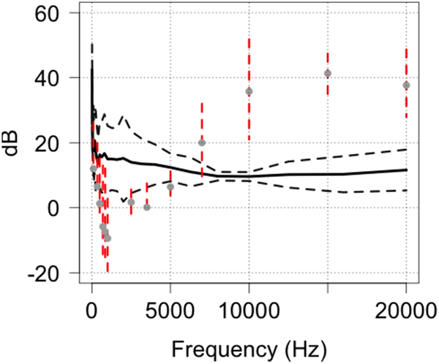 | meek_et_al_2014_fig11.png | **Meek et al. (2014b) - Fig. 11.** Comparison of the predicted hearing range of the red fox in relation to the outputs of HC600 camera traps and as a function of frequency | meek_et_al_2014b
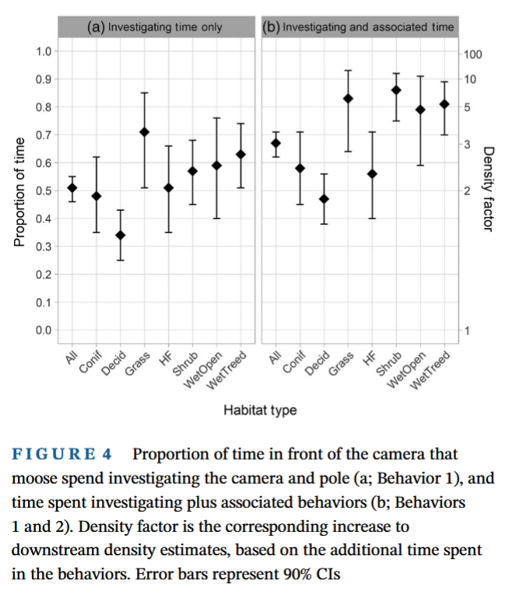 | becker_et_al_2022_fig4.png | **Becker et al. (2022) - Fig 4.** Proportion of time in front of the camera that moose spend investigating the camera and pole (a; Behavior 1), and time spent investigating plus associated behaviors (b; Behaviors 1 and 2). Density factor is the corresponding increase to downstream density estimates, based on the additional time spent in the behaviors. Error bars represent 90% Cis. | becker_et_al_2022
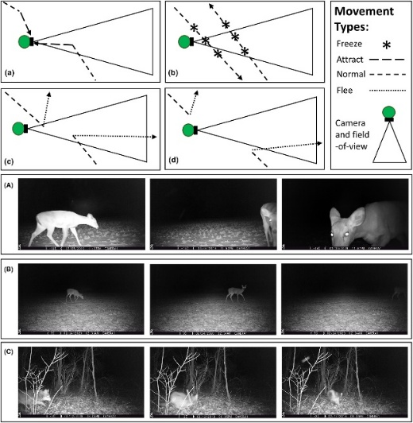 | delisle_et_al_2023_fig1.jpg | **Delisle et al. (2023) - Fig 1.** Conceptual movement paths in which animals exhibit a variety of different reactive behaviours towards camera traps: (A) attraction towards the camera trap; (B) freezing normal travel; (C) fleeing in response to being detected by the camera trap; and (d) fleeing in response to the presence of the camera trap regardless of being detected. Panels depicting actual animals exhibiting a variety of reactive behaviours towards camera traps: (A) white-tailed deer (*Odocoileus virginianus*) that is attracted towards the camera trap; (B) white-tailed deer that freezes in front of a camera trap; and (C) coyote (*Canis latrans*) that flees in response to being detected by a camera trap. | delisle_et_al_2023
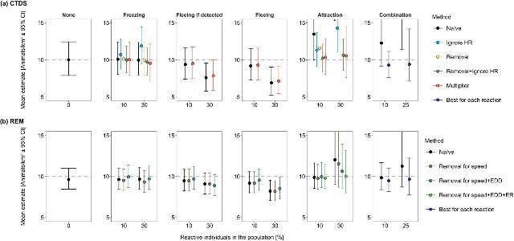 | delisle_et_al_2023_fig2.jpg | **Delisle et al. (2023) - Fig 2.**  :::{dropdown}  The average density estimates (animals/km<sup>2</sup> ± 95% confidence intervals [CI]) from detections of simulated animals at camera traps across 100 total simulations for each reaction type. Densities were estimated using camera trap distance sampling (CTDS; a) and the random encounter model (REM; b). Simulated populations contained a fraction of the population (reactive individuals in the population [%]) that froze in response to cameras (Freezing), fled from the camera when the camera detected the individual (Fleeing if detected), fled from the camera regardless of being detected by the camera (Fleeing) and were attracted to cameras (Attraction). Additionally, we simulated a population that did not contain any reactive individuals (None). For each density estimate, we enacted a specific method to reduce bias associated with reactive movement (Method). Methods for CTDS included doing nothing (Naïve), removing detections of reactive individuals from consideration (Removal), ignoring the hazard rate key function (Ignore HR), combining Ignore HR and Removal, and using the ratio of average number of detections of reactive and nonreactive individuals as a multiplier (Multiplier). Methods for REM included doing nothing (Naïve), removing reactive encounters when estimating the speed parameter (Removal for speed), removing reactive encounters when estimating the speed parameter and the effective detection distance (Removal for speed +EDD) and removing reactive encounters when estimating the speed parameter, effective detection distance and the encounter rate (Removal for speed +EDD + ER). The grey dotted line represents true density (10 animals/km<sup>2</sup>). Some density estimates are above the upper limit of the y-axis due to severe bias (see Tables S1 and S2 for these estimates and the extent of their confidence intervals in the Supporting Information).  ::: | delisle_et_al_2023
 | figure5_filename.png | figure5_caption | figure5_ref_id
 | figure6_filename.png | figure6_caption | figure6_ref_id

Video
caption | URL (no < / > before/after URL | ref_id
vid1_caption | vid1_url | vid1_ref_id
vid2_caption | vid2_url | vid2_ref_id
vid3_caption | vid3_url | vid3_ref_id
vid4_caption | vid4_url | vid4_ref_id
vid5_caption | vid5_url | vid5_ref_id
vid6_caption | vid6_url | vid6_ref_id

Analytical tools & resources

Type | Name | Note | URL | ref_id
Correction factors (Marcus) | resource1_name | resource1_note | resource1_url | resource1_ref_id
resource2_type | resource2_name | resource2_note | resource2_url | resource2_ref_id
resource3_type | resource3_name | resource3_note | resource3_url | resource3_ref_id
resource4_type | resource4_name | resource4_note | resource4_url | resource4_ref_id
resource5_type | resource5_name | resource5_note | resource5_url | resource5_ref_id
resource6_type | resource6_name | resource6_note | resource6_url | resource6_ref_id
resource7_type | resource7_name | resource7_note | resource7_url | resource7_ref_id
resource8_type | resource8_name | resource8_note | resource8_url | resource8_ref_id
resource9_type | resource9_name | resource9_note | resource9_url | resource9_ref_id
resource10_type | resource10_name | resource10_note | resource10_url | resource10_ref_id
resource11_type | resource11_name | resource11_note | resource11_url | resource11_ref_id
resource12_type | resource12_name | resource12_note | resource12_url | resource12_ref_id
resource13_type | resource13_name | resource13_note | resource13_url | resource13_ref_id
resource14_type | resource14_name | resource14_note | resource14_url | resource14_ref_id
resource15_type | resource15_name | resource15_note | resource15_url | resource15_ref_id

References / Glossary
ref_id | glossary_keys
{{ rbib_caravaggi_et_al_2017 }}  {{ rbib_caravaggi_et_al_2020 }}  {{ rbib_delisle_et_al_2023 }}  {{ rbib_meek_et_al_2014b }}  {{ rbib_sharma_et_al_2010 }}  {{ rbib_wegge_et_al_2004 }} | keys_here

Notes
- NOTE: Unbiased behaviour in assumptions for = ("mod_scr_secr","mod_ds","mod_2flankspim","mod_rem","mod_rest","mod_tifc")
Meek et al., 2014
Observations of responses to mensurative devices strongly imply that learning can occur as a consequence of exposure to the devices. For examples, camera traps could be detected by animals for the following reasons:
1. Auditory – by the emission of sounds from the electronic and mechanical components of the device: these could be in the infra, audible and ultra-sound ranges.
2. Olfactory – metal, plastic and human scents on the device [6,9], 3. Learned association – avoidance of the camera trap through wariness of human presence at a site [6] or attraction to the camera trap through lures and food baits,
4. Visual (day) – neophobia towards foreign objects introduced into their environment; regular-shaped objects (essentially rectangular prisms) attached to trees or posts [12,13],
5. Visual (night) – the flash of xenon light, white LED or infrared LED illumination [7].

For example, the bold or exploratory behaviour of one species may result in more frequent detections than the number of animals of that species that would have passed through the detection zone if no camera was present (e.g., coyotes; Caravaggi et al., 2020; Rowcliffe et al., 2011).

POPULATE – INFO
File from = 00_tools\00_00_template-master.docx

---
jupytext:
[[space2]]formats: md:myst
[[space2]]text_representation:
[[space4]]extension: .md
[[space4]]format_name: myst
kernelspec:
[[space2]]display_name: Python 3
[[space2]]language: python
[[space2]]name: python3
editor_options:
[[space2]]markdown:
[[space4]]wrap: none
---
(i_sp_behav)=
# {{ title_i_sp_behav }}

::::::::{hint}
Examples of comparable species that can be used to select the most appropriate option:
- **{{ term_sp_behav_exploratory }}**: {{ def_sp_behav_exploratory }}
- **{{ term_sp_behav_neutral }}**: {{ def_sp_behav_neutral }}
- **{{ term_sp_behav_unkn }}**: {{ def_sp_behav_unkn }}
- **{{ term_sp_behav_unkn }}**: {{ def_sp_behav_unkn }}
- **{{ term_sp_behav_variable }}**: {{ def_sp_behav_variable }}
::::::::

::::::::{tab-set}

:::::::{tab-item} Overview
It's important to consider how your Target Species may react to the camera being placed.

While remote cameras are fairly non-invasive survey method, their presence on the landscape, in and of itself, can alter the behaviour of the species you aim to measure (potential attraction to, or avoidance of, the camera), ultimately interfering with detection rates / detection probability ({{ rtxt_meek_et_al_2014) (e.g., "trap-shy" tigers are thought to avoid cameras due to the white flash emitted [{{ rtxt_wegge_et_al_2004 }}; {{ rtxt_sharma_et_al_2010 }}).

Examples of comparable species that can be used to select the most appropriate option:
- **{{ term_sp_behav_exploratory }}**: {{ def_sp_behav_exploratory }}
- **{{ term_sp_behav_neutral }}**: {{ def_sp_behav_neutral }}
- **{{ term_sp_behav_unkn }}**: {{ def_sp_behav_unkn }}
- **{{ term_sp_behav_unkn }}**: {{ def_sp_behav_unkn }}
- **{{ term_sp_behav_variable }}**: {{ def_sp_behav_variable }}

:::::::

:::::::{tab-item} In-depth
```{include} include/00_coming_soon.md
```
:::::::

:::::::{tab-item} Visual resources
::::::{grid} 3
:gutter: 3
:class-container: wrapper
:::::{grid-item-card} {{ rtxt_meek_et_al_2014b }}
<img src="../03_images/03_image_files/meek_et_al_2014_fig11.png" class="img_grid"><br><br>**Meek et al. (2014b) - Fig. 11.** Comparison of the predicted hearing range of the red fox in relation to the outputs of HC600 camera traps and as a function of frequency
:::::

:::::{grid-item-card} {{ rtxt_becker_et_al_2022 }}
<img src="../03_images/03_image_files/becker_et_al_2022_fig4.png" class="img_grid"><br><br>**Becker et al. (2022) - Fig 4.** Proportion of time in front of the camera that moose spend investigating the camera and pole (a; Behavior 1), and time spent investigating plus associated behaviors (b; Behaviors 1 and 2). Density factor is the corresponding increase to downstream density estimates, based on the additional time spent in the behaviors. Error bars represent 90% Cis
:::::

:::::{grid-item-card} {{ rtxt_delisle_et_al_2023 }}
<img src="../03_images/03_image_files/delisle_et_al_2023_fig1.jpg" class="img_grid"><br><br>**Delisle et al. (2023) - Fig 1.** Conceptual movement paths in which animals exhibit a variety of different reactive behaviours towards camera traps: (A) attraction towards the camera trap; (B) freezing normal travel; (C) fleeing in response to being detected by the camera trap; and (d) fleeing in response to the presence of the camera trap regardless of being detected. Panels depicting actual animals exhibiting a variety of reactive behaviours towards camera traps: (A) white-tailed deer (*Odocoileus virginianus*) that is attracted towards the camera trap; (B) white-tailed deer that freezes in front of a camera trap; and (C) coyote (*Canis latrans*) that flees in response to being detected by a camera trap.
:::::

:::::{grid-item-card} {{ rtxt_delisle_et_al_2023 }}
<img src="../03_images/03_image_files/delisle_et_al_2023_fig2.jpg" class="img_grid"><br><br>**Delisle et al. (2023) - Fig 2.**

:::{dropdown}
The average density estimates (animals/km<sup>2</sup> ± 95% confidence intervals [CI]) from detections of simulated animals at camera traps across 100 total simulations for each reaction type. Densities were estimated using camera trap distance sampling (CTDS; a) and the random encounter model (REM; b). Simulated populations contained a fraction of the population (reactive individuals in the population [%]) that froze in response to cameras (Freezing), fled from the camera when the camera detected the individual (Fleeing if detected), fled from the camera regardless of being detected by the camera (Fleeing) and were attracted to cameras (Attraction). Additionally, we simulated a population that did not contain any reactive individuals (None). For each density estimate, we enacted a specific method to reduce bias associated with reactive movement (Method). Methods for CTDS included doing nothing (Naïve), removing detections of reactive individuals from consideration (Removal), ignoring the hazard rate key function (Ignore HR), combining Ignore HR and Removal, and using the ratio of average number of detections of reactive and nonreactive individuals as a multiplier (Multiplier). Methods for REM included doing nothing (Naïve), removing reactive encounters when estimating the speed parameter (Removal for speed), removing reactive encounters when estimating the speed parameter and the effective detection distance (Removal for speed +EDD) and removing reactive encounters when estimating the speed parameter, effective detection distance and the encounter rate (Removal for speed +EDD + ER). The grey dotted line represents true density (10 animals/km<sup>2</sup>). Some density estimates are above the upper limit of the y-axis due to severe bias (see Tables S1 and S2 for these estimates and the extent of their confidence intervals in the Supporting Information).
:::
:::::

:::::{grid-item-card} {{ rtxt_figure5_ref_id }}
<img src="../03_images/03_image_files/figure5_filename.png" class="img_grid"><br><br>figure5_caption
:::::

:::::{grid-item-card} {{ rtxt_figure6_ref_id }}
<img src="../03_images/03_image_files/figure6_filename.png" class="img_grid"><br><br>figure6_caption
:::::

::::::
:::::::

:::::::{tab-item} Shiny apps/Widgets
Check back in the future!
:::::::

:::::::{tab-item} Analytical tools & Resources
| Type | Name | Note | URL | Reference |
|:----------------|:-------------------------------|:----------------------------------------------------------------|:----------------------|:----------------------------------------|
| Correction factors (Marcus) | resource1_name | resource1_note | resource1_url | {{ rbib_resource1_ref_id }} |
| resource2_type | resource2_name | resource2_note | resource2_url | {{ rbib_resource2_ref_id }} |
| resource3_type | resource3_name | resource3_note | resource3_url | {{ rbib_resource3_ref_id }} |
| resource4_type | resource4_name | resource4_note | resource4_url | {{ rbib_resource4_ref_id }} |
| resource5_type | resource5_name | resource5_note | resource5_url | {{ rbib_resource5_ref_id }} |
| resource6_type | resource6_name | resource6_note | resource6_url | {{ rbib_resource6_ref_id }} |
| resource7_type | resource7_name | resource7_note | resource7_url | {{ rbib_resource7_ref_id }} |
| resource8_type | resource8_name | resource8_note | resource8_url | {{ rbib_resource8_ref_id }} |
| resource9_type | resource9_name | resource9_note | resource9_url | {{ rbib_resource9_ref_id }} |
| resource10_type | resource10_name | resource10_note | resource10_url | {{ rbib_resource10_ref_id }} |
| resource11_type | resource11_name | resource11_note | resource11_url | {{ rbib_resource11_ref_id }} |
| resource12_type | resource12_name | resource12_note | resource12_url | {{ rbib_resource12_ref_id }} |
| resource13_type | resource13_name | resource13_note | resource13_url | {{ rbib_resource13_ref_id }} |
| resource14_type | resource14_name | resource14_note | resource14_url | {{ rbib_resource14_ref_id }} |
| resource15_type | resource15_name | resource15_note | resource15_url | {{ rbib_resource15_ref_id }} |
| Error! Reference source not found. | Error! Reference source not found. | Error! Reference source not found. | Error! Reference source not found. | {{ rbib_Error! Reference source not found. }} |
| Error! Reference source not found. | Error! Reference source not found. | Error! Reference source not found. | Error! Reference source not found. | {{ rbib_Error! Reference source not found. }} |
| Error! Reference source not found. | Error! Reference source not found. | Error! Reference source not found. | Error! Reference source not found. | {{ rbib_Error! Reference source not found. }} |
| Error! Reference source not found. | Error! Reference source not found. | Error! Reference source not found. | Error! Reference source not found. | {{ rbib_Error! Reference source not found. }} |
| Error! Reference source not found. | Error! Reference source not found. | Error! Reference source not found. | Error! Reference source not found. | {{ rbib_Error! Reference source not found. }} |
<!-- END_RESOURCE_TABLE -->
:::::::

:::::::{tab-item} References
{{ rbib_caravaggi_et_al_2017 }}
{{ rbib_caravaggi_et_al_2020 }}
{{ rbib_delisle_et_al_2023 }}
{{ rbib_meek_et_al_2014b }}
{{ rbib_sharma_et_al_2010 }}
{{ rbib_wegge_et_al_2004 }}
:::::::

::::::::

