Topic Info
info_id | cam_equipment
question | Discuss potential effects of using multiple make/models / how you might address in analysis; loop into analytical recommendations below

Note banner
::::::::{hint}
:::{seealso}
{bdg-link-primary-line}`Camera settings<https://ab-rcsc.github.io/rc-decision-support-tool_concept-library/02_dialog-boxes/01_40_cam_settings.html>`
:::

::::::::

Overview
## Camera hardware options

Remote cameras consist of a digital camera with a lens, external flash, and a passive infrared and/or motion detector (among other features; [Figure 4](#TOC_surv_guidelines_fig_4)).

:::{figure} ../0_figures/Survey-guidelines_CamFeatures.png
:align: center
:scale: 60%
:name: TOC_surv_guidelines_fig_4
:::

**Figure 4.** Examples of the a) external components and b) internal controls and components of a remote camera (Reconyx PC900; Reconyx Inc., 2017)

The camera "make" is the manufacturer of a particular camera (e.g., Reconyx), and the "model" is the model number of a particular camera (e.g., PC900). There are many different options and features to choose from when deciding upon the best {{ cam_make_tu }} and {{ cam_model_tu }} for a particular study, which differ in their impacts on {{ detection_probability_tl_abrv }}. For this reason, deploying multiple [Camera Models](#camera_model) within a study is not advisable (Palencia et al., 2022; Wellington et al., 2014).

It is common for new camera users to confuse the specifications of a particular {{ cam_make_tu }} and {{ cam_model_tu }} with the camera's settings. Specifications refer to the camera's features (characteristics), while settings are options that the user can change. When choosing a {{ cam_make_tu }} and {{ cam_model_tu }}, important specifications include {{ trigger_speed_tl }}, {{ recovery_time_tl }}, {{ detection_zone_tl }} (i.e., the area [conical in shape] in which a remote camera can detect the heat signature and motion of an object Rovero & Zimmermann, 2016; see [Figure 5](#TOC_surv_guidelines_fig_5)), battery life and flash type. The best choice of {{ cam_model_tu }} will depend on the {{ survey_objectives_tu_pl }}, {{ mod_approach_tl }}, {{ target_species_tu }}, and physical environment.

Here are a few examples of specifications to achieve certain {{ survey_objectives_tu_pl }}:

- To estimate {{ density_tl }} with the [random encounter models (REM;](#mods_rem) {{ density_tl }}) approach -- use a camera with a fast {{ trigger_speed_tl }}, a wide {{ detection_zone_tl }}, no-glow infrared (IR) flash, and the ability to take bursts of photos (Rovero et al., 2013).

- To estimate {{ density_tl }} or abundance with mark-recapture methods -- use a camera with a white flash, a short {{ recovery_time_tl }}, and a fast {{ trigger_speed_tl }} (Rovero et al., 2013). Note that white flashes may scare some animals and potentially reduce the number of recaptures (Séquin et al., 2003; Wegge et al., 2004).

- [Occupancy studies](#mods_occupancy) need a fast {{ trigger_speed_tl }} ({{ settings_trigger_sensitivity_tu }} - high) (although the importance of which is species-dependent; Rovero et al., 2013).

- Faunal detections generally require a fast {{ trigger_speed_tl }} ({{ settings_trigger_sensitivity_tu }} - high) and a wide {{ detection_zone_tl }}.

::: {note}
Most [modelling approaches](#mod_approach) require a fast {{ trigger_speed_tl }} (however, the use of {{ baitlure_bait_tl }} or {{ baitlure_lure_tl }} may compensate for slower [trigger speeds](#trigger_speed) in some cases).
:::

Given the numerous [Camera Models](#camera_model) available and the frequent release of new models, it would be difficult to recommend a make and model to fit all users' needs. However, there are many studies and reviews that compare the specifications and the utility of different [Camera Models](#camera_model) (e.g., see <https://www.trailcampro.com/collections/trail-camera-reviews>; <https://www.mammalweb.org/images/schools/Camera-trap-buying-guide.pdf>; Fisher & Burton, 2012; Rovero et al., 2014; Rovero & Zimmermann, 2016; Seccombe, 2017; Wearn & Glover-Kapfer, 2017).

:::{figure} ../0_figures/Survey-guidelines_FOV_DetZone.png
:align: center
:scale: 60%
:name: TOC_surv_guidelines_fig_5
:::

**Figure 5.** The ability to detect an animal will vary according to the camera specifications (and settings). Important specifications include the camera's detection zone (here termed "trigger area"), Field of View (FOV; "viewable area'), and"registration area" (the area in which an animal entering has at least some probability of being captured on the image) (Moeller et al., 2023).

(TOC_surv_guidelines_battery_type)=
### 7.1.1 Battery type

Most remote cameras require AA batteries. It is recommended to use **lithium batteries,** as opposed to alkaline or nickel metal hydride, because they are less affected by cold temperatures. Battery life will be affected not only by the type of batteries but also by the camera settings, temperature, and number of images or videos taken (which are dependent on the camera settings, placement, and level of activity in front of the camera) (Wearn & Glover-Kapfer, 2017). However, some camera user manuals contain information on battery performance and the total number of images a camera can be expected to collect before the batteries die (based on the operating temperature and battery type, e.g., [Reconyx HyperFire Instruction Manual](https://images.reconyx.com/file/HyperFireManual.pdf) [Reconyx Inc., 2017]).

(TOC_surv_guidelines_sd_cards)=
### 7.1.2 SD cards

It is important to consider the **size**, **type**, and **class** of **SD (Secure Digital) card** since the available options vary in storage capacity, compatibility, and write-speed (Wearn & Glover-Kapfer, 2017).

The **size of the SD card** (i.e., storage capacity) should be considered in relation to the expected duration of {{ deployment_tl }}, the deployment area, and the level of activity expected to occur in front of the camera. For example, a camera placed in a grassy area might be expected to produce more {{ false_trigger_tl_pl }} due to grass waving in front of the camera. Or perhaps a camera placed near a den might be expected to have higher animal activity. Both situations might warrant using a larger SD card. A 4 GB SD card is capable of storing \~8,000-20,000 images (400-900 KB in size), which might be sufficient if you plan to revisit the camera frequently (\~every four weeks) (Wearn & Glover-Kapfer, 2017). We suggest using a card with at least 16 GB, and Wearn & Glover-Kapfer (2017) suggest larger (32 GB) if the video is enabled or if the camera will be active for long periods.

There are three **types of SD card:** standard (SD; maximum memory of 2 GB), high-capacity (SDHC; maximum memory of 32 GB) and extended-capacity (SDXC; maximum memory of \> 32 GB) (Wearn & Glover-Kapfer, 2017). Note that SDHC cards are not compatible with most [Camera Models](#camera_model). Be sure to check the camera user manual to confirm the compatible SD card type(s) (Wearn & Glover-Kapfer, 2017).

The **“class” of an SD card** (e.g., class 2, 4, 6, or 10) indicates the “write-speed” (i.e., the speed at which the SD card can read and write data; Wearn & Glover-Kapfer, 2017). Slower write speeds may perform poorly if the camera is set to collect images continuously, as fast as possible (i.e., rapid-fire or “near-video”) or if the video setting is activated. It is recommended to use an SD card of class 4 or higher, ideally class 10 (Wearn & Glover-Kapfer, 2017).

Caution should be used when deploying older SD cards (Wearn & Glover-Kapfer, 2017) and, perhaps, microSD card types; a few remote camera users in Alberta have described a 50% SD card failure rate with microSD cards (St. Clair, personal communications). See Wearn & Glover-Kapfer (2017) for additional information on choosing and maintaining (i.e., regularly formatting) SD cards.

In-depth
```{include} include/00_coming_soon.md
```

Figures
Image | file_name | Caption (if applicable) | ref_id
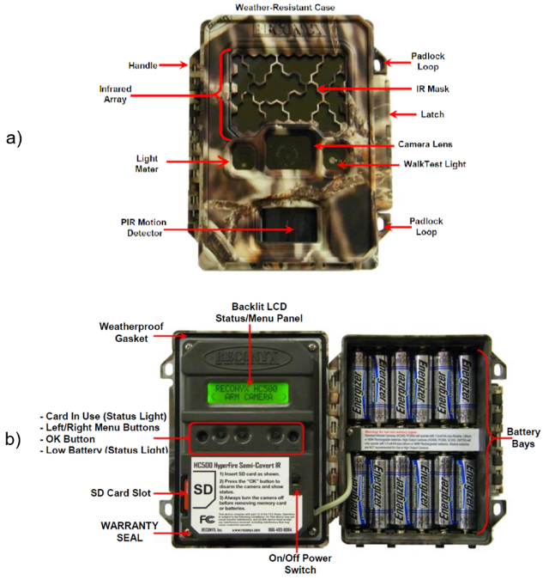 | rcsc_et_al_2024_CamFeatures.png |  | rcsc_et_al_2024
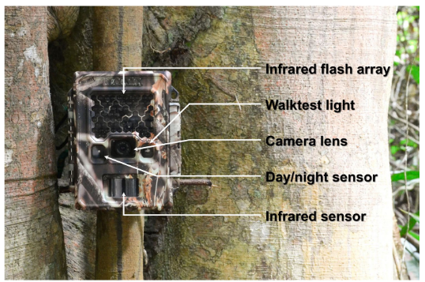 | wearn_gloverkapfer_2017_fig4_3_clipped.png |  | wearn_gloverkapfer_2017
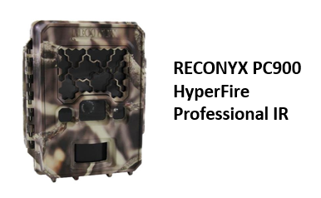 | model_reconyxpc900_hf_pir.png |  | figure3_ref_id
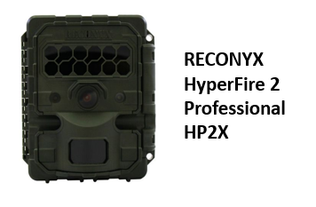 | model_reconyxhp2x.png |  | figure4_ref_id
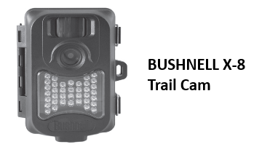 | model_bushnellx_8.png |  | figure5_ref_id
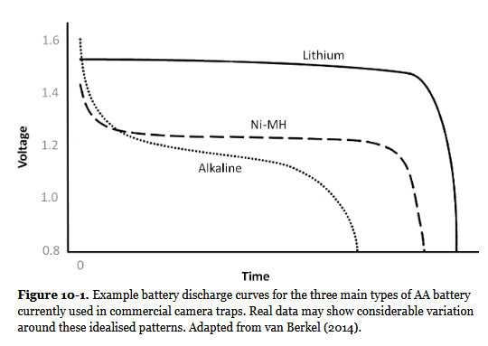 | wearn_gloverkapfer_2017_fig10_1.png |  | wearn_gloverkapfer_2017

Video
caption | URL (no < / > before/after URL | ref_id
vid1_caption | vid1_url | vid1_ref_id
vid2_caption | vid2_url | vid2_ref_id
vid3_caption | vid3_url | vid3_ref_id
vid4_caption | vid4_url | vid4_ref_id
vid5_caption | vid5_url | vid5_ref_id
vid6_caption | vid6_url | vid6_ref_id

Shiny
Shiny name = shiny_name
Shiny caption = shiny_caption
Shiny URL = shiny_url

Analytical tools & resources
Type | Name | Note | URL | ref_id
resource1_type | resource1_name | resource1_note | resource1_url | resource1_ref_id
resource2_type | resource2_name | resource2_note | resource2_url | resource2_ref_id
resource3_type | resource3_name | resource3_note | resource3_url | resource3_ref_id
resource4_type | resource4_name | resource4_note | resource4_url | resource4_ref_id
resource5_type | resource5_name | resource5_note | resource5_url | resource5_ref_id
resource6_type | resource6_name | resource6_note | resource6_url | resource6_ref_id
resource7_type | resource7_name | resource7_note | resource7_url | resource7_ref_id
resource8_type | resource8_name | resource8_note | resource8_url | resource8_ref_id
resource9_type | resource9_name | resource9_note | resource9_url | resource9_ref_id
resource10_type | resource10_name | resource10_note | resource10_url | resource10_ref_id
resource11_type | resource11_name | resource11_note | resource11_url | resource11_ref_id
resource12_type | resource12_name | resource12_note | resource12_url | resource12_ref_id
resource13_type | resource13_name | resource13_note | resource13_url | resource13_ref_id
resource14_type | resource14_name | resource14_note | resource14_url | resource14_ref_id
resource15_type | resource15_name | resource15_note | resource15_url | resource15_ref_id

References / Glossary
ref_id | glossary_keys
Refs | keys_here

Notes
"Which camera trap type and how many do I need?" A review of camera features and study designs for a range of wildlife research applications, Francesco Rovero et al.

Camera Trap Recommendations, eMammal

https://wildcams.ca/site/assets/files/1390/wildcam_network_camera_trapping_best_practices_literature_synthesis.pdf

below from lit synthesis????
Often the first choice one would like to make when designing a camera trap survey is to decide on a make and model of camera. There are many different options and features to choose from, which differ in their impacts on the detection process (see also sections Error! Reference source not found. and Error! Reference source not found.). For that reason, deploying multiple types of camera models is not advisable (Palencia et al., 2022). There may be specific camera specifications and settings that are ideal or required to meet the survey objectives; thus, this step should occur after the survey objective(s) have been considered carefully. For example, if the intent is to estimate density via REM, a camera with a fast trigger speed and an infrared (IR) flash is ideal, whereas Xenon white flash may be best for mark-recapture methods (Wearn & Glover-Kapfer, 2017). As another example, faunal detections generally require high sensitivity, fast trigger speeds, wide detection zones (i.e., the area in which a camera can detect a subject through the sensor) and good autonomy (Rovero et al., 2013). Occupancy studies need a fast trigger speed and high sensitivity, although the extent to which is species-dependent (Rovero et al., 2013). As a third example, mark-recapture studies for density or abundance require white flashes, a short recovery time, and a high trigger speed (Rovero et al., 2013). As a final example, random encounter models for density or abundance estimates require a fast trigger speed, large detection zone, no-glow flashes, and the ability to take bursts of photos (Rovero et al., 2013).
Although this is not a complete list, the most important settings/specifications to pay attention to include (see section Error! Reference source not found.): Trigger Speed, Trigger Sensitivity, Flash Type, Flash Sensitivity, Detection Zone, The Number of Photos per Trigger, Quiet Period (aka recovery time), and the Image Quality (resolution/sharpness/clarity; Rovero et al., 2014; Wearn & Glover-Kapfer, 2017). Wearn & Glover-Kapfer (2017) also noted the highly variable detection zones of different sensors.
A detailed comparison of the various hardware options has not been included here, nor is a specific model recommended. Given the numerous camera models available and the frequent release of new models, it would be difficult to provide a recommended make and model that will fit all users' needs. However, there are many studies and reviews that compare the specifications and the appropriateness of different camera models for certain objectives. Refer to the following papers for a more in-depth exploration of camera hardware options:
- Rovero et al. (2014), Glover-Kapfer (2017), Rovero and Zimmermann (2016; sections 2.3 and 2.4.1) for detailed reviews of settings and key features
- Weingarth et al. (2013) compared the image quality and trigger speed of six camera types in relation to detections of elusive species with identifiable markings; only one model was suitable (Cuddeback CaptureTM).
- Wellington et al. (2014) compared two types of cameras with substantially different features/specifications. The Reconyx model, which had a larger detection zone and higher sensitivity sensor, was found to have recorded twice as many independent captures as the other model (Wellington et al. 2014).
- Newey et al. (2015) describe the trade-off between quality vs. cost (cheaper, 'recreational' vs more expensive 'professional' models) and presented two case studies that illustrated that cheaper, recreational models result in higher rates of both false positives and false negative detections.
- Trolliet et al. (2014) reviewed the technical aspects of cameras and suggested that trigger speed is crucial when bait is not deployed or when the target species is slow-moving (since camera traps do not have wide-angle lenses). Trolliet et al. (2014) also suggested that the area of the detection zone is important and should be as large as possible to maximize detection and that recovery time may be very important (objective-dependent) but pointed out that it also varies greatly (for identifying individuals and behaviours, a short recovery time is ideal). Finally, battery life should be as long as possible, but if cameras are frequently serviced, Trolliet et al. (2014) suggested that cheaper cameras may be more cost-effective overall.
- The Zoological Society of London (Seccombe, 2017) empirically tested the detection range and accuracy, burst speed, and image quality of a variety of the most common camera models in a camera trap "buyer's guide."
- Apps and McNutt (2018) outline their reproducible test for camera specifications and offer suggestions as to the most important specifications for specific purposes.
- Palencia et al. (2022) compared six brands of cameras to identify factors that affect the probability of detection. They found that the period (day/ night), the distance between the camera and the animal, camera model, species, deployment height and trigger sensitivity were all significantly related to detection probability (Palencia et al., 2022).

POPULATE – INFO
File from = 00_tools\00_00_template-master.docx

---
jupytext:
[[space2]]formats: md:myst
[[space2]]text_representation:
[[space4]]extension: .md
[[space4]]format_name: myst
kernelspec:
[[space2]]display_name: Python 3
[[space2]]language: python
[[space2]]name: python3
editor_options:
[[space2]]markdown:
[[space4]]wrap: none
---
(i_cam_equipment)=
# {{ title_i_cam_equipment }}

::::::::{hint}
:::{seealso}
{bdg-link-primary-line}`Camera settings<https://ab-rcsc.github.io/rc-decision-support-tool_concept-library/02_dialog-boxes/01_40_cam_settings.html>`
:::

::::::::

::::::::{tab-set}

:::::::{tab-item} Overview
## Camera hardware options

Remote cameras consist of a digital camera with a lens, external flash, and a passive infrared and/or motion detector (among other features; [Figure 4](#TOC_surv_guidelines_fig_4)).

:::{figure} ../0_figures/Survey-guidelines_CamFeatures.png
:align: center
:scale: 60%
:name: TOC_surv_guidelines_fig_4
:::

**Figure 4.** Examples of the a) external components and b) internal controls and components of a remote camera (Reconyx PC900; Reconyx Inc., 2017)

The camera "make" is the manufacturer of a particular camera (e.g., Reconyx), and the "model" is the model number of a particular camera (e.g., PC900). There are many different options and features to choose from when deciding upon the best {{ cam_make_tu }} and {{ cam_model_tu }} for a particular study, which differ in their impacts on {{ detection_probability_tl_abrv }}. For this reason, deploying multiple [Camera Models](#camera_model) within a study is not advisable (Palencia et al., 2022; Wellington et al., 2014).

It is common for new camera users to confuse the specifications of a particular {{ cam_make_tu }} and {{ cam_model_tu }} with the camera's settings. Specifications refer to the camera's features (characteristics), while settings are options that the user can change. When choosing a {{ cam_make_tu }} and {{ cam_model_tu }}, important specifications include {{ trigger_speed_tl }}, {{ recovery_time_tl }}, {{ detection_zone_tl }} (i.e., the area [conical in shape] in which a remote camera can detect the heat signature and motion of an object Rovero & Zimmermann, 2016; see [Figure 5](#TOC_surv_guidelines_fig_5)), battery life and flash type. The best choice of {{ cam_model_tu }} will depend on the {{ survey_objectives_tu_pl }}, {{ mod_approach_tl }}, {{ target_species_tu }}, and physical environment.

Here are a few examples of specifications to achieve certain {{ survey_objectives_tu_pl }}:

- To estimate {{ density_tl }} with the [random encounter models (REM;](#mods_rem) {{ density_tl }}) approach -- use a camera with a fast {{ trigger_speed_tl }}, a wide {{ detection_zone_tl }}, no-glow infrared (IR) flash, and the ability to take bursts of photos (Rovero et al., 2013).

- To estimate {{ density_tl }} or abundance with mark-recapture methods -- use a camera with a white flash, a short {{ recovery_time_tl }}, and a fast {{ trigger_speed_tl }} (Rovero et al., 2013). Note that white flashes may scare some animals and potentially reduce the number of recaptures (Séquin et al., 2003; Wegge et al., 2004).

- [Occupancy studies](#mods_occupancy) need a fast {{ trigger_speed_tl }} ({{ settings_trigger_sensitivity_tu }} - high) (although the importance of which is species-dependent; Rovero et al., 2013).

- Faunal detections generally require a fast {{ trigger_speed_tl }} ({{ settings_trigger_sensitivity_tu }} - high) and a wide {{ detection_zone_tl }}.

::: {note}
Most [modelling approaches](#mod_approach) require a fast {{ trigger_speed_tl }} (however, the use of {{ baitlure_bait_tl }} or {{ baitlure_lure_tl }} may compensate for slower [trigger speeds](#trigger_speed) in some cases).
:::

Given the numerous [Camera Models](#camera_model) available and the frequent release of new models, it would be difficult to recommend a make and model to fit all users' needs. However, there are many studies and reviews that compare the specifications and the utility of different [Camera Models](#camera_model) (e.g., see <https://www.trailcampro.com/collections/trail-camera-reviews>; <https://www.mammalweb.org/images/schools/Camera-trap-buying-guide.pdf>; Fisher & Burton, 2012; Rovero et al., 2014; Rovero & Zimmermann, 2016; Seccombe, 2017; Wearn & Glover-Kapfer, 2017).

:::{figure} ../0_figures/Survey-guidelines_FOV_DetZone.png
:align: center
:scale: 60%
:name: TOC_surv_guidelines_fig_5
:::

**Figure 5.** The ability to detect an animal will vary according to the camera specifications (and settings). Important specifications include the camera's detection zone (here termed "trigger area"), Field of View (FOV; "viewable area'), and"registration area" (the area in which an animal entering has at least some probability of being captured on the image) (Moeller et al., 2023).

(TOC_surv_guidelines_battery_type)=
### 7.1.1 Battery type

Most remote cameras require AA batteries. It is recommended to use **lithium batteries,** as opposed to alkaline or nickel metal hydride, because they are less affected by cold temperatures. Battery life will be affected not only by the type of batteries but also by the camera settings, temperature, and number of images or videos taken (which are dependent on the camera settings, placement, and level of activity in front of the camera) (Wearn & Glover-Kapfer, 2017). However, some camera user manuals contain information on battery performance and the total number of images a camera can be expected to collect before the batteries die (based on the operating temperature and battery type, e.g., [Reconyx HyperFire Instruction Manual](https://images.reconyx.com/file/HyperFireManual.pdf) [Reconyx Inc., 2017]).

(TOC_surv_guidelines_sd_cards)=
### 7.1.2 SD cards

It is important to consider the **size**, **type**, and **class** of **SD (Secure Digital) card** since the available options vary in storage capacity, compatibility, and write-speed (Wearn & Glover-Kapfer, 2017).

The **size of the SD card** (i.e., storage capacity) should be considered in relation to the expected duration of {{ deployment_tl }}, the deployment area, and the level of activity expected to occur in front of the camera. For example, a camera placed in a grassy area might be expected to produce more {{ false_trigger_tl_pl }} due to grass waving in front of the camera. Or perhaps a camera placed near a den might be expected to have higher animal activity. Both situations might warrant using a larger SD card. A 4 GB SD card is capable of storing \~8,000-20,000 images (400-900 KB in size), which might be sufficient if you plan to revisit the camera frequently (\~every four weeks) (Wearn & Glover-Kapfer, 2017). We suggest using a card with at least 16 GB, and Wearn & Glover-Kapfer (2017) suggest larger (32 GB) if the video is enabled or if the camera will be active for long periods.

There are three **types of SD card:** standard (SD; maximum memory of 2 GB), high-capacity (SDHC; maximum memory of 32 GB) and extended-capacity (SDXC; maximum memory of \> 32 GB) (Wearn & Glover-Kapfer, 2017). Note that SDHC cards are not compatible with most [Camera Models](#camera_model). Be sure to check the camera user manual to confirm the compatible SD card type(s) (Wearn & Glover-Kapfer, 2017).

The **“class” of an SD card** (e.g., class 2, 4, 6, or 10) indicates the “write-speed” (i.e., the speed at which the SD card can read and write data; Wearn & Glover-Kapfer, 2017). Slower write speeds may perform poorly if the camera is set to collect images continuously, as fast as possible (i.e., rapid-fire or “near-video”) or if the video setting is activated. It is recommended to use an SD card of class 4 or higher, ideally class 10 (Wearn & Glover-Kapfer, 2017).

Caution should be used when deploying older SD cards (Wearn & Glover-Kapfer, 2017) and, perhaps, microSD card types; a few remote camera users in Alberta have described a 50% SD card failure rate with microSD cards (St. Clair, personal communications). See Wearn & Glover-Kapfer (2017) for additional information on choosing and maintaining (i.e., regularly formatting) SD cards.
:::::::

:::::::{tab-item} In-depth
```{include} include/00_coming_soon.md
```

:::::::

:::::::{tab-item} Visual resources
::::::{grid} 3
:gutter: 3
:class-container: wrapper
:::::{grid-item-card} {{ rtxt_rcsc_et_al_2024 }}
<img src="../03_images/03_image_files/rcsc_et_al_2024_CamFeatures.png" class="img_grid"><br><br>
:::::

:::::{grid-item-card} {{ rtxt_wearn_gloverkapfer_2017 }}
<img src="../03_images/03_image_files/wearn_gloverkapfer_2017_fig4_3_clipped.png" class="img_grid"><br><br>
:::::

:::::{grid-item-card} {{ rtxt_figure3_ref_id }}
<img src="../03_images/03_image_files/model_reconyxpc900_hf_pir.png" class="img_grid"><br><br>
:::::

:::::{grid-item-card} {{ rtxt_figure4_ref_id }}
<img src="../03_images/03_image_files/model_reconyxhp2x.png" class="img_grid"><br><br>
:::::

:::::{grid-item-card} {{ rtxt_figure5_ref_id }}
<img src="../03_images/03_image_files/model_bushnellx_8.png" class="img_grid"><br><br>
:::::

:::::{grid-item-card} {{ rtxt_wearn_gloverkapfer_2017 }}
<img src="../03_images/03_image_files/wearn_gloverkapfer_2017_fig10_1.png" class="img_grid"><br><br>
:::::

:::::{grid-item-card} {{ rtxt_Error! Reference source not found. }}
<img src="../03_images/03_image_files/Error! Reference source not found." class="img_grid"><br><br>Error! Reference source not found.
:::::

:::::{grid-item-card} {{ rtxt_Error! Reference source not found. }}
<img src="../03_images/03_image_files/Error! Reference source not found." class="img_grid"><br><br>Error! Reference source not found.
:::::

:::::{grid-item-card} {{ rtxt_Error! Reference source not found. }}
<img src="../03_images/03_image_files/Error! Reference source not found." class="img_grid"><br><br>Error! Reference source not found.
:::::

:::::{grid-item-card} {{ rtxt_Error! Reference source not found. }}
<img src="../03_images/03_image_files/Error! Reference source not found." class="img_grid"><br><br>Error! Reference source not found.
:::::

:::::{grid-item-card} {{ rtxt_Error! Reference source not found. }}
<img src="../03_images/03_image_files/Error! Reference source not found." class="img_grid"><br><br>Error! Reference source not found.
:::::

:::::{grid-item-card} {{ rtxt_Error! Reference source not found. }}
<img src="../03_images/03_image_files/Error! Reference source not found." class="img_grid"><br><br>Error! Reference source not found.
:::::

:::::{grid-item-card} {{ rtxt_vid1_ref_id }}
<div class="iframe-container-vid"><iframe class="iframe-responsive-vid" src="vid1_url"></iframe></div>
vid1_caption
:::::

:::::{grid-item-card} {{ rtxt_vid2_ref_id }}
<div class="iframe-container-vid"><iframe class="iframe-responsive-vid" src="vid2_url"></iframe></div>
vid2_caption
:::::

:::::{grid-item-card} {{ rtxt_vid3_ref_id }}
<div class="iframe-container-vid"><iframe class="iframe-responsive-vid" src="vid3_url"></iframe></div>
vid3_caption
:::::

:::::{grid-item-card} {{ rtxt_vid4_ref_id }}
<div class="iframe-container-vid"><iframe class="iframe-responsive-vid" src="vid4_url"></iframe></div>
vid4_caption
:::::

:::::{grid-item-card} {{ rtxt_vid5_ref_id }}
<div class="iframe-container-vid"><iframe class="iframe-responsive-vid" src="vid5_url"></iframe></div>
vid5_caption
:::::

:::::{grid-item-card} {{ rtxt_vid6_ref_id }}
<div class="iframe-container-vid"><iframe class="iframe-responsive-vid" src="vid6_url"></iframe></div>
vid6_caption
:::::

:::::{grid-item-card} {{ rtxt_Error! Reference source not found. }}
<div class="iframe-container-vid"><iframe class="iframe-responsive-vid" src="Error! Reference source not found."></iframe></div>
Error! Reference source not found.
:::::

:::::{grid-item-card} {{ rtxt_Error! Reference source not found. }}
<div class="iframe-container-vid"><iframe class="iframe-responsive-vid" src="Error! Reference source not found."></iframe></div>
Error! Reference source not found.
:::::

:::::{grid-item-card} {{ rtxt_Error! Reference source not found. }}
<div class="iframe-container-vid"><iframe class="iframe-responsive-vid" src="Error! Reference source not found."></iframe></div>
Error! Reference source not found.
:::::

::::::
:::::::

:::::::{tab-item} Shiny apps/Widgets
Check back in the future!
:::::::

:::::::{tab-item} Shiny apps/Widgets
::::::{card} shiny_name
shiny_caption
<div class="iframe-container-shiny"><iframe class="iframe-responsive-shiny" src="shiny_url"></iframe></div>
::::::
:::::::

:::::::{tab-item} Shiny apps/Widgets
::::::{card}
:::::{dropdown} shiny_name
shiny_caption
<div class="iframe-container-shiny"><iframe class="iframe-responsive-shiny" src="shiny_url"></iframe></div>
:::::
:::::{dropdown} Error! Reference source not found.
Error! Reference source not found.
<div class="iframe-container-shiny"><iframe class="iframe-responsive-shiny" src="Error! Reference source not found."></iframe></div>
:::::
::::::
:::::::

:::::::{tab-item} Analytical tools & Resources
| Type | Name | Note | URL | Reference |
|:----------------|:-------------------------------|:----------------------------------------------------------------|:----------------------|:----------------------------------------|
| resource1_type | resource1_name | resource1_note | resource1_url | {{ rbib_resource1_ref_id }} |
| resource2_type | resource2_name | resource2_note | resource2_url | {{ rbib_resource2_ref_id }} |
| resource3_type | resource3_name | resource3_note | resource3_url | {{ rbib_resource3_ref_id }} |
| resource4_type | resource4_name | resource4_note | resource4_url | {{ rbib_resource4_ref_id }} |
| resource5_type | resource5_name | resource5_note | resource5_url | {{ rbib_resource5_ref_id }} |
| resource6_type | resource6_name | resource6_note | resource6_url | {{ rbib_resource6_ref_id }} |
| resource7_type | resource7_name | resource7_note | resource7_url | {{ rbib_resource7_ref_id }} |
| resource8_type | resource8_name | resource8_note | resource8_url | {{ rbib_resource8_ref_id }} |
| resource9_type | resource9_name | resource9_note | resource9_url | {{ rbib_resource9_ref_id }} |
| resource10_type | resource10_name | resource10_note | resource10_url | {{ rbib_resource10_ref_id }} |
| resource11_type | resource11_name | resource11_note | resource11_url | {{ rbib_resource11_ref_id }} |
| resource12_type | resource12_name | resource12_note | resource12_url | {{ rbib_resource12_ref_id }} |
| resource13_type | resource13_name | resource13_note | resource13_url | {{ rbib_resource13_ref_id }} |
| resource14_type | resource14_name | resource14_note | resource14_url | {{ rbib_resource14_ref_id }} |
| resource15_type | resource15_name | resource15_note | resource15_url | {{ rbib_resource15_ref_id }} |
| Error! Reference source not found. | Error! Reference source not found. | Error! Reference source not found. | Error! Reference source not found. | {{ rbib_Error! Reference source not found. }} |
| Error! Reference source not found. | Error! Reference source not found. | Error! Reference source not found. | Error! Reference source not found. | {{ rbib_Error! Reference source not found. }} |
| Error! Reference source not found. | Error! Reference source not found. | Error! Reference source not found. | Error! Reference source not found. | {{ rbib_Error! Reference source not found. }} |
| Error! Reference source not found. | Error! Reference source not found. | Error! Reference source not found. | Error! Reference source not found. | {{ rbib_Error! Reference source not found. }} |
| Error! Reference source not found. | Error! Reference source not found. | Error! Reference source not found. | Error! Reference source not found. | {{ rbib_Error! Reference source not found. }} |
<!-- END_RESOURCE_TABLE -->
:::::::

:::::::{tab-item} References
Refs

:::::::

::::::::

