Topic Info
info_id | mod_divers_rich

Note banner
:::{seealso}
{{ link_bdg_sp_asymptote }}
{{ link_bdg_sp_rarity }}
:::

Overview
**{{ term_mod_divers_rich_rich }}**: {{ def_mod_divers_rich_rich }}
**{{ term_mod_divers_rich_divers }}**: {{ def_mod_divers_rich_divers }}

Note that there are multiple parameters corresponding to different scales and incorporating of evenness; these include:
- **{{ term_mod_divers_rich_alpha }}**: {{ def_mod_divers_rich_alpha }}
- **{{ term_mod_divers_rich_beta }}**: {{ def_mod_divers_rich_beta }}
- **{{ term_mod_divers_rich_gamma }}**: {{ def_mod_divers_rich_gamma }}

Refer to the "Assumptions, Pros, Cons" dropdown above to see relevant information for all three.

```{figure} ../03_images/03_image_files/pyron_2010_fig1_clipped.png
:align: center
:scale: 60%
```
> **Pyron (2010) - Fig. 1**: Species evenness and species richness for animalcule communities. Both communities contain five species of animalcules. Species richness is the same. The community on the left is dominated by one of the species. The community on the right has equal proportions of each species. Evenness is higher when species are present in similar proportions. Thus the community on the left has higher species diversity, because evenness is higher.

In-depth
:::{note}
This section is still in progress
:::

**{{ term_mod_divers_rich_rich }}**: {{ def_mod_divers_rich_rich }}

**{{ term_mod_divers_rich_divers }}**: {{ def_mod_divers_rich_divers }}

## Study design
### Number of cameras

The optimal number of cameras required will be influenced by factors such as landscape heterogeneity, {{ survey_tl }} duration and spatial scale, species rarity and desired level of precision ({{ rtxt_colyn_et_al_2018 }}; {{ rtxt_rovero_et_al_2013 }}). For example, Kays et al. (2020) found that 25–35 cameras were needed for precise estimates of species richness, depending on the spatial scale of the {{ survey_tl }} and landscape diversity. In general, deploying more cameras and/or for longer durations always results in more precise estimates; however, users can consider rotating cameras across multiple sites for shorter durations (if feasible).

### Duration - Camera days per camera location

For measures of species richness or diversity, it is presumed that a camera is active long enough to detect rare species that may occur at a specific location ({{ rtxt_wearn_gloverkapfer_2017 }}). If this is not the case, the results will indicate that the species was not present when it was (i.e., a "false negative"). False negatives may also be problematic for other measures, such as **{{ mod_rai_tl }}** (count data, with or without {{ mod_zero_inflation_tl }} and/or {{ mod_overdispersion_tl }}), even if the model type used can account for {{ imperfect_detection_tl }} explicitly (e.g., combined occurrence/{{ mod_rai_tl }}; {{ mod_n_mixture_tu }}).

### Number of cameras vs. Camera days per camera location

If a user must choose between more cameras *vs.* fewer cameras with longer {{ survey_tl_pl }}, Chatterjee et al. (2021) suggested that for rare species, the optimal precision can be obtained by increasing the number of sites, whereas for common species, increasing the number of samples is more effective. For measuring species richness, Si et al. (2014) found that rotating cameras to new sites was more efficient than leaving cameras at fewer sites for longer periods. O'Connor et al. (2017) also recommended utilizing more cameras *vs*. increasing study length to increase {{ detection_probability_tl_pl }}. In general, regardless of species and {{ survey_objectives_tl_abrv }}, increasing the number of {{ survey_tl }} locations or the {{ survey_tl }} length improved precision ({{ rtxt_chatterjee_et_al_2021 }}).
Analysis

Note that there are multiple parameters corresponding to different scales and incorporating of evenness; these include:
- **{{ term_mod_divers_rich_alpha }}**: {{ def_mod_divers_rich_alpha }}
- **{{ term_mod_divers_rich_beta }}**: {{ def_mod_divers_rich_beta }}
- **{{ term_mod_divers_rich_gamma }}**: {{ def_mod_divers_rich_gamma }}

Its important to note the difference in **Observed *vs* estimated species richness** (from {{ rtxt_wearn_gloverkapfer_2017 }}):
- **Observed species richness**: the sum of the number of species seen (e.g. {{ rtxt_kitamura_et_al_2010 }}; {{ rtxt_pettorelli_et_al_2010 }}; {{ rtxt_ahumada_et_al_2011 }}; {{ rtxt_samejima_et_al_2012 }})
- Observed species richness will not, in general, be a reliable index of actual species richness because, even if sampling effort is strictly controlled, the detectability of species will vary across samples
- **Estimated species richness**: when the "sum of the number of species seen" is adjusted based on corrections for "imperfect detection" (i.e. the fact that some species in a given sample may have been missed)
- (e.g. {{ rtxt_tobler_et_al_2008 }}; {{ rtxt_kinnaird_obrien_2012 }}; {{ rtxt_brodie_et_al_2015 }}; {{ rtxt_yue_et_al_2015 }}; {{ rtxt_wearn_et_al_2016 }})

The **two principal ways of estimating species richness from remote camera data** are (from {{ rtxt_wearn_gloverkapfer_2017 }}):
- non-parametric estimators ({{ rtxt_gotelli_chao_2013 }}), which use information about the rarest species in the sample to provide a minimum estimate of the number of true species (e.g. {{ rtxt_tobler_et_al_2008 }}),
- or 2) occupancy models ({{ rtxt_mackenzie_et_al_2006 }})

Figures
Image | file_name | Caption (if applicable) | ref_id
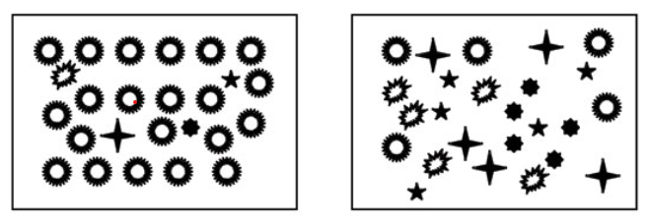 | pyron_2010_fig1_clipped.png | **Pyron (2010) - Fig. 1** Species evenness and species richness for animalcule communities  :::{dropdown}  Both communities contain five species of animalcules. Species richness is the same. The community on the left is dominated by one of the species. The community on the right has equal proportions of each species. Evenness is higher when species are present in similar proportions. Thus the community on the left has higher species diversity, because evenness is higher.  ::: | pyron_2010
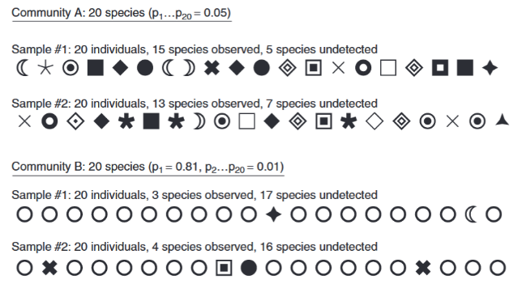 | gotelli_chao_2013_fig1_clipped.png | **Gotelli & Chao (2013) - Fig. 1** Species richness sampling in a hypothetical walk through the woods. Each different symbol represents one of 20 distinct species, and each row contains 20 characters, representing the first 20 individual trees that might be encountered in a random sample. Community A is maximally even, with each of the 20 species comprising 5% of the total abundance. In this assemblage, the two samples of 20 individual trees yielded 15 and 13 species, respectively. Community B is highly uneven, with one species (the open circle) representing 81% of the total abundance, and the remaining 19 species contributing only 1% each. In this assemblage, the two samples of 20 individual trees yielded only three and four species, respectively. | gotelli_chao_2013
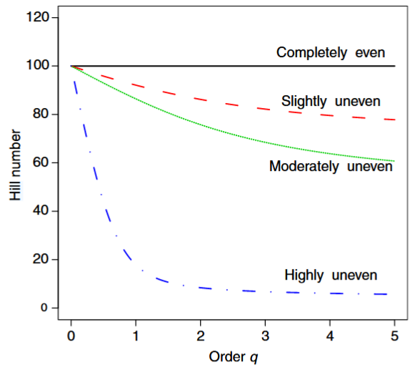 | gotelli_chao_2013_fig6_clipped.png | **Gotelli & Chao (2013) - Fig. 6** Diversity profile for assemblages of differing evenness.  :::{dropdown}  The x-axis is the order *q* in the Hill number (eqn [23a]), and is illustrated for values of *q* from 0 to 5. The y-axis is the calculated Hill number (the equivalent number of equally abundant species). Each of the four assemblages has exactly 100 species and 500 individuals, but they differ in their relative evenness: (1) completely even assemblage (black solid line): each species is represented by five individuals; (2) slightly uneven assemblage (red dashed line): 50 species each represented by seven individuals and 50 species each represented by three individuals (this structure is denoted as {50 x 7, 50 x 3}); (3) moderately uneven assemblage (green dotted line): {22 x 10, 28 x 5, 40 x 3, 10 x 2}; (4) highly uneven assemblage (blue dash–dot line): {1 x 120, 1 x 80, 1 x 70, 1 x 50, 3 x 20, 3 x 10, 90 x 1}. For *q*=0, the Hill number is species richness, which is equal to 100 for all assemblages. Because Hill numbers represent the equivalent number of equally abundant species, the curve for the perfectly even assemblage (black solid line) does not change as q is increased. Larger values of q place progressively more weight on common species, so the equivalent number of equally abundant species is much lower for the more uneven assemblages than for more even assemblages.  ::: | gotelli_chao_2013
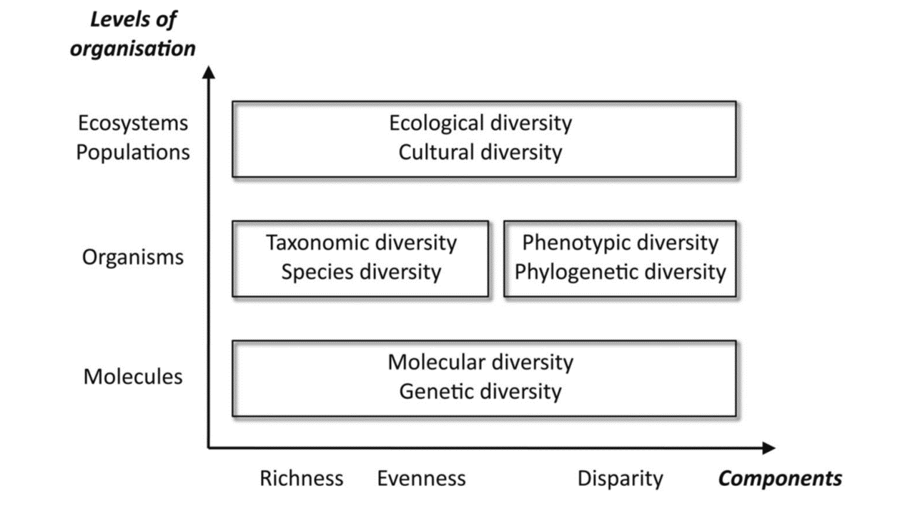 | loreau_2010_fig3.png | **Loreau et al. (2010) - Fig. 3** The various levels of organisation and components that define the multiple facets of biodiversity | loreau_2010
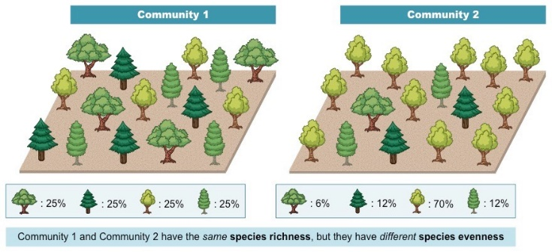 | bioninja_nd_fig1.jpeg | There are two main components that contribute to biodiversity – species richness and species evenness  - Species richness describes the number of different species present in an area (more species = greater richness)  - Species evenness describes the relative abundance of the different species in an area (similar abundance = more evenness) | bioninja_nd
 | figure6_filename.png | figure6_caption  need look at subscript  Figure 1: concepts and notation for interpolation (solid curves) and extrapolation (dashed curves) from an abundance reference sample (individual-based models) or an incidence reference sample (sample-based models), indicated by filled black circles, under three statistical models: (a) the multinomial model, (b) the Poisson model and (c) the Bernoulli product model. *S<sub>est</sub>* is the estimated asymptotic number of species in the assemblage. The reference sample of n individuals (multinomial), the individuals found in area *A* (Poisson) or *T* sampling units (Bernoulli product model) reveals *S<sub>obs</sub>* species. Interpolation (rarefaction) shows the estimated number of species S~indðmÞ found among m individuals, m < n (multinomial, Equation 4), the estimated number of species *S<sub>area</sub>(a)* found area a, a < A (Poisson, Equation 6), or the estimated number of species S~sampleðtÞ found in t sampling units, t < T (Bernoulli product, Equation 17). Extrapolation shows the estimated number of species S~indðn + mÞ found among an augmented sample of n + m (multinomial, Equation 9) individuals, the estimated number of species S~areaðA + aÞ found in a larger area A + a (Poisson, Equation 12) or the estimated number of species S~sampleðT + tÞ found in T + t sampling units (Bernoulli product, Equation 18), For extrapolation, m~ g estimates the number of additional individuals (multinomial, Equation 11), a~ g the additional area (Poisson, Equation 14) and t~ g the additional number of sampling units (Bernoulli product, Equation 20), required to reach proportion g of the asymptotic richness *S<sub>est</sub>*. | colwell_et_al_2012
 | figure7_filename.png | figure7_caption | figure7_ref_id
 | figure8_filename.png | figure8_caption | figure8_ref_id
 | figure9_filename.png | figure9_caption | figure9_ref_id
 | figure10_filename.png | figure10_caption | figure10_ref_id
 | figure11_filename.png | figure11_caption | figure11_ref_id
 | figure12_filename.png | figure12_caption | figure12_ref_id
Images in
- Colwell, RK, A Chao, NJ Gotelli, SY Lin, CX Mao, RL Chazdon, and JT Longino. "Models and Estimators Linking Individual-Based and Sample-Based Rarefaction, Extrapolation and Comparison of Assemblages." JOURNAL OF PLANT ECOLOGY 5, no. 1 (March 2012): 3–21. https://doi.org/10.1093/jpe/rtr044.
- Gotelli, Nicholas J., and Anne Chao. "Measuring and Estimating Species Richness, Species Diversity, and Biotic Similarity from Sampling Data." In Encyclopedia of Biodiversity, 195–211. Elsevier, 2013. https://doi.org/10.1016/B978-0-12-384719-5.00424-X.
- https://biology4isc.weebly.com/2-biodiversity-today.html

Video
caption | URL (no < / > before/after URL | ref_id
Abundance, species richness, and diversity | https://www.youtube.com/embed/ghhZClDRK_g?si=khprL1u5NJrFduTb | project_dragonfly_2019
Species accumulation and rarefaction curves | https://www.youtube.com/embed/4gcmAUpo9TU?si=_S-JYDDskR8QbHs5 | mecks100_2018
Using vegan to calculate alpha diversity metrics within the tidyverse in R (CC196) | https://www.youtube.com/embed/wq1SXGQYgCs?si=Re5tglERblfkCNhDl | riffomonas_project_2022a
Species abundance tools in Genstat | https://www.youtube.com/embed/wBx7f4PP8RE?si=D6mtAMNMLlk3aH8H | vsn_international_2022
Species Diversity and Species Richness | https://www.youtube.com/embed/UXJ0r4hjbqI?si=gYR6rOmIMgyibyvR | baylor_tutoring_center_2021
Field Ecology - Diversity Metrics in R | https://www.youtube.com/embed/KBByV3kR3IA?si=RPcG1lFQ-v0Shwaw | styring_2020a
Generating a rarefaction curve from collector's curves in R within the tidyverse (CC198) | https://www.youtube.com/embed/ywHVb0Q-qsM?si=_xJ5jbFc6MDEQlAh | riffomonas_project_2022b
Community structure and diversity | https://www.youtube.com/embed/Clxji2_36Do?si=H2UUsKL_F9FGRTvZ | benedetto_2021
vid9_caption | vid9_url | vid9_ref_id
vid10_caption | vid10_url | vid10_ref_id
vid11_caption | vid11_url | vid11_ref_id
vid12_caption | vid12_url | vid12_ref_id
vid13_caption | vid13_url | vid13_ref_id
vid14_caption | vid14_url | vid14_ref_id
vid15_caption | vid15_url | vid15_ref_id
vid16_caption | vid16_url | vid16_ref_id
vid17_caption | vid17_url | vid17_ref_id
vid18_caption | vid18_url | vid18_ref_id

Shiny
Shiny name = iNext Online
Shiny caption = Software for interpolation and extrapolation of species diversity.<br><br>{{ rbib_chao_et_al_2016 }}
Shiny URL = https://chao.shinyapps.io/iNEXTOnline

Shiny name = Visualizing Biodiversity in \[U.S.\] National Parks
Shiny caption = 'Biodiversity in National Parks is an app that let you visualize Kaggle’s biodiversity dataset. By using the National Park Service database of animal and plant species, the application offers a graphical representation of the data with maps and charts'<br><br>{{ rbib_benedetti_2024 }}
Shiny URL = https://abenedetti.shinyapps.io/bioNPS/

Benedetti, A. (2024). *Visualizing Biodiversity in \[U.S.\] National Parks.* https://shiny.posit.co/r/gallery/life-sciences/biodiversity-national-parks

Analytical tools & resources
Type | Name | Note | URL | ref_id
R package | Chapter 9 Community composition |  | <https://bookdown.org/c_w_beirne/wildCo-Data-Analysis/composition.html#estimated-richnes> | wildco_lab_2021b
R package | R package "vegan |  | <https://cran.r-project.org/web/packages/vegan/index.html> | oksanen_et_al_2024
Program | EstimateS | Dedicated software for estimating diversity, using asymptotic or rarefaction methods. Mac version available | <https://www.robertkcolwell.org/pages/1407> | colwell_2022
R package | Package ‘iNEXT’ - Interpolation and Extrapolation for Species Diversity | The iNext package (INterpolation and EXTrapolation of species richness) - is both easy to use and rapid to compute. It also comes with a wealth of plotting functions - see the iNext Quick Introduction for a great walk through tutorial. Its core functionality is based on: Chao, Anne, et al. "Rarefaction and extrapolation with Hill numbers: a framework for sampling and estimation in species diversity studies." Ecological monographs 84.1 (2014): 45-67. | <https://cran.r-project.org/web/packages/iNEXT/iNEXT.pdf> | chao_et_al_2016
Exercise/Tutorial | 2.2: Measuring Species Diversity | Easy to interpet explanation of species richness vs evenness, species area curves, rarefaction, and how to calculate diversity | <https://bio.libretexts.org/Courses/University_of_California_Davis/BIS_2B%3A_Introduction_to_Biology_-_Ecology_and_Evolution/02%3A_Biodiversity/2.02%3A_Measuring_Species_Diversity> | gerhartbarley_nd
R package / Tutorial | Species Accumulation Curves with vegan, BiodiversityR and ggplot2 | Software for interpolation and extrapolation of species diversity | <https://rpubs.com/Roeland-KINDT/694021> | roeland_2020
resource7_type | resource7_name | resource7_note | resource7_url | resource7_ref_id
resource8_type | resource8_name | resource8_note | resource8_url | resource8_ref_id
resource9_type | resource9_name | resource9_note | resource9_url | resource9_ref_id
resource10_type | resource10_name | resource10_note | resource10_url | resource10_ref_id
resource11_type | resource11_name | resource11_note | resource11_url | resource11_ref_id
resource12_type | resource12_name | resource12_note | resource12_url | resource12_ref_id
resource13_type | resource13_name | resource13_note | resource13_url | resource13_ref_id
resource14_type | resource14_name | resource14_note | resource14_url | resource14_ref_id
resource15_type | resource15_name | resource15_note | resource15_url | resource15_ref_id
resource16_type | resource16_name | resource16_note | resource16_url | resource16_ref_id
resource17_type | resource17_name | resource17_note | resource17_url | resource17_ref_id
resource18_type | resource18_name | resource18_note | resource18_url | resource18_ref_id
resource19_type | resource19_name | resource19_note | resource19_url | resource19_ref_id
resource20_type | resource20_name | resource20_note | resource20_url | resource20_ref_id
resource21_type | resource21_name | resource21_note | resource21_url | resource21_ref_id
resource22_type | resource22_name | resource22_note | resource22_url | resource22_ref_id
resource23_type | resource23_name | resource23_note | resource23_url | resource23_ref_id
resource24_type | resource24_name | resource24_note | resource24_url | resource24_ref_id
resource25_type | resource25_name | resource25_note | resource25_url | resource25_ref_id

References / Glossary
ref_id
{{ rbib_ahumada_et_al_2011 }}
{{ rbib_baylor_tutoring_center_2021 }}
{{ rbib_benedetti_2024 }}
{{ rbib_bioninja_nd }}
{{ rbib_brodie_et_al_2015 }}
{{ rbib_chatterjee_et_al_2021 }}
{{ rbib_chao_et_al_2016 }}
{{ rbib_chao_et_al_2014 }}
{{ rbib_colwell_2022 }}
{{ rbib_gerhartbarley_nd }}
{{ rbib_gotelli_chao_2013 }}
{{ rbib_hsieh_et_al_2015 }}
{{ rbib_iknayan_et_al_2014 }}
{{ rbib_kinnaird_obrien_2012 }}
{{ rbib_kitamura_et_al_2010 }}
{{ rbib_loreau_2010 }}
{{ rbib_mackenzie_et_al_2006 }}
{{ rbib_mecks100_2018 }}
{{ rbib_oconnor_et_al_2017 }}
{{ rbib_oksanen_et_al_2024 }}
{{ rbib_pettorelli_et_al_2010 }}
{{ rbib_project_dragonfly_2019 }}
{{ rbib_pyron_2010 }}
{{ rbib_riffomonas_project_2022a }}
{{ rbib_riffomonas_project_2022b }}
{{ rbib_samejima_et_al_2012 }}
{{ rbib_si_et_al_2014 }}
{{ rbib_styring_2020a }}
{{ rbib_styring_2020b }}
{{ rbib_tobler_et_al_2008 }}
{{ rbib_vsn_international_2022 }}
{{ rbib_wearn_et_al_2016 }}
{{ rbib_wearn_gloverkapfer_2017 }}
{{ rbib_wildco_lab_2021b }}
{{ rbib_yue_et_al_2015 }}

Notes

"Species richness** is simply "the total number of species in an assemblage or a sample" ({{ rtxt_gotelli_chao_2013 }}.

Species richness in an assemblage is difficult to estimate reliably from sample data because it is very sensitive to the number of individuals and the number of samples collected. Species richness is a diversity of order 0 (which means it is completely insensitive to species abundances). ({{ rtxt_gotelli_chao_2013 }}.

"Species diversity is more complex, and includes a measure of the number of species in a community, and a measure of the abundance of each species. Species diversity is usually described by an index, such as Shannon's Index H'." ({{ rtxt_pyron_2010 }})

**Pyron (2010) - Figure 1**:
"Species richness" can be thought of as the sum of different species seen in a particular area during a particular time period
Pg 62 wearn
6-2 Community variance or β-diversity

When considering two (or more) communities, it is possible to calculate a state variable which reflects the differences between the communities or, more formally, the variance among the communities. We sometimes call this community variance "β-diversity" (betadiversity). This is useful, for example, for assessing the degree to which communities subject to different management differ (e.g. comparing an old-growth site, a selectively-logged site and a plantation forest site). This is sometimes called "across-site" β-diversity, because it is being used to assess community variance across heterogeneous habitat types.

β-diversity measures can also be used to assess community variance within single habitat types, at a smaller scale. This is sometimes called "within-site" β-diversity (although the distinction from across-site β-diversity may not always be clear-cut). This can be important because changes in community variance within a study site may reflect changes in the fundamental processes which generate biodiversity at local scales (such as habitat heterogeneity and the connectivity of populations).

β-diversity should also play an important role in spatial conservation planning, for example in designing networks of reserves. All else being equal, if β-diversity is high, it will be important to establish a network of reserves so that all species in the landscape are covered. On the other hand, if β-diversity is low and communities are similar across space, then a single large reserve may be the best option.

Communities can also be compared across time, rather than across space, giving rise to temporal β-diversity. This can be used to track how much, and how quickly, communities are changing at a single site over time.

Camera trap studies typically sample a large number of locations, making them highly suitable for quantifying β-diversity, but this has rarely been done (but see: Wearn et al. 2016). At least in part, this is probably because the importance of β-diversity is poorly appreciated amongst wildlife biologists and conservationists. In addition, there are many different ways β-diversity can be calculated, each with their own strengths and weaknesses, with no single best measure. This can be confusing and lead to "analysis paralysis". In common with species richness, β-diversity is also dependent on spatial scale (Olivier & Aarde 2014). For example, some habitats such as logged forests may show high β-diversity (rapid community turnover) at fine spatial scales, but low β-diversity (homogenous communities) at coarse spatial scales (Wearn et al. 2016). Finally, interpreting and communicating measures of β-diversity can be hard, because they are often in meaningless units, or because they do not lend themselves directly to comparisons across different studies.

POPULATE - MOD
File from = 00_tools\00_00_template-master.docx

---
jupytext:
[[space2]]formats: md:myst
[[space2]]text_representation:
[[space4]]extension: .md
[[space4]]format_name: myst
kernelspec:
[[space2]]display_name: Python 3
[[space2]]language: python
[[space2]]name: python3
editor_options:
[[space2]]markdown:
[[space4]]wrap: none
---
(i_mod_divers_rich)=
# {{ title_i_mod_divers_rich }}

:::{seealso}
{{ link_bdg_sp_asymptote }}
{{ link_bdg_sp_rarity }}
:::

```{include} pro_con_assump/mod_divers_rich_apc.md
```

::::::::{tab-set}

:::::::{tab-item} Overview
**{{ term_mod_divers_rich_rich }}**: {{ def_mod_divers_rich_rich }}
**{{ term_mod_divers_rich_divers }}**: {{ def_mod_divers_rich_divers }}

Note that there are multiple parameters corresponding to different scales and incorporating of evenness; these include:
- **{{ term_mod_divers_rich_alpha }}**: {{ def_mod_divers_rich_alpha }}
- **{{ term_mod_divers_rich_beta }}**: {{ def_mod_divers_rich_beta }}
- **{{ term_mod_divers_rich_gamma }}**: {{ def_mod_divers_rich_gamma }}

Refer to the "Assumptions, Pros, Cons" dropdown above to see relevant information for all three.

```{figure} ../03_images/03_image_files/pyron_2010_fig1_clipped.png
:align: center
:scale: 60%
```
> **Pyron (2010) - Fig. 1**: Species evenness and species richness for animalcule communities. Both communities contain five species of animalcules. Species richness is the same. The community on the left is dominated by one of the species. The community on the right has equal proportions of each species. Evenness is higher when species are present in similar proportions. Thus the community on the left has higher species diversity, because evenness is higher.
:::::::

:::::::{tab-item} In-depth
:::{note}
This section is still in progress
:::

**{{ term_mod_divers_rich_rich }}**: {{ def_mod_divers_rich_rich }}

**{{ term_mod_divers_rich_divers }}**: {{ def_mod_divers_rich_divers }}

## Study design
### Number of cameras

The optimal number of cameras required will be influenced by factors such as landscape heterogeneity, {{ survey_tl }} duration and spatial scale, species rarity and desired level of precision ({{ rtxt_colyn_et_al_2018 }}; {{ rtxt_rovero_et_al_2013 }}). For example, Kays et al. (2020) found that 25–35 cameras were needed for precise estimates of species richness, depending on the spatial scale of the {{ survey_tl }} and landscape diversity. In general, deploying more cameras and/or for longer durations always results in more precise estimates; however, users can consider rotating cameras across multiple sites for shorter durations (if feasible).

### Duration - Camera days per camera location

For measures of species richness or diversity, it is presumed that a camera is active long enough to detect rare species that may occur at a specific location ({{ rtxt_wearn_gloverkapfer_2017 }}). If this is not the case, the results will indicate that the species was not present when it was (i.e., a "false negative"). False negatives may also be problematic for other measures, such as **{{ mod_rai_tl }}** (count data, with or without {{ mod_zero_inflation_tl }} and/or {{ mod_overdispersion_tl }}), even if the model type used can account for {{ imperfect_detection_tl }} explicitly (e.g., combined occurrence/{{ mod_rai_tl }}; {{ mod_n_mixture_tu }}).

### Number of cameras vs. Camera days per camera location

If a user must choose between more cameras *vs.* fewer cameras with longer {{ survey_tl_pl }}, Chatterjee et al. (2021) suggested that for rare species, the optimal precision can be obtained by increasing the number of sites, whereas for common species, increasing the number of samples is more effective. For measuring species richness, Si et al. (2014) found that rotating cameras to new sites was more efficient than leaving cameras at fewer sites for longer periods. O'Connor et al. (2017) also recommended utilizing more cameras *vs*. increasing study length to increase {{ detection_probability_tl_pl }}. In general, regardless of species and {{ survey_objectives_tl_abrv }}, increasing the number of {{ survey_tl }} locations or the {{ survey_tl }} length improved precision ({{ rtxt_chatterjee_et_al_2021 }}).
Analysis

Note that there are multiple parameters corresponding to different scales and incorporating of evenness; these include:
- **{{ term_mod_divers_rich_alpha }}**: {{ def_mod_divers_rich_alpha }}
- **{{ term_mod_divers_rich_beta }}**: {{ def_mod_divers_rich_beta }}
- **{{ term_mod_divers_rich_gamma }}**: {{ def_mod_divers_rich_gamma }}

Its important to note the difference in **Observed *vs* estimated species richness** (from {{ rtxt_wearn_gloverkapfer_2017 }}):
- **Observed species richness**: the sum of the number of species seen (e.g. {{ rtxt_kitamura_et_al_2010 }}; {{ rtxt_pettorelli_et_al_2010 }}; {{ rtxt_ahumada_et_al_2011 }}; {{ rtxt_samejima_et_al_2012 }})
- Observed species richness will not, in general, be a reliable index of actual species richness because, even if sampling effort is strictly controlled, the detectability of species will vary across samples
- **Estimated species richness**: when the "sum of the number of species seen" is adjusted based on corrections for "imperfect detection" (i.e. the fact that some species in a given sample may have been missed)
- (e.g. {{ rtxt_tobler_et_al_2008 }}; {{ rtxt_kinnaird_obrien_2012 }}; {{ rtxt_brodie_et_al_2015 }}; {{ rtxt_yue_et_al_2015 }}; {{ rtxt_wearn_et_al_2016 }})

The **two principal ways of estimating species richness from remote camera data** are (from {{ rtxt_wearn_gloverkapfer_2017 }}):
- non-parametric estimators ({{ rtxt_gotelli_chao_2013 }}), which use information about the rarest species in the sample to provide a minimum estimate of the number of true species (e.g. {{ rtxt_tobler_et_al_2008 }}),
- or 2) occupancy models ({{ rtxt_mackenzie_et_al_2006 }})

:::::::

:::::::{tab-item} Visual resources
::::::{grid} 3
:gutter: 3
:class-container: wrapper
:::::{grid-item-card} {{ rtxt_pyron_2010 }}
<img src="../03_images/03_image_files/pyron_2010_fig1_clipped.png" class="img_grid"><br><br>**Pyron (2010) - Fig. 1** Species evenness and species richness for animalcule communities

:::{dropdown}
Both communities contain five species of animalcules. Species richness is the same. The community on the left is dominated by one of the species. The community on the right has equal proportions of each species. Evenness is higher when species are present in similar proportions. Thus the community on the left has higher species diversity, because evenness is higher.
:::
:::::

:::::{grid-item-card} {{ rtxt_gotelli_chao_2013 }}
<img src="../03_images/03_image_files/gotelli_chao_2013_fig1_clipped.png" class="img_grid"><br><br>**Gotelli & Chao (2013) - Fig. 1** Species richness sampling in a hypothetical walk through the woods. Each different symbol represents one of 20 distinct species, and each row contains 20 characters, representing the first 20 individual trees that might be encountered in a random sample. Community A is maximally even, with each of the 20 species comprising 5% of the total abundance. In this assemblage, the two samples of 20 individual trees yielded 15 and 13 species, respectively. Community B is highly uneven, with one species (the open circle) representing 81% of the total abundance, and the remaining 19 species contributing only 1% each. In this assemblage, the two samples of 20 individual trees yielded only three and four species, respectively.
:::::

:::::{grid-item-card} {{ rtxt_gotelli_chao_2013 }}
<img src="../03_images/03_image_files/gotelli_chao_2013_fig6_clipped.png" class="img_grid"><br><br>**Gotelli & Chao (2013) - Fig. 6** Diversity profile for assemblages of differing evenness.

:::{dropdown}
The x-axis is the order *q* in the Hill number (eqn [23a]), and is illustrated for values of *q* from 0 to 5. The y-axis is the calculated Hill number (the equivalent number of equally abundant species). Each of the four assemblages has exactly 100 species and 500 individuals, but they differ in their relative evenness: (1) completely even assemblage (black solid line): each species is represented by five individuals; (2) slightly uneven assemblage (red dashed line): 50 species each represented by seven individuals and 50 species each represented by three individuals (this structure is denoted as {50 x 7, 50 x 3}); (3) moderately uneven assemblage (green dotted line): {22 x 10, 28 x 5, 40 x 3, 10 x 2}; (4) highly uneven assemblage (blue dash–dot line): {1 x 120, 1 x 80, 1 x 70, 1 x 50, 3 x 20, 3 x 10, 90 x 1}. For *q*=0, the Hill number is species richness, which is equal to 100 for all assemblages. Because Hill numbers represent the equivalent number of equally abundant species, the curve for the perfectly even assemblage (black solid line) does not change as q is increased. Larger values of q place progressively more weight on common species, so the equivalent number of equally abundant species is much lower for the more uneven assemblages than for more even assemblages.
:::
:::::

:::::{grid-item-card} {{ rtxt_project_dragonfly_2019 }}
<div class="iframe-container-vid"><iframe class="iframe-responsive-vid" src="https://www.youtube.com/embed/ghhZClDRK_g?si=khprL1u5NJrFduTb"></iframe></div>
Abundance, species richness, and diversity
:::::

:::::{grid-item-card} {{ rtxt_mecks100_2018 }}
<div class="iframe-container-vid"><iframe class="iframe-responsive-vid" src="https://www.youtube.com/embed/4gcmAUpo9TU?si=_S-JYDDskR8QbHs5"></iframe></div>
Species accumulation and rarefaction curves
:::::

:::::{grid-item-card} {{ rtxt_riffomonas_project_2022a }}
<div class="iframe-container-vid"><iframe class="iframe-responsive-vid" src="https://www.youtube.com/embed/wq1SXGQYgCs?si=Re5tglERblfkCNhDl"></iframe></div>
Using vegan to calculate alpha diversity metrics within the tidyverse in R (CC196)
:::::

:::::{grid-item-card} {{ rtxt_vsn_international_2022 }}
<div class="iframe-container-vid"><iframe class="iframe-responsive-vid" src="https://www.youtube.com/embed/wBx7f4PP8RE?si=D6mtAMNMLlk3aH8H"></iframe></div>
Species abundance tools in Genstat
:::::

:::::{grid-item-card} {{ rtxt_baylor_tutoring_center_2021 }}
<div class="iframe-container-vid"><iframe class="iframe-responsive-vid" src="https://www.youtube.com/embed/UXJ0r4hjbqI?si=gYR6rOmIMgyibyvR"></iframe></div>
Species Diversity and Species Richness
:::::

:::::{grid-item-card} {{ rtxt_styring_2020a }}
<div class="iframe-container-vid"><iframe class="iframe-responsive-vid" src="https://www.youtube.com/embed/KBByV3kR3IA?si=RPcG1lFQ-v0Shwaw"></iframe></div>
Field Ecology - Diversity Metrics in R
:::::

:::::{grid-item-card} {{ rtxt_riffomonas_project_2022b }}
<div class="iframe-container-vid"><iframe class="iframe-responsive-vid" src="https://www.youtube.com/embed/ywHVb0Q-qsM?si=_xJ5jbFc6MDEQlAh"></iframe></div>
Generating a rarefaction curve from collector's curves in R within the tidyverse (CC198)
:::::

:::::{grid-item-card} {{ rtxt_benedetto_2021 }}
<div class="iframe-container-vid"><iframe class="iframe-responsive-vid" src="https://www.youtube.com/embed/Clxji2_36Do?si=H2UUsKL_F9FGRTvZ"></iframe></div>
Community structure and diversity
:::::

:::::{grid-item-card} {{ rtxt_vid9_ref_id }}
<div class="iframe-container-vid"><iframe class="iframe-responsive-vid" src="vid9_url"></iframe></div>
vid9_caption
:::::

::::::
:::::::

:::::::{tab-item} Shiny apps/Widgets
::::::{card}
:::::{dropdown} iNext Online
Software for interpolation and extrapolation of species diversity.<br><br>{{ rbib_chao_et_al_2016 }}
<div class="iframe-container-shiny"><iframe class="iframe-responsive-shiny" src="https://chao.shinyapps.io/iNEXTOnline"></iframe></div>
:::::
:::::{dropdown} Visualizing Biodiversity in \[U.S.\] National Parks
'Biodiversity in National Parks is an app that let you visualize Kaggle’s biodiversity dataset. By using the National Park Service database of animal and plant species, the application offers a graphical representation of the data with maps and charts'<br><br>{{ rbib_benedetti_2024 }}
<div class="iframe-container-shiny"><iframe class="iframe-responsive-shiny" src="https://abenedetti.shinyapps.io/bioNPS/"></iframe></div>
:::::
::::::
:::::::

:::::::{tab-item} Analytical tools & Resources
| Type | Name | Note | URL | Reference |
|:----------------|:-------------------------------|:----------------------------------------------------------------|:----------------------|:----------------------------------------|
| R package | Chapter 9 Community composition | | <https://bookdown.org/c_w_beirne/wildCo-Data-Analysis/composition.html#estimated-richnes> | {{ rbib_wildco_lab_2021b }} |
| R package | R package "vegan | | <https://cran.r-project.org/web/packages/vegan/index.html> | {{ rbib_oksanen_et_al_2024 }} |
| Program | EstimateS | Dedicated software for estimating diversity, using asymptotic or rarefaction methods. Mac version available | <https://www.robertkcolwell.org/pages/1407> | {{ rbib_colwell_2022 }} |
| R package | Package ‘iNEXT’ - Interpolation and Extrapolation for Species Diversity | The iNext package (INterpolation and EXTrapolation of species richness) - is both easy to use and rapid to compute. It also comes with a wealth of plotting functions - see the iNext Quick Introduction for a great walk through tutorial. Its core functionality is based on: Chao, Anne, et al. "Rarefaction and extrapolation with Hill numbers: a framework for sampling and estimation in species diversity studies." Ecological monographs 84.1 (2014): 45-67. | <https://cran.r-project.org/web/packages/iNEXT/iNEXT.pdf> | {{ rbib_chao_et_al_2016 }} |
| Exercise/Tutorial | 2.2: Measuring Species Diversity | Easy to interpet explanation of species richness vs evenness, species area curves, rarefaction, and how to calculate diversity | <https://bio.libretexts.org/Courses/University_of_California_Davis/BIS_2B%3A_Introduction_to_Biology_-_Ecology_and_Evolution/02%3A_Biodiversity/2.02%3A_Measuring_Species_Diversity> | {{ rbib_gerhartbarley_nd }} |
| R package / Tutorial | Species Accumulation Curves with vegan, BiodiversityR and ggplot2 | Software for interpolation and extrapolation of species diversity | <https://rpubs.com/Roeland-KINDT/694021> | {{ rbib_roeland_2020 }} |
| resource7_type | resource7_name | resource7_note | resource7_url | {{ rbib_resource7_ref_id }} |
| resource8_type | resource8_name | resource8_note | resource8_url | {{ rbib_resource8_ref_id }} |
| resource9_type | resource9_name | resource9_note | resource9_url | {{ rbib_resource9_ref_id }} |
| resource10_type | resource10_name | resource10_note | resource10_url | {{ rbib_resource10_ref_id }} |
| resource11_type | resource11_name | resource11_note | resource11_url | {{ rbib_resource11_ref_id }} |
| resource12_type | resource12_name | resource12_note | resource12_url | {{ rbib_resource12_ref_id }} |
| resource13_type | resource13_name | resource13_note | resource13_url | {{ rbib_resource13_ref_id }} |
| resource14_type | resource14_name | resource14_note | resource14_url | {{ rbib_resource14_ref_id }} |
| resource15_type | resource15_name | resource15_note | resource15_url | {{ rbib_resource15_ref_id }} |
| resource16_type | resource16_name | resource16_note | resource16_url | {{ rbib_resource16_ref_id }} |
| resource17_type | resource17_name | resource17_note | resource17_url | {{ rbib_resource17_ref_id }} |
| resource18_type | resource18_name | resource18_note | resource18_url | {{ rbib_resource18_ref_id }} |
| resource19_type | resource19_name | resource19_note | resource19_url | {{ rbib_resource19_ref_id }} |
| resource20_type | resource20_name | resource20_note | resource20_url | {{ rbib_resource20_ref_id }} |
<!-- END_RESOURCE_TABLE -->
:::::::

:::::::{tab-item} References
{{ rbib_ahumada_et_al_2011 }}
{{ rbib_baylor_tutoring_center_2021 }}
{{ rbib_benedetti_2024 }}
{{ rbib_bioninja_nd }}
{{ rbib_brodie_et_al_2015 }}
{{ rbib_chatterjee_et_al_2021 }}
{{ rbib_chao_et_al_2016 }}
{{ rbib_chao_et_al_2014 }}
{{ rbib_colwell_2022 }}
{{ rbib_gerhartbarley_nd }}
{{ rbib_gotelli_chao_2013 }}
{{ rbib_hsieh_et_al_2015 }}
{{ rbib_iknayan_et_al_2014 }}
{{ rbib_kinnaird_obrien_2012 }}
{{ rbib_kitamura_et_al_2010 }}
{{ rbib_loreau_2010 }}
{{ rbib_mackenzie_et_al_2006 }}
{{ rbib_mecks100_2018 }}
{{ rbib_oconnor_et_al_2017 }}
{{ rbib_oksanen_et_al_2024 }}
{{ rbib_pettorelli_et_al_2010 }}
{{ rbib_project_dragonfly_2019 }}
{{ rbib_pyron_2010 }}
{{ rbib_riffomonas_project_2022a }}
{{ rbib_riffomonas_project_2022b }}
{{ rbib_samejima_et_al_2012 }}
{{ rbib_si_et_al_2014 }}
{{ rbib_styring_2020a }}
{{ rbib_styring_2020b }}
{{ rbib_tobler_et_al_2008 }}
{{ rbib_vsn_international_2022 }}
{{ rbib_wearn_et_al_2016 }}
{{ rbib_wearn_gloverkapfer_2017 }}
{{ rbib_wildco_lab_2021b }}
{{ rbib_yue_et_al_2015 }}
:::::::

::::::::

