Topic Info
info_id | viewshed_dens_est

Note banner
<!--
:::{info}
Viewshed density estimators: methods used to estimate the abundance of unmarked populations from observations of animals that relate animal observations to the space directly sampled by each camera’s viewshed ({{ rtxt_moeller_et_al_2023 }}); they result in viewshed density estimates that can be extrapolated to abundance within broader sampling frames ({{ rtxt_gilbert_et_al_2020 }}; {{ rtxt_moeller_et_al_2023 }}).
:::
-->

Overview
```{include} include/00_coming_soon.md
```

In-depth
```{include} include/00_coming_soon.md
```

Figures
Image | file_name | Caption (if applicable) | ref_id
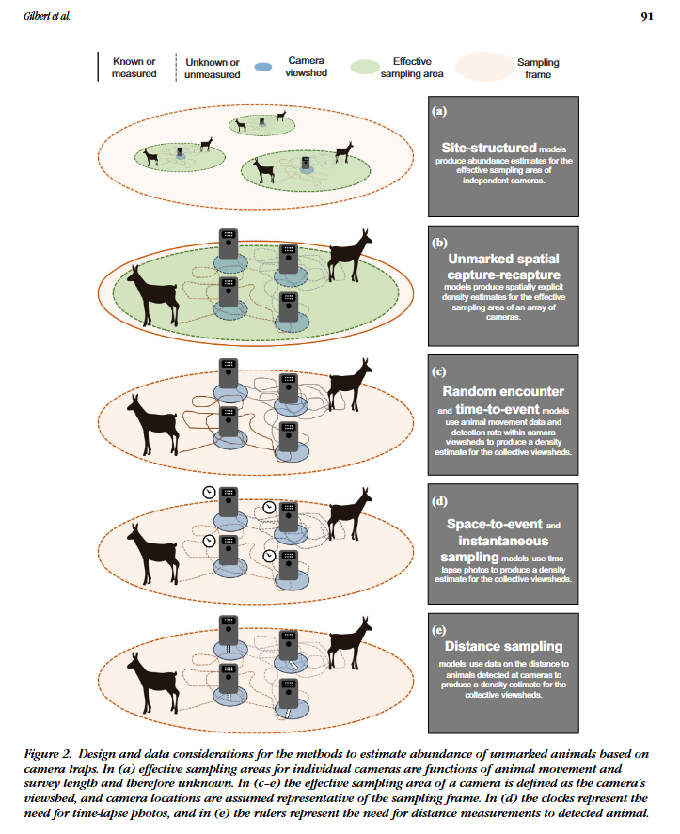 | figure1_filename.png | figure1_caption | figure1_ref_id
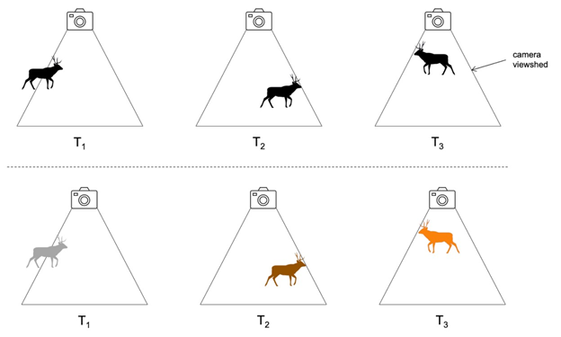 | gilbert_et_al_2019_fig3.png | figure2_caption | figure2_ref_id
 | figure3_filename.png | figure3_caption | figure3_ref_id
 | figure4_filename.png | figure4_caption | figure4_ref_id
 | figure5_filename.png | figure5_caption | figure5_ref_id
 | figure6_filename.png | figure6_caption | figure6_ref_id
 | figure7_filename.png | figure7_caption | figure7_ref_id
 | figure8_filename.png | figure8_caption | figure8_ref_id
 | figure9_filename.png | figure9_caption | figure9_ref_id
 | figure10_filename.png | figure10_caption | figure10_ref_id
 | figure11_filename.png | figure11_caption | figure11_ref_id
 | figure12_filename.png | figure12_caption | figure12_ref_id
 | figure13_filename.png | figure13_caption | figure13_ref_id
 | figure14_filename.png | figure14_caption | figure14_ref_id
 | figure15_filename.png | figure15_caption | figure15_ref_id
 | figure16_filename.png | figure16_caption | figure16_ref_id
 | figure17_filename.png | figure17_caption | figure17_ref_id
 | figure18_filename.png | figure18_caption | figure18_ref_id
 | figure19_filename.png | figure19_caption | figure19_ref_id
 | figure20_filename.png | figure20_caption | figure20_ref_id
 | figure21_filename.png | figure21_caption | figure21_ref_id
 | figure22_filename.png | figure22_caption | figure22_ref_id
 | figure23_filename.png | figure23_caption | figure23_ref_id
 | figure24_filename.png | figure24_caption | figure24_ref_id
 | figure25_filename.png | figure25_caption | figure25_ref_id
 | figure26_filename.png | figure26_caption | figure26_ref_id
 | figure27_filename.png | figure27_caption | figure27_ref_id
 | figure28_filename.png | figure28_caption | figure28_ref_id
 | figure29_filename.png | figure29_caption | figure29_ref_id

Video
caption | URL (no < / > before/after URL | ref_id
vid1_caption | vid1_url | vid1_ref_id
vid2_caption | vid2_url | vid2_ref_id
vid3_caption | vid3_url | vid3_ref_id
vid4_caption | vid4_url | vid4_ref_id
vid5_caption | vid5_url | vid5_ref_id
vid6_caption | vid6_url | vid6_ref_id
vid7_caption | vid7_url | vid7_ref_id
vid8_caption | vid8_url | vid8_ref_id
vid9_caption | vid9_url | vid9_ref_id
vid10_caption | vid10_url | vid10_ref_id
vid11_caption | vid11_url | vid11_ref_id
vid12_caption | vid12_url | vid12_ref_id
vid13_caption | vid13_url | vid13_ref_id
vid14_caption | vid14_url | vid14_ref_id
vid15_caption | vid15_url | vid15_ref_id
vid16_caption | vid16_url | vid16_ref_id
vid17_caption | vid17_url | vid17_ref_id
vid18_caption | vid18_url | vid18_ref_id

Shiny
Shiny name = shiny_name
Shiny caption = shiny_caption
Shiny URL = shiny_url
Shiny name = shiny_name2
Shiny caption =shiny_caption2
Shiny URL = shiny_url2

Analytical tools & Resources
Type | Name | Note | URL | ref_id
resource1_type | resource1_name | resource1_note | resource1_url | resource1_ref_id
resource2_type | resource2_name | resource2_note | resource2_url | resource2_ref_id
resource3_type | resource3_name | resource3_note | resource3_url | resource3_ref_id
resource4_type | resource4_name | resource4_note | resource4_url | resource4_ref_id
resource5_type | resource5_name | resource5_note | resource5_url | resource5_ref_id
resource6_type | resource6_name | resource6_note | resource6_url | resource6_ref_id
resource7_type | resource7_name | resource7_note | resource7_url | resource7_ref_id
resource8_type | resource8_name | resource8_note | resource8_url | resource8_ref_id
resource9_type | resource9_name | resource9_note | resource9_url | resource9_ref_id
resource10_type | resource10_name | resource10_note | resource10_url | resource10_ref_id
resource11_type | resource11_name | resource11_note | resource11_url | resource11_ref_id
resource12_type | resource12_name | resource12_note | resource12_url | resource12_ref_id
resource13_type | resource13_name | resource13_note | resource13_url | resource13_ref_id
resource14_type | resource14_name | resource14_note | resource14_url | resource14_ref_id
resource15_type | resource15_name | resource15_note | resource15_url | resource15_ref_id
resource16_type | resource16_name | resource16_note | resource16_url | resource16_ref_id
resource17_type | resource17_name | resource17_note | resource17_url | resource17_ref_id
resource18_type | resource18_name | resource18_note | resource18_url | resource18_ref_id
resource19_type | resource19_name | resource19_note | resource19_url | resource19_ref_id
resource20_type | resource20_name | resource20_note | resource20_url | resource20_ref_id
resource21_type | resource21_name | resource21_note | resource21_url | resource21_ref_id
resource22_type | resource22_name | resource22_note | resource22_url | resource22_ref_id
resource23_type | resource23_name | resource23_note | resource23_url | resource23_ref_id
resource24_type | resource24_name | resource24_note | resource24_url | resource24_ref_id
resource25_type | resource25_name | resource25_note | resource25_url | resource25_ref_id

References / Glossary
ref_id
Refs

Notes
POPULATE – INFO
File from = 00_tools\0_find_replace\00_00_template-master.docx

