- Open the “ExifToolGUI_X64.exe”
- Navigate to the files you would like to change in the left folder menu
- Select all of the images EXCEPT for the first image. You will be copied metadata from this file. I’m not sure it really matters if you select all though.
- Click “Export/Import” tab at the top, and then “Copy metadata from a single file”, click Ok”
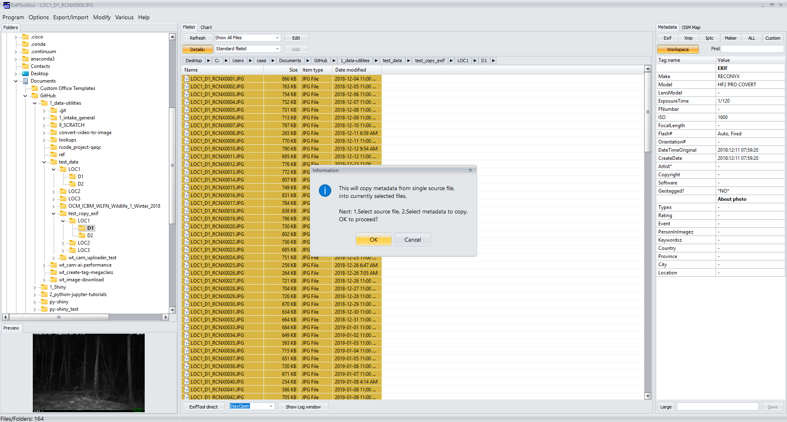
- Select the file the metadata should be copied from (first image, or could be another image elsewhere). If there are multiple folders, just put the “copy from” file somehere else to refer to.
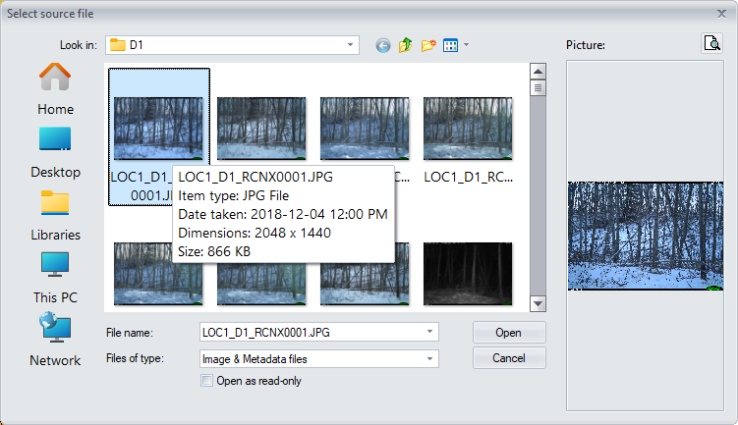
- Flag “import ALL metadata” at the top and then “Execute”.
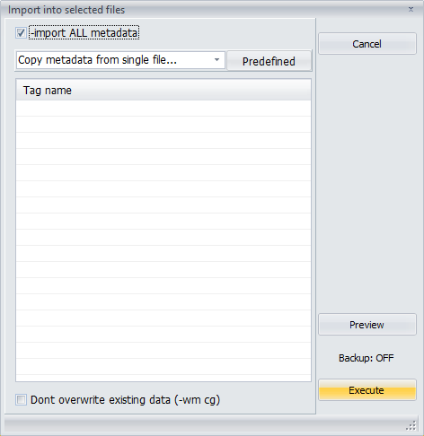
Voila! Now you can run the r code to

- Remove Exifdata:

