Run from visual basic

 | Selection | Step | Options
Path | C:\Users\cassi\Documents\GitHub_AB-RCSC\rc-tool_concept-library\02_dialog-boxes\00_tools
XLS_find_replace: | C:\Users\cassi\Documents\GitHub_AB-RCSC\rc-tool_concept-library\02_dialog-boxes\00_tools\string_find_replace_2024-10-18.xlsm
Select a Method: | XLS
Select a FileType: | *.docx
Select a Sheet: | Sheet1
Directory | 0_find_replace
Update Markdown Template: | 00_00_template-master.docx | 1
 | Rscript C:\Users\cassi\Documents\GitHub_AB-RCSC\rc-tool_concept-library\00_tools\pandoc_run.R | 2
 |  | 3
 |  | 4 | Run pandoc R code
 |  | 5

Notes

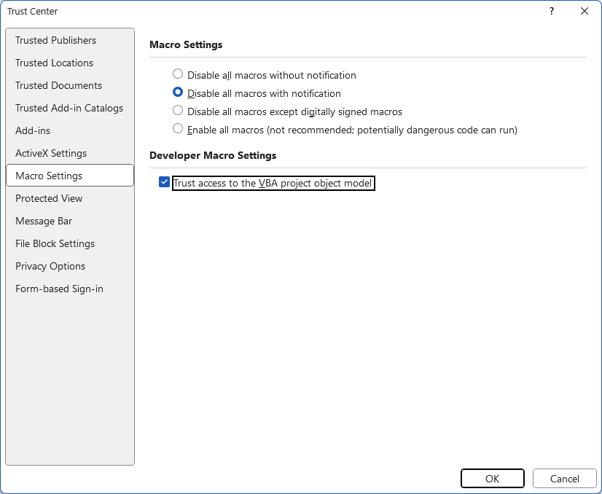

Steps to convert docs

Find all: | ^p
Replace with: | ^l
Find all: | ^l^l
Replace with: | ^p^p

