

|  |
| --- |
| Software Testing |
| **Flow Chart MCDC Path Prediction Test Oracle** |
| Assignment 3 | Section 2 |

|  |
| --- |
| **BSE173017 – Mohammad Abdur-Rahman**  **BSE173004 – Abdul Moiz**  **BSE173025 – Abdul Basit**  **BSE173041 – Huraira Ali** |

Table of Contents

Code 2

Flow Chart 2

MCDC 3

DECISION COVERAGE TEST CASES: 3

CONDITION COVERAGE TEST CASES: 3

Test Oracle 30

Path Prediction 4

CODE: 4

# Code

#include <iostream>

using namespace std;

int main()

{

int num;

cout << "Enter an integer: ";

cin >> num;

if (num >-1)

{

cout << "Number is positive" << endl;

}

else

{

cout << "Number is negative" << endl;

}

if (num != 0)

{

if ((num % 2) == 0) {

cout << "The number is even." << endl;

}

else {

cout << "The number is odd." << endl;

}

}

else {

cout << "The number is 0 and it is neither even nor odd." << endl;

}

cout << "This line is always printed." << endl;

system("pause");

return 0;

}

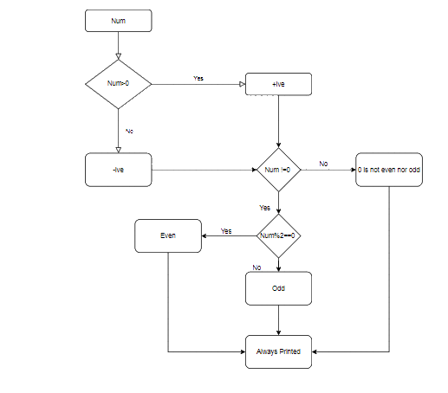

# Flow Chart

# MCDC

## DECISION COVERAGE TEST CASES:

num=6 → (num>0) T,

(num!=0) T,

(num%2==0) T

num=-0 →(num>0) F,

(num!=0) F,

(num%2==0) F

## CONDITION COVERAGE TEST CASES:

num=2 → (num>0) T,

(num!=0) T,

(num%2==0) F

num=-3 →(num>0) F,

(num!=0) T,

(num%2==0) F

num= 0 →(num>0) T,

(num!=0) F,

(num%2==0) F

# Test Oracle

* Input num=3:

Expected output=odd

Path: 1 -> 2 -> 3 -> 5 -> 6 -> 8 -> 10

Test oracle: odd

* Input num=2:

Expected output: even

Path: 1 -> 2 -> 3 -> 5 -> 6 -> 7 -> 10

Test oracle: even

* Input num=0:

Expected output: 0 is not odd or even

Path: 1 -> 2 -> 3 -> 5-> 9 -> 10

# Path Prediction

* If input, num=2:

Path: 1 -> 2 -> 3 -> 5 -> 6 -> 7 -> 10

* If input, num=-0

Path: 1 -> 2 -> 4 -> 5 -> 9 -> 10

* If input, num=7:

Path: 1 -> 2 -> 3 -> 5 -> 6 -> 8 -> 10

* input, num=-3:

Path: 1 -> 2 -> 4 -> 10

# CODE:

#include <iostream>

using namespace std;

int main() {

int num;

cout << "Enter an integer number between 1 & 99999: ";

cin >> num;

if (num < 100 && num >= 1) {

cout << "Its a two digit number";

}

else if (num < 1000 && num >= 100) {

cout << "Its a three digit number";

}

else if (num < 10000 && num >= 1000) {

cout << "Its a four digit number";

}

else if (num < 100000 && num >= 10000) {

cout << "Its a five digit number";

}

else {

cout << "number is not between 1 & 99999";

}

system("pause");

return 0;

}