

|  |
| --- |
| Software Testing |
| **UCL Buddy** |
| Assignment 3 | Section 2 |

|  |
| --- |
| **BSE173017 – Mohammad Abdur-Rahman**  **BSE173004 – Abdul Moiz**  **BSE173025 – Abdul Basit**  **BSE173041 – Huraira Ali** |

Table of Contents

Case Study 2

Introduction 2

Brief Description 2

Identified Functions **Error! Bookmark not defined.**

Function I 2

Function II 4

Function III 5

Black-Box Testing **Error! Bookmark not defined.**

Worst Case BVA **Error! Bookmark not defined.**

Function I **Error! Bookmark not defined.**

Function II **Error! Bookmark not defined.**

Function III **Error! Bookmark not defined.**

Strong Robust Equivalence Classes **Error! Bookmark not defined.**

Function I **Error! Bookmark not defined.**

Function II **Error! Bookmark not defined.**

Function III **Error! Bookmark not defined.**

Comparison between strong robust equivalence class and robust worst case BVA **Error! Bookmark not defined.**

Function 1 **Error! Bookmark not defined.**

Function II **Error! Bookmark not defined.**

Function III **Error! Bookmark not defined.**

# Case Study

## Introduction

UEFA Champions league is football competition where there are many teams that play against each other to win the champions league title. In this competition top 2 to 4 teams from all Europeans football leagues take part and the winner team is called the best team in Europe and is selected for the Club World Cup to get the Club world Cup title and also the winner team is give almost 85m Dollars as reward price followed by 65m Dollars for runner ups.

## Brief Description

In this application the player performance is tracked i.e. his goals, assists and matches are counted by the application. Goals assist ratio (G/A) is calculated by the sum of number of goals a player scores and the number of assists he has given in a match where goals are valued twice as assists. Goal range in the champions’ league is 0 to 15(including 0 and 15), and number of assists could be from 0 to max 10 in the competition. Also, G/A can’t be calculated if the number of matches is 0. G/A can be calculated by adding Goals and assists and dividing the number with the total matches played

Player rating is calculated by using the G/A, if the rating is low, we will write bad season, average season for average rating and great season for high rating

Tracking system is also used to track the progress of the goal keeper and calculate that how much clean sheet a keeper keeps in a number of matches. A clean sheet is kept by a keeper if he doesn’t let the opposition team score against him. Also, there can be only one clean sheet per match so the number of matches may be equal to or higher than the clean sheets a keeper kept. If the numbers of clean sheets are higher than matches then the output should be invalid.

# Cause Effect Graphing

## Function I

float playerGA (float matches,float goal, float assist)

|  |  |
| --- | --- |
| **Causes** | **Effects** |
| **C1:** goal>=0 && goal<=15 | **E1:** GA is displayed by the system |
| **C2:** matches=>0&&matches<=7 | **E2:** Invalid |
| **C3:** assist>=0&&assist<=10 |  |
| **C4:** matches > 0 |  |

### Cause Effect Graph

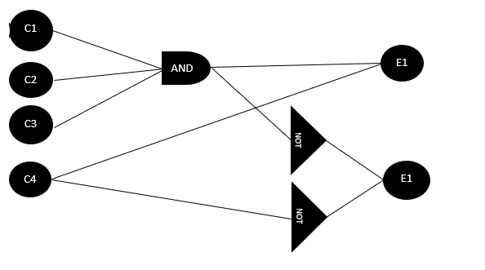

### Decision Table

|  |  |  |  |  |  |  |  |  |  |
| --- | --- | --- | --- | --- | --- | --- | --- | --- | --- |
| **Action** | **T1** | **T2** | **T3** | **T4** | **T5** | **T6** | **T7** | **T8** | **T9** |
| **C1** | 0 | 1 | 0 | 0 | 1 | 0 | 1 | 1 | 1 |
| **C2** | 0 | 0 | 1 | 0 | 1 | 1 | 0 | 1 | 1 |
| **C3** | 0 | 0 | 0 | 1 | 0 | 1 | 1 | 1 | 1 |
| **C4** | No value | No value | No value | No value | No value | No value | No value | 0 | 1 |
| **E1** | 0 | 0 | 0 | 0 | 0 | 0 | 0 | 0 | 1 |
| **E2** | 1 | 1 | 1 | 1 | 1 | 1 | 1 | 1 | 0 |

### Test Cases

|  |  |  |  |  |
| --- | --- | --- | --- | --- |
| **Test cases** | **Causes** | | | **Expected Output (Effects)** |
| **Goals** | **Matches** | **Assist** |
| **T1** | -1 | 0 | 11 | Invalid |
| **T2** | 10 | 8 | 13 | Invalid |
| **T3** | -3 | 3 | 15 | Invalid |
| **T4** | -5 | 10 | 5 | Invalid |
| **T5** | 5 | 2 | -1 | Invalid |
| **T6** | 20 | 4 | 6 | Invalid |
| **T7** | 15 | -1 | 8 | Invalid |
| **T8** | 13 | 0 | 7 | Invalid |
| **T9** | 14 | 5 | 9 | GA |

## Function II

float GAratio(int GA)

### Cause & Effects

|  |  |
| --- | --- |
| **Causes** | **Effects** |
| **C1:** GA>0 && GA<=40 | **E1:** result displayed |
| **C2:** GA >= 0 && GA < 40 | **E2:** Invalid |

### Cause Effect Graph

### Decision Table

|  |  |  |
| --- | --- | --- |
| **Action** | **T1** | **T2** |
| **C1** | 0 | 1 |
| **C2** | 1 | 0 |
| **E1** | 0 | 1 |
| **E2** | 1 | 0 |

### Test Cases

|  |  |  |
| --- | --- | --- |
| **Test case** # | **Input (Causes)** | **Expected Output (Effects)** |
| **GA ratio** |
| **T1** | 20 | result displayed |
| **T2** | 50 | Invalid |

## Function III

float cleansheetratio (float matches, float cs)

### Cause & Effects

|  |  |
| --- | --- |
| **Causes** | **Effects** |
| **C1:** matches >= 0 && matches <= 7 | **E1:** Clean sheets ratio |
| **C2:** CS >= 1 && BD <= 7 | **E2:** Invalid |
| **C3:** CS < matches |  |

### Cause Effect Graph

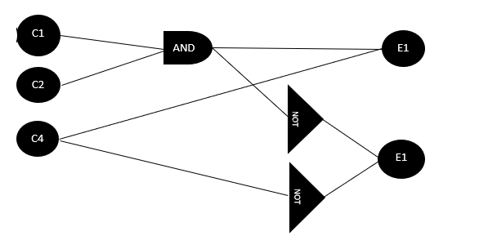

### Decision Table

|  |  |  |  |  |  |
| --- | --- | --- | --- | --- | --- |
| **Action** | **T1** | **T2** | **T3** | **T4** | **T5** |
| **C1** | 0 | 1 | 0 | 1 | 1 |
| **C2** | 0 | 0 | 1 | 1 | 1 |
| **C3** | No value | No value | No value | 0 | 1 |
| **E1** | 0 | 0 | 0 | 0 | 1 |
| **E2** | 1 | 1 | 1 | 1 | 0 |

### Test Cases

|  |  |  |  |
| --- | --- | --- | --- |
| **Test cases** | **Input (Causes)** | | **Expected Output (Effects)** |
| **Matches** | **CS** |
| **T1** | 0 | 0 | Invalid |
| **T2** | 4 | 0 | Invalid |
| **T3** | 0 | 4 | Invalid |
| **T4** | 3 | 5 | Invalid |
| **T5** | 5 | 3 | result displayed |