PRACTICAL NO. 1
Aim: Import the legacy data from different sources such as ( Excel , SqlServer, Oracle etc.) and load in the target system. ( You can download sample database such as Adventureworks, Northwind, foodmart etc.)
Step 1: Open Power BI
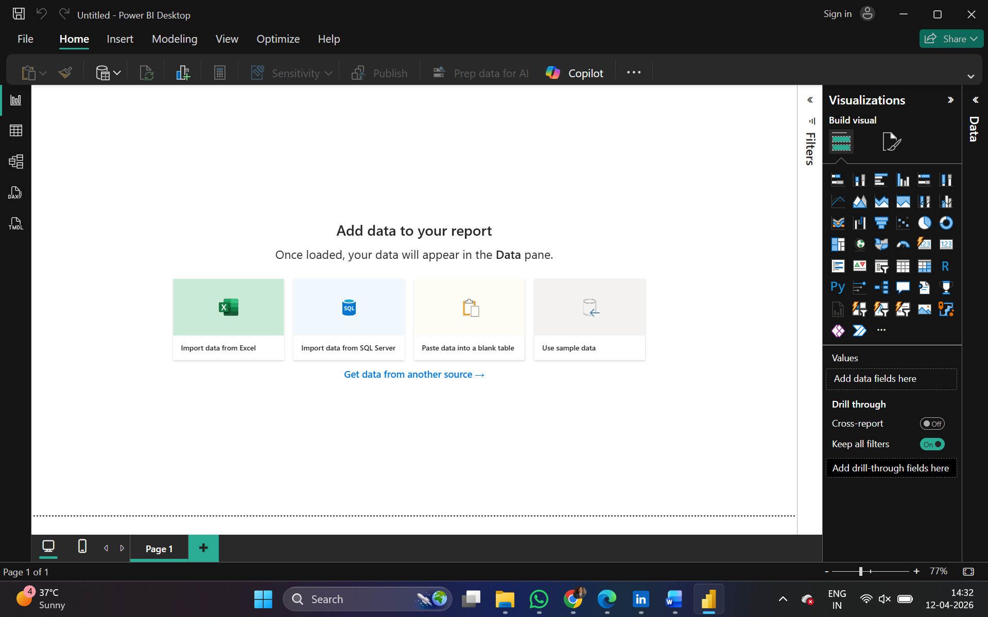
Step 2: Click on Get data following list will be displayed → select Excel
Data can also be imported from SQL Server and Oracle databases using the Get Data option in Power BI.
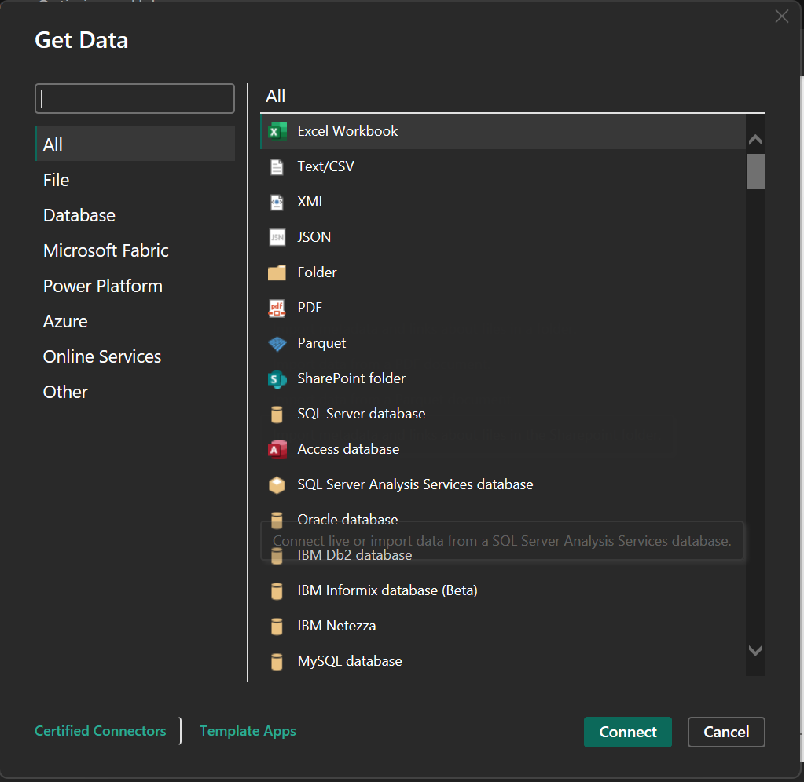

Step 3: Select required file and click on Open, Navigator screen appears

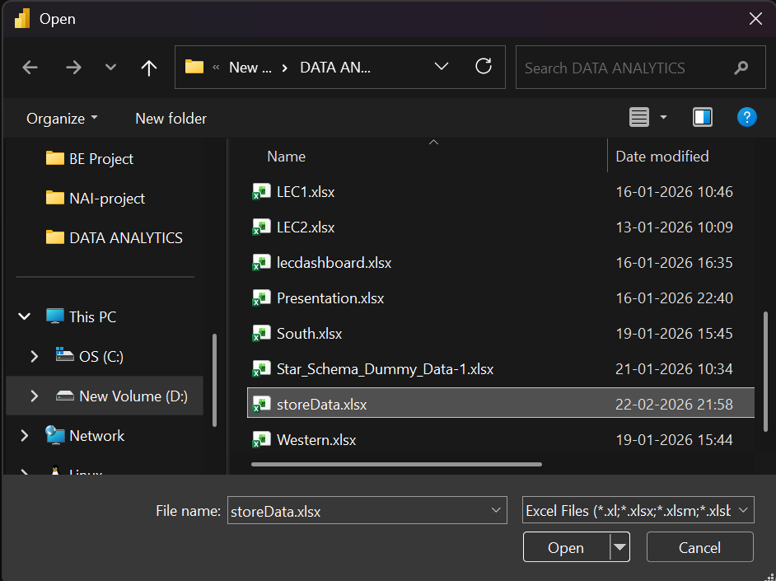.
Step 4: Select file and click on transform data

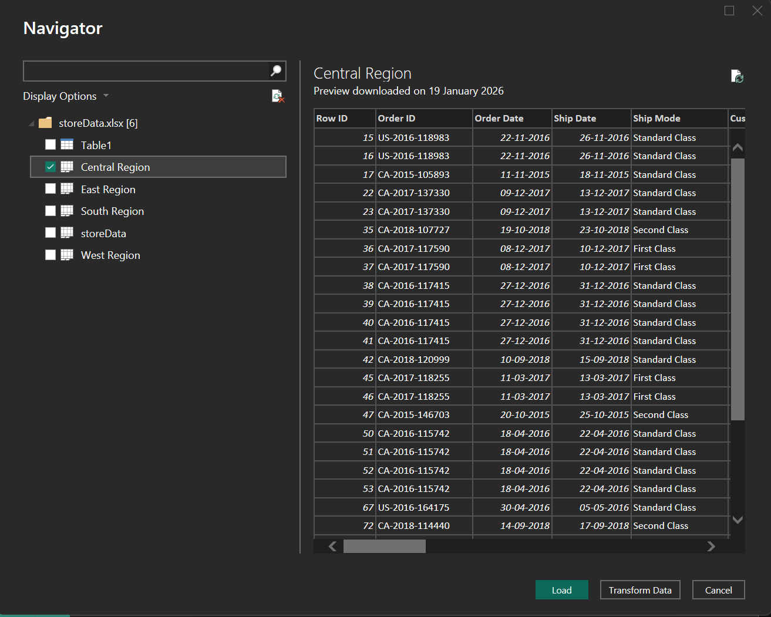

Step 5: Power query editor appears
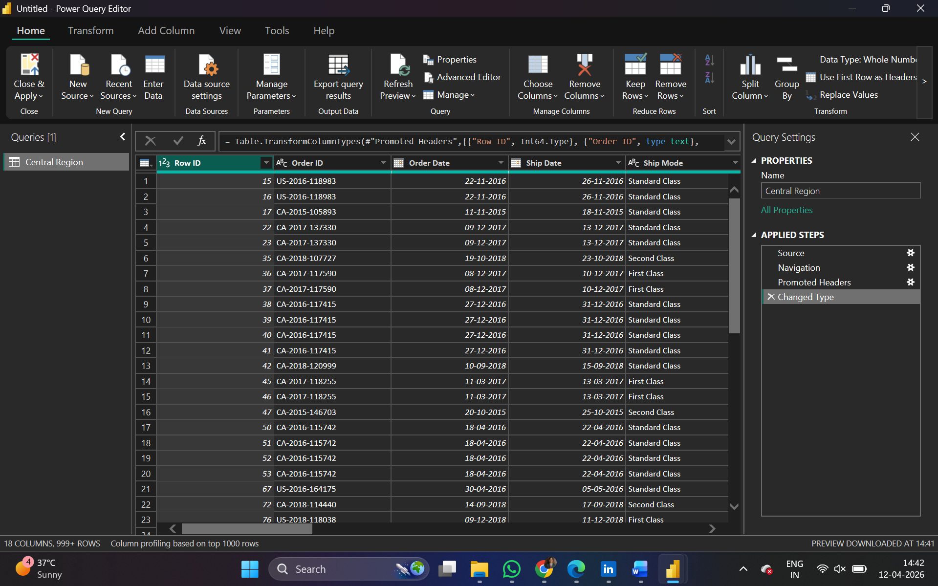

Step 6: Again, go to Get Data and select OData feed
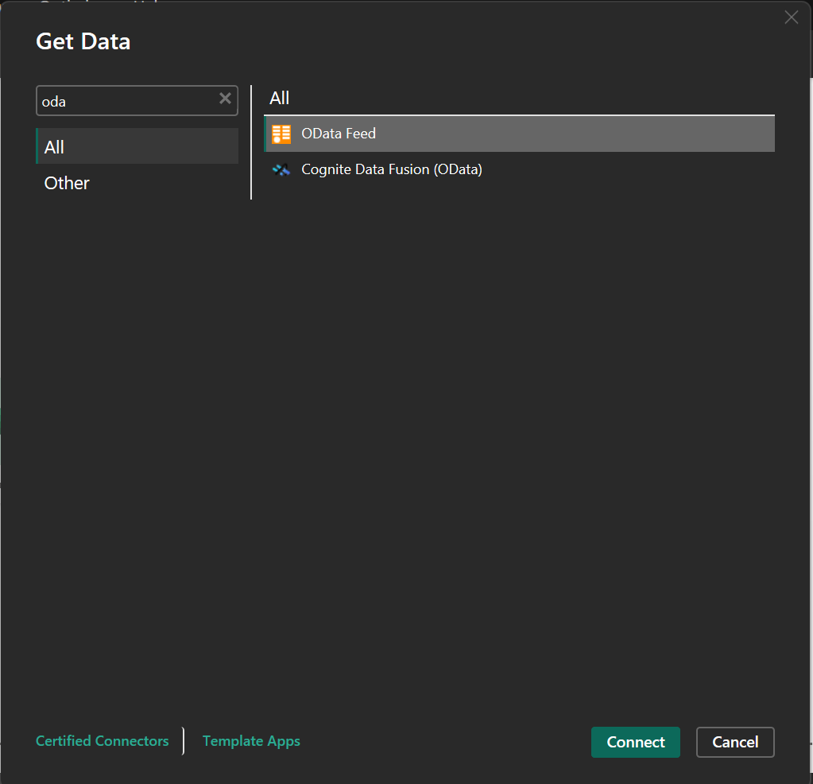
Step 7:
Paste url as http://services.odata.org/V3/Northwind/Northwind.svc/ Click on ok
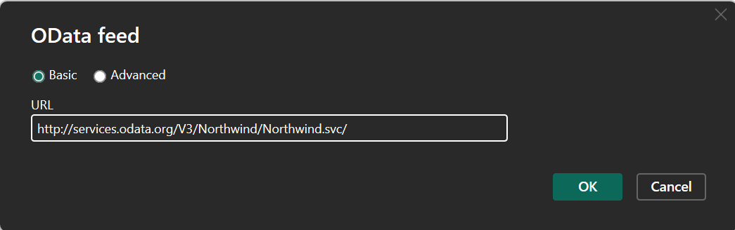

Step 8: Select orders table
And click on edit
Note: If you just want to see preview you can just click on table name without clicking on checkbox
Click on transform to view table
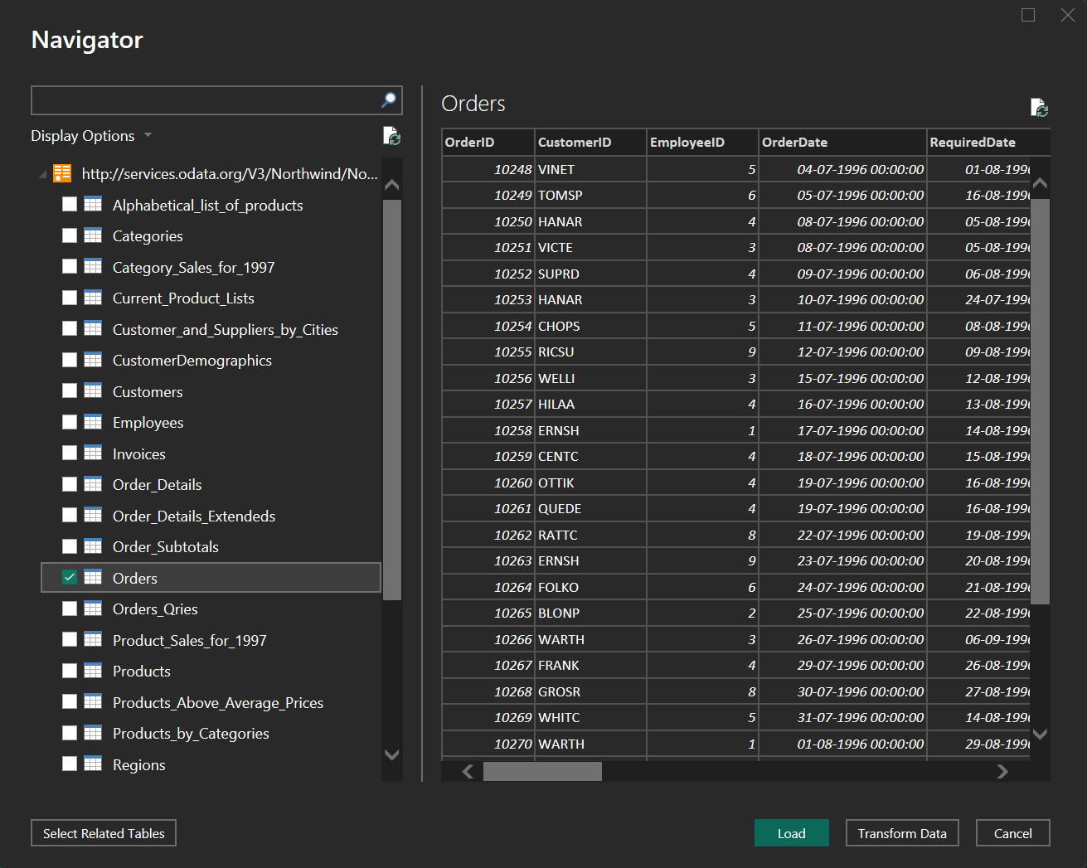
Step 9: Click on Close & Apply to load the data into Power BI.
The Orders table from Northwind OData source is successfully loaded and displayed.

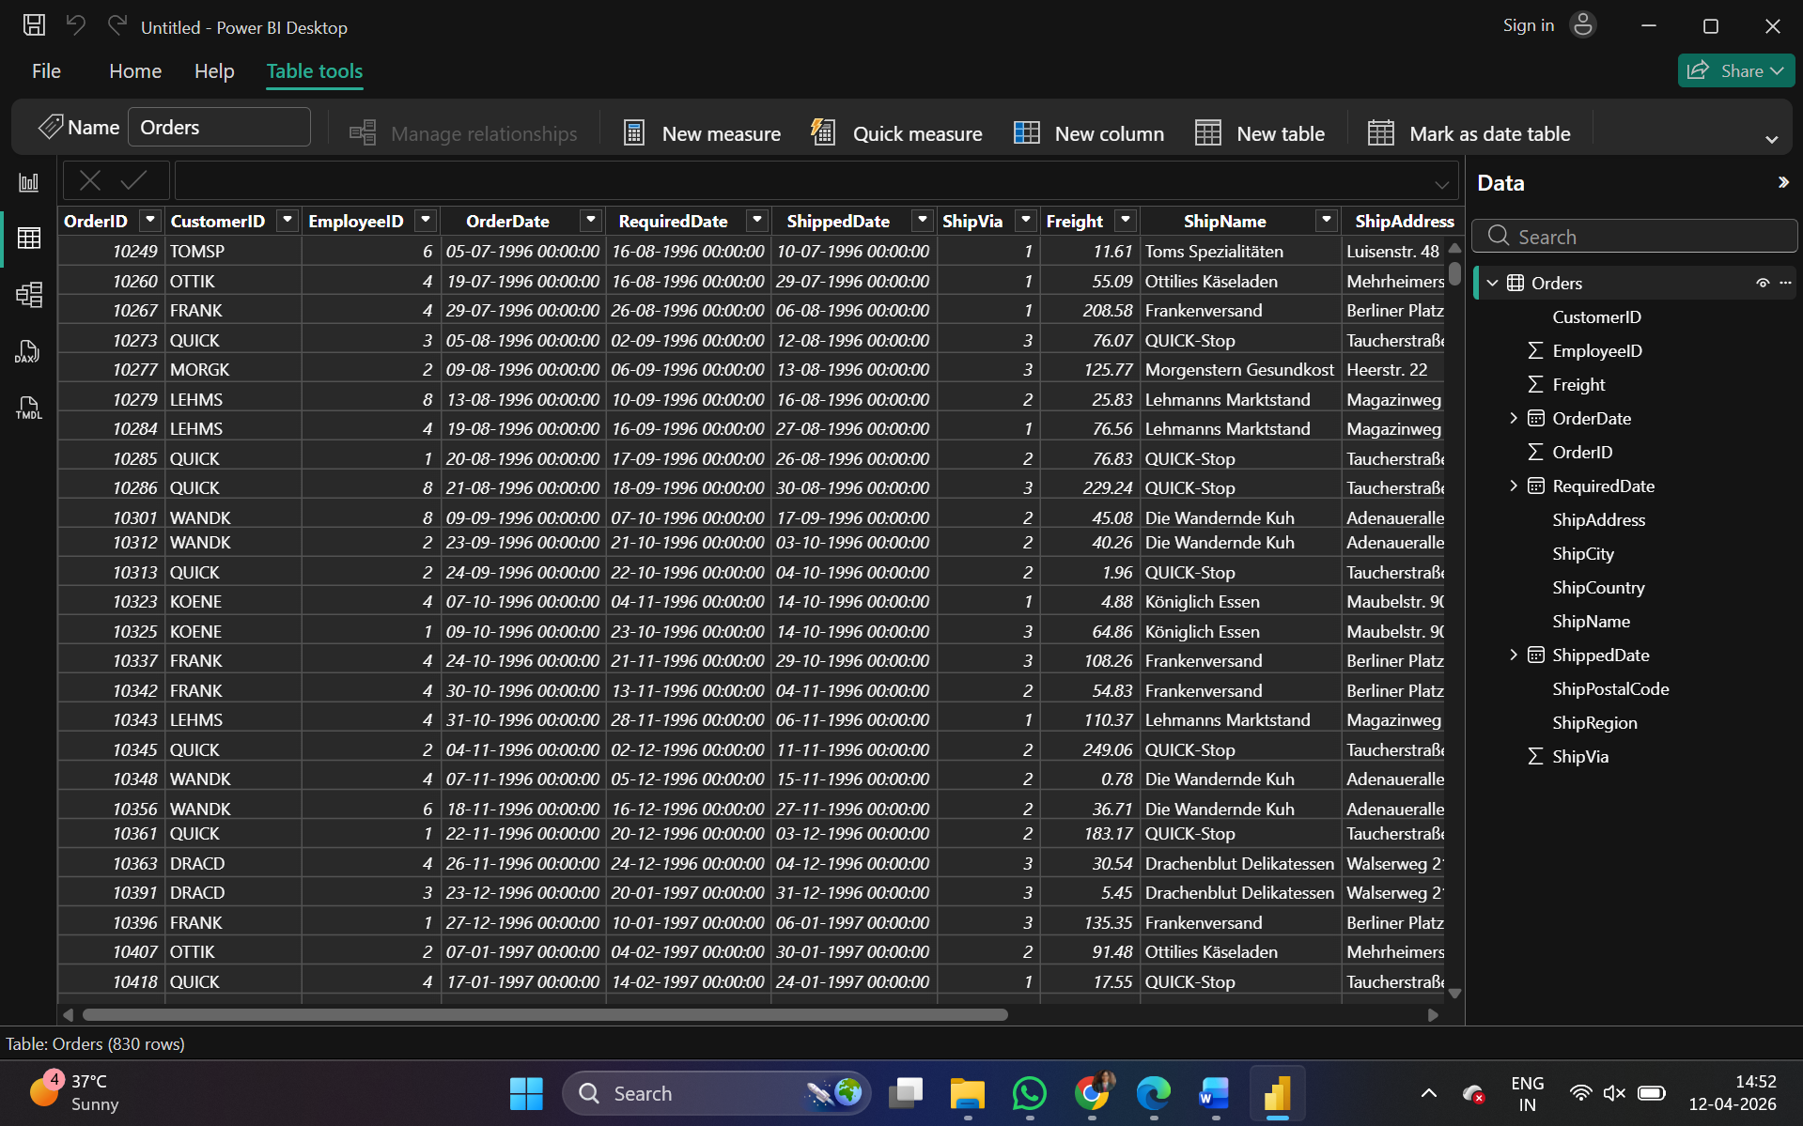
Result:
The legacy data from Excel and OData (Northwind Orders table) is successfully imported and loaded into Power BI.

