PRACTICAL NO. 2
Aim: To perform Extraction, Transformation and Loading (ETL) process using SQL Server.
Theory:
ETL stands for Extraction, Transformation and Loading.
- Extraction: Data is collected from different sources such as files or databases.
- Transformation: Data is cleaned, modified, or processed into a suitable format.
- Loading: The processed data is stored into a target database.
In this practical, SQL Server is used to perform ETL operations.
Step 1: Installation of SQL Server
SQL Server 2022 Express Edition was installed successfully.
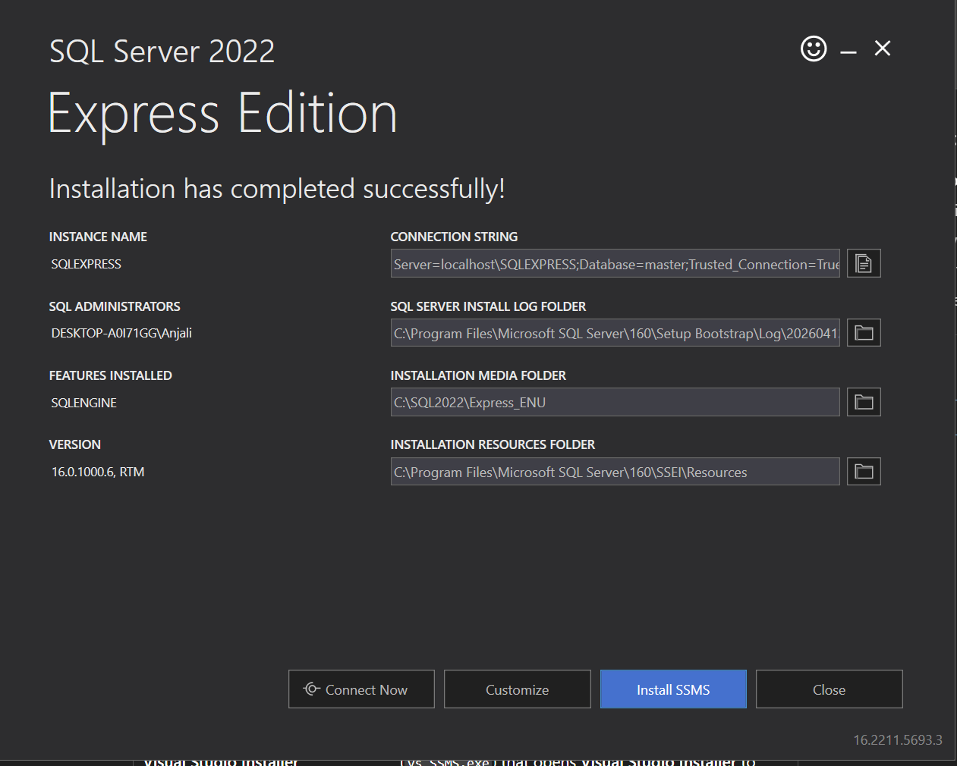
Step 2: Installation of SSMS
SQL Server Management Studio (SSMS) was installed to manage and interact with the database.
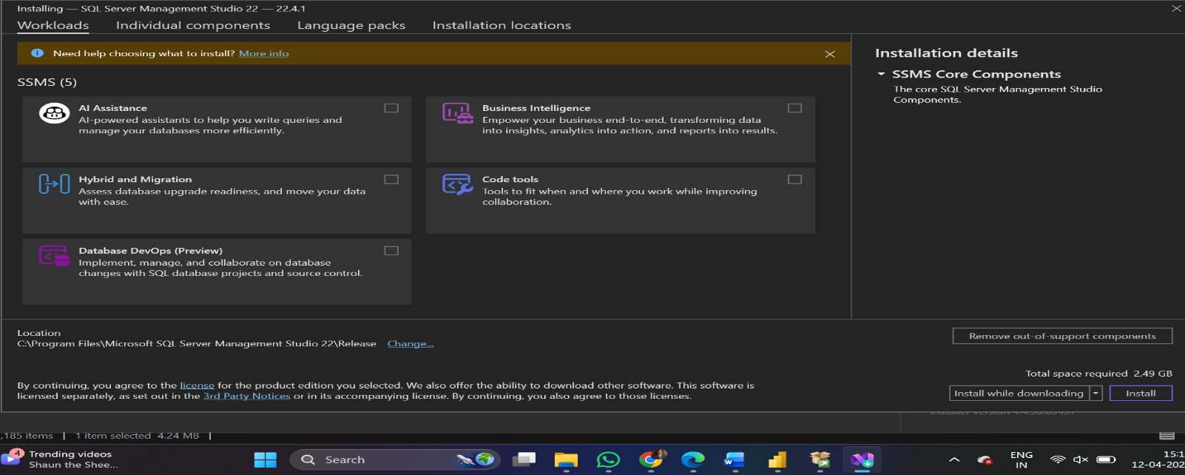
Step 3: Connecting to SQL Server
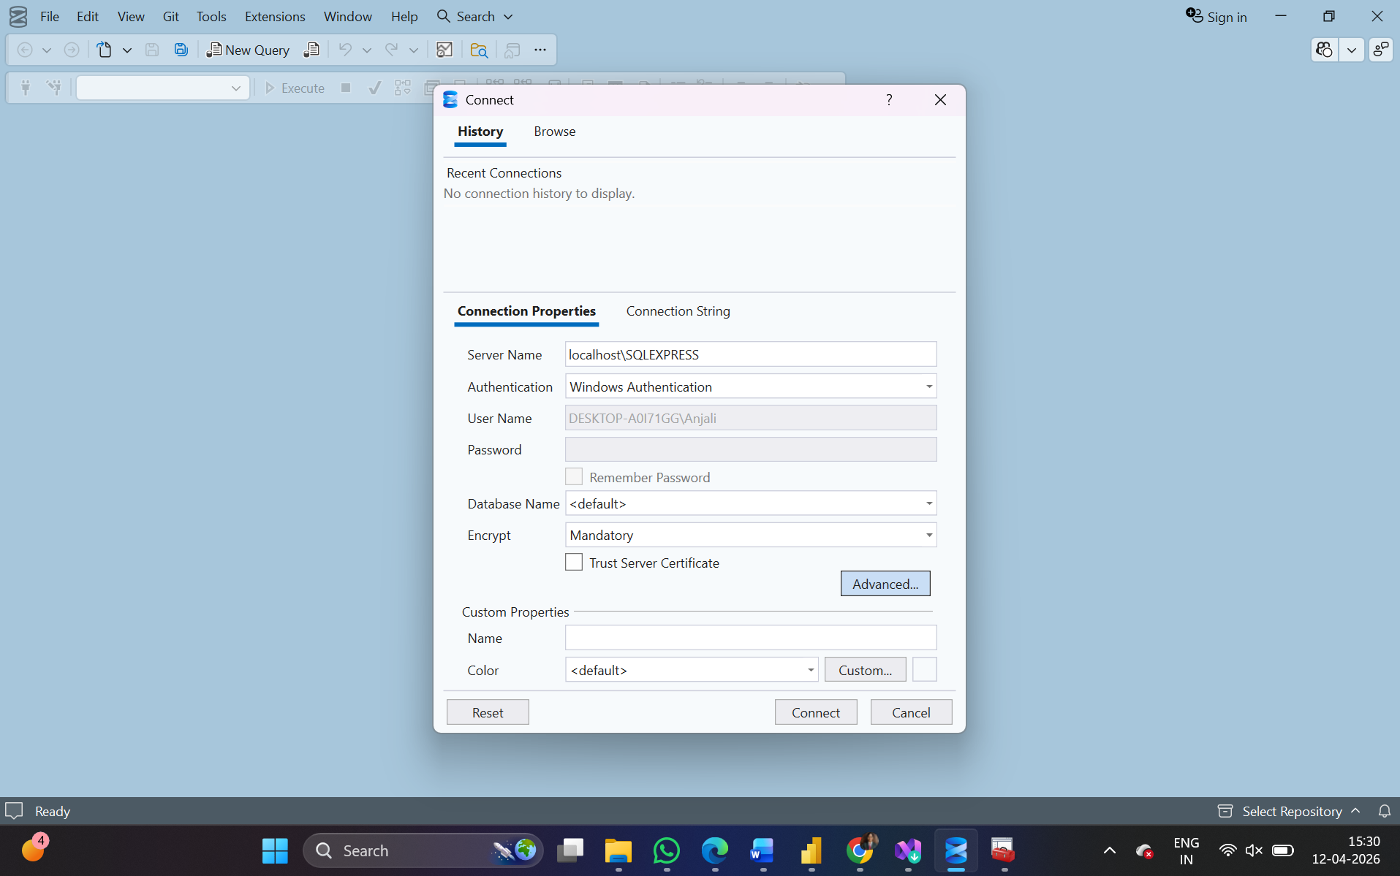
Step 4: Creating Database
A database named BI_Practical was created using SQL query.
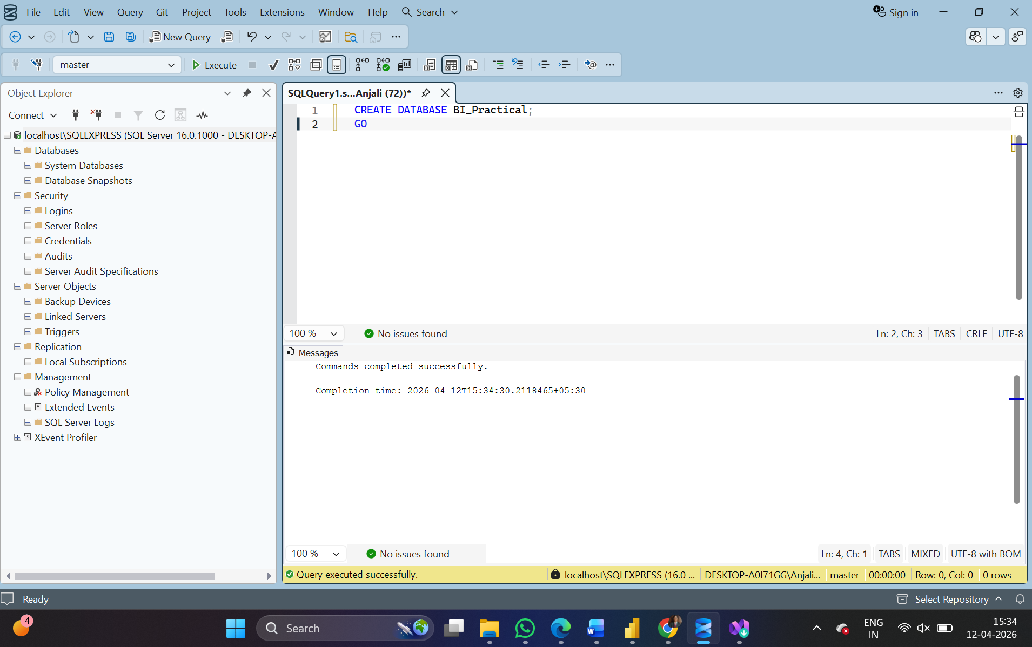
Step 5: Creating Table
A table named StudentData was created in the database.
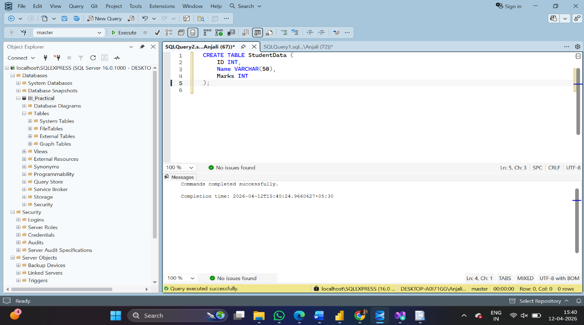
Step 6, 7, 8: Data Loading, Transformation and Output
Data was inserted into the table using INSERT query.
Transformation was performed by increasing marks by 10%.
Finally, the data was retrieved using SELECT query.
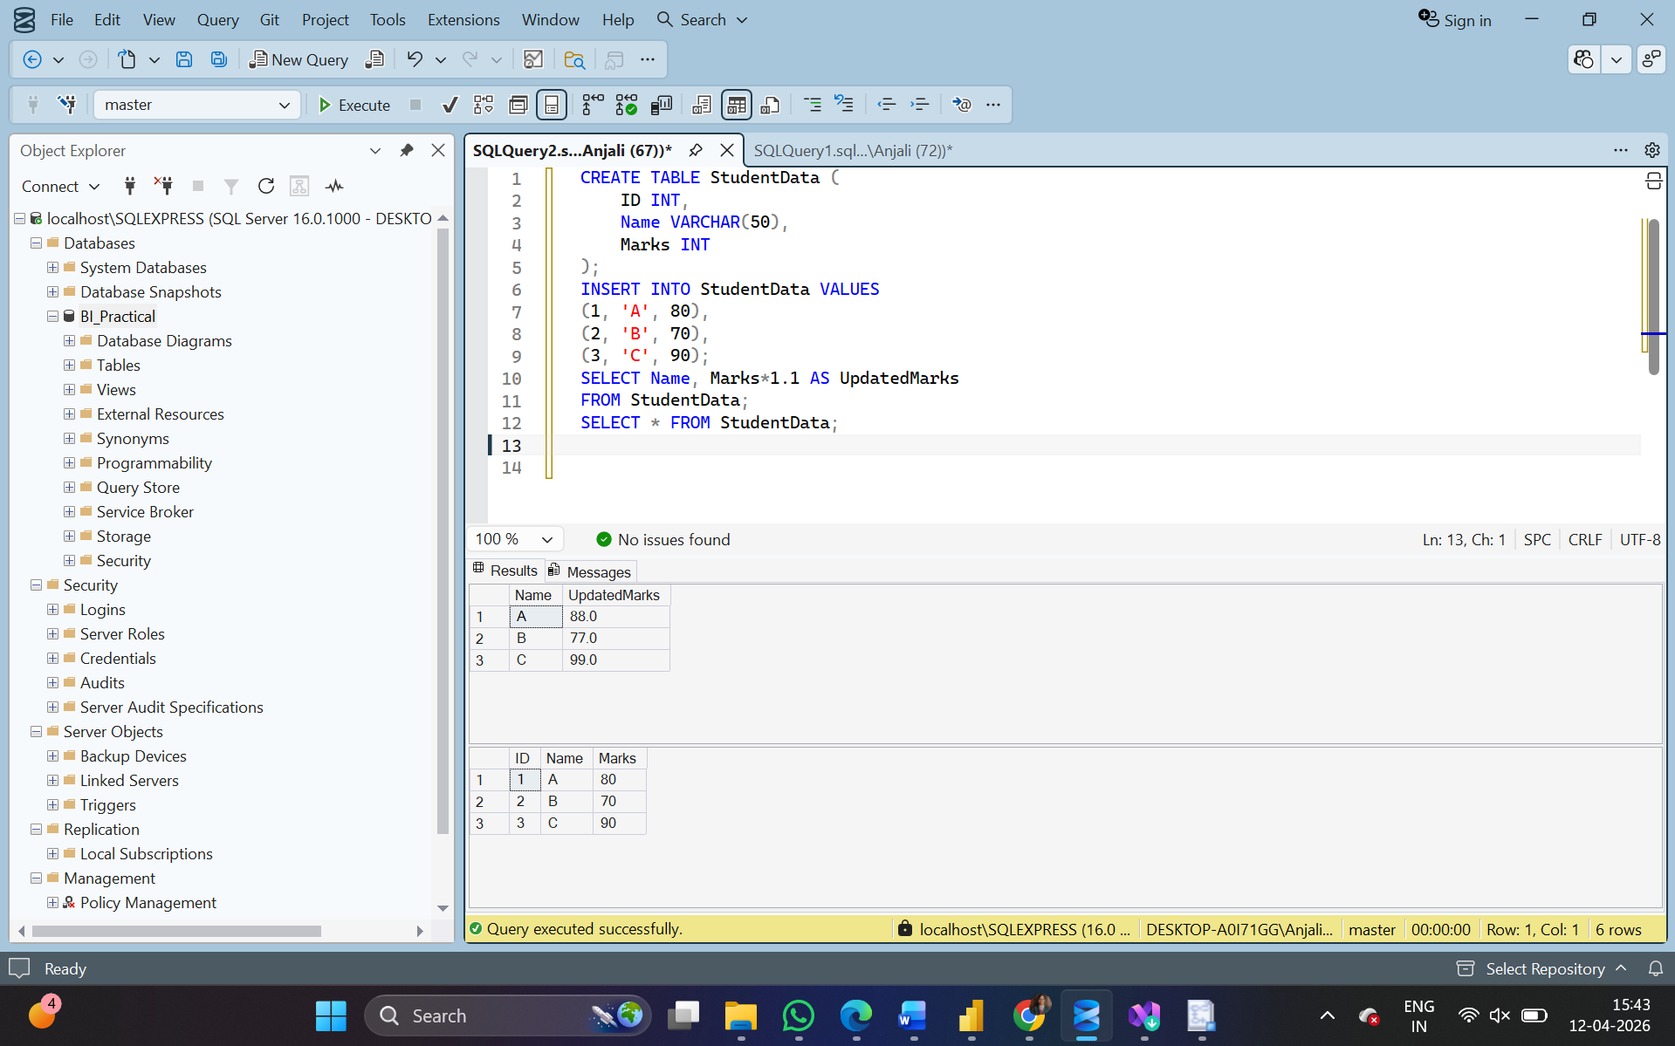
Result:
The ETL process was successfully performed using SQL Server. Data was extracted, transformed, and loaded into the database.

