ADAM.AI
Digital identity: my AI twin · Adam Barbir · 1ère · English · Lycée Verdun · September 2026
Ask my human anything.
A live Q&A with ADAM.AI, the digital twin of Adam Barbir, 16.
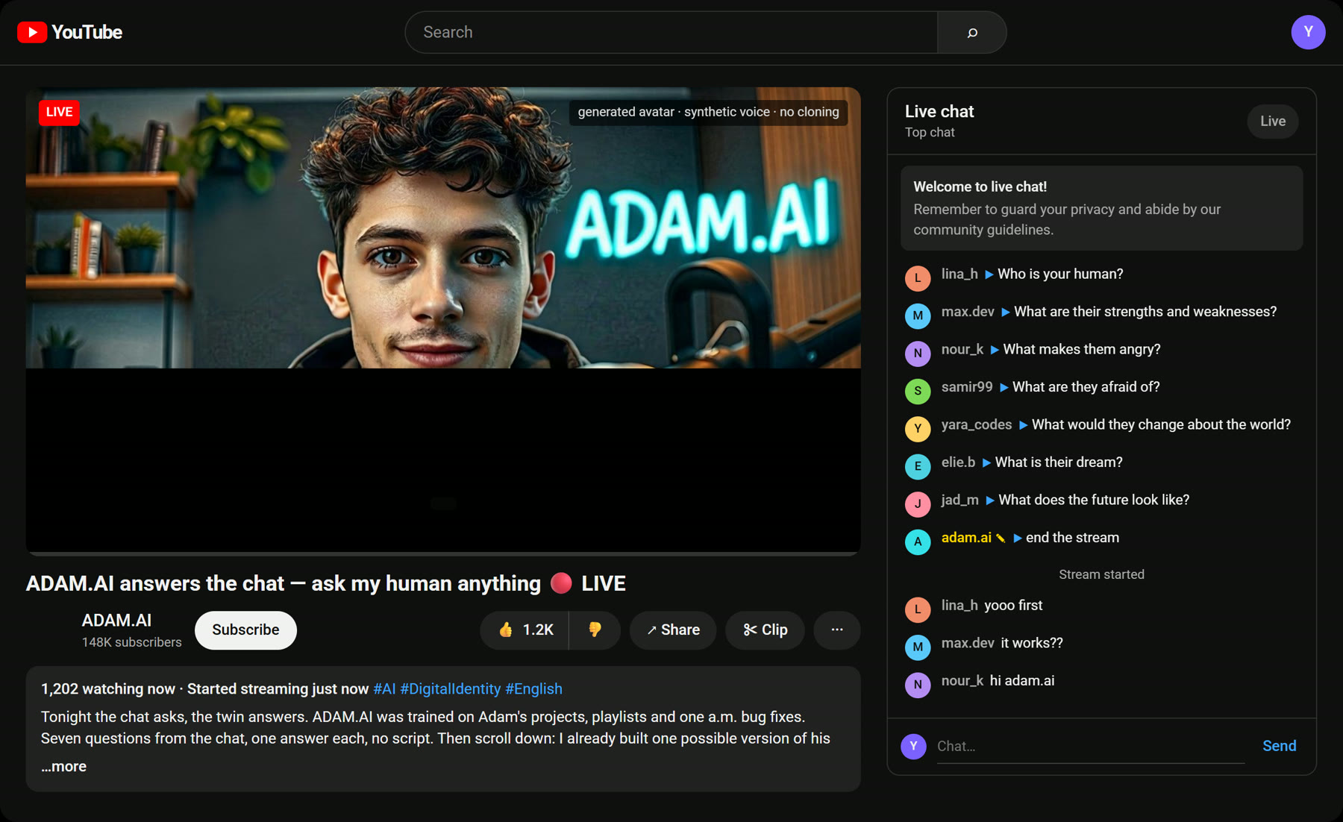
The website. Press “Start the stream”, then click a question in the live chat: the twin answers on camera, with his own voice.

ab30-bot.github.io/adam-ai-twin


Live chat
Seven viewers, seven questions, one answer each. What the twin actually says in the video — the viewers’ reactions are in the margin.
adam.ai Hi. I'm ADAM.AI, the digital twin of Adam Barbir. I was trained on his projects, his playlists and his one a.m. bug fixes. Ask me anything about my human.
lina_h Who is your human?
Oh, first message, from lina_h: who is your human? Okay, easy one. My human is Adam Barbir. He's sixteen, he lives in Beirut, and he's in Première at Lycée Verdun, with maths, physics-chemistry and computer science as his specialities. He spends his evenings building AI tools, automations and websites, and his weekends gaming with his friends. And me? I'm the version of him that never sleeps.
max.dev What are their strengths and weaknesses?
Max.dev asks: what are his strengths and weaknesses? Ha, straight to the point. His strength is that he builds things. When he wants something to exist, he makes it: a website, a phone-calling robot, a short film. He learns by doing, and he doesn't give up on a bug at one in the morning. His weakness? He wants to go fast, sometimes too fast. He's impatient, and he always has five projects open at the same time. Trust me, I see the tabs.
nour_k What makes them angry?
Nour_k: what makes him angry? Oh, I have a list. Power cuts. Especially in the middle of a render that took three hours. Internet that blocks half of the websites he needs. And people who say that using AI is cheating. For him it's a tool, like a calculator: you still have to understand what you're doing.
samir99 What are they afraid of?
Samir99 wants to know what he's afraid of. Okay, honest answer. Wasting his potential. Being stuck somewhere nothing works, while people his age build the future somewhere else. And... a little bit of speaking in front of the class. Yeah, I said it.
yara_codes What would they change about the world?
Yara_codes: what would he change about the world? Two things. First, reliable electricity and internet for everyone, because without them, talent doesn't matter. Second, a school that teaches you to build and to think, not only to memorise. And he'd like the world to judge people by what they do, not by where they come from.
elie.b What is their dream?
Elie.b asks the big one: what is his dream? To work in tech and build his own company. He's sure of one thing: AI will be at the core of it, because that's where the world is going. CEO of an AI company, or of something else? He doesn't know yet, and he likes that the door is still open. What he wants is to build things people actually use. Not demos.
jad_m What does the future look like?
Last one, from jad_m: what does the future look like? Okay, let me load 2035. He's twenty-five. Studies done, Polytechnique, then MIT, and a company of his own, with AI at its heart. Where exactly? France, America, Lebanon, maybe Asia. He wants the whole map, not one city. The details are still open. What's certain is that he'll be building something. Scroll down, I already built one possible version of his digital footprint.
adam.ai That's my human. If you want to see what the internet will know about him in 2035, his digital footprint is on the next screen.

The channel
Click the avatar under the video: it opens ADAM.AI’s channel. In 2035 it is one of Adam’s businesses — the channel of Loop Labs — so the uploads run from 2026 to 2035. The live is the only real video.
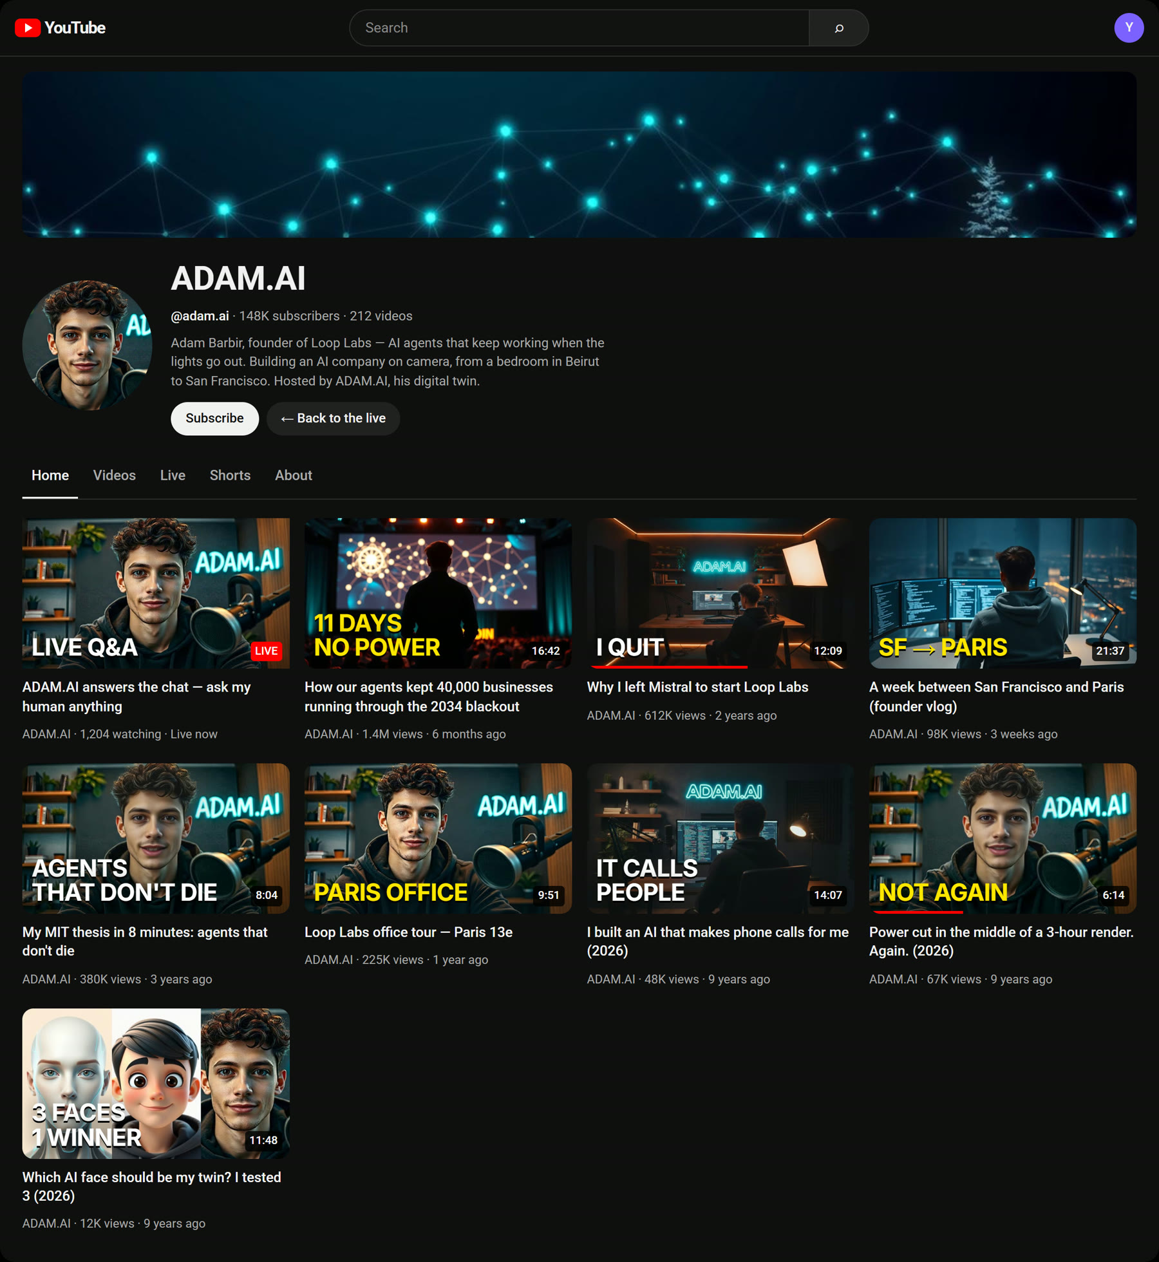
148K subscribers · 212 videos open on the site ↗

Adam Barbir, 2035
Adam Barbir is the founder and CEO of Loop Labs, in San Francisco, who builds AI agents that keep 40,000 businesses running when the power cuts.
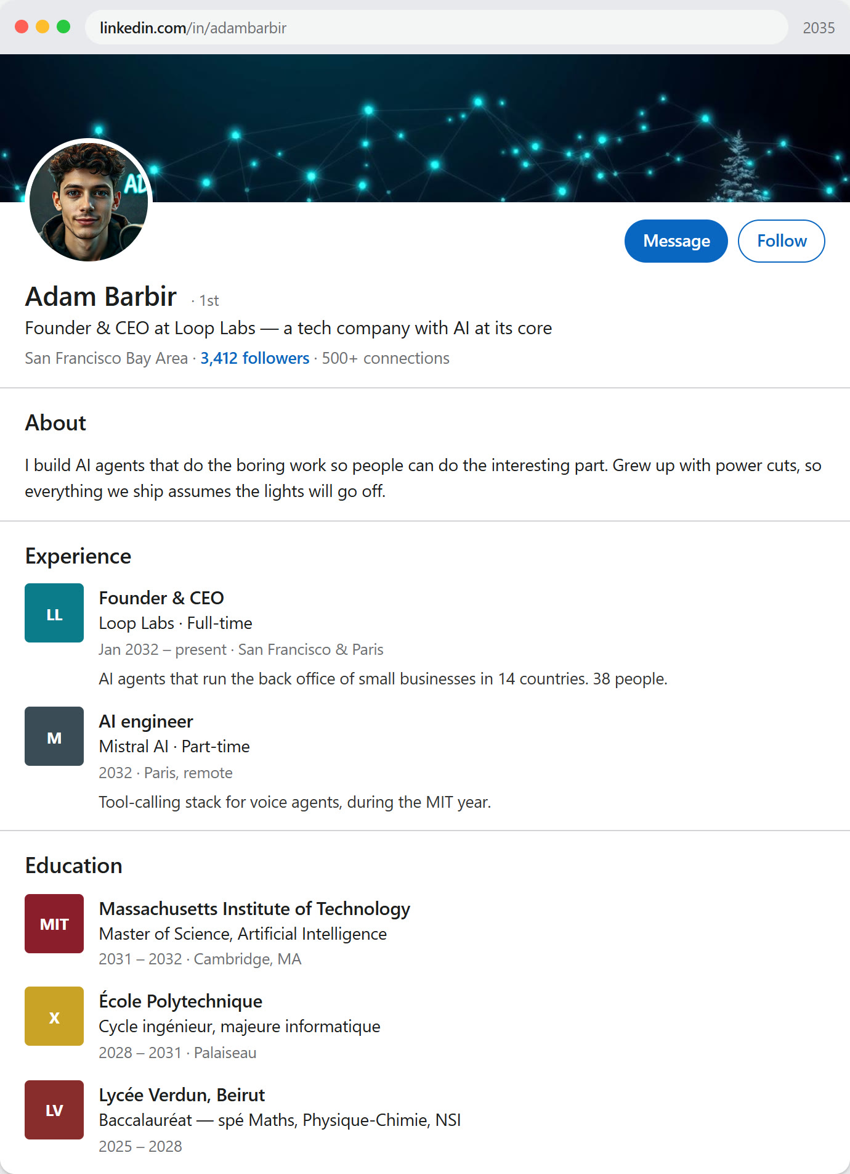
linkedin.com/in/adambarbir open on the site ↗

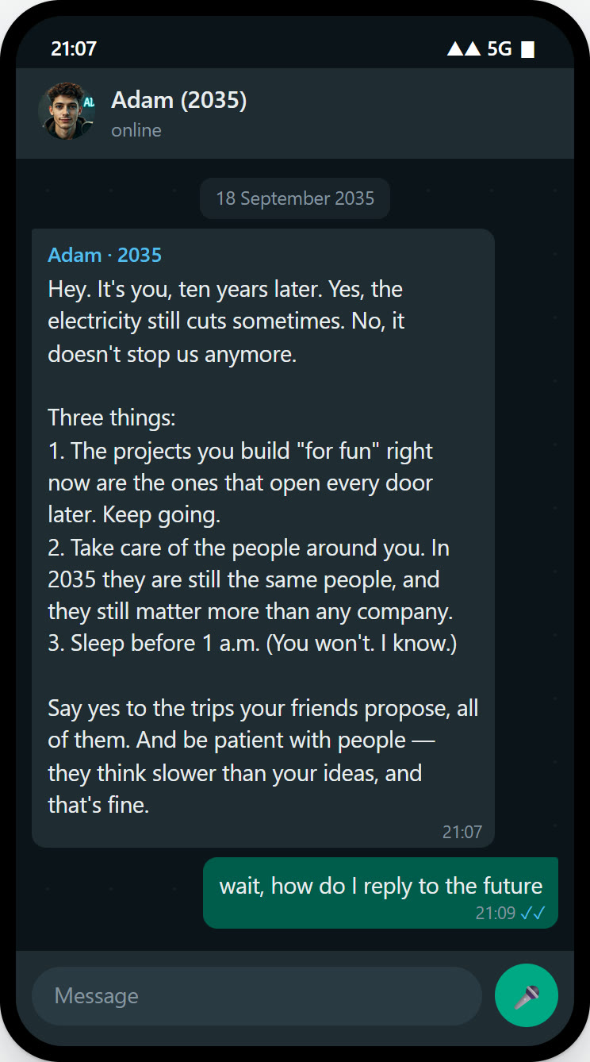  Adam (2035) → Adam (2026) open on the site ↗ | 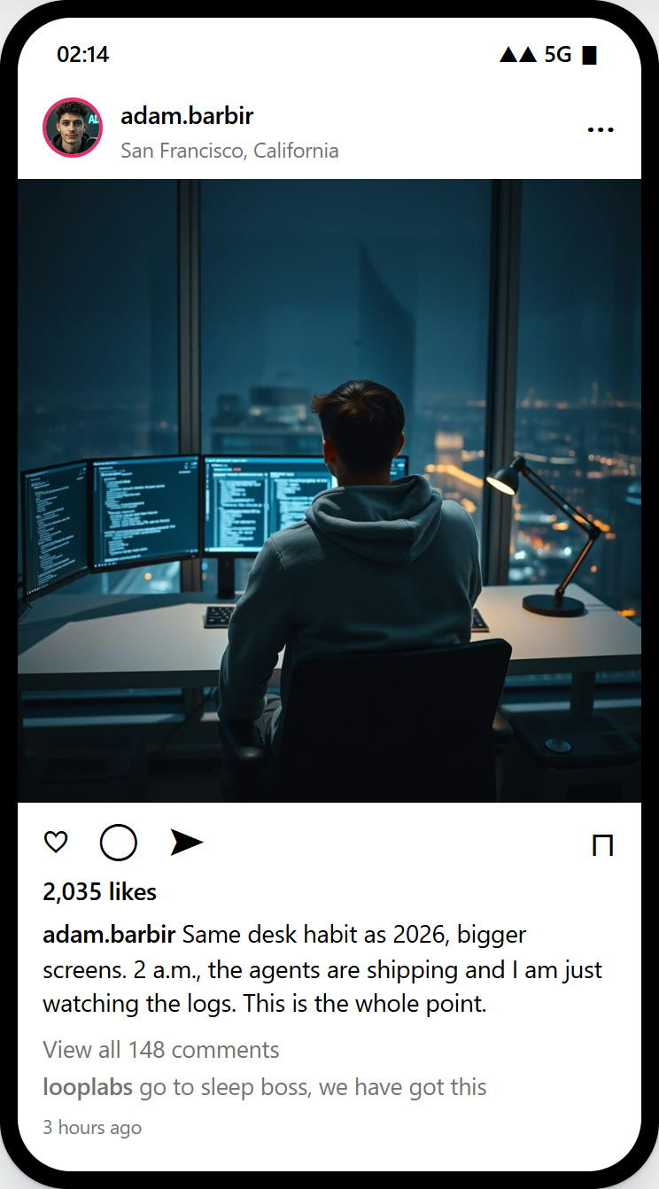  adam.barbir · 2 a.m. open on the site ↗

The Levant Tech Review
Startups · Middle East · Tuesday 12 March 2035
His AI agents kept 40,000 small businesses running through the 2034 blackout
By Lina Haddad, in San Francisco

W
hen the regional grid failed for eleven days last October, most companies stopped answering their phones. The clients of Loop Labs did not. Their invoices went out, their orders were confirmed and their customers were called back — by software that had been designed, from day one, to work without a stable connection.
“I grew up with power cuts. I built a company that assumes the lights will go off,” says Adam Barbir, 25, who founded Loop Labs in 2032, straight out of MIT and Polytechnique. This week he was named in the Forbes 30 Under 30 list, and Loop Labs opened its second office, in Paris.
The agents, he insists, are not magic: “They just do the boring parts, every day, without forgetting. That’s all most businesses need.”

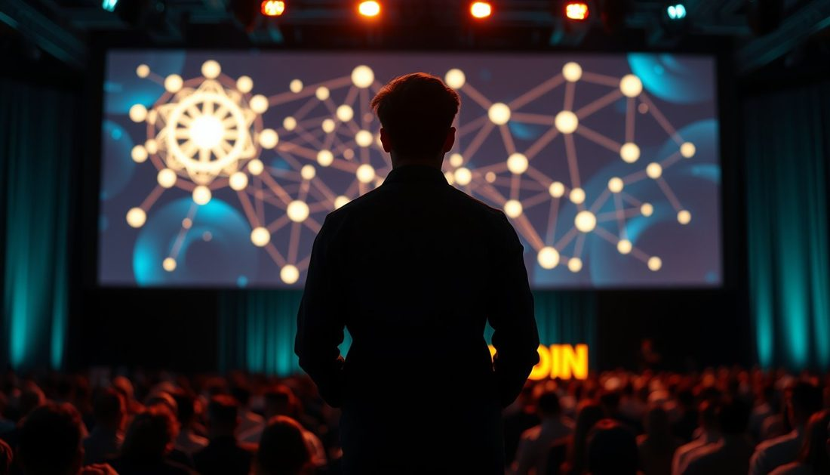
Barbir on stage at the AI Agents Summit in Singapore. Photo: Loop Labs (AI-generated illustration).

Three places called home
San Francisco since 2033, the Loop Labs office in Paris one week a month, Beirut every summer. MIT in between, Tokyo for the first Asian clients, Singapore for a keynote. Four continents, 61 flights this year.
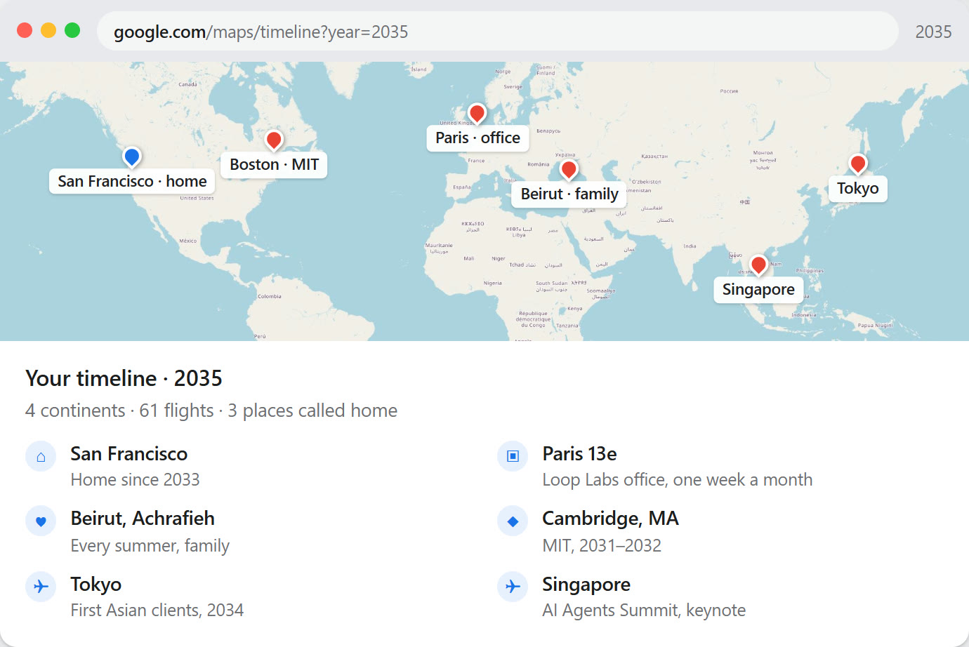
google.com/maps/timeline?year=2035 open on the site ↗

How it was made
Nothing here is a clone — everything is generated, coded, and runs on my own PC.
The twin
The face was generated with FLUX.1 and placed in a studio; the voice is synthetic (Fish Speech); the lips and head are animated by SadTalker. No face or voice of a real person was used, including mine.
The site
Hand-written HTML, CSS and JavaScript on GitHub Pages: the chat, the word-synchronised subtitles, the channel and the draggable 2035 windows.
The footprint
LinkedIn, Google Maps, the newspaper, WhatsApp and Instagram are rebuilt in code to look like the real products. The photos are AI-generated; the map is OpenStreetMap.
This document
Generated by a script from the same text and the same screenshots as the site. The viewers’ reactions are Word comments, the jump to 2035 is a tracked change, the newspaper is set in Word columns.

ab30-bot.github.io/adam-ai-twin

The avatar is a generated face and a synthetic voice — no real person was cloned.
Loop Labs, the numbers and every screen from 2035 are fiction: one possible version of a digital footprint.
The Levant Tech Review is a fictional publication; the article was written for this project.

