{Angry Birds Sprite DAT Files Edition Guide}

What.Dat files do in Angry Birds?
.Dat files are used to seperate the ingame spritesheets into
single sprites. The spritesheet dats were originally made using the KA3D engine but we can’t really use this to our advantage since there is almost no information about the programm.

So how do we edit these dat files?
Well first of all you’re gonna need a hex editor preferably HxD.

Copy any dat file or if you would like to add something to a dat file then feel free to do it cause you can also do that.
Now when you will first open your HxD
you will probaly see this
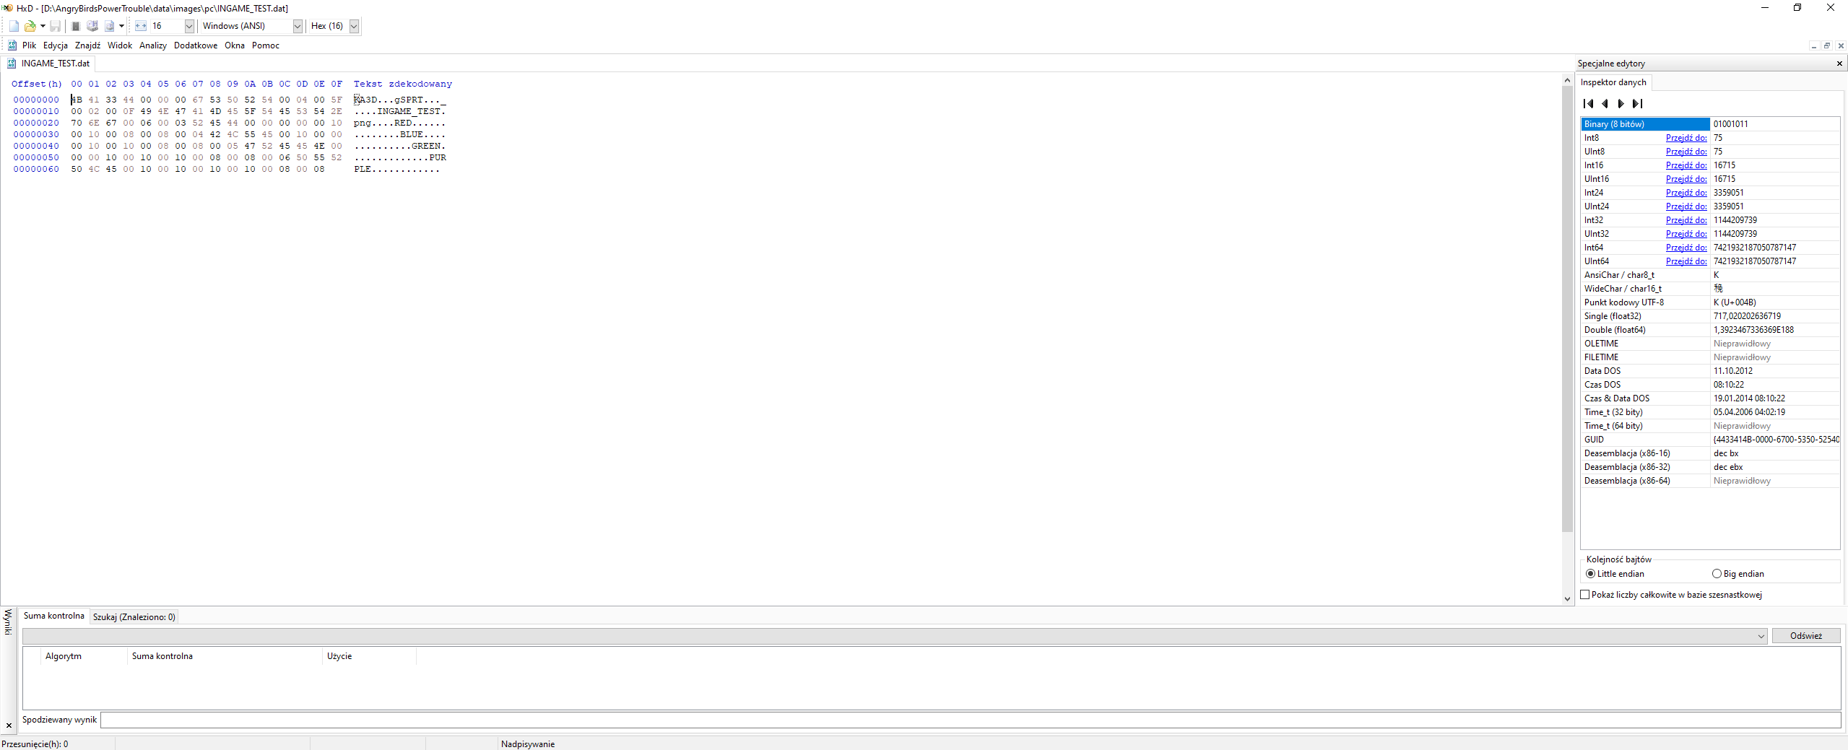
All im going to say is don’t worry i will explain all of this in a second.
Go to data inspector (the window on the right) and toggle on big endian. This way you can read the values
lets explain everything
the 1st 4 bytes say KA3D that happens to be the header
next 2 bytes are empty but the next 2 are the number of bytes -8 we will touch this when we finish then next 4 bytes say SPRT we don’t really care bout that
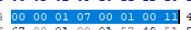
This string
(1st 2 bytes) 00 00 dunno dont change
(2nd 2 bytes) 01 07 number of bytes in the file -16
(3rd 2 bytes) 00 01 minimum number of sprites
(4th 2 bytes) 00 11 name length of spritesheet name (for this dat its INGAME_WIZPIG.png)
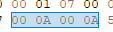
the 1st 00 0A is max number of sprites in the spritesheet
the next 2 bytes are going to be explained along with more strings (the 00 0A is used in the 00 06 context here)
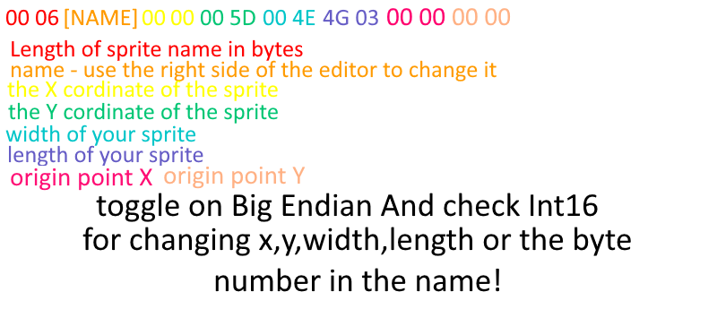
if you want more sprites just repeat the formula till you have all the sprites you want.

Hope this helped. :>

Keymil Animations

