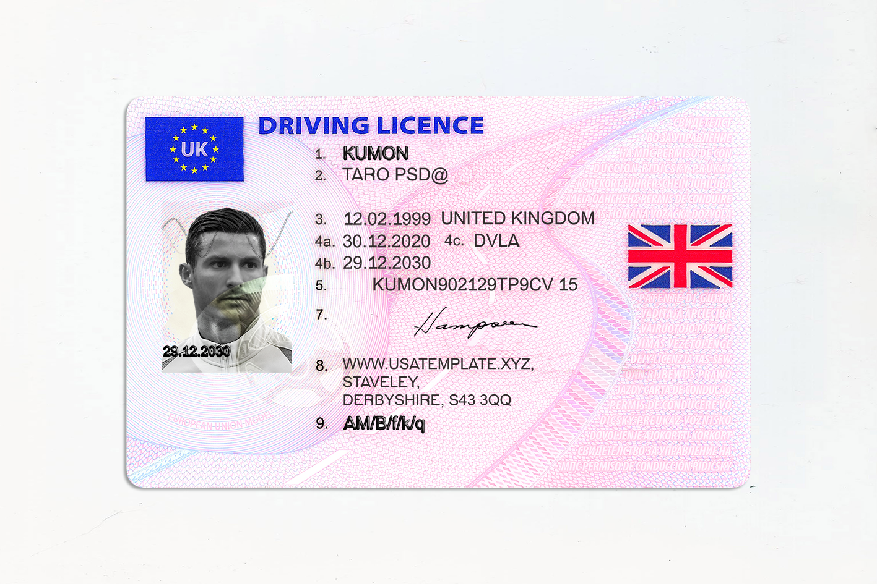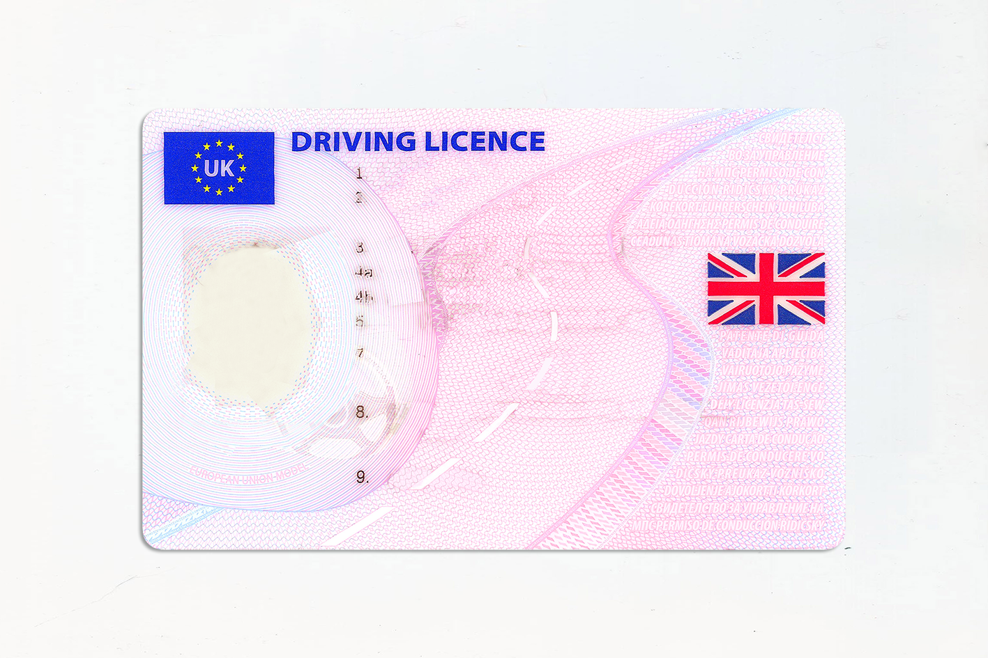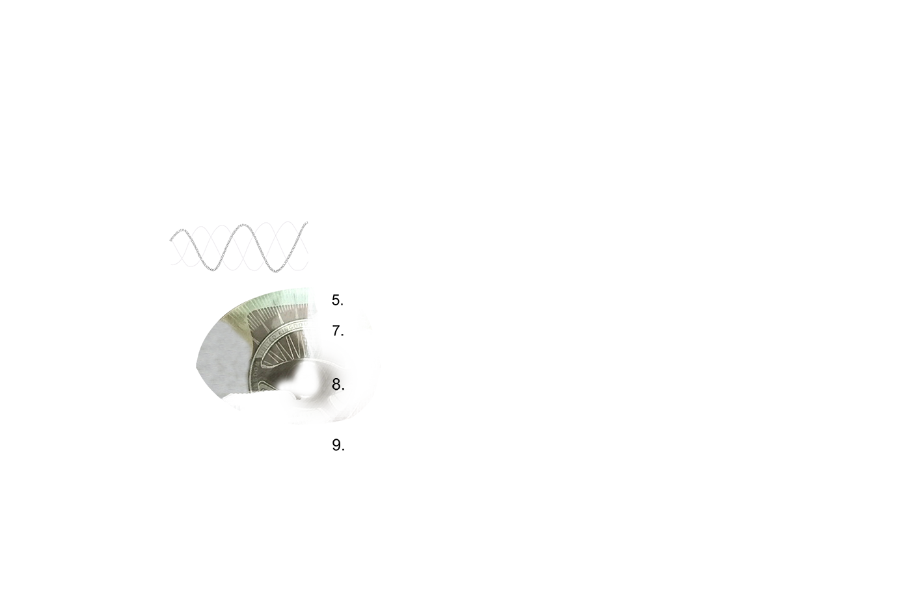



AUTHORITY

POB

DOI

DOE

NUMBER

NUMBER2

ADDRES2

ADDRESS

GIWENNAME

SURNAME

DOB