SMART IRRIGATION SYSTEM

|  |  |  |  |  |  |
| --- | --- | --- | --- | --- | --- |
| **Atharva Bedekar** | **Satvik Yadav** | **Rai Aseem Vijay** |  |  |  |
| **241000021** | **221000051** | **221000044** |  |  |  |
| [bedekar24100@iiitnr.edu.in](mailto:bedekar24100@iiitnr.edu.in) | [satvik22100@iiitnr.edu.in](mailto:satvik22100@iiitnr.edu.in) | [rai22100@iiitnr.edu.in](mailto:rai22100@iiitnr.edu.in) |  |  |  |

**Abstract -** This report presents the design and development of a smart wheelchair that integrates advanced control mechanisms to improve accessibility, safety, and user experience. The system leverages an Android-based Bluetooth app, touch interface, speech recognition, and gesture controls to offer versatile and user-friendly operation. The integration of these technologies addresses the diverse needs of users with varying levels of physical abilities. The system also incorporates safety features such as obstacle detection to prevent collisions, ensuring secure mobility in various environments. This project demonstrates the feasibility of using modern technologies to enhance mobility aids for individuals with disabilities.

# I. INTRODUCTION

Mobility is a fundamental aspect of human life, but for individuals with physical impairments, achieving independent mobility can be challenging. Traditional wheelchairs often rely on manual operation or basic joystick controls, which may not cater to users with complex needs. The goal of this project is to develop a **Smart Wheelchair** that offers multiple control options, ensuring accessibility and usability for diverse user groups. By integrating technologies like Bluetooth, speech recognition, and gesture control, the wheelchair provides intuitive operation methods.

This paper presents the design, implementation, and evaluation of a smart irrigation system that utilizes

IoT technology. The proposed system aims to optimize water usage, improve crop yields, and contribute to sustainable agricultural practices. By combining Node MCU microcontrollers, wireless connectivity, and various sensors, the system provides an intelligent and automated approach to irrigation. Real-time data from soil moisture sensors, temperature sensors, and humidity sensors are collected and analyzed to determine the optimal watering schedule and amount of water required. This information is then communicated to the irrigation system, which adjusts the water flow accordingly.

Furthermore, the IoT connectivity of the system allows for remote monitoring and control. Users can access the system through a mobile application, providing convenience and

flexibility in managing irrigation settings from anywhere. The system also incorporates notifications and alerts, enabling users to receive timely updates on irrigation status, system performance, and potential issues such as low soil moisture levels

The effectiveness of the smart irrigation system is evaluated through extensive field tests, comparing it to traditional irrigation methods. Key performance indicators include water conservation, crop growth, and overall system reliability. The results demonstrate the system's ability to optimize water usage, maintain ideal soil moisture levels, and enhance crop yields while reducing resource waste.

## Soil moisture sensor

The soil moisture sensor is a vital component of the Arduino-based smart irrigation system, responsible for monitoring the moisture content in

the soil. It plays a crucial role in enabling eﬃcient water management by providing real-time data on soil moisture levels.

The soil moisture sensor is typically a probe or module that measures the volumetric water content or electrical conductivity of the soil. It utilizes two conductive electrodes to assess the moisture content. When the sensor is inserted into the soil, the electrodes come into contact with the soil particles, and the electrical resistance between them is measured. This resistance is directly related to the soil moisture level, as moisture increases conductivity and reduces resistance.

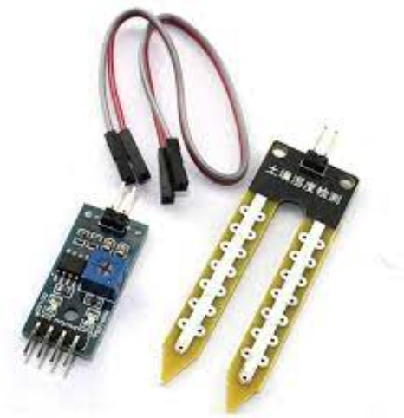

Fig 1 Soil moisture sensor

In the context of the Arduino-based smart irrigation system, the soil moisture sensor connects to the Arduino Uno's analog input pins. The sensor provides analog readings to the microcontroller,

which correspond to the soil moisture level at the probe's location in the soil.

The primary role of the soil moisture sensor in the smart irrigation system is to continuously monitor the moisture level in the soil. The analog readings obtained from the sensor serve as a crucial input for decision-making within the system. By comparing these readings against a predefined threshold value, which is set based on the desired soil moisture level for optimal plant growth, the system determines whether irrigation is required.

When the soil moisture reading falls below the threshold value, indicating that the soil is too dry, the Arduino Uno triggers the irrigation system to turn on the motor. The motor then activates the water supply, providing irrigation to the plants or specific zones. On the other hand, if the soil moisture reading is above or equal to the threshold value, the Arduino Uno instructs the system to turn oﬀ the motor, conserving water and preventing overwatering.

Additionally, the soil moisture readings can be communicated to an IoT platform or central server via the Arduino Uno's wireless communication module. This enables remote monitoring and control of the irrigation system through a mobile application or web interface. Users can access the real-time soil moisture data, set the desired threshold value, and receive notifications/alerts regarding irrigation activities.

## Node MCU ESP 32

The NodeMCU ESP32 is a popular development board that combines the capabilities of a microcontroller and Wi-Fi connectivity. It serves a crucial role in the Arduino-based

smart irrigation system, enabling IoT connectivity, data retrieval, and decision-making based on weather forecast information.

The NodeMCU ESP32 is based on the ESP32 microcontroller, which integrates a dual-core processor and a Wi-Fi module. This board provides a compact and efficient platform for connecting the irrigation system to the internet and accessing weather forecast data.

In the context of the smart irrigation system, the NodeMCU ESP32 board is responsible for two main functions:

IoT Connectivity: The NodeMCU ESP32 connects the Arduino-based smart irrigation system to the internet via Wi-Fi. This enables the system to retrieve weather forecast data for the location of the irrigation system. By establishing a connection to an IoT platform or a weather API, the NodeMCU ESP32 retrieves the forecast information, including temperature, humidity, and precipitation data, for the next few days.

Decision-Making based on Weather Forecast: Once the weather forecast data is obtained, the NodeMCU ESP32 facilitates decision-making within the smart irrigation system. The data retrieved from the internet is analyzed and compared with the predefined threshold values for

the system. For example, if the weather forecast indicates rain or high humidity in the coming days, the system may decide to delay or reduce irrigation to avoid overwatering. On the other hand, if the forecast suggests dry conditions, the system may increase the irrigation frequency or duration to ensure adequate moisture for the plants.

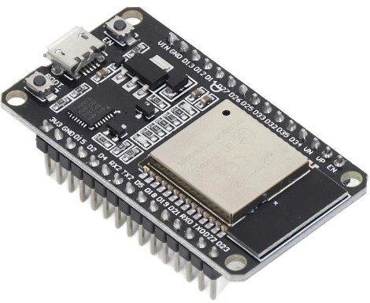

Fig 2 Node MCU

Additionally, the NodeMCU ESP32 enables synchronization of the irrigation system with real-time weather conditions. By periodically updating the weather forecast data, the system can dynamically adjust its watering schedule to respond to changing weather patterns. This helps optimize water usage, conserve resources, and ensure efficient irrigation practices.

The integration of the NodeMCU ESP32 with the Arduino Uno and the soil moisture sensor is crucial for achieving a holistic smart irrigation system. The NodeMCU ESP32 gathers the analog readings from the soil moisture sensor through the Arduino Uno, which indicates the soil moisture level. It combines this local sensor data with the retrieved weather forecast information to make informed decisions about irrigation scheduling and motor control.

## Relay module

The relay module is a crucial component in the Arduino-based smart irrigation system, serving as an interface between the microcontroller and the motor or pump. It plays a pivotal role in controlling the power supply to the motor based on the soil moisture readings and the predefined threshold values set by the system

The relay module acts as an electrical switch that allows or interrupts the flow of current to the motor. It consists of a control circuit and one or

more relays, which are electromechanical switches controlled by an electrical signal. The relay module typically includes multiple channels, enabling it to control multiple motors or devices simultaneously

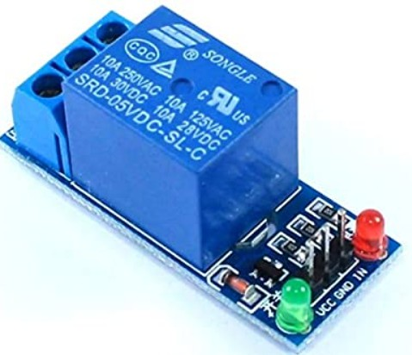

Fig 3 Relay module

In the smart irrigation system, the relay module is connected to the Arduino Uno and the motor or pump responsible for supplying water to the irrigation system. The relay module is designed to handle higher currents and voltages than the microcontroller, making it suitable for controlling the motor's power supply

The role of the relay module in the smart irrigation system is to receive control signals from the Arduino Uno and accordingly switch the motor or pump on or off. When the soil moisture readings obtained from the analog sensor fall below the predefined threshold value, indicating a need for irrigation, the Arduino Uno sends a control signal to the relay module to activate the relay. This action completes the electrical circuit, allowing power to flow to the motor, which starts the water supply

Conversely, when the soil moisture readings indicate that the moisture level is above or equal to the threshold value, suggesting adequate soil moisture, the Arduino Uno sends a signal to the relay module to deactivate the relay. This breaks the electrical circuit, cutting off the power supply to the motor and stopping the water supply

The relay module's ability to handle higher currents and its ability to isolate the microcontroller from potentially high-voltage circuits ensure safe and efficient operation of the irrigation system. By utilizing the relay module, the Arduino-based smart irrigation system achieves precise control over the motor, ensuring

that irrigation is only activated when necessary based on the soil moisture readings.

# SYSTEM DESIGN

Nowadays the agricultural field is facing a lot of problems due to lack of water resources. In order to help the farmers to overcome the difficulties, a smart irrigation system has been used. In this system, sensors such as soil moisture sensor, Node MCE ESP32, relay module, Gps neo 6 and the pump are connected to the input pins of the arduino microcontroller If the sensed value goes beyond the threshold values set in the program, the pump will be automatically switched ON/OFF by the relay circuit and it is connected to the driver circuit which helps to switch the voltage. The farmer will be intimated about the current field condition through the system we have built because of the data uploaded on cloud for the program . By using this system, the farmer can access the details about the condition of the field anywhere at any time.

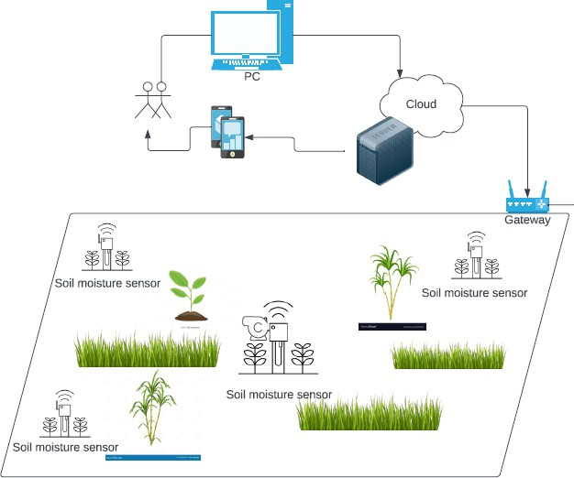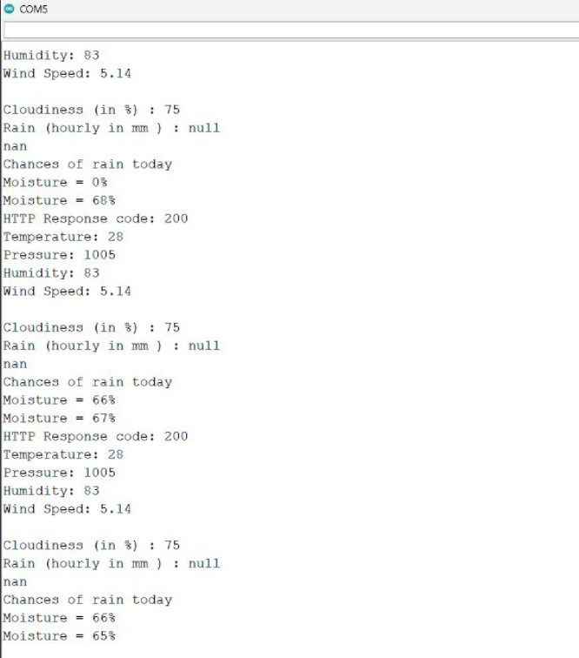

Fig 4 Conceptual diagram

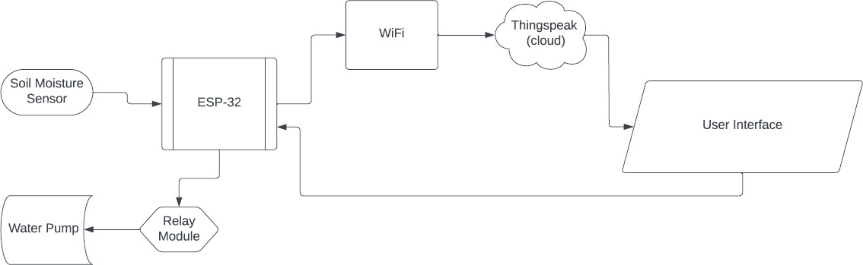

Fig 5 Block diagram

# V. SOFTWARE PART

Fig 6 Code of the project

# RESULTS

The results of the model are attached here: i) the data will be collected from the soil moisture sensor and the gps module which accesses the weather forecast continuously. ii) The pump will turn on and off according to the soil moisture value and the weather forecast of the location

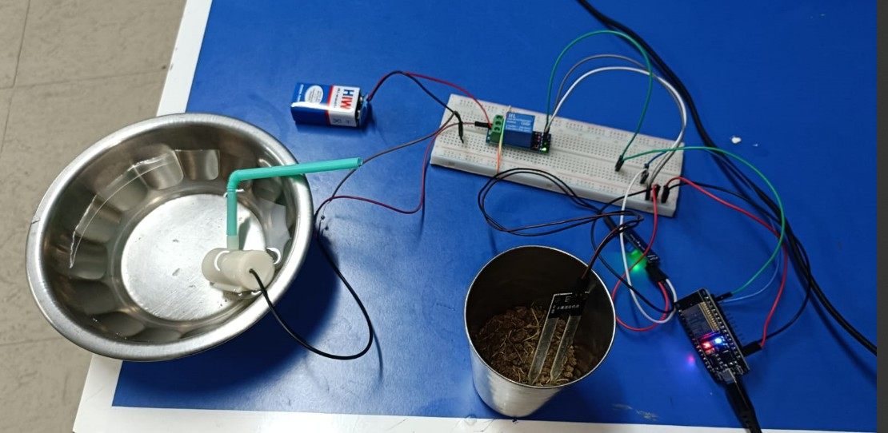

Fig 7 Project im

# CONCLUSION

The **Smart Wheelchair** successfully demonstrates the integration of modern technologies to improve mobility aids. By combining Android, touch, speech, and gesture controls, the system provides versatile and accessible solutions for users with varying needs.

# REFERENCES

[1] Archana and Priya, ”Design and Implementation of Automatic Plant Watering System” presented at International Journal of

1Advanced Engineering and Global technology , vol-04, Issue-01 , Jan-2016

. [2] Sonali.D.Gainwar and Dinesh.V.Rojatkar ,“Soil Parameters Monitoring with Automatic Irrigation System” presented at International Journal of Science, Engineering and Technology Research(IJSETR),vol-04,Issue 11,Nov 2015.

1. V.R.Balaji and M.Sudha , “Solar Powered Auto Irrigation System” presented at International Journal of Emerging Technology in Computer Science and Electronics (IJETCSE), vol-20 Issue-2, Feb-2016.
2. R.Subalakshmi and Anu Amal, “GSM Based Automated Irrigation using Sensors” presented at Special Issue published in International Journal of Trend in Research and Development (IJTRD), March-2016 .
3. Karan Kansara and Vishal Zaweri, ”Sensor Based Automated Irrigation System with IOT” presented at International Journal of Computer Science and Information Technologies, vol-06, 2015.
4. C.H.Chavan and V.Karnade ,” Wireless Monitoring of Soil moisture, Temperature and Humidity using Zigbee in Agriculture” presented at International Journal of

1

Engineering Trends and Technology (IJETT)

,vol-11, May-2014.

1. G.Parameswaran and K.Sivaprasath, ”Arduino Based Smart Drip Irrigation System Using IOT” presented at International Journal of Engineering Science and Computing (IJESC),May-2016.
2. S.Reshma and B.A.Sarath Manohar Babu, ”Internet of things Based Automatic Irrigation System using Wireless Sensor Networks” presented at International Journal and Magazine of Engineering, Technology, Management and Research, vol-03, Issue-09, Sep-2016.
3. Joaquin Gutierrez and Juan Francisco, “Automated Irrigation System using a Wireless sensor Network and GPRS Module” presented at IEEE Transactions on Instrumentation and Measurement, 2013.
4. Yunseop Kim and Robert G.Evans, “Remote Sensing and Control of an Irrigation System using a Distributed Wireless Sensor Network” presented at IEEE Transactions on Instrumentation and Measurement, Vol-57, July-2008.

# FUTURE SCOPE

The future scope of the Arduino-based smart irrigation system includes the following possibilities for further enhancements and advancements

Integration of Advanced Sensors: While the system currently utilizes a soil moisture sensor to monitor soil moisture levels, additional sensors can be incorporated to collect more data about environmental conditions. For example, sensors for measuring temperature, humidity, sunlight intensity, and rainfall can provide a comprehensive understanding of the irrigation requirements and enable more precise control over the irrigation process

Wireless Communication and Remote Monitoring: Implementing wireless communication protocols such as Wi-Fi, Bluetooth, or LoRaWAN can allow remote monitoring and control of the irrigation system. This enables users to access real-time data and make adjustments to irrigation schedules or settings through mobile applications or web interfaces from anywhere

Data Analytics and Machine Learning: Applying data analytics techniques and machine learning algorithms to the collected sensor data can provide valuable insights and optimize the irrigation system's performance. By analyzing historical data, the system can learn patterns and make predictions, improving water management efficiency and reducing water wastage

Integration with Automated Weather Stations: Instead of relying solely on weather forecast data from online sources, integrating the system with automated weather stations can provide more accurate and localized weather information. Real-time data on rainfall, wind speed, and other meteorological parameters can be obtained, allowing the system to dynamically adjust irrigation schedules based on actual weather conditions

Integration with Water Level Monitoring: Including water level sensors in the irrigation system can monitor the water levels in storage tanks or water sources. This information, combined with soil moisture data, can help optimize irrigation timing and prevent overuse or shortage of water resources

Smart Irrigation Scheduling Algorithms: Developing intelligent algorithms that consider multiple factors, including soil moisture levels, weather conditions, plant types, and evapotranspiration rates, can enable the system to generate optimal irrigation schedules. These algorithms can ensure efficient water usage and promote sustainable irrigation practices

Integration with Smart Home Systems: Integrating the smart irrigation system with existing smart home systems can provide seamless control and automation. Users can synchronize irrigation schedules with other household activities, control the system through voice commands, or receive notifications and alerts regarding irrigation events

Water Quality Monitoring: Incorporating water quality sensors into the system can assess the quality of the water used for irrigation. Monitoring parameters such as pH, conductivity, and nutrient levels can help optimize irrigation practices based on water quality considerations and the specific needs of plants

By exploring these future enhancements, the Arduino-based smart irrigation system can evolve into a more intelligent, efficient, and environmentally-friendly solution for automated irrigation, ensuring optimal plant growth while conserving water resources.