# Databases Assignment

**Student number: ST10202742**

**Name & Surname: Abonile NKONJANE**

**Question 1**

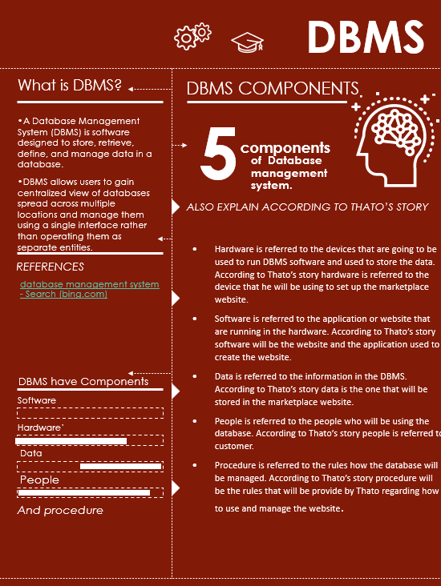

**Question 2**

**Q.2.1** I would recommend relational database for data about courses because according to (Anon., ) they provide a structured way to store and manage large amounts of data and they make it easy to add, update, and retrieve data as needed. Relational database is used for small data.

**Q.2.2** I would recommend NoSQL database because according to (Jatana, et al., 2012) it can capture all types of data (documents, file, videos, etc) including unstructured data. NoSQL database is used for big data.

**Question 3**

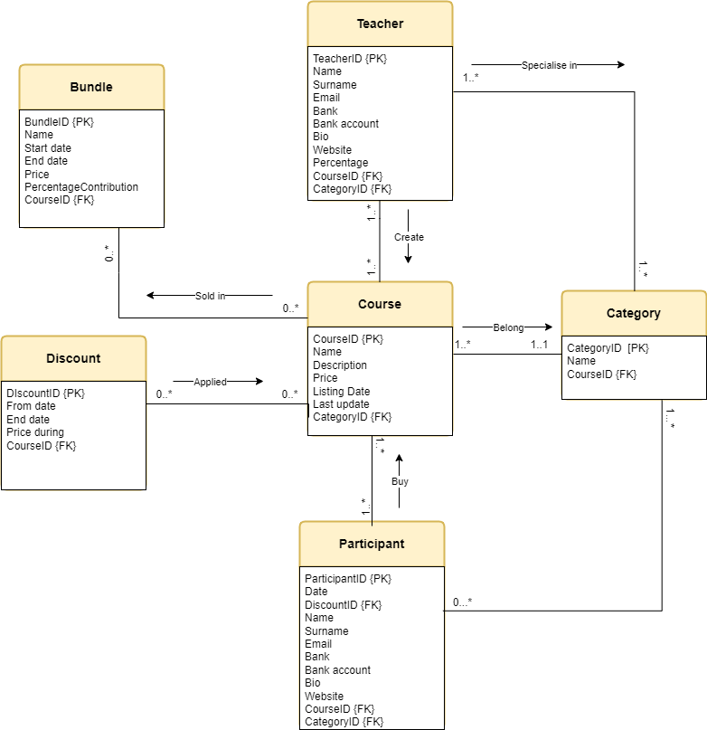

**Question 4**

# 10 CHANGES

* The entity “Item” is not from the rules. All the names of entities must be directly from the rules.
* The name of the entities must be nouns from the business rules and entity “Item” is not in the business rules.
* There is no direction between the entities. The direction describes the relationship between the entities how they link to each other with a name on top.
* The name of the direction should be a verb from the business rules.
* Some entities does not have the primary key. All entities must have the primary key.
* Your entities does not have the foreign key. Foreign also makes the relationship between the entities to be clearer.
* Entity “Supplier” does not have attributes and all entities should have attributes.
* According to the business rules above, entity “Supplier” in not in a relationship with the entity “Item”, instead is linked with entity Component.
* Entity “Colour” is not linked with entity “Item”, instead is linked with production line.
* All entities should have cardinality and according to your diagram you only have one.

# Corrected Diagram

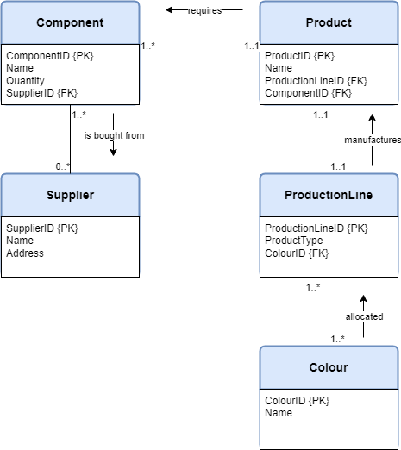

# References

Anon., . *A Relational Database Overview.* [Online]   
Available at: https://docs.oracle.com/javase/tutorial/jdbc/overview/database.html  
[Accessed 12 4 2023].

Jatana, N. et al., 2012. A Survey and Comparison of Relational and Non-Relational Database. *International journal of engineering research and technology,* , 1(6), p. .

Database Star.,.September 2016. A Guide to the Entity Relationship Diagram (ERD).

Available at : [A Guide to the Entity Relationship Diagram (ERD) - Database Star](https://www.databasestar.com/entity-relationship-diagram/)