MERIDIAN TECHNOLOGIES · BOARD STRATEGIC REVIEW · OPENING REMARKS
Catherine Park, President & CEO · Prepared remarks (~5 minutes)

Meridian enters 2026 profitable and enterprise-strong — but with three unresolved issues that will determine whether we lead the agentic era or get displaced by it.

Good morning. I want to use my five minutes to give you the unvarnished picture, name the three issues I believe are most consequential, and end with a specific ask. You will hear more detail from David on the financials and from each segment GM later today. My job right now is to tell you what I think is true.
Where we stand. Full-year 2025 revenue was $400M, up 11%. Operating margin 12.4%. Free cash flow margin 17.8%. Cash of $463M, no debt. These are respectable numbers. They are also the slowest growth rates in our public history, and our 2026 guidance of 10–14% tells the board we are not projecting an inflection yet. The deceleration is structural and I want to address it directly.
Issue 1 Mid-market NRR is approaching stall speed.
Mid-market is 47% of our ARR — the largest single pool of revenue we have. Net revenue retention has declined in every quarter for two years, from 108% in Q1 2024 to 102% today. If that line crosses 100%, our biggest segment becomes a net drag on ARR. On the current trajectory, it gets there within three to four quarters.
The cause is identifiable: competitors are bundling AI features into mid-tier plans and customers are pressing us at every renewal for price holds, expanded seats at flat cost, or free Copilot inclusion. The most-requested mid-market product — resource management — was deferred twice in 2025 and is now targeted for Q2 2026. We have to deliver it on time.
Evidence:
— KPI data: NRR mid-market 108% (Q1 2024) → 102% (Q4 2025) — unbroken 8-quarter decline
— Segments overview: mid-market ARR grew only 6% YoY vs. enterprise at 21%
— Q3 2025 earnings call: "We are seeing renewals push for a price hold, expanded seats at flat cost, or Copilot bundled at no cost"
— Product roadmap: resource management deferred twice; now Q2 2026 — listed as top-3 customer advisory board request
Issue 2 The AI competitive gap is real — and our bet is early.
We entered 2025 roughly 18 months behind the AI curve. By year-end we have 710 paying Copilot seats, $3.5M in AI ARR, a 44% attach rate on Q4 enterprise renewals, and the Helio Labs team integrated and shipping. These are genuine proof points and I am proud of the team for getting here.
But the landscape did not stand still. Asana bundled its full agent suite into the standard tier in November. Monday is now larger than us by ARR. Atlassian announced agentic Jira in January — they will be in our enterprise deals directly. ClearAI Work raised $120M at a $1B+ valuation. The question is not whether we made the right bets. We did. The question is whether we are executing them fast enough, and whether the Helio team stays.
Evidence:
— Q4 2025 earnings: 710 Copilot paying seats vs. zero at the start of 2025; $3.5M AI ARR
— Q4 2025 earnings: Asana full agent suite live November 2025; Atlassian agentic Jira announced January 2026
— KPI data: magic number 1.20 (Q1 2024) → 0.92 (Q4 2025) — sales efficiency declining as AI gap persists
— Product roadmap risk: "Agent-builder roadmap depends on Helio retention. If the team unwinds after the 2026 compensation cliff, the roadmap is exposed"
Issue 3 Engineering capacity is the binding constraint on everything else.
The 2026 roadmap is ambitious and right. It also assumes engineering capacity we do not currently have. We have 750 engineers. At 15% annual attrition and a plan to hire 80 in H1, net adds will be closer to 25. In 2025, 10 of 12 roadmap commitments were late or deferred. The CPO's own document calls engineering capacity "the binding constraint."
The organizational signal is equally clear. The employee survey found "roadmap thrash" cited in 31% of engineering open-ends. The People team has flagged a specific risk of losing 15–25 senior engineers in Q1 2026 due to compensation falling behind market. I cannot execute the AI roadmap or stabilize mid-market without addressing this now.
Evidence:
— Product roadmap: 10 of 12 2025 commitments late or deferred; "engineering capacity is the binding constraint"
— Employee survey (Oct 2025, 81% response rate): roadmap thrash cited in 31% of engineering responses
— Employee survey: 27% of senior engineers flagged pay below market; People team warns of "15–25 senior engineers at flight risk in Q1 2026"
— Employee survey: 19% of all employees (28% of sales) say they cannot differentiate Meridian from Asana with AI

Supporting chart — Net Revenue Retention by Segment (Q1 2024–Q4 2025)
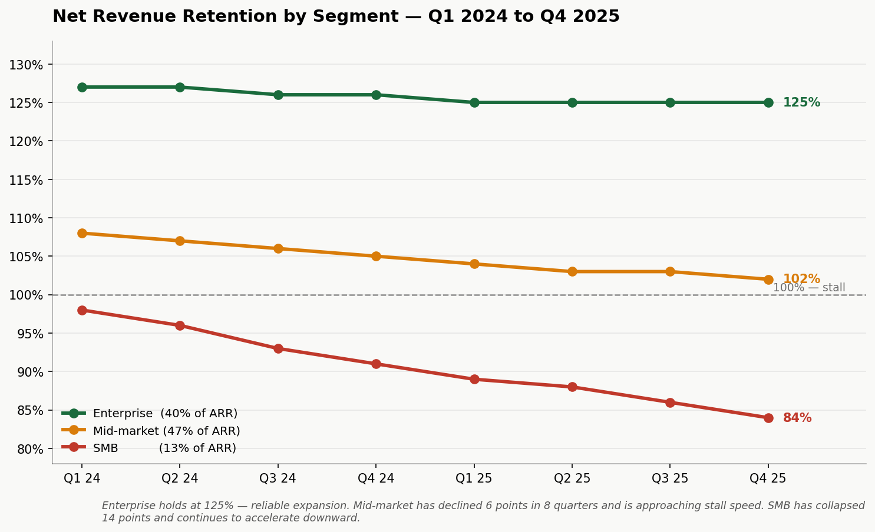
Enterprise holds at 125% NRR. Mid-market has declined 6 points across 8 consecutive quarters and is 2 points above stall speed. SMB has collapsed 14 points and is accelerating downward. Source: meridian_kpis_2024.csv.

My one ask of the board.
Before we close today, I need the board's alignment on one question: Is Meridian an agentic work platform that happens to have project management as one of its surfaces — or are we a project management tool with AI features added on?
The answer to that question changes our R&D priorities, our sales motion, our pricing model, and our positioning. I have a strong point of view — I will share it in detail at Investor Day on March 11. But I need to know the board is with me before I take that position publicly. Everything else on our agenda today — the segment P&Ls, the AI roadmap, the engineering compensation review — should be read in light of that choice.
I am asking for thirty minutes at the end of today's session for a board-only conversation on strategic direction. No slides. No management team in the room. Just alignment.

The enterprise franchise Lenore built is a genuine asset and it is growing. We have the cash, the team, and — I believe — the strategic clarity to navigate what comes next. But we have to move. Let's get to work.

