MERIDIAN TECHNOLOGIES · INVESTOR DAY · MARCH 11, 2026
Strategic Positioning Memo · Catherine Park, President & CEO · Confidential

Meridian Is the Agentic Work Platform That Regulated Enterprises Trust
EXECUTIVE SUMMARY

Meridian enters Investor Day 2026 with a clear strategic declaration: we are the agentic work platform for regulated enterprises — combining the governance infrastructure that no AI-native company has built with the agent framework that no legacy PM tool has shipped. Our enterprise business is growing 21% year-over-year at 125% NRR. AI Copilot reached GA in September 2025, closed the year at 710 paying seats with a 44% attach rate on enterprise renewals, and generated $3.5M in ARR in its first year. We acquired Helio Labs in Q4 — 28 engineers and a working agent framework — for a total deal value of $78M structured as retention equity. Three things we are committing to on this stage: the Enterprise Governance Suite in GA by end of Q1 2026, consumption pricing live in H2 2026, and AI ARR of $40M or more by end of 2026. The competitive white space is real and ours to lose: no competitor owns governance-grade agentic work for regulated industries outside of developer organizations. We intend to own it.
OUR POSITION

"Meridian is the agentic work platform that regulated enterprises trust — built on the governance infrastructure that no AI-native company has, and the agent framework that no legacy PM tool has shipped."
This is not a feature announcement. It is a declaration of what Meridian is for the next three years — and a commitment to the sales motion, pricing model, R&D priorities, and hiring mix that follow from it.
WHY THIS POSITION, WHY NOW

— Customer demand is explicit. 18 of 22 enterprise advisory sessions in the last 90 days asked specifically for agent governance: auditability, role-based agent permissions, model selection, and data residency. This is not a PM-with-AI ask. It is an agentic platform ask with a governance filter — and no competitor delivers both today.
— The competitive white space is unoccupied. Asana and Monday are racing to bundle agentic features at low cost but have not invested in governance. Atlassian is building a governance-grade agentic platform — but explicitly for developer and IT organizations. Smartsheet has rejected the agentic label entirely. The position we are claiming — governed agentic platform for regulated enterprise outside dev/IT — has no incumbent. See competitive landscape below.
— We have the only asset combination that makes it credible. FedRAMP Moderate, HIPAA, and the start of a GxP story on the governance side. The Helio agent framework — 26 engineers, a working orchestration layer — on the agent side. No AI-native upstart can replicate the compliance moat in under 18 months. No legacy PM competitor has the agent framework.
— The financial capacity exists. $506M in liquidity, $250M estimated M&A capacity, $55M in AI-specific R&D for 2026. We can afford to execute this path.
COMPETITIVE LANDSCAPE

The matrix below plots our four direct competitors on two dimensions: PM-centric vs. agentic positioning (x-axis) and bundled vs. premium/add-on pricing (y-axis). Meridian today sits in the upper-middle — premium pricing, identity still transitioning. The Option B target is the upper-right: agentic, premium, governed.
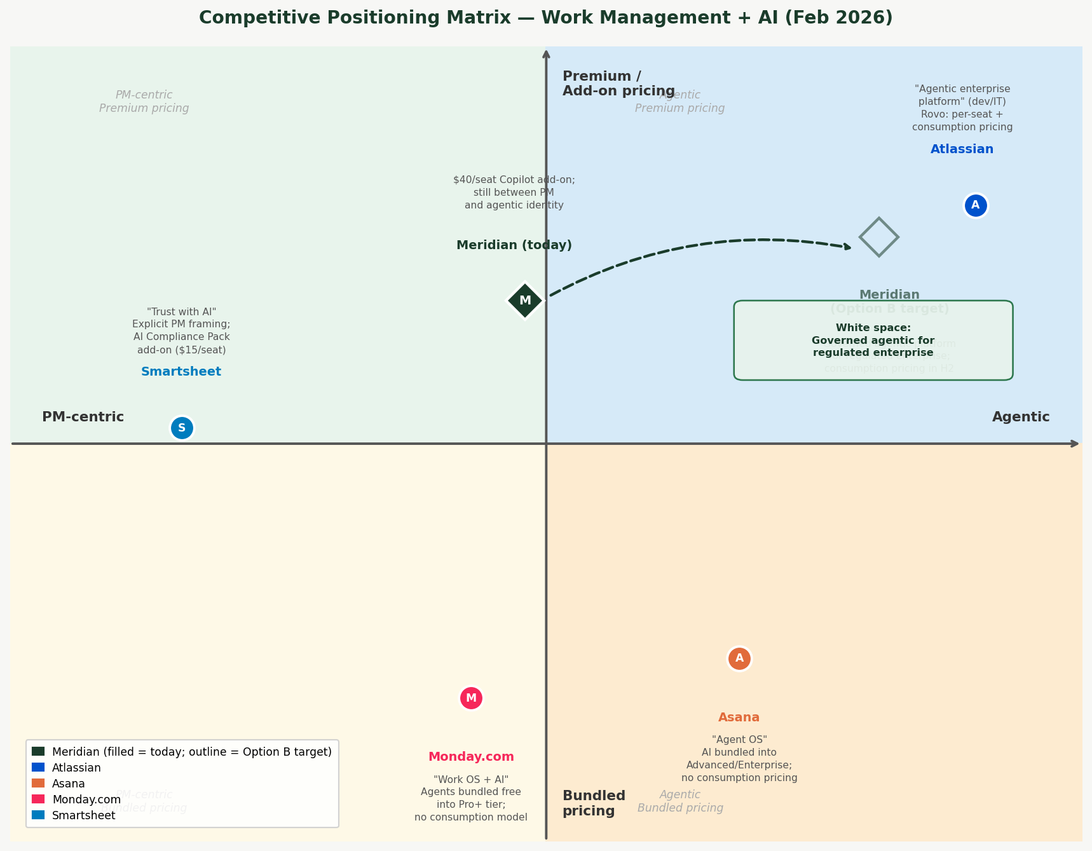
Figure 1 — Competitive positioning matrix. Filled diamond = Meridian today. Outlined diamond = Meridian Option B target. Green box = unoccupied white space. Source: competitors_cached/, Feb 2026.
Key read: three of four competitors are moving toward agentic positioning. Asana and Monday are bundling AI free, competing on price in the bottom-right quadrant. Atlassian is the only competitor with consumption pricing and a serious governance story — but their install base is developer-shaped. Smartsheet, the only Option A peer, is decelerating. The upper-right quadrant — governed agentic for regulated enterprise — is ours to claim.
THREE RISKS WE ARE MANAGING EXPLICITLY

1. Revenue air gap during the transition. Declaring an agentic identity before agentic revenue scales creates a window where mid-market customers — who bought a PM tool — feel the shift before they benefit from it. We are mitigating this by bundling Copilot into the standard mid-market tier simultaneously with this announcement, and by sequencing the agent platform story as an extension of enterprise trust, not a departure from PM.
2. Microsoft ships governance-grade agents into M365. Microsoft has the enterprise relationships, the compliance infrastructure, and the distribution to enter this space at no incremental cost to the buyer. Our mitigation is vertical depth: regulated-industry workflow specificity (financial services, life sciences, pharma) that generic platforms do not replicate quickly, and model neutrality that Microsoft structurally cannot offer.
3. Helio retention after the 2026 compensation cliff. The agent roadmap depends materially on 26 engineers whose retention agreements include a cash event in 2026. We are addressing this through an equity refresh program in Q1 2026, clear product ownership, and explicit public commitment to the agentic roadmap that makes Meridian the kind of company those engineers want to build.
THREE COMMITMENTS TO INVESTORS

1. Enterprise Governance Suite in GA by end of Q1 2026. Audit logs, role-based agent permissions, model selection, and data residency enforcement — the features our enterprise customers asked for by name. This is the product proof point that makes the platform declaration credible.
2. Consumption pricing live in H2 2026. We will introduce per-seat-plus-agent-action pricing for enterprise customers in H2 2026. We will report agent consumption ARR as a separate line starting Q3 2026. We are committing to transparency: investors will be able to track the ramp.
3. AI ARR of $40M or more by end of 2026. From $3.5M at end of 2025. This requires scaling Copilot attach rates from 44% to 60%+ on enterprise renewals, converting mid-market to bundled Copilot, and landing the first consumption contracts. We are not modeling this as the dominant growth driver in 2026 — we are modeling it as the proof point that makes 2027 guidance credible.

The enterprise franchise Lenore Pak built is a real and growing asset. The governance moat is real and defensible. The Helio team is here and building. The white space is real and unoccupied. What we are committing to today is the identity and the execution that ties those assets together. We will come back to this stage in twelve months and show you what we shipped.

