

**The Experiment Report Of**

***Deep Learning***

Subject : Software Engineering  
 College : Software College.

Student ID: 201722800094

E-mail : [abas.aboras1@gmail.com](mailto:abas.aboras1@gmail.com)

Tutor : prof. Mingkui Tan

Date submitted: 2017 - 12 - 8

Reporter : ABAS MOHAMMED NAGI

Content Report:

Chapter1: Linear Regression and Gradient Descent

Chapter2: Linear Classification and Gradient Descent

**CHAPTER1**

**Topic1:** Linear Regression and Gradient Descent.

**Purposes:**

In this experiment we'll implement simple linear regression using gradient descent. Such that gradient descent is an algorithm that minimizes functions. Also process of optimization and adjusting parameters and further understand of liner regression and gradient descent.

**Data sets and data analysis:**

In this experiment use Data set ( housing_scale.txt) to procedure process training.  
Linear Regression uses Housing in LIBSVM Data, including 506 samples and each sample has 13 features. You are expected to download scaled edition. After downloading, you are supposed to divide it into training set, validation set.

**Experimental steps:**1) Load data set file (housing_scale.txt) via file from any folder save. Or using lode online data set via

Link (<https://www.csie.ntu.edu.tw/~cjlin/libsvmtools/datasets/regression/housing_scale> )

2) Divide dataset into training set and validation set using [train_test_split](http://scikit-learn.org/stable/modules/generated/sklearn.model_selection.train_test_split.html) function.

3) Initialize linear model parameters set all parameter into zero, initialize it randomly or with normal distribution.

4) Using loss function and derivation.

5) Calculate gradient descent G toward loss function from all samples (506).

6) Update Weight.  
7) Get the loss Ltrain under the training set Lvalidation and by validating under validation set.  
8) Drawing graph of Ltrain and Lvalidation.

**Experiment Code:**

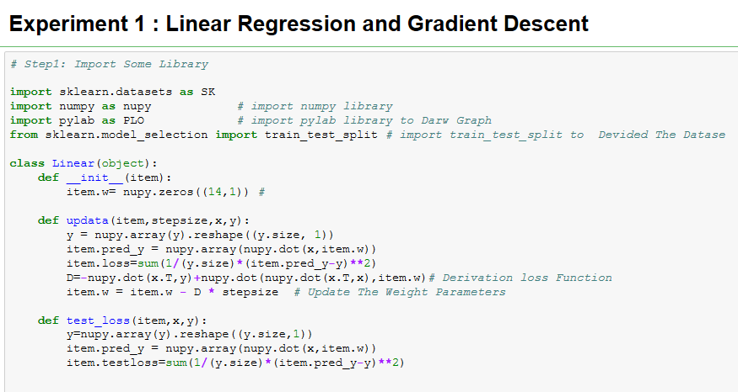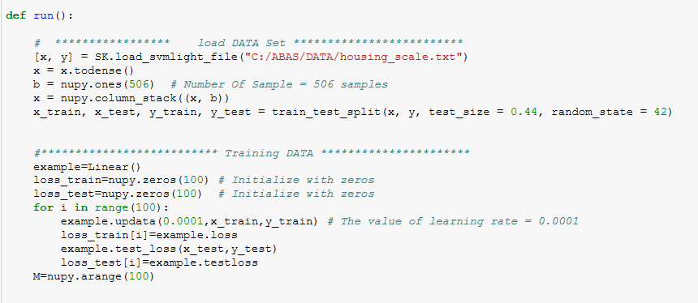

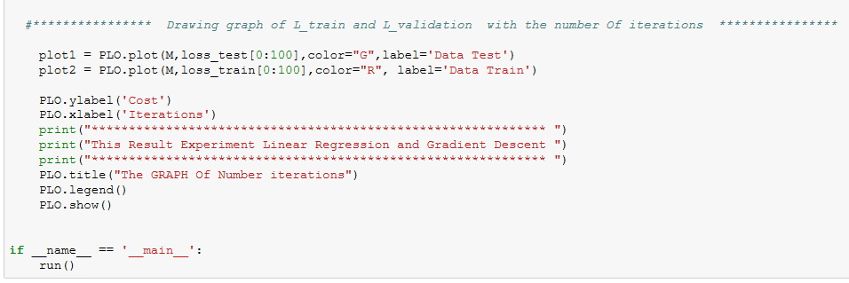

**Selection of validation(hold-out,cross-validation, k-folds cross-validation,etc.)**

Test size= 0.44 random =42



**Experimental results and curve:**

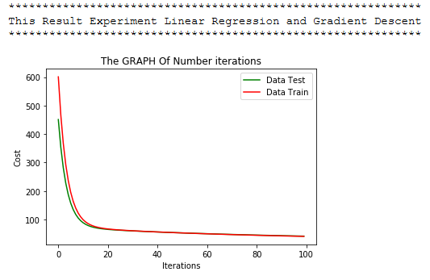

**CHAPTER 2**

**Topic:**  Linear Classification and Gradient Descent

**Purposes:**

In this experiment we'll implement simple linear classification using gradient descent. Such that gradient descent is an algorithm that minimizes functions.

**Data sets and data analysis:**

In this experiment use Data set (Australian scale) to procedure process training.  
Linear classification uses Australian in LIBSVM Data, including 690 samples and each sample has 14 features. You are expected to download scaled edition. After downloading, you are supposed to divide it into training set, validation set.

**Experimental steps:**1) Load data set file (australian_scale.txt) via file from any folder save. Or using lode using requests.get() online data set via

Link (https://www.csie.ntu.edu.tw/~cjlin/libsvmtools/datasets/binary/australian_scale)

2) Divide dataset into training set and validation set using [train_test_split](http://scikit-learn.org/stable/modules/generated/sklearn.model_selection.train_test_split.html) function.

3) Initialize linear model parameters set all parameter into zero, initialize it randomly or with normal distribution.

4) Using loss function and derivation.

5) Calculate gradient descent G toward loss function from all samples (690).

6) Update Weight.  
7) Get the loss Ltrain under the training set Lvalidation and by validating under validation set.  
8) Drawing graph of Ltrain and Lvalidation.

**Experiment Code:**

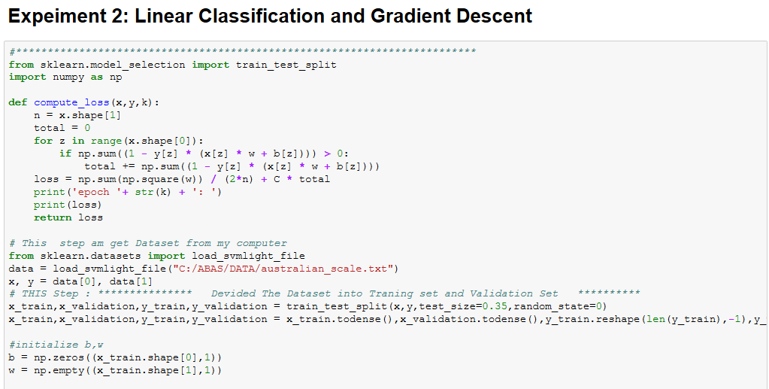

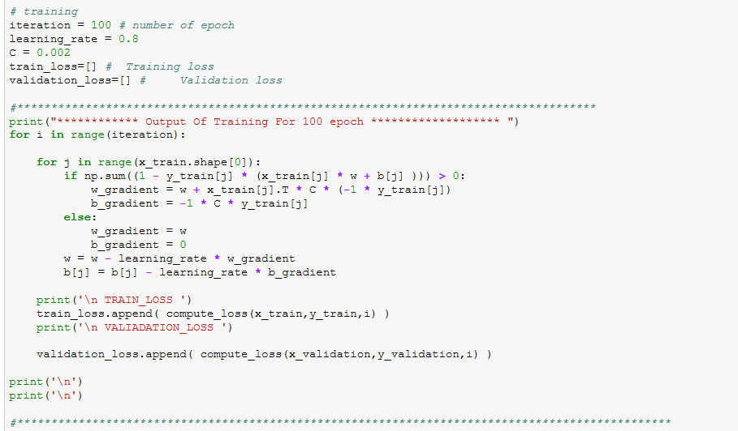

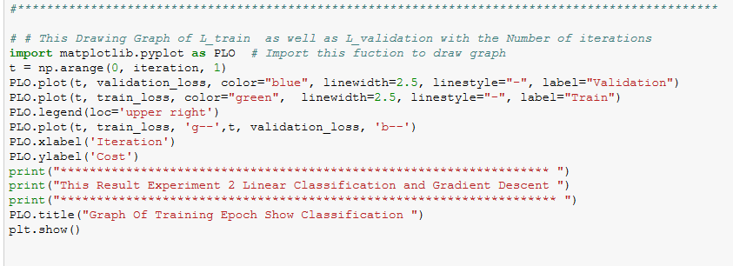

**Experimental results and curve:**

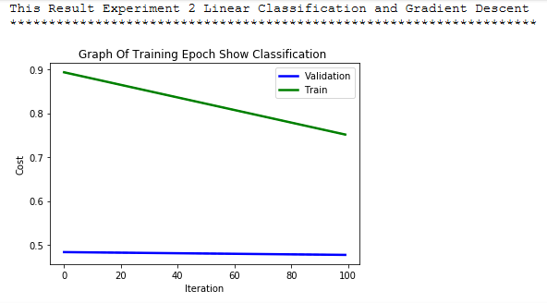

**Selection of validation(hold-out,cross-validation, k-folds cross-validation,etc.)**

Test size= 0.35 , random state = 44



**Similarities and differences between linear regression and linear classification:**

Linear classification uses the linear combination of the features to make a classification on the data set. Linear regression is the most basic type of regression and commonly used predictive analysis. Also linear regression is a linear approach for modeling the relationship between a scalar dependent variable y and one or more explanatory variables (or independent variables) denoted X.   
Both regression and classification problems belong to the supervised category of machine learning. In Supervised machine learning, a model or a function is learnt from the data to predict the future data.  
***The main difference*** between the classification and the regression is their dependent variable. For the classification, the dependent variables are categorical, while the regression has numerical dependent variables.

**Results analysis:**

From result which show in the graph it’s easily understandable that the train curve and the test curve are it consider the same.

**Summary:**

In this experiment I discovered the simple linear regression model and how to train it using gradient descent. I work through the experiment of the update rule for gradient descent. I also learned how to make predictions with a learned linear regression model.