Air-Gapped GitHub Copilot CLI with Local Models
Test Campaign Report — Linux / arm64 (NVIDIA GB10)
GHCP-AIR-GAPPED
2026-06-27
Table of Contents

1 Executive summary
This report documents a test campaign for running the GitHub Copilot CLI fully offline (air-gapped) against local models served by a Dockerized Ollama backend, on a Linux / arm64 host equipped with an NVIDIA GB10 (Grace-Blackwell) GPU.
The work covered four things:
- Porting the project’s Windows PowerShell launchers to native Linux/arm64 Bash scripts.
- Building an automated test harness that measures whether a given model can actually drive the agentic CLI (structured tool calls, streaming, instruction-following) and how fast it runs.
- Running the campaign across eight models (1B → 30B, multiple families) — first CPU-only, then GPU-accelerated.
- Discovering and fixing the key bottleneck: the container was not using the GB10 GPU. Enabling it changed the result from “only ≤3B models usable” to “every tool-capable model is interactive.”
Headline result: on CPU, prefill of the large (~13.4k-token) agent prompt capped throughput so badly that every model ≥7B exceeded the CLI’s ~10-minute request timeout. Enabling the GB10 GPU made prompt processing 39–128× faster, and every tool-capable model now completes a real Copilot turn in under a minute.

2 Test bench
Property | Value
Host OS / arch | Ubuntu 24.04.4 LTS, aarch64 (arm64)
CPU / RAM | 20 cores / 121 GiB
GPU | NVIDIA GB10 (Grace-Blackwell), CUDA 12.1, iGPU, 121.6 GiB unified memory
GPU driver | 580.159.03 (CUDA runtime 13.0)
Backend | Dockerized Ollama 0.30.10 on :11434 (OpenAI-compatible /v1)
Agent | GitHub Copilot CLI 1.0.65
Mode | COPILOT_OFFLINE=true — no GitHub egress, no telemetry, no auto-update
Container Toolkit | NVIDIA Container Toolkit 1.19.1 (Docker nvidia runtime registered)

3 How it works (architecture)
The Copilot CLI speaks the OpenAI Chat Completions protocol. Pointing it at a local OpenAI-compatible endpoint and enabling offline mode keeps all inference on-device:
User ─▶ start-copilot-with-docker.sh (wrapper)
├─ ensure Docker daemon is up (systemctl)
├─ docker compose up -d ollama ─▶ [ Ollama container ] OpenAI API @ :11434/v1
│ └─ GB10 GPU via NVIDIA runtime; models in a named volume
├─ ensure the model is present (pull once while online)
├─ export COPILOT_PROVIDER_* + COPILOT_OFFLINE=true
└─ exec `copilot` ─▶ inference runs 100% on-device, no GitHub egress
The four environment variables that wire the CLI to the local backend:
Variable | Value
COPILOT_PROVIDER_TYPE | openai
COPILOT_PROVIDER_BASE_URL | http://localhost:11434/v1 (the /v1 suffix is required)
COPILOT_PROVIDER_API_KEY | ollama (dummy; local needs no auth)
COPILOT_MODEL | e.g. gpt-oss:20b
COPILOT_OFFLINE | true

4 Deliverables (scripts created)
File | Purpose
start-copilot-with-docker.sh | Linux/arm64 port of the Docker launcher: starts the daemon (systemctl), brings up Ollama, ensures the model, exports COPILOT_*, launches copilot. Flags: --model, --port, --context-length, --online/--offline, --pull, --no-launch.
start-observability.sh | Linux/arm64 port of the Grafana stack launcher (--no-browser, --down); opens the dashboard via xdg-open.
model-test-campaign.sh | Automated test harness (below). Probes capabilities + throughput per model and writes a Markdown report. Flags: --models, --full, --keep-going, --out, --port.

5 Methodology — what is measured and why
The agentic CLI only works if a model satisfies three hard requirements, plus a practical speed gate:
- Structured tool_calls — the model must return tool invocations as a structured tool_calls array, not as JSON text inside content. If it returns text, the agent loop cannot parse or execute the call.
- Streaming with finish_reason — the Copilot stream parser needs finish_reason on the terminal chunk.
- Instruction-following — a trivial deterministic check (“reply with exactly PONG”).
- Speed — the agent system prompt is large (~13,400 tokens). A turn must finish inside the CLI’s ~10-minute request timeout.
The harness derives two timing numbers from Ollama’s nanosecond timing fields:
- 1-pass = one forward pass of the agent prompt = promptTokens / promptRate + 300 / genRate.
- est. real turn = 1-pass × 3.2. A real turn runs several LLM calls (think → tool → think …). The ×3.2 factor was calibrated from mistral:7b, whose measured Copilot turn was 13m35s versus a 4m14s single pass. The verdict uses est. real turn.

6 Results

6.1 CPU baseline (GPU disabled)
Model | Size | tool_calls | prompt t/s | gen t/s | est. real turn | Verdict
llama3.2:1b | 1.3 GB | PASS | 288.6 | 26.3 | 3m05s | Good
llama3.2:3b | 2.0 GB | PASS | 106.1 | 22.9 | 7m26s | Usable — slow
qwen2.5-coder:7b | 4.7 GB | FAIL | 77.4 | 14.2 | 10m21s | Unsupported (text tool calls)
mistral:7b | 4.4 GB | PASS | 59.3 | 14.2 | 13m11s | Too slow
llama3.1:8b | 4.9 GB | PASS | 64.7 | 13.2 | 12m16s | Too slow
mistral-nemo:12b | 7.1 GB | PASS | 53.7 | 11.6 | 14m40s | Too slow
gpt-oss:20b | 13 GB | PASS | 33.3 | 11.0 | 22m56s | Too slow
qwen3:30b-a3b | 18 GB | PASS | 44.8 | 17.8 | 16m51s | Too slow

6.2 GPU-accelerated (NVIDIA GB10, CUDA)
Model | Size | tool_calls | prompt t/s | gen t/s | est. real turn | Verdict
llama3.2:1b | 1.3 GB | PASS | 16642.4 | 132.0 | 0m10s | Good
llama3.2:3b | 2.0 GB | PASS | 6379.7 | 73.5 | 0m20s | Good
qwen2.5-coder:7b | 4.7 GB | FAIL | 3024.0 | 40.0 | 0m38s | Unsupported (text tool calls)
mistral:7b | 4.4 GB | PASS | 2841.1 | 39.1 | 0m40s | Good
llama3.1:8b | 4.9 GB | PASS | 2877.4 | 36.7 | 0m41s | Good
mistral-nemo:12b | 7.1 GB | PASS | 2117.4 | 27.1 | 0m56s | Good
gpt-oss:20b | 13 GB | PASS | 4257.3 | 50.1 | 0m29s | Good
qwen3:30b-a3b | 18 GB | PASS | 2973.3 | 69.6 | 0m28s | Good

6.3 CPU vs GPU — the decisive factor
Model | prompt t/s (CPU → GPU) | est. real turn (CPU → GPU) | Verdict (CPU → GPU)
llama3.2:1b | 289 → 16642 (~58×) | 3m05s → 0m10s | Good → Good
llama3.2:3b | 106 → 6380 (~60×) | 7m26s → 0m20s | Usable → Good
qwen2.5-coder:7b | 77 → 3024 (~39×) | 10m21s → 0m38s | Unsupported → Unsupported
mistral:7b | 59 → 2841 (~48×) | 13m11s → 0m40s | Too slow → Good
llama3.1:8b | 65 → 2877 (~44×) | 12m16s → 0m41s | Too slow → Good
mistral-nemo:12b | 54 → 2117 (~39×) | 14m40s → 0m56s | Too slow → Good
gpt-oss:20b | 33 → 4257 (~128×) | 22m56s → 0m29s | Too slow → Good
qwen3:30b-a3b | 45 → 2973 (~66×) | 16m51s → 0m28s | Too slow → Good

6.4 Real Copilot CLI turns (GPU, --full)
Ground-truth, end-to-end runs of copilot -p … --allow-all-tools against each model:
Model | Wall time — outcome
llama3.2:1b | 0m03s — ok (said PONG)
llama3.2:3b | 0m04s — ok (said PONG)
mistral:7b | 0m10s — completed but off-task
llama3.1:8b | 0m06s — completed but off-task
mistral-nemo:12b | 0m09s — ok (said PONG)
gpt-oss:20b | 0m08s — ok (said PONG)
qwen3:30b-a3b | 0m10s — ok (said PONG)

7 Enabling the GB10 GPU (the key fix)
Initially the container ran CPU-only — the deploy GPU block in docker-compose.yml was commented out, so the Blackwell GPU sat idle. Everything needed was already present (GB10 driver, NVIDIA Container Toolkit 1.19.1, Docker nvidia runtime). Enabling it:
# docker-compose.yml — ollama service
environment:
- NVIDIA_VISIBLE_DEVICES=all
- NVIDIA_DRIVER_CAPABILITIES=compute,utility
deploy:
resources:
reservations:
devices:
- driver: nvidia
count: all
capabilities: ["gpu"]
After recreating the container, Ollama detected the GPU:
inference compute library=CUDA compute=12.1 name="NVIDIA GB10"
type=iGPU total="121.6 GiB" available="113.2 GiB"
vram-based default context: total_vram="121.6 GiB" default_num_ctx=262144
Because the GB10 uses unified memory (121.6 GiB), even the 30B model loads entirely into GPU memory with no offloading — and there is headroom for 70B-class models.

8 Per-model notes & limitations
- llama3.2:1b — Good. Fastest; lowest agentic quality. Instruction-following was nondeterministic (PASS/FAIL across runs).
- llama3.2:3b — Good on GPU. Solid lean default; structured tool calls.
- qwen2.5-coder:7b — Unsupported. Emits the tool call as JSON text in content (e.g. {"name":"get_weather","arguments":{"city":"Paris"}}), so no tool_calls are returned and the agent loop cannot act. Fails on both CPU and GPU — a model limitation, not hardware. A “coder” model is not automatically better here.
- mistral:7b / llama3.1:8b — Good on GPU; structured tool calls. In the --full runs they finished fast but occasionally ignored the trivial instruction.
- mistral-nemo:12b — Good on GPU. Dense 12B; reliable structured tool calls.
- gpt-oss:20b — Good on GPU; MoE (20.9B, MXFP4). Strong quality + speed balance.
- qwen3:30b-a3b — Good on GPU; MoE (3B active) gives the best generation rate for its size. Best quality on this host.

9 Foundry Local evaluation (why not on this host)
Microsoft Foundry Local was evaluated as an alternative backend. It is now installable on Linux ARM64 (CLI preview 0.10.1) and its catalog includes gpt-oss, qwen, mistral, phi. However, it would run CPU-only on this machine — it cannot use the GB10 GPU.
Foundry Local execution-provider (EP) coverage:
Execution Provider | Hardware | Platform
CPU | universal fallback | all platforms
WebGPU | any GPU | Windows x64, macOS arm64
CUDA | NVIDIA | Windows x64, Linux x64
OpenVINO | Intel | Windows x64
QNN | Qualcomm NPU | Windows ARM64
TensorRT RTX | NVIDIA | Windows x64
VitisAI | AMD NPU | Windows x64
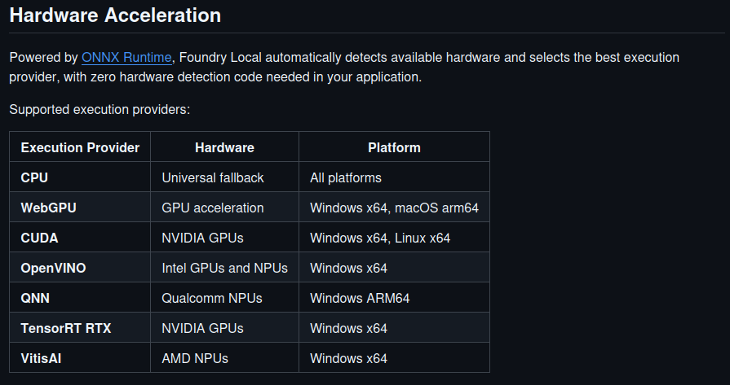
Foundry Local — Hardware Acceleration execution-provider support (official Microsoft docs). The CUDA row lists only Windows x64, Linux x64 — there is no Linux arm64 (aarch64) entry — and WebGPU is limited to Windows x64 / macOS arm64. On this Linux/arm64 host that leaves CPU as the only execution provider.
This host is Linux aarch64. There is no CUDA EP for Linux arm64, and WebGPU is not offered for Linux → the only EP available is CPU. The campaign already showed CPU-only makes every model ≥7B exceed the agent timeout, so Foundry Local here would be strictly slower than the GPU-accelerated Ollama path, with no GPU upside.
Additional caveats: the repo’s Start-CopilotWithFoundryLocal.ps1 targets the old foundry service … CLI (renamed to foundry server …), and Foundry tool-calling is preview-grade (one tool call per request; past streaming tool_calls bugs; an open issue “Tool calling fails on NVIDIA GPUs”).
Conclusion: Foundry Local fits Windows x64 / Linux x64 + NVIDIA or macOS Apple Silicon. On this Linux/arm64 + GB10 box, the Dockerized Ollama + CUDA path is correct.

10 Observability (Grafana)
A Dockerized observability stack (exporter + Prometheus + Loki + Promtail + Grafana) parses the Ollama logs and /api/ps and renders a live dashboard at http://localhost:3000/d/ollama-copilot. It is started with ./start-observability.sh.
The dashboard shows the served model, processor (CPU/GPU), context window, KV-cache occupancy, per-request prefill/generation throughput, cache hit/miss, total turns and requests, plus the parsed request log.
Campaign timeline (actual, 2026-06-27, local time +0200). The screenshots below are anchored to the real test window measured from Prometheus:
Event | Time
Observability stack started | 11:37
First generation (CPU era begins) | 11:48
Backend recreated with GPU — CPU → GPU flip | 12:31
Last generation (GPU era) | 13:10
Total campaign span | ≈ 1h 22m
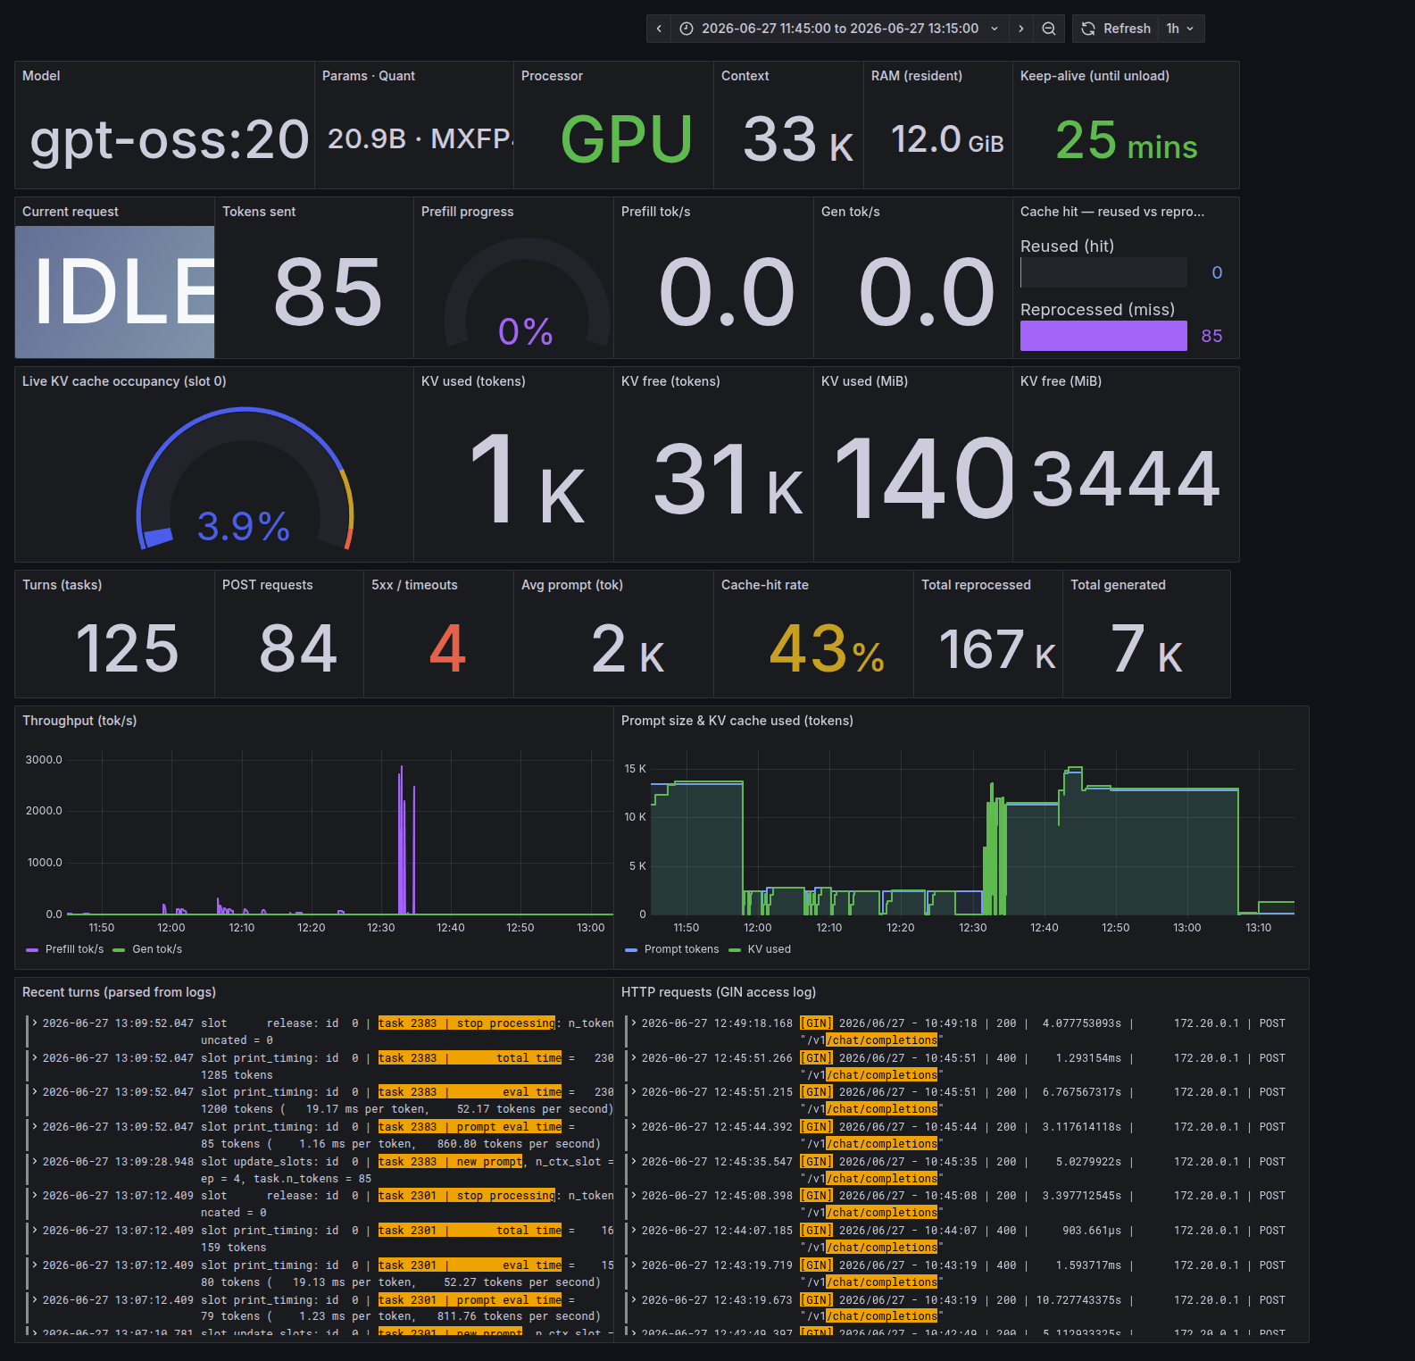
Grafana — full campaign window 11:45 → 13:15 (covers every test). Note Processor: GPU, gpt-oss:20b resident in 12 GiB, 125 turns / 84 POSTs / 43% cache-hit / 167K reprocessed. In Throughput (tok/s) the GPU prefill spikes (~2.5–3.0k tok/s) near 12:30 dwarf the CPU era (sub-300 tok/s, flat on this axis). Prompt size & KV cache shows the ~13K-token agent prompt in the CPU era (≈11:50), then the GPU activity from 12:31.
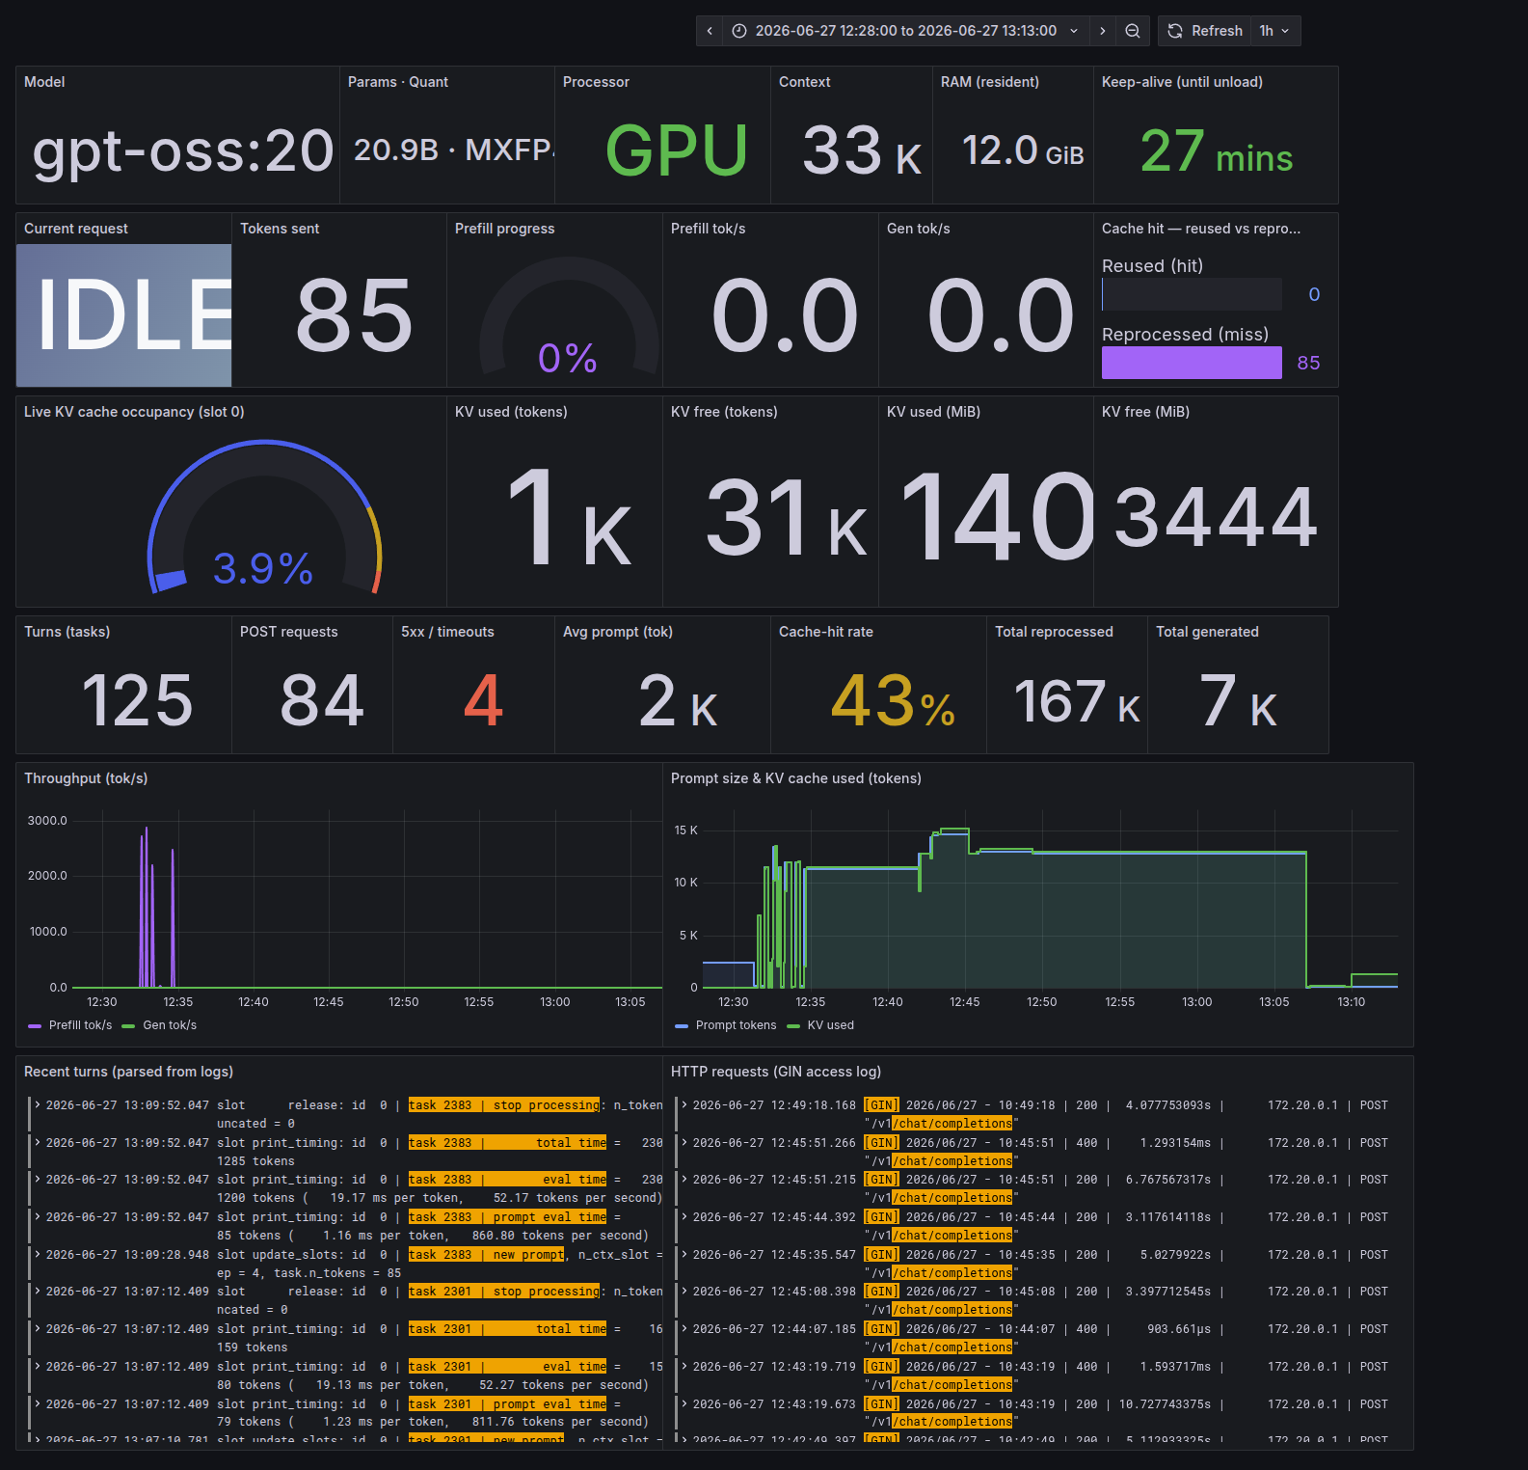
Grafana — GPU-accelerated era zoom 12:28 → 13:13. The prefill bursts at ~2.5–3.0k tok/s (12:32–12:35) are the GPU campaign; KV-cache fills to the ~13K-token agent prompt and the parsed turn/HTTP logs show per-request timings (e.g. prompt eval … 860 tokens/second).

11 Findings & limitations (consolidated)
- Tool-call format is the hard gate, and it is hardware-independent. qwen2.5-coder:7b fails on both CPU and GPU because it serializes tool calls as text.
- On CPU, prefill of the ~13.4k-token agent prompt is the bottleneck — not model size or RAM. Only ≤3B was usable; 121 GiB of RAM did not help.
- The GB10 GPU removes that wall: 39–128× faster prefill; every tool-capable model finishes a real turn in under a minute (validated by live --full runs).
- Unified memory (121.6 GiB) → no offloading, with headroom for 70B-class models.
- MoE helps generation, not CPU prefill. gpt-oss:20b was the slowest to prefill on CPU; on GPU the MoE models post the best generation rates for their size.
- Instruction-following is imperfect / nondeterministic on some models — validate per use case; bigger ≠ always more obedient.
- Projection caveat: the ×3.2 turn factor is calibrated from a single CPU data point. It is a planning heuristic; the GPU --full measurements are the ground truth.

12 Recommendations
- Keep the GPU enabled (committed in docker-compose.yml).
- Best quality + speed on this host: qwen3:30b-a3b or gpt-oss:20b.
- Lean default: llama3.1:8b or mistral:7b (~40 s real turn).
- Avoid for agentic use: qwen2.5-coder:7b (text tool calls — agent loop cannot parse).
- Everyday launch: ./start-copilot-with-docker.sh --model gpt-oss:20b.

13 Appendix

13.1 Reproduce the campaign
# bring up the GPU-accelerated backend (offline)
./start-copilot-with-docker.sh --no-launch --model gpt-oss:20b
# run the full campaign incl. real Copilot turns, write TEST-RESULTS.md
./model-test-campaign.sh --keep-going --full \
--models "llama3.2:1b llama3.2:3b qwen2.5-coder:7b mistral:7b llama3.1:8b mistral-nemo:12b gpt-oss:20b qwen3:30b-a3b"
# observability dashboard
./start-observability.sh

13.2 File inventory
File | Role
start-copilot-with-docker.sh | Linux/arm64 Docker + Ollama launcher
start-observability.sh | Linux/arm64 Grafana stack launcher
model-test-campaign.sh | Automated model test harness
docker-compose.yml | Ollama (GPU-enabled) + observability stack
TEST-RESULTS.md | Auto-generated GPU campaign report + analysis
TEST-RESULTS-cpu.md | CPU baseline report
docs/screenshots/ | Grafana dashboard screenshots

