Sharing library resources
with the ABCD Site
Egbert de Smet and Sangeeta N Dhamdhere
Antwerp University, Antwerp, Belgium, egbert.desmet@ua.ac.be
Modern College of Arts, Science and Commerce, Pune, India, modernlibrary.sangeeta@gmail.com
___________________________________________________________________________
______________________________________________________________________________
Abstract:

In spite of the library website being a very good medium and platform to communicate details of various print and electronic resources of the library to its users, still many libraries, esp. in the South, fail to share their resources due to a lack of technical or computer skills to do so. Yet many interactive tools to share library contents are available as Content Management System solutions, e.g. Joomla, Drupal, etc. These facilitate the use of Web 2.0 techniques such as blogs, RSS, instant messaging, social networking services, wikis, and social tagging applications. In this context we present the ABCD Site module, one of the easiest tools for libraries in developing their interactive library website, as part of the ABCD integrated library automation suite. With a minimum of efforts and time spent, libraries can easily become active members of the digital age in publishing and sharing their information to a wide audience.

Keywords: Library website design, Tools and techniques, Cloud computing, Web 2.0, Library 2.0, subject databases, online databases, electronic services, Library Innovation, Best practices, ABCD software.
______________________________________________________________________________

Introduction:

Library websites as a publishing tool.

With the help of ICT nowadays an incredible amount of information is available at the fingertips on a computer keyboard or touch-screen. The education sector is closely following this trend in using new technology. Organizations, industry, colleges, schools, small offices.. all have their website. Having a website or uploading contents on the internet is a very popular way everywhere to provide services, to promote products and sell them. The website is an effective marketing and communication tool nowadays. Based on the idea of Open Access many researchers and scholars are publishing online for easy and quick access and to avoid duplication of work. Also publishers prefer more and more to publish their materials (books, journals, etc) online because of its cost-effectiveness, speed and increased customer/user reach. In the same line, today’s librarians recognize the importance of publishing their services using a library website. As libraries shift more services to the Internet, the library website becomes increasingly important -- as a product (service) in its own right and as a major tool in marketing other products of the library. Libraries can use the Web to provide services as per users needs, to market services, or as part of the marketing process. As Poll, Rosvitha (2007) state, in the traditional library users had to enter the library in order to use its services: the collections, the reading-rooms, the equipment, or the lending and help services. With the development of electronic collections and services, libraries have started to offer a new virtual “entrance” to their services: the library website. Users can “visit” the library and use many of its services from remote places, e.g. from their workplace or from home. Such visits, in analogy to the traditional physical visits, are called “virtual visits”.

The library website may be the library’s own domain, or it may be a place within the institution’s/community’s website. Initially institution websites were maintained by an external agency, but as there is a constant need of updating the website and also the volume of contents to be accessed through the library webpage is exploding, many library websites are nowadays maintained in-house by the librarians themselves.

To some users the library website is the core of the library, as it provides the contents of the library itself through public access catalogs and a variety of search options with immediate full-text presentation of the information. The library website is part of the public image of the library in the community, therefore the library website can be a mirror of the library, showing its collection, services, facilities, communication media and other information.

Library users expect added value from a website: good performance, reliability, durability, quality, appealing appearance -- and a wide variety of features and options that enhance access to library resources and increase availability and accessibility. The library homepage should guide quickly to frequently requested information, serve as efficient sign-posting to the services, apply user-friendly terminology and give an overview without confusing users. Normally it contains practical information such as the library name, location and phone, opening hours, links to branch information, a link to the catalog(s), links to services, programs, calendar, general introduction about the library, a site map, a news and events section, a link to "support the library" and tothe Library Friends group, or a way to get involved as a library supporter, etc.
Information on the homepage should be short and concise to offer overview of all services.

The library website should support the mission on the library. The virtual world offers ways to overcome the limitations of the library facilities and the constraints of time, increasing the ability of the library to carry out its mission. The success of the website may differ with user groups. Several websites are devoted to universal usability, universal design, and universal access. Truly accessible design requires converting to the latest standards for design.

For creating such a library website, there are not many ready-made tools available for libraries. In India e.g. still few libraries have their webpage linked on the main website of the institute. Few are linking their web catalog access (OPAC) in the institutions website. Very few are having a separate website developed by professionals or by librarians using HTML or other (web-) programming languages.

The ABCD Site CMS as a solution for libraries in the South

As a solution to this still lacking presence of libraries – mostly in the South - on the WWW, the ABCD site Content Management System (CMS) is a powerful tool for libraries to create library websites and is basically meant for libraries only, as part of the ABCD library automation software suite. The ABCD site CMS, as part of the free ABCD software for library automation and digital libraries (de Smet, 2009), supports the design of a library website for any library, irrespective of whatever software used. Many libraries in the South, esp. Latin America, are using it very effectively. It does not require programming skills, only adding information in the CMS worksheets provided. Application of Web 2.0 tools and access to dynamic electronic resources is rather easy to incorporate into the ABCD Site.

The ABCD-Site CMS is an integral tool which enables libraries to create, manage and publish their site. It is a customized partial version of the Virtual Health Library (VHL)-Site, produced and maintained by BIREME (a WHO-organisation in Brazil). The full package of VHL-Site can be downloaded from: http://bvsmodelo.bvsalud.org/php/level.php?lang=en&component=27&item=10. A Virtual Library is a model for the management of information and knowledge, which includes the cooperation and convergence between institutions, systems, networks, and initiatives of producers, intermediaries, and users in the operation of networks of local, national, regional and international information sources favoring open and universal access.
The ABCD-Site organizes information in a structure that integrates and interconnects reference databases, specialist directories, events and institutions, a catalogue of the information resources available on the internet, collections of full texts.

We will discuss the possibilities of the ABCD Site CMS in the remaining part of this paper.

The ABCD Site CMS
The ABCD-Site currently has interfaces in 4 (four) languages and it is possible to work in any number or combinations of these languages. The websites themselves can be in any language. The content of each interface is managed separately with the use of a code and a password.
There are two types of users on the ABCD-Site administration system:
• Administrator: full access to all areas of the ABCD-Site
• Content: restricted access to only the Components area

Possibilities of the ABCD Site CMS
The ABCD Site CMS allows librarians to build their own website themselves without any knowledge of web-technology or HTML-coding. A whole range of elements can be presented in a rather well-structured way. The own resources (catalogs, databases) will be accessible directly form the website with an integrated search facility (‘metasearch’) but surrounded by other resources and information from both the Web 1.0 era (links to external information) and the Web 2.0 (interaction with users).
We will briefly discuss the principal elements of such a web-site under here. We hope to illustrate the large number of pre-defined elements available, covering almost all library website needs while still remaining flexible.
- The main page
The main page of the ABCD Site CMS allows management of the contents of an ABCD-Site with identification of sources, topics, links with other sites, etc. It is divided into 3 main areas: Structure, Components and Access.

Figure 2
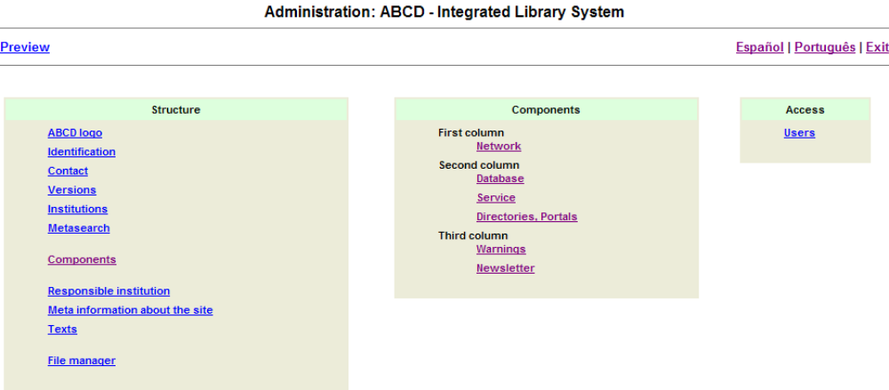

- The Structure elements
Structure refers to the ‘infrastructure’ of the ABCD Site elements : nomenclature, labels, languages, content access control (information sources, topics and communities) and to annexes (highlights and notices) etc.
- The Components
Components refer to the actual contents (information sources, topics and communities) which will be available in the ABCD interface.
- Access
Access refers to the access mode of the producers responsible for information, updates and validations of the content of the site.

General tools
These relate to features available in any ABCD content management window, whether in STRUCTURE, COMPONENTS or ACCESS. Each service box helps us to design the website as per our need, e.g. to add items according to the type of contents existing that section, modify content, delete content and save the changes made in that section and records them into the interface files. Item-lists list the items according to the type of content existing in the section. The information is shown in a hierarchical way, determining how it is displayed in the ABCD site. Up and Down arrows enable us to change the sequence, while left-right arrows allow to position the item correctly in the hierarchy of the page.

Specific tools:
These vary according to the type available for each component of the system. To illustrate the multitude of possible elements we list them here with a very brief description.
The Structure Area Management:
- ABCD Logo: adds URL of the logo and URL for the responsible organization providing ABCD. Local images and logo’s will add a lot to a ‘localized’ look-and-feeling of the site.
- Identification: Identifies the ABCD name that will be displayed in the banner and at the top of the administration system page.
- Contact: enables to add E-mail to contact the person(s) responsible for ABCD. More than one address can be registered, which in the public interface will be selected via a box, in the form.
- Version: makes available public interfaces in other languages. English, French, Spanish and Portuguese language interfaces are available currently in the administration module. One can add other languages too, up to 9 in total.
- Institution: enables to add institutions name, image/logo and link for reference
- Meta-information: identifies and enables changing labels of research services available on the public interface.
- Responsible institution: enables to enter data for contacting the institution in charge of the Site, address and phone no.,etc on the site footnote.
- Meta information of the site: is the space for ABCD’s brief description, which will allow the ABCD to be indexed and retrieved by web browsers. Enables description by author, keyword and description,etc. figure shows how easy to add information in the site
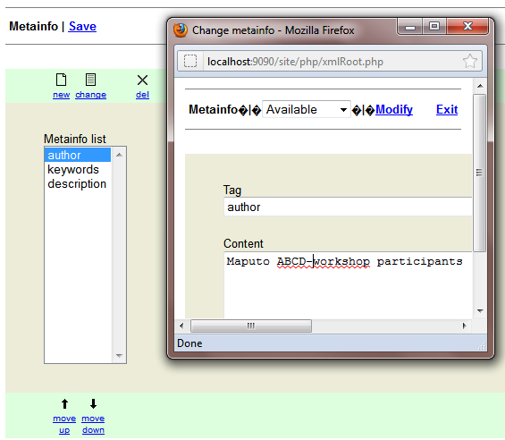
- Texts: manages the list comprising all labels and image URLs that identify common actions and areas of the ABCD site, other than the search services. A lot of localization re language and terminology is possible here.
File manager: allows the uploading of local files to a dedicated are of the server into a directory which can be defined by the manager.
- The administrator can filter the type of files admitted to upload, modifying the variable in the configuration file.
It is recommended to design a clear strategy of filing archives in this area classifying them by type. If there were a lot of files of the same class, it is recommended to prepare a balanced hierarchical structure, so that there are not too many files in a folder at the same level.

B. Components: This part of the Site enables administration of the system via “columns” subdivided into components (or content types), with no limits as to the number of component inside each one of them in that:
Column 1 – links to other Libraries or related portals.
Column 2 – collection of ABCD information sources (local as well as non-local).
Column 3 – space available for highlights, news, etc.
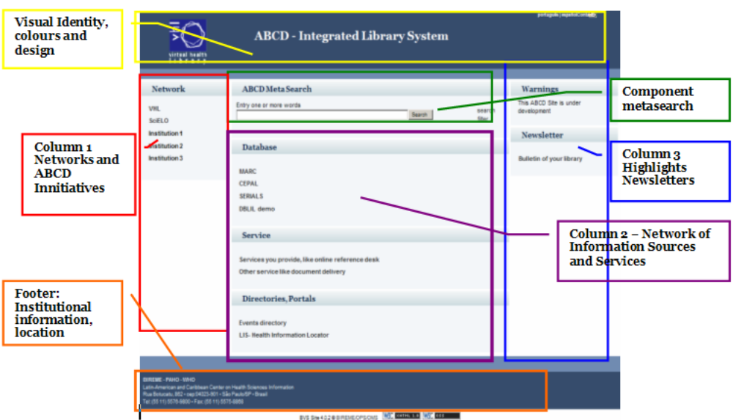A basic list of the 3 ABCD Site columns is illustrated below. By clicking on any of these, more detailed settings can be edited while the CMS itself will translate all these settings into the proper HTML-coding.
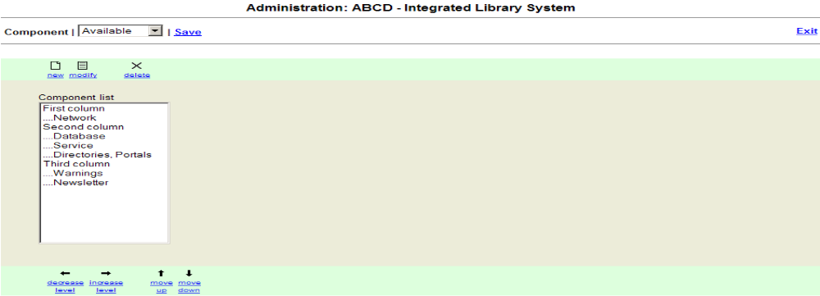
Sources collection for the meta-search
This is probably the most important – therefore central – part of the Site : ABCD-based resources can be included into the list, making them part of the ‘meta-search’ integrated approach (the search key will be searched in all listed and active resources with results displayed separately). 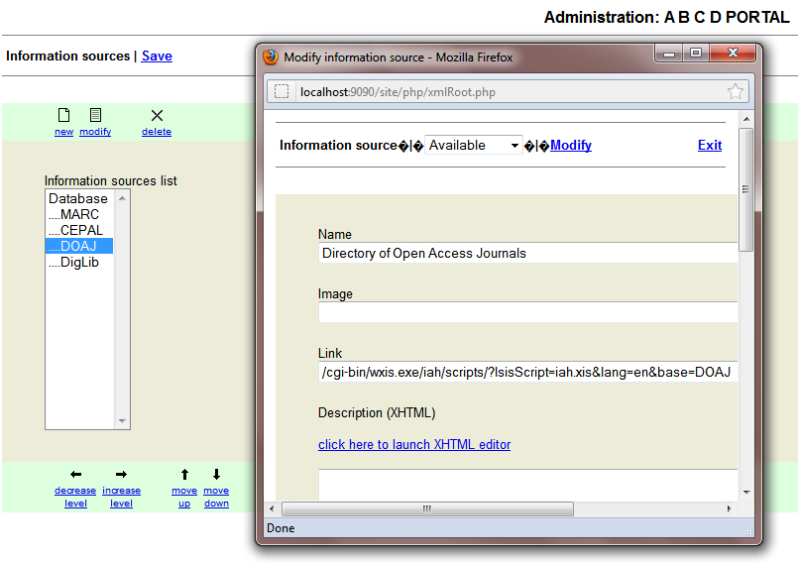
Its output on the site will be something like e.g. : (example taken from the Virtual Health Library)
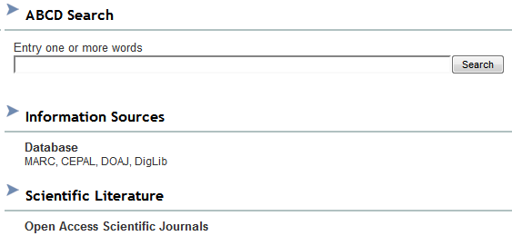

Portal web page : The ABCD Site can be used to contain links to second level pages (therefore acting as a portal), edited in XHTML (with a built-in easy HTML-editor). An example from the VHL is shown here :
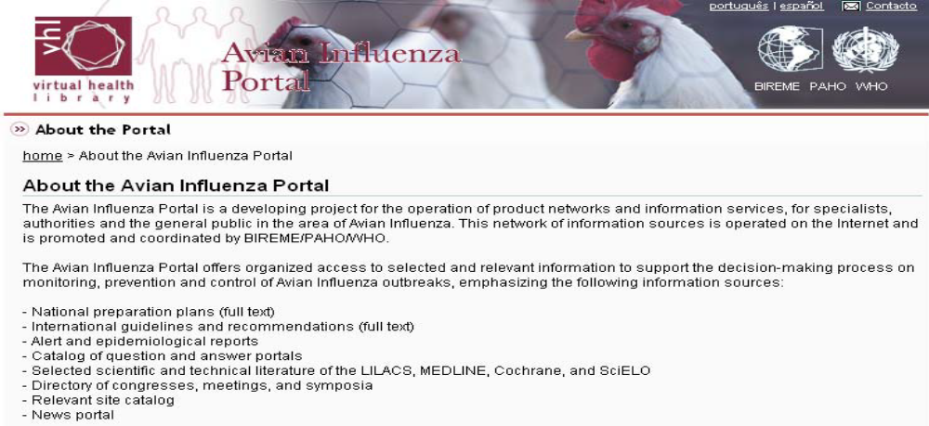

Communities
Enables the registration of a specific Community information resource such as virtual communities, forums, etc.
Portals
Collection of links to other web portals related to ABCD.
RSS
Creates a link with news agencies that make the RSS feature available to users.

An example for a typical element in this communication area of ABCD Site is shown here, as a result of copy/pasting some commonly available HTML-code for Twitter and Facebook into the dedicated XHTML-editor field of the CMS (shown in right part of the illustration) :
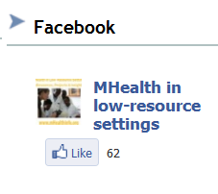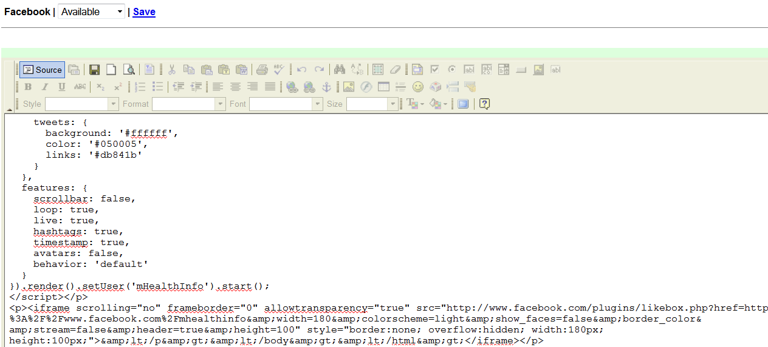

C. ACCESS management
This last part refers to the management and control of users, passwords and those responsible for the administration of ABCD. In this section, one may add, edit or delete the registration of users and passwords to limit the management of the Interface.

Dealing with the graphical design
Since ABCD uses CSS-techniques all the way, it is relatively easy to change the overall ‘style’ or ‘theme’ of the website, e.g. by adding background pictures, colors and other graphical elements. A discussion of this would lead us too far here, but a comprehensive ‘ABCD Site graphic design’ manual is available at the ABCD-download pages (http://bvsmodelo.bvsalud.org/php/level.php?lang=en&component=27&item=13#Manuals).

Some examples
Esp. in the context of the ‘Virtual Health Library’ in many Latin American countries one can find many websites created with this CMS, which became integrated into ABCD as the ABCD Site CMS. Although, as is intended, with many different layouts and contents, one can mostly still easily recognize the main basic 3-parts structure of such a website with the central ‘meta-search’ part somehow built in.
The first example is a full-blown example of BIREME’s VHL site itself.
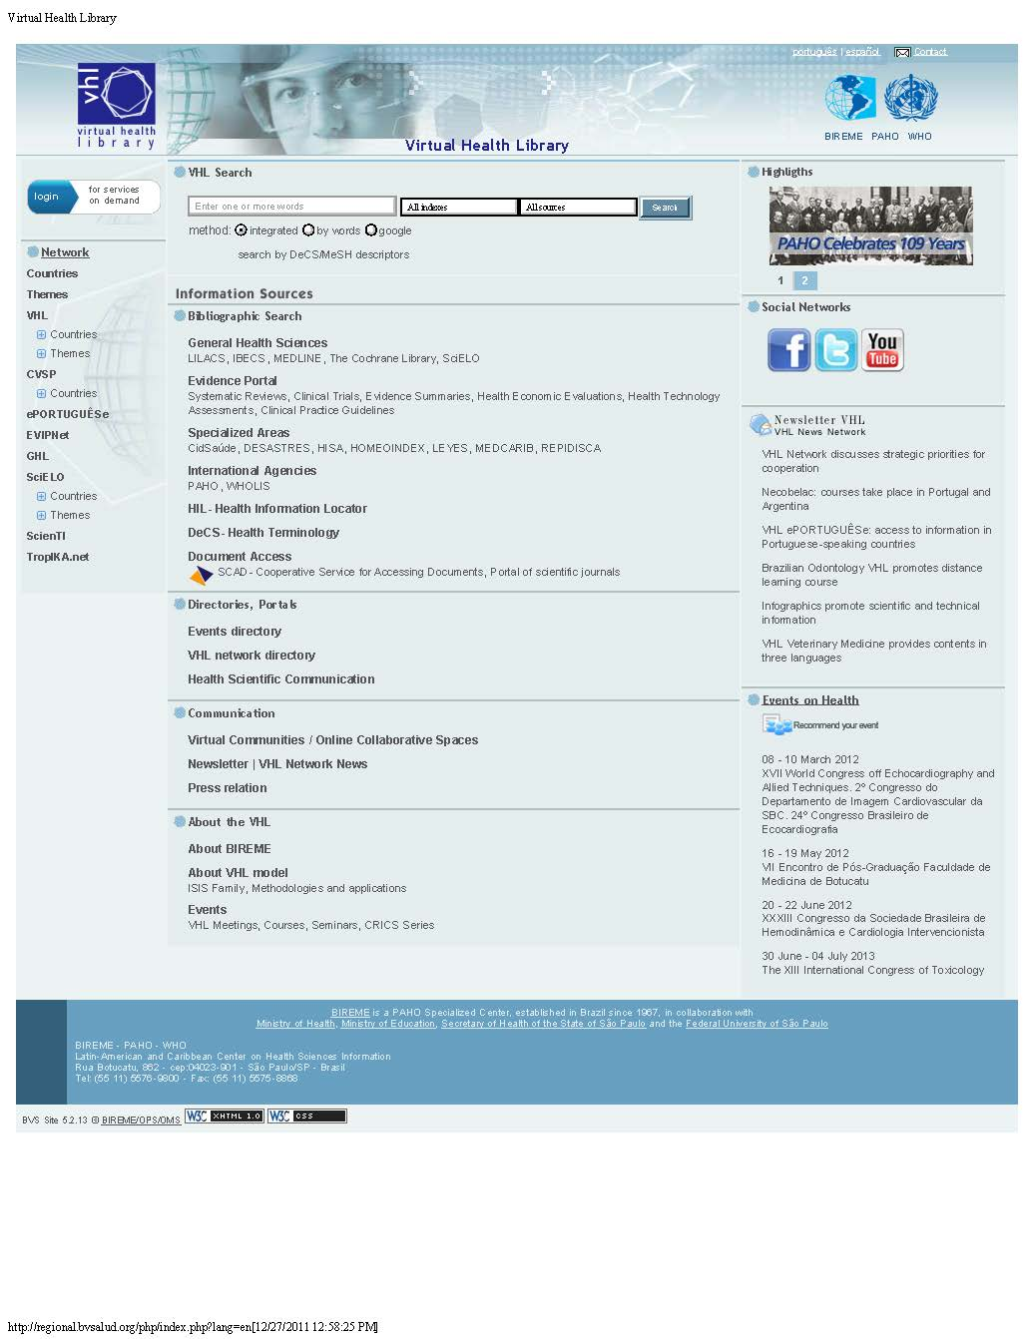
The second example is a more typical one, resulting from a mere 2-hours session on the ABCD-Site in a typical ABCD-workshop (in this case a workshop in Maputo, Mozambique, December 2011), where all the elements were created by the participants as a hands-on training on ABCD.

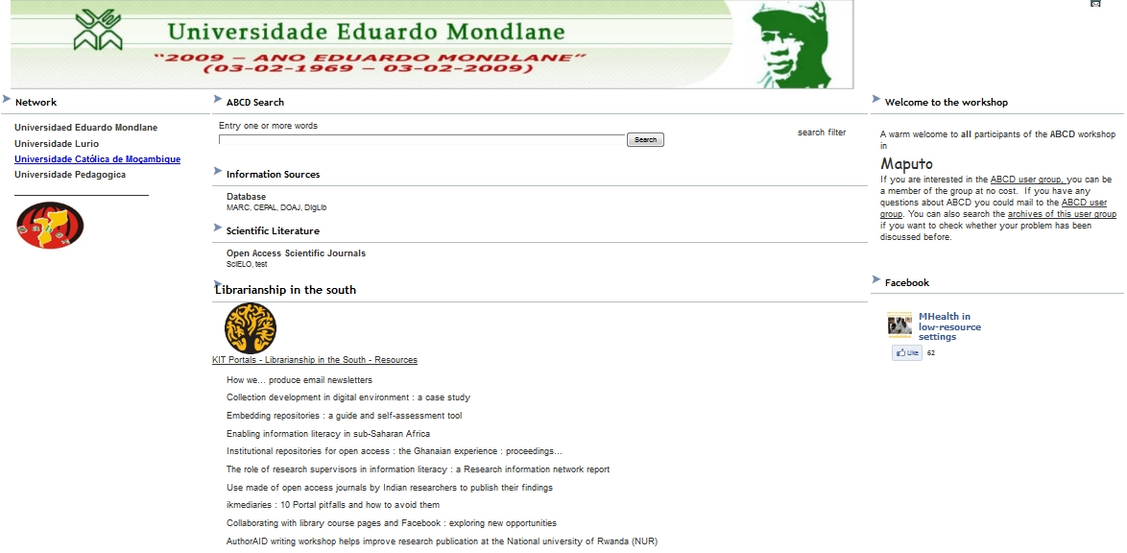

Conclusion

The ABCD Site CMS is suitable for all types of libraries in developed and developing countries. The example of Virtual Health Library and their allied libraries mentioned above illustrates its excellent functionality, presenting a wealth of information sources around its own ‘metasearch’ core for availing local information. As this tool is for libraries in any type of institutes and quite easy to manage and create, it can be used to publish and share all types of information and library services.

References:
- Howarth, L (2003). Metadata Schemas for Subject Gateways. Paper presented at World Library and Information Congress: 69th IFLA General Conference and Council.1-9 August 2003, Berlin.
- Poll, R(2007). Evaluating the library website: Statistics and quality measures. Paper presented at WORLD LIBRARY AND INFORMATION CONGRESS: 73RD IFLA GENERAL CONFERENCE AND COUNCIL.19-23 August 2007, Durban, South Africa.
- Emde, J and et.al.(2009). Testing an academic library website for usability with faculty and graduate students. Evidence Based Library and Information Practice 2009, 4:4
- Jasek, C(2004). How to Design Library Web Sites to Maximize Usability. Pamphlet#5. Library Connect. ELSEVIER. San Diego, CA 92101, USA.
- BIREME (2010) ABCD site administration manual. Available at http://bvsmodelo.bvsalud.org/download/abcd/manuais/ABCD-Site-Manual.4.0_en-OfficialVersion.pdf
- De Smet, E. (2009) ‘-ABCD: a new FOSS library automation solution based on ISIS, Information Development 2009 25: 61-67

