Practical – 4

* Aim: Implement ***Geolocation API*** to retrieve the user's current location.

<!DOCTYPE html>

<html lang="en">

<head>

<meta charset="UTF-8">

<meta name="viewport" content="width=device-width, initial-scale=1.0">

<title>Geolocation API Example</title>

</head>

<body>

<h1>Your Current Location</h1>

<p id="location">Click the button to get your location.</p>

<button onclick="getLocation()">Get Location</button>

<script>

function getLocation() {

if (navigator.geolocation) {

navigator.geolocation.getCurrentPosition(showPosition, showError);

} else {

document.getElementById("location").innerHTML = "Geolocation is not supported by this browser.";

}

}

function showPosition(position) {

let lat = position.coords.latitude;

let lon = position.coords.longitude;

document.getElementById("location").innerHTML = `Latitude: ${lat}, Longitude: ${lon}`;

}

function showError(error) {

document.getElementById("location").innerHTML = "An error occurred while retrieving the location.";

}

</script>

</body>

</html>

Output:  
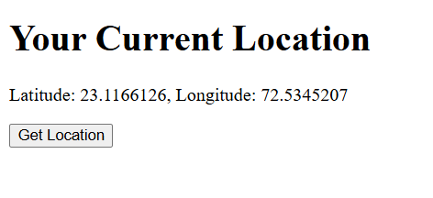

* Aim: Implement JavaScript to interact with the **Local Storage**

<!DOCTYPE html>

<html lang="en">

<head>

<meta charset="UTF-8">

<meta name="viewport" content="width=device-width, initial-scale=1.0">

<title>Local Storage</title>

</head>

<body>

<h1>Local Storage</h1>

<input type="text" id="name" placeholder="Enter your name">

<button onclick="saveName()">Save</button>

<button onclick="loadName()">Load</button>

<p id="savedName"></p>

<script>

function saveName() {

let name = document.getElementById("name").value;

localStorage.setItem("userName", name);

alert("Name saved to local storage!");

}

function loadName() {

let name = localStorage.getItem("userName");

if (name) {

document.getElementById("savedName").innerText = `stord name is = ${name}!`;

} else {

document.getElementById("savedName").innerText = "No name found in local storage.";

}

}

</script>

</body>

</html>

Output:  
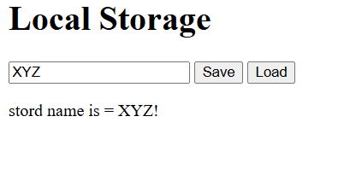

Aim: Demonstrating the **Drag and Drop API**

<!DOCTYPE *html*>

<html *lang***=**"en">

<head>

  <meta *charset***=**"UTF-8">

  <meta *name***=**"viewport" *content***=**"width=device-width, initial-scale=1.0">

  <title>Drag and Drop Example</title>

  <style>

    div{

        align-items**:** center**;**

    }

*#dragElement* {

      width**:** 100px**;**

      height**:** 100px**;**

      background-color**:** rgb(203**,** 237**,** 5)**;**

      margin**:** 10px**;**

      cursor**:** pointer**;**

    }

*#dropZone* {

      width**:** 200px**;**

      height**:** 200px**;**

      background-color**:** rgb(0**,** 0**,** 0)**;**

      margin**:** 10px**;**

      position**:** relative**;**

      color**:** white**;**

    }

  </style>

</head>

<body>

  <h1>Drag and Drop</h1>

  <div ***id*=**"dragElement" *draggable***=**"true">Drag me</div>

  <div ***id*=**"dropZone">Drop here</div>

  <script>

    const dragElement **=** document**.**getElementById("dragElement")**;**

    const dropZone **=** document**.**getElementById("dropZone")**;**

    dragElement**.**addEventListener("dragstart"**,** (**event**) **=>** {

      event**.***dataTransfer***.**setData("text"**,** event**.***target***.***id*)**;**

    })**;**

    dropZone**.**addEventListener("dragover"**,** (**event**) **=>** {

      event**.**preventDefault()**;**

    })**;**

    dropZone**.**addEventListener("drop"**,** (**event**) **=>** {

      event**.**preventDefault()**;**

      const data **=** event**.***dataTransfer***.**getData("text")**;**

      const draggedElement **=** document**.**getElementById(data)**;**

      dropZone**.**appendChild(draggedElement)**;**

    })**;**

  </script>

</body>

</html>

output:  
