**Roll No. 24BCE532  
Name: Vaghani Nigam mohitbhai**

**Sub: FSWD**

Practical – 1

* **Demonstrate JavaScript code embedded within the HTML file.**

<!DOCTYPE html>

<html lang="en">

<head>

<meta charset="UTF-8">

<meta name="viewport" content="width=\, initial-scale=1.0">

<title>Document</title>

</head>

<body>

<button id="btn" onclick="add()">ADD</button>

<button onclick="sub()">SUBTRACT</button>

<h3 id="value">0</h3>

<script>

let bol = true;

function add(){

let valu = parseInt(document.getElementById("value").innerHTML);

document.getElementById("value").innerHTML = valu + 1;

let valu2 = document.getElementById("value");

document.getElementById("btn").style.boxShadow = "2px 2px 5px black";

if(valu >= 0){

valu2.style.color = 'black';

}

}

function sub(){

let valu = parseInt(document.getElementById("value").innerHTML);

if(valu != 0){

document.getElementById("value").innerHTML = valu - 1;

}

if (valu == 0){

let b = document.getElementById("value");

b.innerHTML = valu- 1;

b.style.color = 'red';

}

}

console.log(document.getElementById('value').innerHTML);

console.log(document.getElementById('value').innerText);

const obj = {"name" : "nigam"};

</script>

</body>

</html>

Output:  
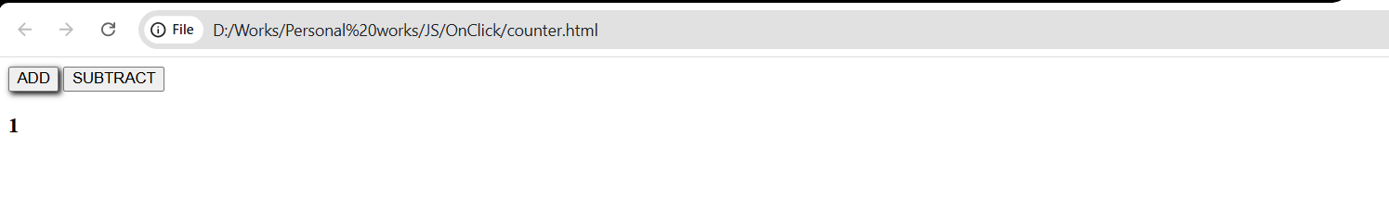

* **Install Node.js: Download and install Node.js from nodejs.org.**

1. Install Node.js: Download and install Node.js from nodejs.org.

2. Run the setup file and follow the default installation steps.

3. Check the installation by typing node –version in the terminal.

4. Verify the version of Node.js installed; an error indicates a problem.



* **create a “script.js” file to print “Hello world” on the server side\**

console.log("Hello world");

output:



* **create an “app.js” file to create and store JSON Object in the File**

const fs = require('fs');

const obj = {

name: "nigam",

age: 21,

college : "Nirma"

}

var obj_str = JSON.stringify(obj, null, 2);

fs.writeFile('data.json',obj_str, (err) =>{

if(err){

console.log("ERROR");

}

else{

console.log("Confirm");

}

})

Output:  
Data.json

{

"name": "nigam",

"age": 21,

"college": "Nirma"

}

Terminal:  
