**kfg g+= ^!^)%##@* btf{ g+= )$÷)&&÷)&\***

**k|b]z g+= ! yf]s pkef]Qmf ljlzli6s[t**

**;xsf/L ;+3 lnld6]8**

**bds (, emfkf**

**k|f/lDes ;fwf/0f ;ef**

**@)&(**

**;~rfns ;ldlt**

**dx]Gb| s'df/ lu/L**

**cWoIf**

k|ltlglw M ;fxf/f g]kfn art tyf C0f ;xsf/L ;+:yf ln=

ldlt M @)&(÷)#÷@^

>L========================================== Ho",

====================================================

laifo M k|f/lDes ;fwf/0f ;DawL ;'rgf .

dxf]bo,

pk/f]Qm ;DaGwdf ;+3sf] ldlt @)&(÷)@÷@^ ut]sf] ;~rfns ;ldltsf] a}+7ssf] lg0f{o cg';f/ o; ;+3sf] k|f/lDes ;fwf/0f ;ef ;+l3o ;xsf/L P]g @)&$ sf] kl/R5]b ^ sf] bkmf $) sf] pkbkmf %, k|b]z ;xsf/L P]g @)&^, k|b]z ;xsf/L lgofdjfnL @)&^, ;+3sf] ljlgod @)&*, k|b]z ;xsf/L /lhi6«f/sf] sfo{non] ljleGg ;dodf hf/L u/]sf] lgb]{zg cg';f/ lgDg laifox?df 5nkmn u/L lg0f{o ug{sf] nfuL ;a} ;]o/ ;b:o ;+:yfsf k|ltlglwx?nfO{ ;fwf/0f ;efsf] a}7sdf ;xeflutfsf] nfuL xflb{s cg'/f]w ul/G5 .

;fwf/0f ;efsf k|:tfjx? M

!= ;~rfns ;ldltsf] k|f/lDes k|ltj]bg kfl/t ug]{ ;DaGwdf .

@= cf=j= )&&÷)&* sf] jflif{s n]vf kl/If0f k|ltj]bg kfl/t ug]{ ;DaGwdf .

#= cf=j= )&*÷)&( sf] nfuL n]vf kl/Ifssf] lgo'lQm tyf kfl/>lds tf]Sg] ;DaGwdf .

$= cf=j= )&*÷)&( sf] gLlt, sfo{qmd tyf ah]6 sfof{Gjogsf] nfuL lhDj]jf/L lbg] ;DaGwdf .

%= clGtd dfOGo'6 k|dfl0ft ug{ k|ltlglw 5gf]6 ug]{ ;DaGwdf .

^= ;+3sf] k|yd clwj]zg ;DkGg ug]{ ;DaGwdf .

&= ljlew .

**;+3sf] ;+lIfKt hfgsf/L**

**gfdM k|b]z g+= ! yf]s pkef]Qmf ljlzli6s[t ;xsf/L ;+3 lnld6]8**

**:yfkgf ldlt M @)&* ciff9 !( ut]**

**btf{ g+= M )$**÷**)&&**÷**)&\***

**btf{ sfo{no M k|b]z ;xsf/L /lhi6«f/ sfo{no, O6x/L, ;'g;/L**

**;+3df cfa4 k|f/lDes ;+:yf M #^ j6f**

**;+3sf] sfo{If]q M k|b]z g+= !**

**;+3sf] xfnsf] r'Stf ;]o/ k'FhL M !,#^,)),)))** ÷–

;+3sf] P

**kl/sNkgf**

* ;xsf/Lx?sf] dfWod 4f/f a:t' tyf ;]jfsf] ahf/Ls/0f u/L lbuf] Aoj;foLs ;+3 ?kdf :yflkt x'g] .

**Wo]o**

* ;xsf/Lx? jLrsf] nufgLaf6 Aoj;flos ;+3sf] ?kdf lrgLg],
* k|f/DeLs ;xsf/Lx? tyf ;xsf/Lsf ;b:ox?nfO{ Aoj;fo ug{ k|f]T;fxg ug]{,
* ;xsf/Lx?nfO{ cfjZos kg]{ s[lif cf}hf/, pks/0f, k|fljlws 1fg / l;ksf] vf]lh ul/ k|f/DeLs ;xsf/Lx? ;Dd k'/\ofpg],
* k|f/DeLs ;xsf/Lx?sf a:t'x? yf]s dfqfdf vl/bul/ a|f08Lª ;lxt ;xsf/Lsf] dfWodaf6 g} las|Lsf] Aoj:yf ldnfpg],
* pTkflbt a:t'x?sf nfuL d]lr b]vL dxfsfnL ;Dd Pp6} a|f08 cGtu{t /lx ahf/sf] la:tf/ ug]{,
* cTofw'lgs k|lalw ;Fu} Aoj;fonfO{ hf]8\b} nfg],

**k|b]z g+= ! yf]s pkef]Qmf ljlzli6s[t ;xsf/L ;+3 lnld6]8, bds (, emfkf**

**k|f/lDes ;fwf/0f ;ef @)&(**

**;+rfns ;ldltsf] tkm{af6 tof/ u/LPsf] cWoIf åf/f k|:t't k|ltj]bg**

k|b]z g+= ! yf]s pkef]Qmf ljlzli6s[t ;xsf/L ;+3 lnld6]8sf] o; k|f/lDes ;fwf/0f ;efdf kfNg' x' g] k|d'v cltly Ho", ljlzi7 cltly Ho", cltly Ho"x?, k|f/lDes ;xsf/L ;+:yfsf cWoIf, Aoj:yfks tyf k|ltlglw Ho"x?, kqsf/ ldqx? ;Dk'0f{df xflb{s :jfut clejfbg JoQm ub{5'.

cf­­ cfkmgf] 9+un] Joj;flos sf/f]jf/ ul//x]sf k|f/lDes ;xsf/Lx?nfO{ Psfsf/ agfP/ pkef]Uo a:t', :6]zg/L tyf 5kfO{, x:tsnfsf ;fdfu|L, s[lif d]lzg/L ;fy} k|f/lDes ;xsf/L tyf z]o/ ;b:ox?sf] pTkfbgnfO{ k|zf]wg tyf ahf/Ls/0f u/L Ps4f/ k|0ffnLsf] lgdf{0f ug]{, h;n] k|f/lDes ;xsf/Lx?sf] Joj;flos sf/f]jf/nfO{ lj:tf/, k|j4{g dfkm{t ;xsf/L ;+:yfx?nfO{ ;jn, ;Ifd, Joj;flos ;+:yfsf ?kdf klxrfg jgfpg] d'n pb]Zo /fvL :yfkgf ul/Psf] o; ;+3sf] k|f/lDes ;fwf/0f ;efdf oxfFx?nfO{ :jfut ug{ kfpbf uf}/fDjLt dxz'; u/]sf] 5' .

;xsf/L cleofgdf ;b:ox?nfO{ Joj;flos agfpg] k|of;x? ePsf] kfOG5 t/ tL k|of;x?n] Joj;flox?sf] ahf/;Dd kx'r gePsf] / clxn] klg ljrf}lnofx?sf] xftdf ahf/ rn]sf] kfOG5 . o;/L ;xsf/L :jodn] jf ;xsf/L z]o/ ;b:ox?n] pTkgbg u/]sf] a:t'x?nfO{ ahf/ ;Dd k'of{pg ;xsf/L s} dfWod lgdf{0f ug'{ ckl/xfo{ /x]sf] 5 . log} a:t'ut ;d:of / cfjZostfx?nfO{ dWogh/ ub}{ /flib|o ;xsf/L dxf;+3sf] kxndf k|b]z g+= ! yf]s pkef]Qmf ljlzli6s[t ;xsf/L ;+3sf] :yfkgf ePsf] xf] . o; k|b]z g+= ! yf]s pkef]Qmf ljlzli6s[t ;xsf/L ;+3sf] k|j4{g tyf Joj;flos sf/f]af/df ;d]t ;xof]u k'of{pg k|ToIf, k/f]If xft dxf;+3sf] /x]sf] 5 . Joj;flos k|j4{gsf] lglDt ljp kFhLsf] ?kdf ? !),)),))) cIf]?kL bz nfv dfq ;xof]u k|fKt ePsf] 5 .

of] ;+3 a:t' tyf ;]jfx?sf] yf]s dfqfdf sf/f]jf/ ug{ :yfkgf ePsf] k|b]z :t/Lo ;+3 xf] . “;xsf/Lsf] pTkfbg, ;xsf/L 4f/f ahf/Ls/0f” eGg] d'n gf/fnfO{ cfTd;fy u/L ;xsf/Lsf] pTkfbgx?nfO{ Pp6} COOP a|f08 cGtu{t pTkfbgnfO{ k|f]T;fxg ub}{ ahf/Ls/0fsf] ;d:ofnfO{ ;dfwfg ug{ o; ;+3sf] :yfkgf ul/Psf] xf] .

cfb/l0fo z]o/ ;b:o ;+:yfsf k|ltlglwHo"x? ca d ;+3n] xfn ;Dd eP u/]sf ultljlw x?nfO{ oxfFx? ;dIf ;+lIfKt ?kdf kz] ug]{ cg'dtL rfxfG5' .

!= **;+3 btf{** **M** @)&*.)#.)( ut] k|b]z ;xsf/L /lhi6f/sf] sfof{nodf k|b]z g+= )! yf]s pkef]Stf ljlzli6s[t ;xsf/L ;+3 ln= sf] gfddf ;+3 btf{ ul/Psf] / sfo{no bds /xg] u/L btf{ ul/Psf] .

@= **:yfO{ n]vf g+= btf{ M** @)&*.)[#.@&](mailto:#.@&) ut]sf lbg cfGtl/s /fhZj sfof{no eb|k'/ emfkfdf :yfoL n]vf gDa/ btf{ ul/Psf] .

#= **cGt/lqmof sfo{s|d ;DkGg M**

s= k|f/lDes ;xsf/L ;+:yfsf k|ltlglw Ho"x?, ;+3 lhNnf ;xsf/L ;+3 jrt ;+3 s[lif ;+3 b'Uw lrof ;+3 /fli6o ;xsf/L a}+ssf] zfvf sfof{no Onfdsf] ;xof]udf /fli6o ;xsf/L dxf;+3sf] pkfWoIf >L /d]z k|;fb kf]v|]nsf] k|d'v cfltYotfdf, dxf;+3s} k|b]z g+= )! OGrfh{ u0f]z 9sfn Ho" sf] ;d]t pkl:ytLdf ldlt @)&*.)%.#) ut] Onfd lhNnfdf cGt/lqmofTds sfo{qmd ;+rfng ul/of] .

v= lhNnf ;xsf/L ;+3 emfkfsf] ;+of]hgdf emfkf lhNnfsf] dfOk'j{df /x]sf k|f/lDes ;xsf/Lsf k|ltlglw ljr ! lbjl;o cGt/lqmofTds sfo{qmd ;fxf/f g]kfn art tyf C0f ;xsf/L ;+:yff ln= sf] ;efxndf ldlt @)&*.)^.!$ ut] sfo{qmd ;DkGg ul/of] .

u= df]/8 lhNnfsf] lj/f6rf}s If]qdf k|f/lDes ;xsf/Lx? ljr ! lbg] ;xsf/L cGt/lqmofTds sfo{qmd /fli6o ;xsf/L a}+s lj/f6rf}s zfvfsf] ;xof]udf /fli6«o ;xsf/L dxf;+3sf] pkfWoIf >L /d]z k|;fb kf]v|]n Ho"sf] k|d'v cfltYotfdf ;DkGg ul/of] h;df ^! j6f k|f/lDes ;xsf/Lx?sf] k|ltlglw Ho"x?sf] pkl:ytLdf ldlt @)&*.!).!$ ut] ;DdGg ul/of] .

^= s[lif cf}hf/ pks/0f :6]zg/L ;fdfu|L jhfl/s/0fsf] sfd k|f/De u/]sf] .

s]xL s[lif cf}hf/ pks/0fx? tyf :6]zg/Lsf] tl:j/x?===

&= **6]**«**8dfs{ btf{ M** @)&(.)#.)^ ut] pBf]u ljefu lqk'/]Zj/ sf7df08f}df Alpine the coops brand” gfdsf] 6]8{ dfs{ btf{sf] k|s[of cuf8L a9fOPsf] 5.

*= vfB k|ljlw tyf u'0f lgoGq0f sfo{nodf vfB cg'1fkq lngsf] nfuL k|s[of cuf8L a9fOPsf] 5 .

(= k|f/lDes ;xsf/L ;+:yfx?sf] cyf]{8S;, l;=l6=;L= lrof vl/b ul/ Kofls8 / ahf/Ls/0fsf] sfd z'? ul/Psf] 5 .

!)= k|b]z yf]s pkef]Qmfsf] Jofkfl/s k|df]zgsf nflu /fli6o lrof tyf slkm ljsf; jf]8{n] cfof]hgf u/]sf] /fli6o lrof tyf slkm k|bzlgdf @)&(.)#.)# / )$ ut] ?kGb]xLsf] a'6jndf ;xeflutf hgfOPsf] .

!!= Joj;flos sf/f]jf/sf nfuL Joj;flos ;du|L vl/b ubf{ klg k|f/lDes ;xsf/L tyf ;b:ox?af6 ug]{ / ljlqm ubf{ klg ;xsf/L dfkm{t ug]{ eGg] d'n dfGotfdf cfwf/Lt /lx jhf/Ls/0fsf nflu lhNnf ;xsf/L ;+3 dsjfgk'/, lhNnf b'Uw ;xsf/L ;+3 dsjfgk'/ ;Fu cGt/lqmof ;DkGg ul/ l;=l6=l;= lrof, lu|g l6 tyf dfofsf lrgf]x? pQm :yfgdf pxfFx?sf] g]t[Tjdf ahf/Ls/0f k|f/De ug]{ jftfj/0f jgfOPsf] 5 .

!@= lhNnf ;xsf/L ;+3 lrtjg ;+u pxfFx?sf] pTkfbg z'4 tf]/Lsf] t]n k|b]z )! leq ljlqm ljt/0fsf nflu cflwsfl/s sf/f]jf/ o; k|b]z g+= )! Yff]s pkef]Qmf dfkm{t ug]{ u/L ;demfbf/L cuf8L a9fOPsf] 5 .

!#= emfkfsf] ;xf/f ;tf;L dlxnf df}/L dx pBf]un] pTkfbg u/]sf] # k|sf/sf] dxx? Tff]/L, kmfk/ / h+unL dxsf] ahf/Ls/0f ug{ cfkm\gf] a|f08sf] n]jn nufO ljlqm ljt/0fsf nflu ;dembf/L ePsf] 5 .

!$= ?kGb]xL lhNnf ;xsf/L ;+3 dfkm{t k|f/lDes ;xsf/Lsf] pTkfbgx?sf] Ps csf{df ljlqm ljt/0fsf nflu cfk;L ;dembf/L ePsf] 5 .

!%= ;+3n] sf7df08f}+ cjl:yt 3/]n' x:tsnf s]Gb| ;Fu x:tsnf ;Dalwt ;fdu|Lx? Hf:t} dfofsf] lrgf], laleGg cfsif{s l8hfOgsf k|m]dx? pTkfbgsf nfuL ;Demf}tf u/L las|L lat/0f ;'? u/]sf] 5 .

x:tsnf ;fdu|Lx?sf] s]xL tl:j/x?===

!^= ;]So'l/6L lk|lG68 nflu af3 e}/j ;]Do'l/6L k|]; ;+usf] ;Demf}tf dfkm{t r]ssf] lk|G6L8sf] sf/f]jf/ z'? ul/Psf] 5 .

!&= g]kfln sfuhsf] pTkfbgsf nfuL lqz'n xft] sfuh pBf]u ;Fu ;Demf}tf eO{ las|L lat/0f ;'? u/]sf 5 .

!*= ;+3sf] sf/f]af/ ;xh agfpgsf nfuL O hf]g sDkgLsf] Accounting Software k|of]u ug{ yflnPsf] 5 .

!(= l;4fy{ a}+sdf ;+3sf] vftf vf]nL pQm vftf dfkm{t cfoft tyf lgof{tsf nfuL Exim Code lnPsf] 5 .

@)= ;+3n] lrofsf] u'0f:t/ dfkg ug{ lrof laz]if1 /fvL u'0f:t/ dfkg u/L Alpine gfds a|f08df las|L lat/0f ;'? u/]sf] 5 .

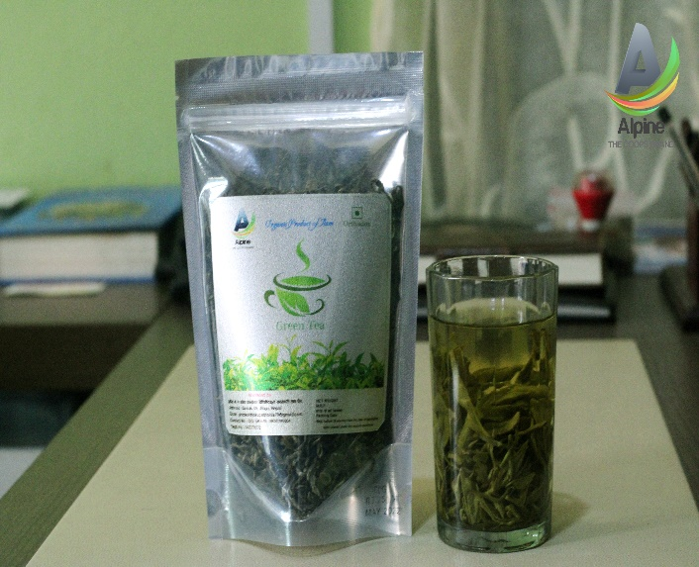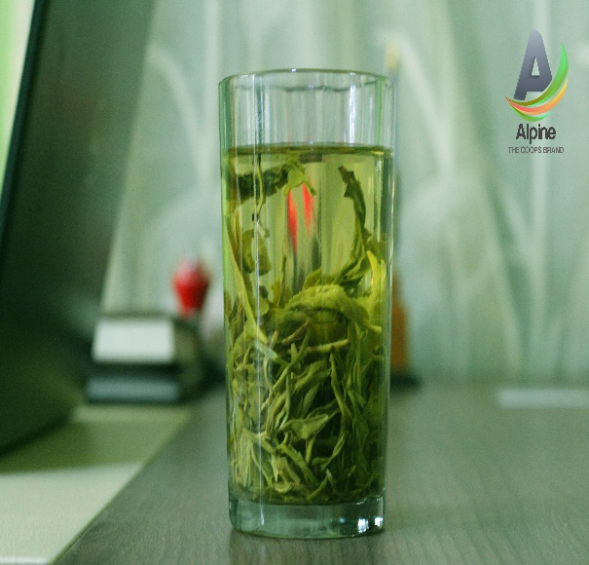lrofsf s]xL tl:j/x?===

**k|b]z g+= )! yf]s pkef]Stf ljlzli6s[t ;xsf/L ;+3 ln=**

**cf=j= )&(÷)*) df ;+rfng ug]{ k|:tfljt sfo{qmdx? M**

!= z]o/ ;b:otf M o; ;+3df xfn #^ ;+:yf ;b:o /x]sf] / o; cf=j=df !)) j6f agfOg]5 .

@= z]o/ kF'hL M o; ;+3sf] xfn z]o/ kF'hL !,#^,)),)))÷– /x]sf] / o; cf=j=df @,)),)),)))÷– k'of{Og]5 .

#= z]o/ ;b:o, k|f/lDes ;xsf/Lx?, lhNnf ;xsf/L ;+3, art ;+3, b'Uw ;+3, s[lif ;+3, ljlzli6s[t ;+3x? ;Fu Jofkfl/s ;Demf}tf dfkm{gb v t yf]s sf/f]jf/sf] yfngL ul/g]5 .

$= vfBfGg cGtut{ xfn ;+rfng u/sf Green Tea, Black Tea, CTC Tea, dx, z'4 tf/Lsf] t]n nufotsf pkef]Uo a:t'x? cfjZostf cg';f/ “ALPINE THE COOPS BRAND” a|f08df Kofs]lhË tyf ahfl/s/0f u/L lj:tf/ ul/g]5 .

%= lrtjg lhNnf ;+3 ;+usf] z'4 tf]/Lsf] t]nnfO{ k|b]z g+= )! leqsf] cflwsf/Ls yf]s ljqm]tfsf] dfWodaf6 x/]s k|f/lDes ;xsf/L dfkm{t z]o/ ;b:o ;Dd k'¥ofpg] cleofg rnfOg]5 .

^= k|f/lDes ;xsf/LnfO{ cfjZos kg]{} :6]zg/Lsf ;fdfu|Lx?, 5fkfvfgfsf] sfd Ps4f/ k|0ffnLaf6 ;/n, ;xh, ;j{;'ne cuf8L a9fOg]5 .

&= afu e}/j ;]So'l/6L k|]; ;+usf] sf/f]jf/nfO{ lg/Gt/tf lbb} cem lj:tf/ ub}{ nlug]5 .

*= cf=j= )&(.)*) sf] z'?jft jf6 g} 9'jfgL ;fwgsf] Joj:yf u/L ;xh 9'jfgLsf] Joj:yf ldnfOg]5 .

(= dx]Gb| /fhdfu{ xfOj]df g} o; yf]s pkef]Qmfsf] Display ;f]?d :yfkgf ul/g]5 .

!)= “;xsf/Lsf] pTkfbg ;xsf/Lsf] k|j4{g” eGg] gf/fnfO{ ;fsf/ kfg{ k|f/lDes ;+:yfx?sf pTkfbgx?nfO{ yk a|fl08ª, Kofs]lhª ub}{ Joj;flos sf/f]af/ cuf8L a9fpg] / 9'jfgL ;fwgsf] nfuL k|b]z g+= ! s[lif, e'ld, ;xsf/L tyf ul/aL lgjf/0f dGqfno ;Fu ;jf/L ;fwg dfu ul/g]5.

!!= o; ;+3sf] Joj;flos sf/f]af/nfO{ la:tf/ ug{ yk ahf/ k|ltlglw (Marketing Staff) /flvg]5 .

!@= /fli6o ;xsf/L a}+snfO{ o; ;+3n] k|Ztfj ul/ l:js[t ePsf] ahf/sf] ;DefJotf cWofog tyf /0flglts of]hgfsf] sfdnfO{ cl3 a9fOg]5 .

!#= ahf/Ls/0fdf oL # j6f If]qnfO{ k|yldstfdf /flvg]5 .

* + vfBfGo ;fdu|Lsf] ahf/Ls/0f
  + :6]zg/L, 5kfO{, tyf dfofsf] lrgf]sf] ahf/Ls/0f
  + s[lif oGq, pks/0fsf] ahf/Ls/0f

!$= Kof]lhª ;xh agfpgsfnfuL Kof]lhª d]l;g ylkg]5 .

!%= o; yf]s pkef]Qmf ljlzli6s[t ;xsf/L ;+3sf] sf/f]jf/nfO{ lj:tf/ ug{ k|b]z g+= ! sf !$ j6f} lhNnf ;+3x? ;Fu cGtlqmofTds sfo{s|d ;+rfng ul/g] 5 .

!^= /flib|o ;xsf/L a}+s ;Fusf] k|:tfj l:js[t eP cg';f/ o; k|b]z g+= ! yf]s pkef]Qmf ljlzli6s[t ;xsf/L ;+3sf] Joj;flos ;DefAotf cWofog tyf /0flglts of]hgf cfufdL cf=j= leqdf ;DkGg ul/g] 5 .

**k|b]z g+= )! yf]s pkef]Qmf ljlzli6s[t ;xsf/L ;+3 ln=**

bds, emfkf

)&( h]i7 d;fGt

cfo Joo ljj/0f

|  |  |  |
| --- | --- | --- |
| **qm=;=** | **ljj/0f** | **/sd** |
| ! | las|L cfDbfgL | #*&((#)=)# |
| @ | cGo cfDbfgL dxf;+3 af6 k|fKt | $((@) |
| # | Aofh /sd | $*(@)&=(( |
| $ | 5'6 k|fKt | %!)$ |
|  | **s'n k|ToIf cfDbfgL** | **$$@$!^@=)@** |
| % | nfut vr{ | #$&(&^)=#% |
|  | **s'n gfkmf, gf]S;fg** | **($$$)!=^!** |
| ^ | vfgf, kfgL | ##$^% |
| & | OG6/g]6 | !^&&@ |
| * | lalaw vr{ | #!!^) |
| ( | sfo{no vr{ | @)$%$ |
| !) | 3/ ef8f | !!&))) |
| !! | ;km\6j]o/ | @)))) |
| !@ | 6]lnkmf]g dx;'n | $&#% |
| !# | otfot vr{ | !))(% |
| !$ | 9'jfgL vr{ | $!(%$ |
| !% | sd{rf/L tnj | ^)&^!%=( |
|  | **s'n ck|ToIf vr{** | **()#@%)=(** |
|  | **v'b gfkmf, gf]S;fg** | **$!!%)=&&** |

**k|b]z g+= )! yf]s pkef]Qmf ljlzli6s[t ;xsf/L ;+3 ln=**

bds, emfkf

)&( h]i7 d;fGt

jf;fnft

|  |  |  |
| --- | --- | --- |
| **qm=;=** | **k'FhL tyf bfloTj** | **/sd** |
| ! | Z]fo/ k'FhL | !#^))))) |
| @ | ;b:otf z'Ns af6 k|fKt /sd | %!))) |
| # | 3'DtL sf]if af6 k|fKt /sd cg'bfg | !)))))) |
| $ | e'QmfgL lbg' kg]{ /sd cg';'rL ! | $^%#*&=&$ |
| % | s/ bfloTj Eof6 | -!!!!$=&(_ |
| ^ | v'b Gffkmf, gf]S;fg | $!!%)=&& |
|  | s'n k'FhL tyf bfloTj | !%!$^$@#=&@ |
| **qm=;=** | **;DktL** | **/sd** |
| ! | a}+s df}hft | !))^%&%&=#$ |
| @ | gut df}hft | !@!@) |
| # | e'QmfgL kfpg' kg]{ /sd cg''';'rL @ | %@&!&$=## |
| $ | cu|Ld e'QmfgL | !@)^^#( |
| % | df}Hbft ;fdu|L | @@()!!#=)% |
| ^ | z]o/ nufgL /fli6o ;xsf/L a}+s ln= | !))%)) |
| & | l:y/ ;DktL cg';'rL # | ($$!@) |
|  | s'n ;DktL | !%!$^$@#=&@ |

**k|b]z g+= )! yf]s pkef]Qmf ljlzli6s[t ;xsf/L ;+3 ln=**

bds, emfkf

cfj4 ;xsf/L ;+:yfx?sf] gfdfjnL

|  |  |  |  |  |  |  |
| --- | --- | --- | --- | --- | --- | --- |
| **qm=;=** | **;+:yfsf] gfd** | **7]ufgf** | **k|ltlglwsf] gfd** | **kmf]g g+=** | **Od]n 7]ufgf** | **nufgL /sd** |
| ! | ;fxf/f g]kfn art tyf C0f ;xsf/L ;+:yf ln= | ljtf{df]8, emfkf | dx]Gb| s'df/ lu/L | (*%@^&@%!$ | ceo@saharanepal.coop.np | !),)),))) |
| @ | k"j{ g]kfn a=;=;=ln= | sdn, emfkf | k|]d ;fksf]6f | (*%@^@)#@! | Purbanepal.manager@gmail.com | %,)),))) |
| # | d]rL apb]ZoLo ;xsf/L ;+:yf ln | bds, emfkf | vf]d s'df/ aufn] | (*%@^&^%)# |  | %,)),))) |
| $ | OGb|]0fL a=;=;=ln= | sdn, emfkf | 6]s]Gb| s'df/ >]i7 | (*$@^%!^#) | indrenicooperative@yahoo.com | %,)),))) |
| % | gjf]bo j=;=;= ln= | sdn, emfkf | z/0f s'= k/fh'nL  kml8Gb| sfsL{{ | (*$@^@)%^^ | [navodaya4434@gmail.com](mailto:navodaya4434@gmail.com) | %,)),))) |
| ^ | gjb'uf{ a=;xsf/L ;+:yf | bds, emfkf | k|]d s'df/ sf]O/fnf | (*$@^#)!!) | nawadurgacoop@gmail.com | %,)),))) |
| & | :j0f{nIdL art tyf C0f ;xsf/L ;+:yf ln= | bds, emfkf | sdn l3ld/] | (*%@^*#&&( | swornalaxmidamak@gmail.com | %,)),))) |
| * | o'lgs jrt tyf C0f ;xsf/L ;+:yf ln= | bds, emfkf | s]jnL/fd cfrfo{ | (*%@^&)^^$ | uniquecop@yahoo.com | %,)),))) |
| ( | klAns jrt C0f ;xsf/L ;+:yf ln= | latf{df]8, emfkf | k|ldnf uf}td | (*$@^$*#% | cooperativepublic@gmail.com | %,)),))) |
| !) | z'enIdL ;xsf/L ;+:yf ln= | uf}/fbx, emfkf | x]drGb| l3ld/] | (*%@^&^@&! | [subhalaxmi023@gmail.com](mailto:subhalaxmi023@gmail.com) | %,)),))) |
| !! | lbuf]kg ;fdflhs pwd dlxnf ;+3 ln= | ;'Gb/x/}rf, df]/Ë | /msd0fL sfsL{ | (*^@#!%@!@ |  | !,)),))) |
| !@ | b'u}{Zj/L s[lif ;xsf/L ;+:yf ln= | d]rLgu/, emfkf | las|d d]r] | (*$@&!()$( | Durgeshori.sahakari@gmail.com | !,)),))) |
| !# | >L Pstf ax'pb]ZoLo ;xsf/L ;+:yf ln= | xlNbaf/L, emfkf | lg/fh kf]v|]n | (*$@&!^$%% | emchaldibari@gmail.com | %,)),))) |
| !$ | la/f6ch'{g pkef]Qf ;xsf/L ;+:yf ln= | ljtf{df]8, | e'ldsf l3ld/] | )@#%()(@$ | biratarjun@gmail.com | !,)),))) |
| !% | >L xf]S;] s[lif ;xsf/L ;+:yf ln= | a'WbzflGt xf]S;] | df]xg k|;fb ltlD;gf | )@#$!^)) | hksakhari03@gmail.com | !,)),))) |
| !^ | ;f}uft ;fsf]; ln= | la/f6gu/ | cg'k :ofª\af] | (*$@)#!%&) |  | %,)),))) |
| !& | u|fdnIdL jrt C0f ;xsf/L ;+:yf ln= | la/f6gu/ | ;Gtf]if d08n | (*$@)@*#%* |  | @,)),))) |
| !* | uf]kfn ax'd'vL ;xsf/L | la/f6gu/ | la/]Gb| s'df/ ofbk | (*%@)@&!(% |  | #,)),))) |
| !( | :6f/ ax'd'vL ;xsf/L | la/f6gu/ | /d]z k|;fb kf]v|]n | (*%@)@!#%@ |  | %,)),))) |
| @) | a/uf5L ax'd'vL ;xsf/L | la/f6gu/ | dfwj c6/L |  |  | #,)),))) |
| @! | s[kfnIdL ;fsf]; | la/f6gu/ | cd[t u'?Ë | (*@%#&!^! |  | #,)),))) |
| @@ | gjb'uf{ ;fsf]; | Og?jf |  |  |  | %,)),))) |
| @# | ;befj ;fsf]; | /+u]nL | sDn]Zj/ 7fs'/ | (*%@)#)%^& |  | #,)),))) |
| @$ | ;u'g s[lif ;xsf/L ;+:yf | O6x/L | l6sfbTQ jg | (*%@)$**@& |  | %,)),))) |
| @% | emf]/fxf6 ;xsf/L ;+:yf | emf]/fxf6 | laho s'df/ dfemL | (*$@)%(^@! |  | #,)),))) |
| @^ | b'uf{ art tyf C0f ;xsf/L ;+:yf ln= | ;'g;/L | nId0f k|;fO{ | (*%@)%&&%@ |  | #,)),))) |
| @& | gjo'u a= ;xsf/L ;+:yf | Og?jf |  |  |  | %,)),))) |
| @* | zflGt hgsNof0f ;xsf/L ;+:yf | Og?jf |  |  |  | %,)),))) |
| @( | /fi6« ;]js ax'd'vL ;xsf/L ;+:yf | ;'g;/L |  |  |  | !,)),))) |
| #) | dg s'df/ >]:7 | ;'g;/L |  |  |  | !,)),))) |
| #! | hglxt a= ;xsf/L ;+:yf | /fdw'gL |  |  |  | !,)),))) |
| #@ | g]kf a= ;xsf/L ;+:yf | O6x/L | lrqdfg k|wfg | (*$@)@)*%& |  | %,)),))) |
| ## | 8+fkm] jrt C0f ;xsf/L ;+:yf ln= | bds | t'nf/fd Gof}kfg] | (*%@^&)#%! | danphecooperative@gmail.com | %,)),))) |
| #$ | n8 a'Wb ax'd'vL ;xsf/L ;+:yf | O6x/L |  |  |  | #,)),))) |
| #% | ;'gufef ;fsf]; | Onfd | e'jg ;'j]bL |  | Sungava.cooperative@gmail.com | !,)),))) |
| #^ | bds ax'd'vL ;xsf/L ;+:yf | bds | ;'/]Gb| >]i7 | (*%@^(!### | dmultiplec@gmail.com | %,)),))) |

cf=j= )&&,)&* n]vfk/LIf0f k|ltj]bg

cfb/l0fo z]o/ ;b:o k|ltlglw Ho"x?, oxfFx?sf] ul/dfdo pkl:yltsf lardf o; ;+3n] xfn;Dd u/]sf ultljlw / cfufdL cf=j=df k|:tflat sfo{s|dx? af/] oxfFx? ;dIf k]z u/]sf] 5' . o; ;+3sf] :yfkgf ;+u} lgdf{0f ePsf] tby{ ;ldltnfO{ oxfFx?n] ug'{ ePsf] ;fy ;xof]usf lglDt laz]if wGojfb 1fkg ub}{ ca gFof ;+rfns tyf n]vf ;'kl/j]If0f ;ldlt lgdf{0fsf lglDt o; ul/dfdo ;fwf/0f ;efdf k|:tfj k]z ub{5' .

cGTodf cfhsf] ;fwf/0f ;efdf kfNg'xg] k|d'v cltly Ho", ljlzi6 cltly, cltlyx?, k|f/lDes x\;xsf/L ;+:yfsf cWoIf, Joj:yfks tyf k|ltlglw Ho"x?, sd{rf/L ;fyLx?, nufot pkl:yt ;Dk'0f{ dxfg'efjx?df of] ;fwf/0f ;efnfO{ ;Ao, eAo ?kdf ;kmn kfg{ ;xof]u ug'{ x'g] dxfg'efjx?df wGojfb 1fkg ub}{ d]/f] dGtAo olx cGTo ub{5' .

dx]Gb| s'df/ lu/L

cWoIf

\

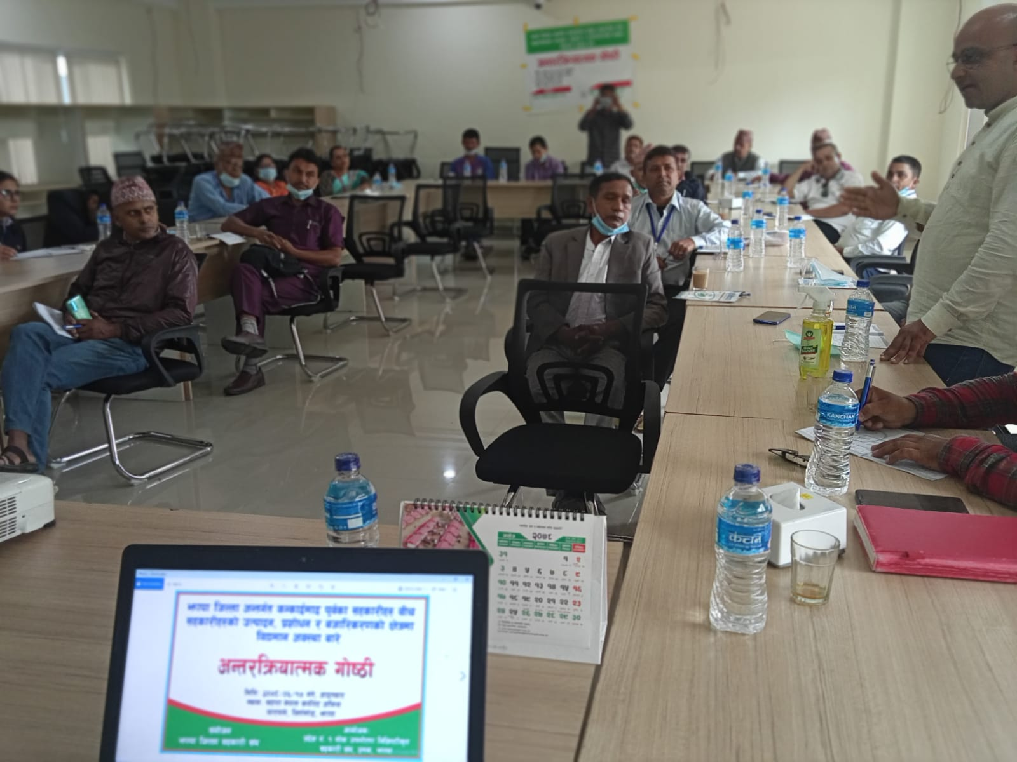**sfo{s|dsf s]xL emnsx?**

cGt/lqmofTds uf]i7L

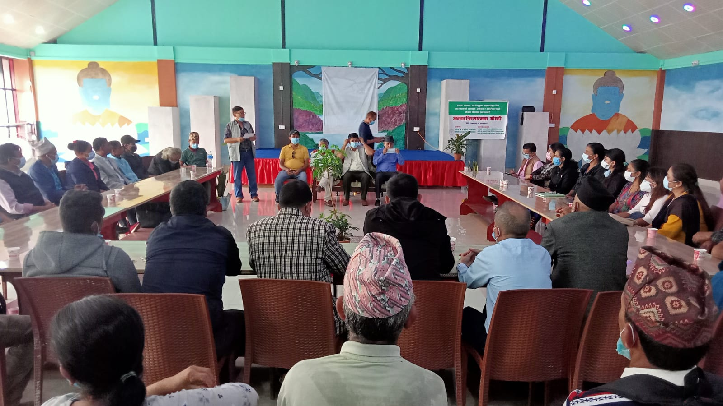latf{df]8

cGt/lqmofTds uf]i7L

Onfd

cGt/lqmofTds uf]i7L

la/f6rf]s

**lrof kl/If0fsf s]xL emnsx?**

