Relevant products for release version 0.2

Product name | Model | Part number
TCU (Sibros stack) | base
Gradient Sensor | base

UI description

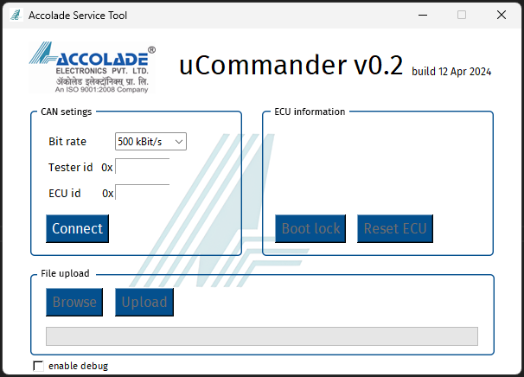

Connection panel

This panel consist of basic CAN connection

Bit rate: 500kbps and 1MBPS is supported
Tester id: This is 29-bit tester id in hex. It is also called as client id. E.g. CDA33F1
ECU id: This is 29-bit ECU id in hex. It is also called as server id. E.g CDAF133
Connect button: It will initialize PCAN hardware with specified configuration

ECU information panel

This panel will display the connected ECU information such as firmware and bootloader version. It is for future provision

Boot lock (TCU only): This is a temporary button provided for locking TCU product into bootloader mode
Reset ECU: Resets the ECU. Option is activated after the file upload is completed at least once

File upload panel

This panel is used for file transfer. The file can be firmware, certificates configuration or other files that bootloader can process

Browse: Option used for browsing the file to upload to target ECU
Upload: Option used for starting the file upload which is browsed and selected previously

Debug enable: This option is used for toggling the debug mode

Usage information

- Obtain PCAN hardware and install necessary drivers
PEAK-System_Driver-Setup.zip
- Refer screen capture for flashing “flashing TCU” for TCU and “flashing Gradient Sensor” for Gradient Sensor projects respectively

