# OR 3: Chapter 4 - Normal Form Games

## Recap

In the [previous lecture](Chapter_04-Dominance.html) we discussed:

* Predicting rational behaviour using dominated strategies;
* The CKR;

We did discover certain games that did not have any dominated strategies.

## Best response functions

### Definition

In an player normal form game. A strategy for player is a best response to some strategy profile if and only if for all .

We can now start to predict rational outcomes in pure strategies by identifying all best responses to a strategy.

We will underline the best responses for each strategy giving:

We see that represented a pair of best responses. What can we say about the long term behaviour of this game?

## Best responses against mixed strategies

We can identify best responses against mixed strategies. Let us take a look at the matching pennies game:

If we assume that player 2 plays a mixed strategy we have:

and

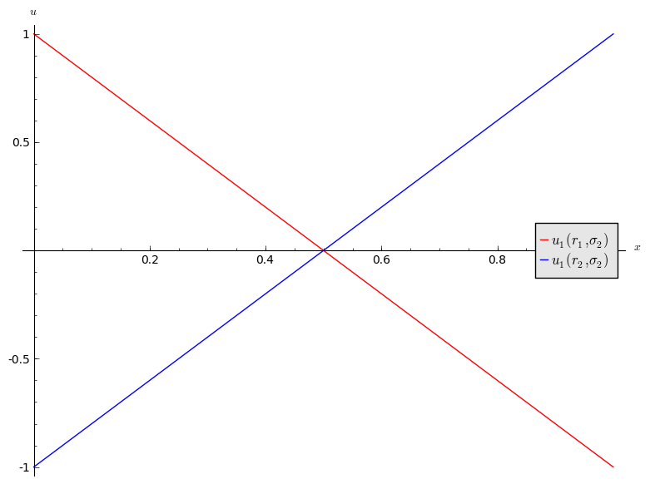

1. If then is a best response for player 1.
2. If then is a best response for player 1.
3. If then player 1 is indifferent.

Let us repeat this exercise for the battle of the sexes game.

If we assume that player 2 plays a mixed strategy we have:

and

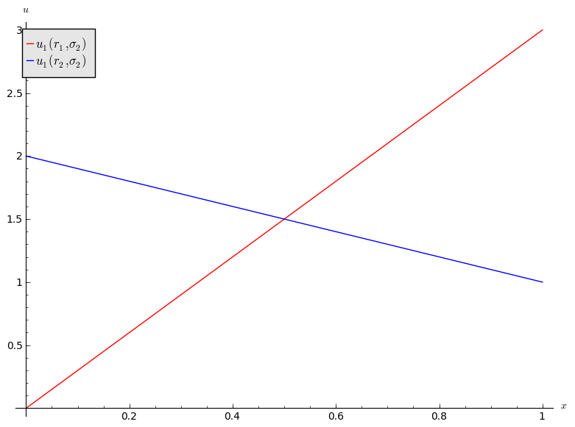

1. If then is a best response for player 1.
2. If then is a best response for player 1.
3. If then player 1 is indifferent.

## Connection between best responses and dominance

### Definition

In an player normal form game, let us define the set :

If we consider the following game:

We have:

### Definition

In an player normal form game, let us define the set :

In other words is the set of functions that are best responses to some strategy profile in .

Let us try to identify for the above game. Let us assume that player 1 plays . This gives:

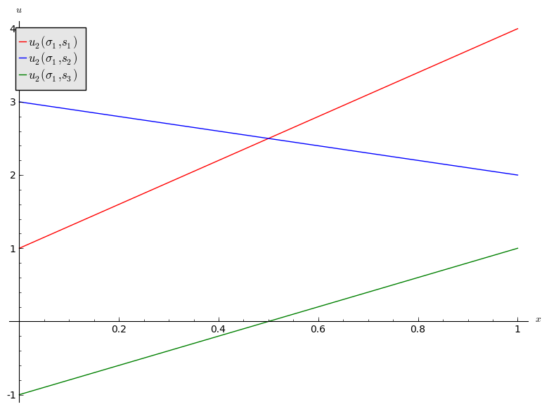

We see that is never a best response for player 2:

We will now attempt to identify for the above game. Let us assume that player two plays . This gives:

However as noted earlier is dominated by so:

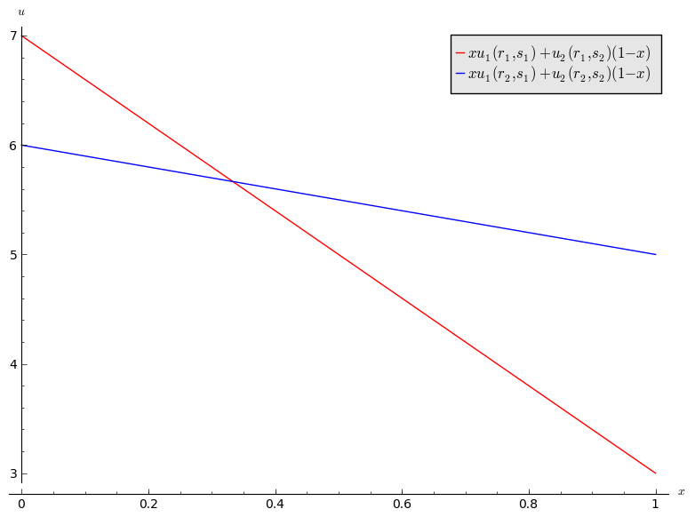

We see that and are best responses for player 1:

We have seen in our little example that . This leads us to two Theorems (the proofs are omitted).

### Theorem

In a 2 player normal form game for all .

This is however not always the case:

In an player normal form game for all .