# OR 3: Lecture 6 - Nash equilibria in mixed strategies

## Recap

In the [previous lecture](Chapter_05-Nash_Equilibria_in_pure_strategies.docx)

* The definition of Nash equilibria;
* Identifying Nash equilibria in pure strategies;
* Solving the duopoly game;

This brings us to a very important part of the course. We will now consider equilibria in mixed strategies.

## Recall of expected utility calculation

In the matching pennies game discussed previously:

Recalling [Chapter 2](Chapter_02-Normal_Form_Games.docx) a strategy profile of and implies that player 1 plays heads with probability .2 and player 2 plays heads with probability .6.

We can extend the utility function which maps from the set of pure strategies to using *expected payoffs*. For a two player game we have:

## Obtaining equilibria

Let us investigate the best response functions for the matching pennies game.

If we assume that player 2 plays a mixed strategy we have:

and

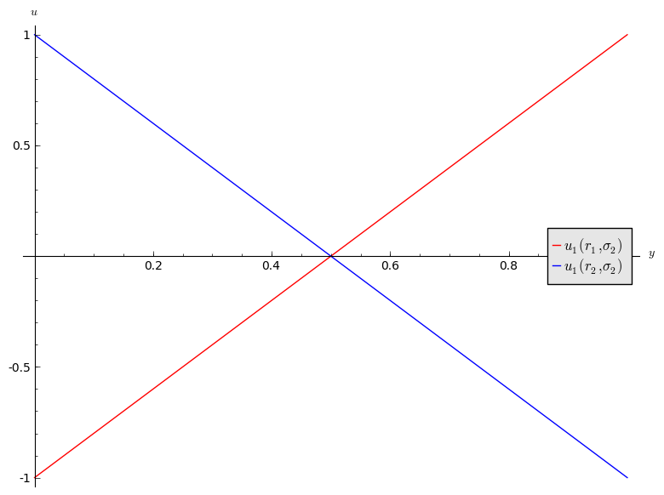

Utilities of player 1 in the matching pennies game.

1. If then is a best response for player 1.
2. If then is a best response for player 1.
3. If then player 1 is indifferent.

If we assume that player 1 plays a mixed strategy we have:

and

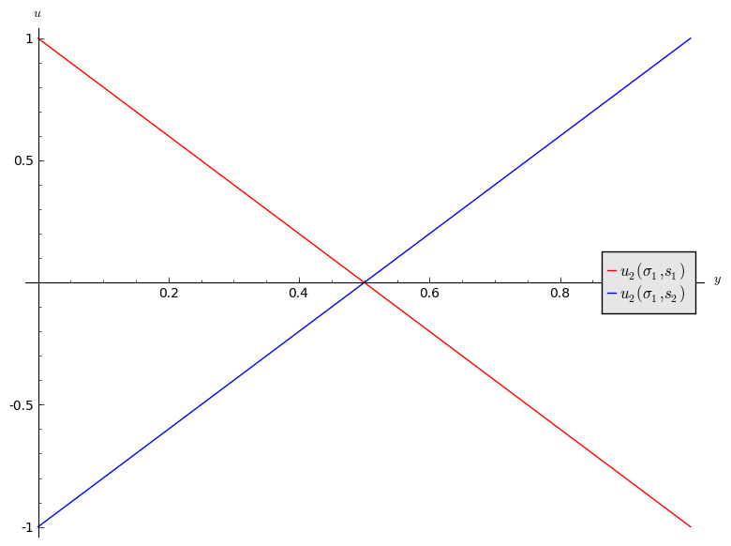

Utilities of player 2 in the matching pennies game.

Thus we have:

1. If then is a best response for player 2.
2. If then is a best response for player 2.
3. If then player 2 is indifferent.

Let us draw both best responses on a single diagram, indicating the best responses in each quadrant . The arrows show the deviation indicated by the best responses.

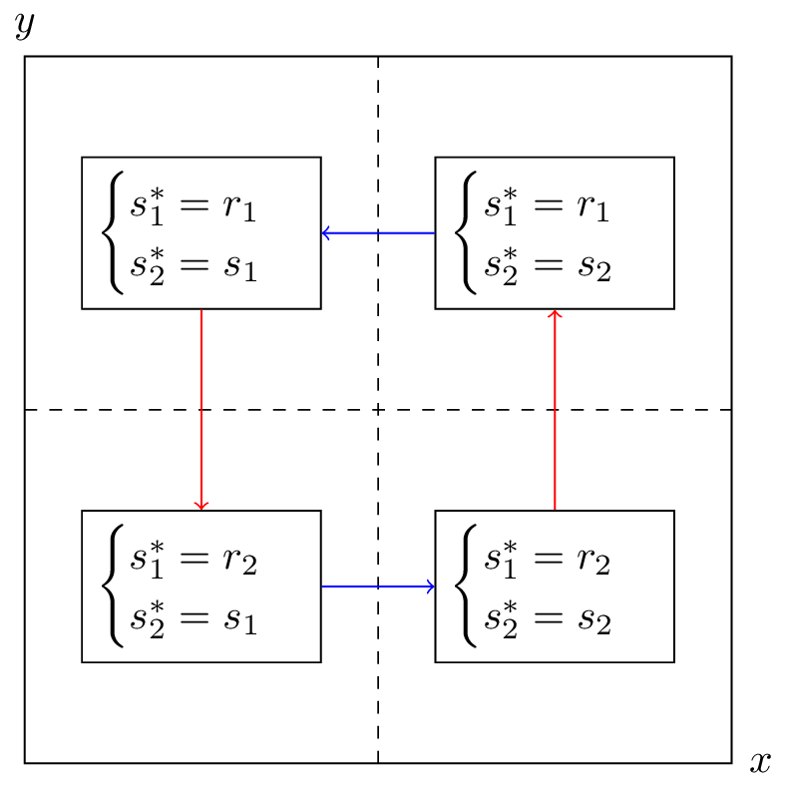

Best response moves based on current strategy.

If either player plays a mixed strategy other than then the other player has an incentive to modify their strategy. Thus the Nash equilibria is:

This notion of "indifference" is important and we will now prove an important theorem that will prove useful when calculating Nash Equilibria.

## Equality of payoffs theorem

### Definition of the support of a strategy

In an player normal form game the **support** of a strategy is defined as:

I.e. the support of a strategy is the set of pure strategies that are played with non zero probability.

For example, if the strategy set is and then .

### Theorem of equality of payoffs

In an player normal form game if the strategy profile is a Nash equilibria then:

### Proof

If then the proof is trivial.

We assume that . Let us assume that the theorem is not true so that there exists such that

Without loss of generality let us assume that:

Thus we have:

Giving:

which implies that is not a Nash equilibrium.

### Example

Let's consider the matching pennies game yet again. To use the equality of payoffs theorem we identify the various supports we need to try out. As this is a game we can take and and assume that is a Nash equilibrium.

from the theorem we have that

Thus we have found player 2's Nash equilibrium strategy by finding the strategy that makes player 1 indifferent. Similarly for player 1:

Thus the Nash equilibria is:

To finish this chapter we state a famous result in game theory:

### Nash's Theorem

Every normal form game with a finite number of pure strategies for each player, has at least one Nash equilibrium.