# OR 3: Lecture 8 - Subgame Perfection

## Recap

In the [previous chapter](Chapter_07-Extensive_form_games_and_backwards_induction.html)

* We took a formal look at extensive form games;
* Investigated an analysis technique for extensive form games called backwards induction.

In this Chapter we will take a look at another important aspect of extensive form games.

## Subgames

We need the following definition:

### Definition

In an extensive form game, a node is said to **initiate a subgame** if and only if and all successors of are in information sets containing only successors of .

In the following game all nodes initiate a subgame:

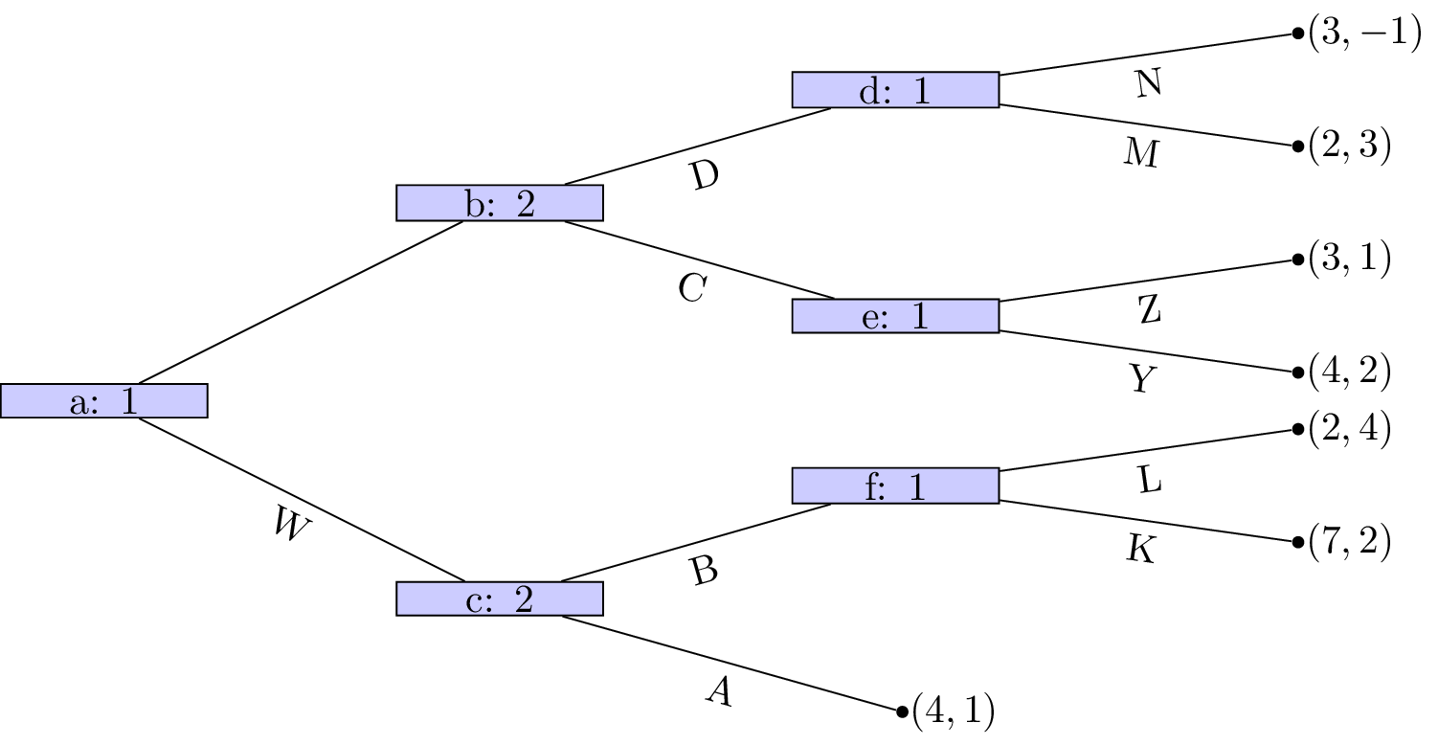

In the following game **that does not have perfect information** nodes , and initiate subgames but all of 's successors do not.

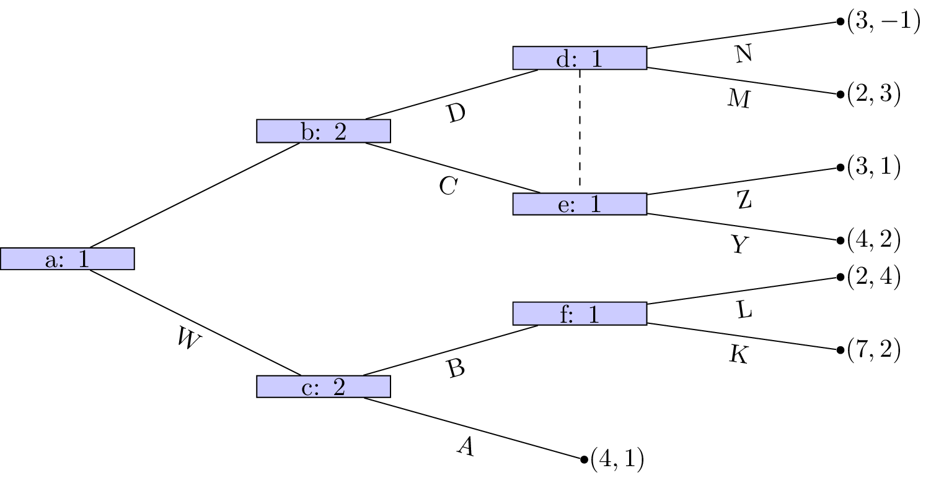

Similarly, in the following game the only node that initiates a subgame is .

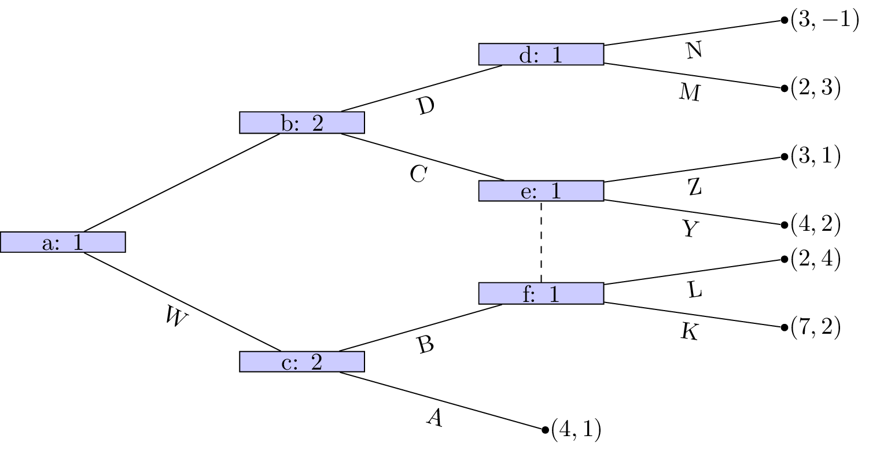

## Subgame pergect equilibria