# OR 3: Chapter 10 - Infinitely Repeated Games

## Recap

In the [previous chapter](Chapter_10_Infinitely_Repeated_Games.html):

* We considered infinitely repeated games using a discount factor;
* We proved a theorem stating that for a high enough discount factor players could end up cooperating.

In this chapter we'll move on to a fascinating area of game theory.

## Discounting

When considering infinitely repeated games () it is easiest to consider a Prisoners dilemma throughout:

Let us denote as the strategy "cooperate at every stage". Let us denote as the strategy "defect at every stage".

If we assume that both players play their utility would be:

Similarly:

It is impossible to compare these two strategies. To be able to carry out analysis of strategies in infinitely repeated games we make use of a **discounting factor** .

The interpretation of is that there is less importance given to future payoffs. One way of thinking about this is that "the probability of recieveing the future payoffs decreases with time".

In this case we write the utility in an infinitely repeated game as:

Thus:

and:

## Conditions for cooperation in Prisoner's Dilemmas

Let us consider the "Grimm trigger" strategy (which we denote ):

Start by cooperating until your opponent defects at which point defect in all future stages.

If both players play we have :

If we assume that and player 2 deviates from to we get:

Deviation from to is rational if and only if:

thus if is large enough is a Nash equilibrium.

Importantly is not a subgame perfect Nash equilibrium. Consider the subgame following having been played in the first stage of the game. Assume that player 1 adhers to :

1. If player 2 also plays then the first stage of the subgame will be (player 1 punishes while player 2 sticks with as player 1 played in previous stage). All subsequent plays will be so player 2's utility will be:

1. If player 2 deviates from and chooses to play in every period of the subgame then player 2's utility will be:

which is a rational deviation (as ).

Two questions arise:

1. Can we always find a strategy in a repeated game that gives us a better outcome than simply repeating the stage Nash equilibria? (Like )
2. Can we also find a strategy with the above property that in fact is subgame perfect? (Unlike )

## Folk theorm

The answer is yes! To prove this we need to define a couple of things.

### Definition

If we interpret as the probability of the repeated game ending then the *average* length of the game is:

We can use this to define the **average payoffs** per stage:

This average payoff is a tool that allows us to compare the payoffs in an infitely repeated game to the payoff in a single stage game.

### Definition

**Individually rational payoffs** are average payoffs that exceed the stage game Nash equilibrium payoff for both players.

As an example consider the following plot corresponding to a repeated Prisoner's Dilemma.

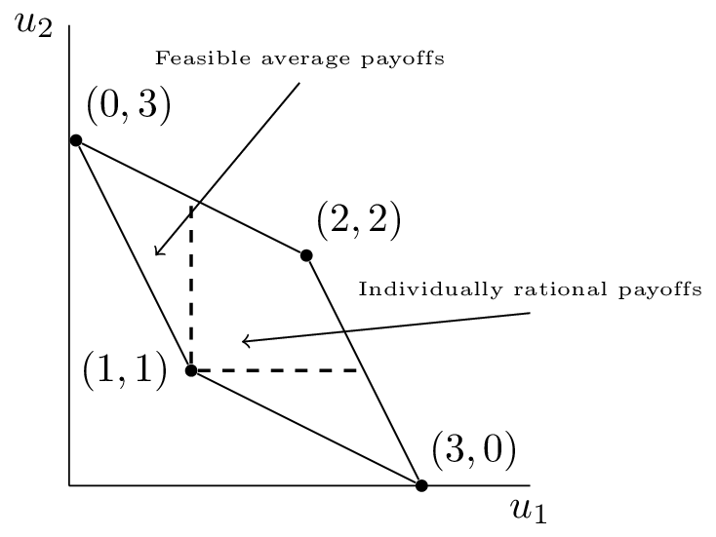

The feasible average payoffs correspond to the feasible payoffs in the stage game. The individually rational payoffs show the payoffs that are **better for both players** than the stag Nash equilibrium.

The following theorem states that we can choose a particular discount rate that for which there exists a subgame perfect Nash equilibrium that would give any individually rational payoff pair!

### Theorem

Let be a pair of Nash equilibrium payoffs for a stage game. For every individually rational pair there exists such that for all there is a subgame perfect Nash equilibrium with payoffs .

### Proof

Let be the stage Nash profile that yields . Now assume that playing and in every stage gives (an individual rational payoff pair).

Consider the following strategy:

"Begin by using and continue to use as long as both players use the agreed strategies. If any player deviates: use for all future stages."

We begin by proving that the above is a Nash equilibrium.

Without loss of generality if player 1 deviates to such that in stage then:

Recalling that player 1 would receive in every stage with no devitation, the biggest gain to be made from deviating is if player 1 deviates in the first stage (all future gains are more heavily discounted). Thus if we can find such that implies that then player 1 has no incentive to deviate.

as , taking gives the required required result for player 1 and repeating the argument for player 2 completes the proof of the fact that the prescribed strategy is a Nash equilibrium.

By construction this strategy is also a subgame perfect Nash equilibrium. Given any history **both** players will act in the same way and no player will have an incentive to deviate:

* If we consider a subgame just after any player has deviated from then both players use .
* If we consider a subgame just after no player has deviated from then both players continue to use .