# OR 3: Chapter 16 - Cooperative games

## Recap

In the [previous chapter](Chapter_15_Matching_games.docx):

* We defined matching games;
* We described the Gale-Shapley algorithm;
* We proved certain results regarding the Gale-Shapley algorithm.

In this Chapter we'll take a look at another type of game.

## Cooperative Games

In cooperative game theory the interest lies with understanding how coalitions form in competitive situations.

### Definition of a characteristic function game

A **characteristic function game** G is given by a pair where is the number of players and is a **characteristic function** which maps every coalition of players to a payoff.

Let us consider the following game:

"3 players share a taxi. Here are the costs for each individual journey: - Player 1: 6 - Player 2: 12 - Player 3: 42 How much should each individual contribute?"

This is illustrated.

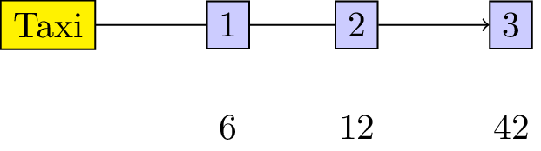

A taxi journey.

To construct the characteristic function we first obtain the power set (ie all possible coalitions) where denotes the set of all players ().

The characteristic function is given below:

### Definition of a monotone characteristic function game

A characteristic function game is called **monotone** if it satisfies for all .

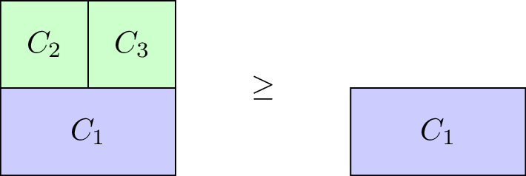

A diagrammatic representation of monotonicity.

Our taxi example is monotone, however the with defined as:

is not.

### Definition of a superadditive game

A characteristic function game is called **superadditive** if it satisfies

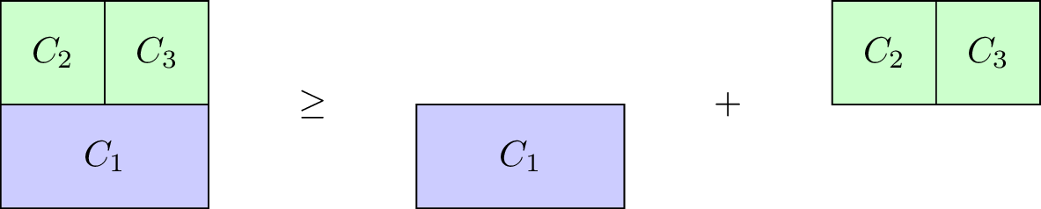

A diagrammatic representation of superadditivity.

Our taxi example is not superadditive, however the with defined as:

is.

## Shapley Value

When talking about a solution to a characteristic function game we imply a payoff vector that divides the value of the grand coalition between the various players. Thus must satisfy:

Thus one potential solution to our taxi example would be . Obviously this is not ideal for player 1 and/or 2: they actually pay more than they would have paid without sharing the taxi!

Another potential solution would be , however at this point sharing the taxi is of no benefit to player 1. Similarly would have no incentive for player 2.

To find a "fair" distribution of the grand coalition we must define what is meant by "fair". We require four desirable properties:

* Efficiency;
* Null player;
* Symmetry;
* Additivity.

### Definition of efficiency

For a payoff vector is **efficient** if:

### Definition of null players

For a payoff vector possesses the **null player property** if for all then:

### Definition of symmetry

For a payoff vector possesses the **symmetry property** if for all then:

### Definition of additivity

For and and where for any . A payoff vector possesses the **additivity property** if:

We will not prove in this course but in fact there is a single payoff vector that satisfies these four properties. To define it we need two last definitions.

### Definition of predecessors

If we consider any permutation of then we denote by the set of **predecessors** of in :

For example for we have .

### Definition of marginal contribution

If we consider any permutation of then the **marginal contribution** of player with respect to is given by:

We can now define the **Shapley value** of any game .

### Definition of the Shapley value

Given the **Shapley value** of player is denoted by and given by:

As an example here is the Shapley value calculation for our taxi sharing game:

For :

For :

For :

For :

For :

For :

Using this we obtain:

Thus the fair way of sharing the taxi fare is for player 1 to pay 2, player 2 to pay 5 and player 3 to pay 35.